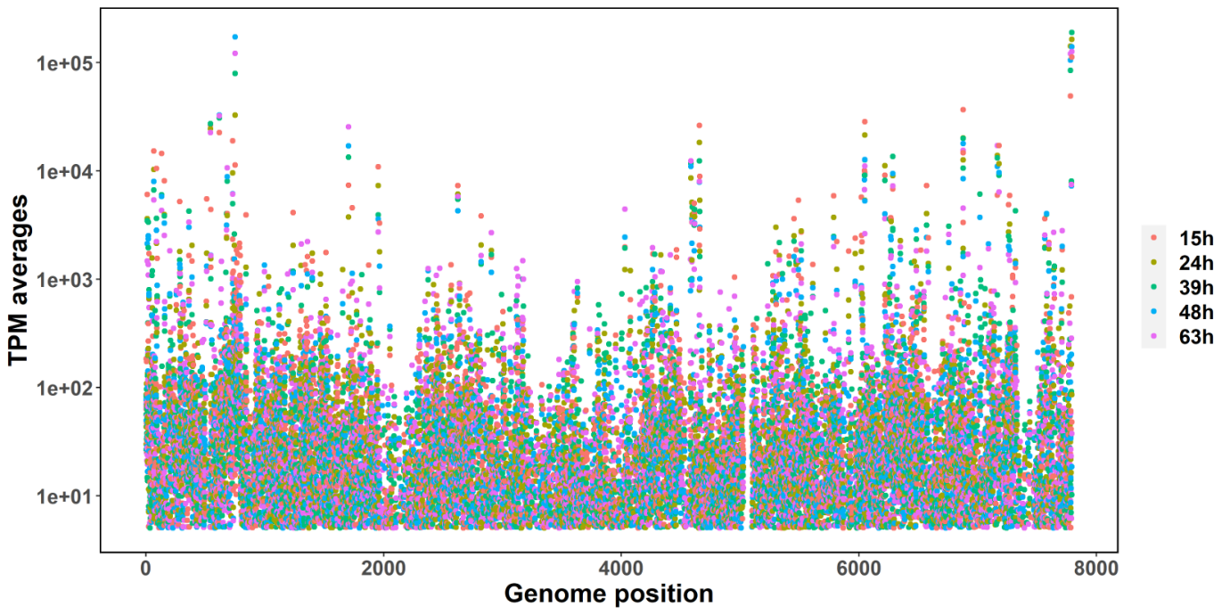

**Supplementary Figure 1 –** Observed average TPMs at each time point as function of genes position.

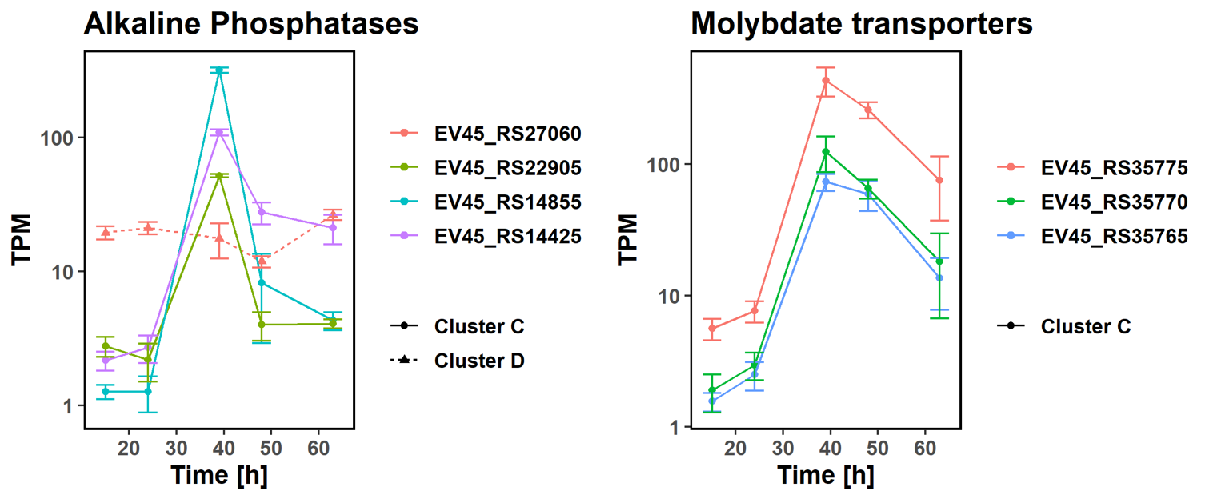

**Supplementary Figure 2 –** Gene expression of the alkaline phosphatases found in the *P. rosea* genome (left side) and the molybdate transport system following the same trend of phosphate and iron transporters. Data shown in logarithmic scale.

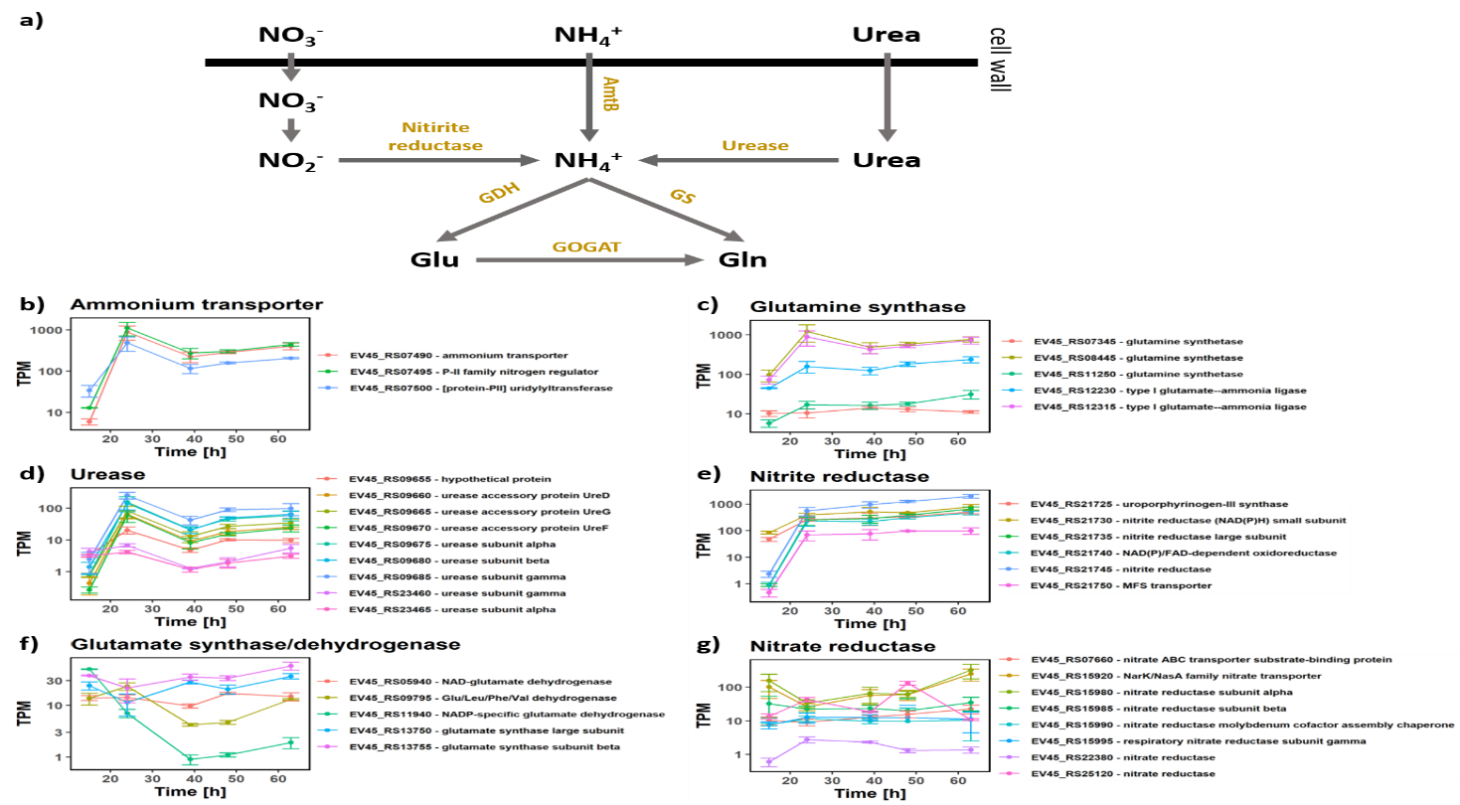

**Supplementary Figure 3 – a)** Gene expression of the genes involved in the nitrogen metabolism. **b)** TPM values (in log scale) of the differentially expressed ammonium transporter and its two neighbouring genes. **c)** TPM values (in log scale) associated glutamine synthases. **d)** TPM values (in log scale) associated with the ureases genes. **e)** TPM values (in log scale) associated with the genes associated with nitrite uptake and reduction. **f)** TPM values (in log scale) associated glutamate synthases and dehydrogenases. The error bars represent the standard deviation calculated from three replicates. **g)** TPM values (in log scale) associated with the genes associated with nitrate uptake and reduction.

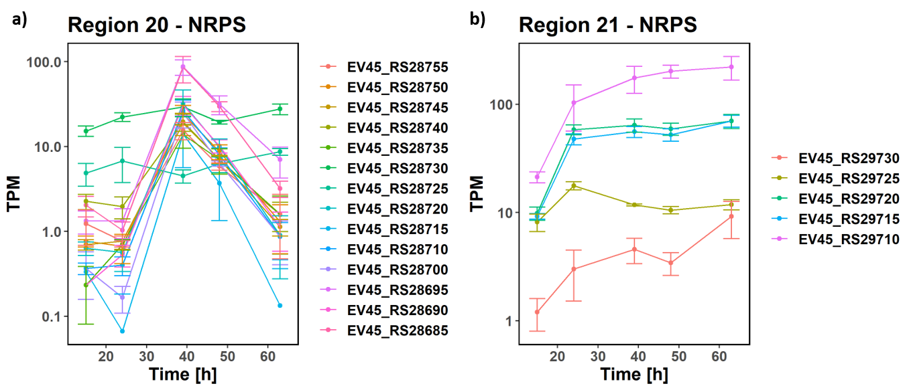

**Supplementary figure 4 – a)** Gene expression of a selection of genes found in the predicted BGC in region 20 (NRPS cluster, moderately similar to the streptobactin cluster). **b)** Gene expression of a selection of genes found in the predicted BGC in region 21 (NRPS cluster, very weakly similar the theonellamide cluster. The error bars represent the standard deviation calculated from three replicates. Data shown in logarithmic scale.

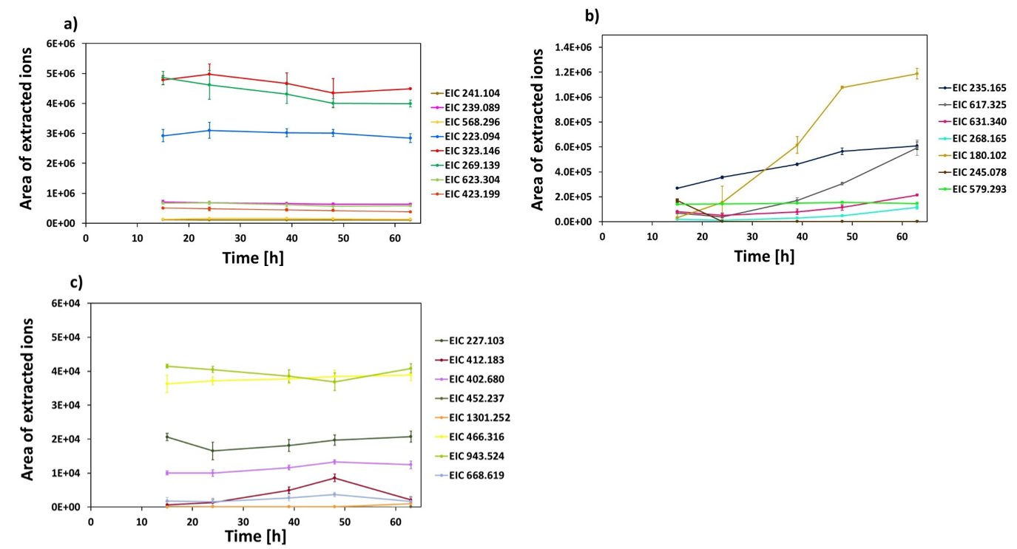

**Supplementary figure 5 – a)** Areas of the extracted ions associated with the *m/z* values of metabolites which concentration is more or less constant over time and show high concentration. **b)** Areas of the extracted ions associated with the *m/z* values of metabolites that increased in the acetonitrile extract throughout fermentation. **c)** Areas of the extracted ions associated with the *m/z* values of metabolites which concentration is more or less constant over time with low concentration. The error bars represent the standard deviation calculated from three replicates.

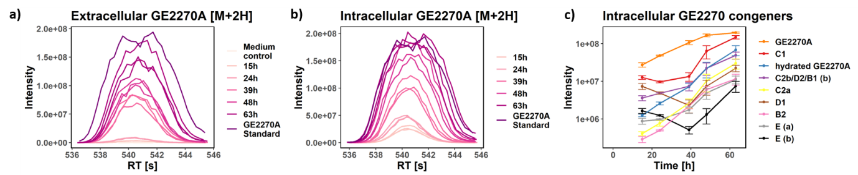

**Supplementary figure 6 – a)** Chromatogram of the main peak associated to GE2270A [M+2H]2+ in the extracellular environment. The comparison with the standard allows a certain identification. **b)** Chromatogram of the main peak associated to GE2270A [M+2H]2+ in the intracellular environment. The comparison with the standard allows a certain identification. **c)** Intensities over time associated with the peaks for which the most likely annotation is one of the GE2270A congeners in the intracellular environment. Data shown in logarithmic scale.

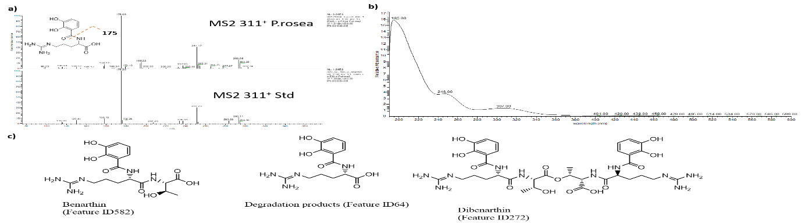

**Supplementary figure 7** – a) MS2 fragmentation spectrum of benarthin; b) UV spectrum benarthin. The UV absorbance is consistence with the one observed for benarthin in Hatsu et al. (1992) Journal of Antibiotics 45,7,1084-1087.

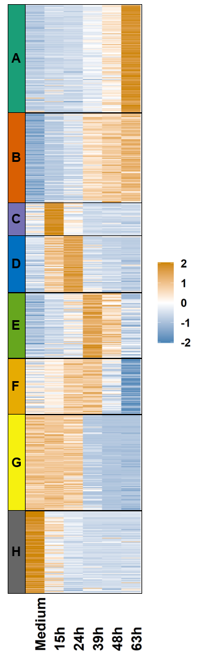

**Supplementary Figure 8 –** Heatmap showing normalized intensity values associated with the peaks, detected in negative mode in the extracellular environment, which levels show a statistically significant change during fermentation. The peaks are clustered into 8 groups with the k-means approach.

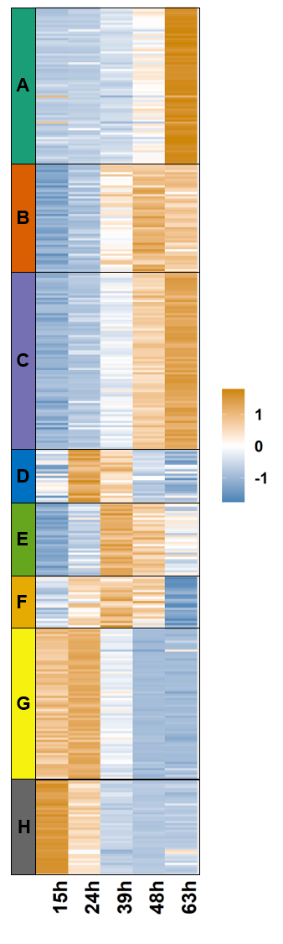

**Supplementary Figure 9 –** Heatmap showing normalized intensity values associated with the peaks, detected in negative mode in the intracellular environment, which levels show a statistically significant change during fermentation. The peaks are clustered into 8 groups with the k-means approach.

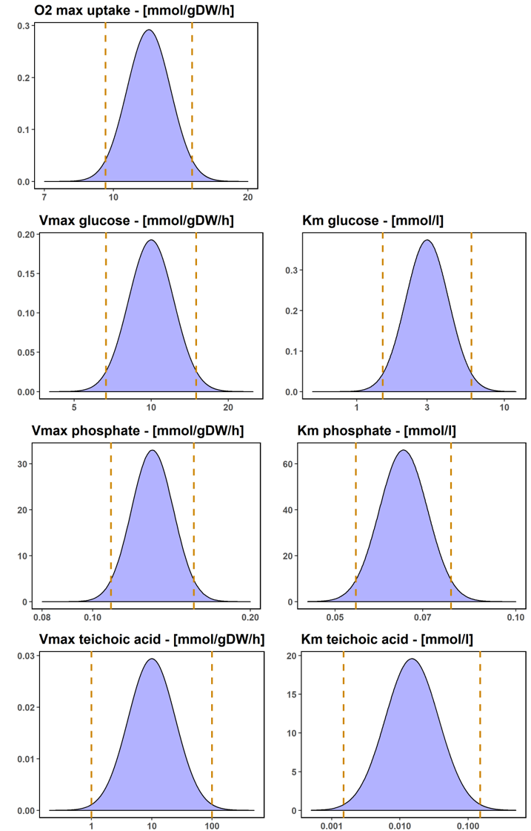

**Supplementary figure 10** – probability distributions used to sample the parameters used for the ensemble modelling. Dashed lines represent 95% confidence intervals.