Supplementary material

**Untargeted metabolomics analysis of whole-broth acetonitrile extracts**

The untargeted metabolomics experiment performed on the acetonitrile extracts detected several mass-to-charge ratios (*m/z*) associated with several metabolites present during fermentation. The metabolites detected were divided in three different groups. The first group contains metabolites that showed a roughly constant and high level over time. The three metabolites with the highest levels are associated with the following *m/z* values: 323.1462, 269.1386 and 223.0941 (**Supplementary figure 4a**).

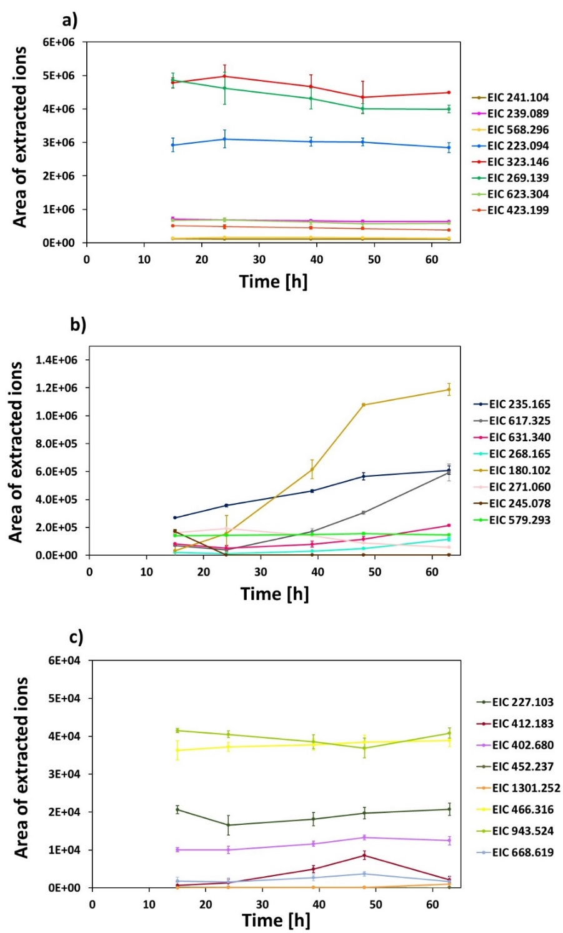

**Supplementary figure 4 – a)** Areas of the extracted ions associated with the *m/z* values of metabolites which concentration is more or less constant over time and show high concentration. **b)** Areas of the extracted ions associated with the *m/z* values of metabolites that increased in the acetonitrile extract throughout fermentation. **c)** Areas of the extracted ions associated with the *m/z* values of metabolites which concentration is more or less constant over time with low concentration. The error bars represent the standard deviation calculated from three replicates.

None of the molecular formulae associated to [M+Na]+= 323.1462 (C15H24O6), and [M+H]+=269.1386 (C14H20O5 and C15H16N4O) could be identified as any known actinomycete metabolite in the Dictionary of Natural Products (DNP Version 29:1, June 2020 CRC Press). The molecular formula C10H16O4 was assigned to the adduct [M+Na]+= 223.0941 with 120 possible hits identified for this molecular formula (**Supplementary tables 2a-2d**).

The second group contains metabolites the level of which increases during fermentation (**Supplementary figure 4b**). In this group, the peak that reaches the highest level at of fermentation has a *m/z* value of 180.1019. The molecular formula C10H13NO2 associated to this peak matches several potential metabolites (**Supplementary tables 2a-2d**). The other two main peaks detected in this group have a *m/z* value of 235.1652 and 617.3253, respectively. The molecular formulae C10H22N2O4 and C24H48N9O14/C25H44N8O10 assigned to these *m/z* values could not be associated to any known metabolite suggesting potentially new metabolites produced by the strain. Finally, the third group contains metabolites showing low intensity and a roughly constant trend throughout fermentation (**Supplementary figure 4c**). One peak found in this group was annotated as benarthin (C17H25N5O7). This compound was detected as the ion [M+H]+ = 412.1830. This peak slightly increased from 15 to 48 hours, reaching the highest level at 48 hours.

|  |  |  |  |  |  |  |  |  |  |  |
| --- | --- | --- | --- | --- | --- | --- | --- | --- | --- | --- |
| RT (min) | [M+H]+ | [M+2H]2+ | [M+H+NH4]2+ | [M+NH4]+ | [M+Na]+ | [M+3H]3+ | [M+2H+Na]3+ | MF | DPN | Identification by DNP |
| 1.18 | 235.1652 |  |  |  |  |  |  | C10H22N2O4 | No hits |  |
| 1.44 | 280.1388 |  |  |  |  |  |  | C11H21NO7 | * | Fructose-valine |
| 1.56 | 235.1191 |  |  |  |  |  |  | C11H14N4O2 | * | Cyclo(histidylproline) |
| 1.67 | 158.0924 |  |  |  |  |  |  | C6H11N3O2 | * |  |
| 1.91 | 226.1549 |  |  |  |  |  |  | C11H19N3O2 | * |  |
| 2.03 | 268.1038 |  |  |  |  |  |  | C10H13N5O4/ C9H17NO8 | * | Adenosine/Fructose-serine |
| 2.38 | **617.3253** | 309.1661 |  |  |  |  |  | C24H48N9O14/ C25H44N8O10 | No hits |  |
| 2.52 | 254.161 |  |  |  |  |  |  | C11H19N5O2/ C10H23NO6 | * | Cyclo(arginylpropyl) |
| 4.05 | 631.3401 |  |  |  |  |  |  | C25H50N4O14/ C23H38N18O4 | No hits |  |
| 4.29 | 169.0969 |  |  |  |  |  |  | C8H12N2O2 | * |  |
| 4.68 | 227.1026 |  |  |  |  |  |  | C10H12N2O4 | 12 Hits | 2-Amino-4-hydroxy-4-(5-hydroxy-2-pyridinyl)-3-methylbutanoic acid (AA residue of nikkomycin Z) / Cyclo(glutamylprolyl) / Nikkomycin D |
| 5.05 | 412.183 |  |  |  |  |  |  | C17H25N5O7 | 1 Hit | Benarthin |
| 5.19 | 261.1315 |  |  |  |  |  |  | C8H16N6O4 | * |  |
| 5.25 | 268.1654 |  |  |  |  |  |  | C13H21N3O3 | No hits |  |
| 5.51 | 283.175 |  |  |  |  |  |  | C12H26O7 | * |  |
| 5.73 | 327.2011 |  |  |  |  |  |  | C14H30O8 | * |  |
| 5.73 | 271.1233 |  |  |  |  |  |  | C14H16N2O3 | * | Cyclo(2-hydroxyprolylphenylalanyl) / Cyclo(prolyltyrosyl) / N-Ac 2-methyltryptophan / Na-Ac methyl tryptophan |

**Supplementary Table 2a –** Summary of the untargeted metabolites detected in *P. rosea*.

*Metabolites detected in the medium.

In those metabolites in which several adducts were detected, the most intense ion is indicated in bold.

Identification was done by searching the molecular formulae in the Dictionary of Natural Products (DPN).

|  |  |  |  |  |  |  |  |  |  |  |
| --- | --- | --- | --- | --- | --- | --- | --- | --- | --- | --- |
| RT (min) | [M+H]+ | [M+2H]2+ | [M+H+NH4]2+ | [M+NH4]+ | [M+Na]+ | [M+3H]3+ | [M+2H+Na]3+ | MF | DPN | Identification by DNP |
| 5.95 | 371.2275 |  |  |  |  |  |  | C16H34O9 | * |  |
| 6.03 | 180.1019 |  |  |  |  |  |  | C10H13NO2 | 92 Hits | Dihydro-N-hydroxyabikoviromycin / 2-Ethyl-6,7-dihydro-7-hydroxy-3(5H)-indolizinone / 3-Hydroxy-3-(2-methylphenyl) propano amide / alanine benzyl ester / alanine N-benzyl methyl ester / alanine N-benzyl |
| 6.15 | 415.2535 |  |  | **432.28** | 437.2354 |  |  | C18H38O10 | * |  |
| 6.22 | 429.2322 |  |  | **446.2593** | 451.2146 |  |  | C18H36O11 | * |  |
| 6.25 | 459.2797 |  |  | **476.3062** | 481.2613 |  |  | C20H42O11 | * |  |
| 6.38 | 503.3057 |  |  | **520.3323** | 525.2874 |  |  | C22H46O12 | * |  |
| 6.52 | 547.332 |  |  | **564.3586** | 569.3138 |  |  | C24H50O13 | * |  |
| 6.62 | 591.3377 |  |  | **608.3845** | 613.3400 |  |  | C26H54O14 | * |  |
| 6.72 | 635.384 |  |  | **652.4106** | 657.3655 |  |  | C28H58O15 | * |  |
| 6.73 | 402.6802 |  |  |  |  |  |  | C34H38N10O13 | 0 Hits |  |
| 6.81 | 679.4100 |  |  | **696.4369** | 701.3924 |  |  | C30H62O16 | * |  |
| 6.89 | 723.4365 | **362.2219** | 370.7554 |  |  |  |  | C32H66O17 | * |  |
| 6.96 | 767.4623 | **384.2349** | 392.7481 |  |  |  |  | C34H70O18 | * |  |
| 7.04 | 811.4873 | **406.2479** | 414.7614 |  |  |  |  | C36H74O19 | * |  |
| 7.09 | 855.5141 | 428.2612 | **436.7748** |  |  |  |  | C38H78O20 | * |  |
| 7.16 | 899.5396 | 450.2743 | **458.7877** |  |  |  |  | C40H82O21 | * |  |
| 7.23 | 943.5669 | 472.2876 | **480.8009** |  |  |  |  | C42H86O22 | * |  |
| 7.30 | 987.5926 | 494.3006 | **502.8139** |  |  |  |  | C44H90O23 | * |  |
| 7.35 | 1031.6182 | **516.3137** | 524.8271 |  |  |  |  | C46H94O24 | * |  |
| 7.40 | 1075.6439 | **538.3267** | 546.8402 |  |  |  |  | C48H98O25 | * |  |

**Supplementary Table 2b –** Summary of the untargeted metabolites detected in *P. rosea*.

*Metabolites detected in the medium.

In those metabolites in which several adducts were detected, the most intense ion is indicated in bold.

Identification was done by searching the molecular formulae in the Dictionary of Natural Products (DPN).

|  |  |  |  |  |  |  |  |  |  |  |
| --- | --- | --- | --- | --- | --- | --- | --- | --- | --- | --- |
| RT (min) | [M+H]+ | [M+2H]2+ | [M+H+NH4]2+ | [M+NH4]+ | [M+Na]+ | [M+3H]3+ | [M+2H+Na]3+ | MF | DPN | Identification by DNP |
| 7.43 | 1119.6802 | **560.3396** | 568.8534 |  |  |  |  | C50H102O26 | * |  |
| 7.48 | 1163.697 | **582.3524** | 590.8665 |  |  |  |  | C52H106O27 | * |  |
| 7.53 | 1207.7297 | **604.3653** | 612.8792 |  |  |  |  | C54H110O28 | * |  |
| 7.57 | 1251.739 | 626.3777 | **634.8919** |  |  |  |  | C56H114O29 | * |  |
| 7.62 | 1295.7725 |  |  |  |  | 432.5968 | **447.2721** | C58H118O30 | * |  |
| 7.63 | 1339.7981 |  |  |  |  | **443.2723** |  | C60H122O31 | * |  |
| 7.67 | 1383.8229 |  |  |  |  | **461.9473** |  | C62H126O32 | * |  |
| 7.70 | 1427.8461 |  |  |  |  | **476.623** |  | C64H130O33 | * |  |
| 7.74 | 1471.8663 |  |  |  |  | **496.9717** |  | C66H134O34 | * |  |
| 7.77 | 1515.8921 |  |  |  |  | **505.9732** |  | C68H138O35 | * |  |
| 7.82 | 1559.9285 |  |  |  |  | **520.6484** |  | C70H142O36 | * |  |
| 7.84 | 1603.9453 |  |  |  |  | **535.3240** |  | C72H146O37 | * |  |
| 8.09 | 255.0650 |  |  |  |  |  |  | C15H10O4 | 88 Hits |  |
| 8.16 | 241.1044 |  |  |  |  |  |  | C8H12N6O3/ C7H16N2O7 | No hits |  |
| 8.70 | 239.0888 |  |  |  |  |  |  | C8H11N6O3/ C7H14N2O7 | No hits |  |
| 8.92 | 452.2370 |  |  |  |  |  |  | C26H45NO5 | No hits |  |
| 8.92 | 271.0598 |  |  |  |  |  |  | C15H10O5/  sC16H6N4O | 174 Hits/ No hits | Genistein (biotransformation product from soy) |
| 9.10 | **1301.2517** | 651.1295 |  |  |  |  |  |  |  |  |
| 9.10 | 466.3158 |  |  |  |  |  |  | C26H43NO6/  C27H39N5O2 | 4 Hits/  No hits | No hits from actinomycetes |
| 9.41 | 551.2688 |  |  | **568.2958** | 573.2511 |  |  | C25H42O13 | 4 Hits | No hits from actinomycetes |

**Supplementary Table 2c –** Summary of the untargeted metabolites detected in *P. rosea*.

*Metabolites detected in the medium.

In those metabolites in which several adducts were detected, the most intense ion is indicated in bold.

Identification was done by searching the molecular formulae in the Dictionary of Natural Products (DPN).

|  |  |  |  |  |  |  |  |  |  |  |
| --- | --- | --- | --- | --- | --- | --- | --- | --- | --- | --- |
| RT (min) | [M+H]+ | [M+2H]2+ | [M+H+NH4]2+ | [M+NH4]+ | [M+Na]+ | [M+3H]3+ | [M+2H+Na]3+ | MF | DPN | Identification by DNP |
| 9.41 | **345.2745** |  |  |  | 367.2564 |  |  | C18H36N2O4 | No hits |  |
| 9.49 | 943.5243 |  |  |  |  |  |  | C44H74N6O16/ C45H70N10O12/ C48H78O18 | No hits |  |
| 10.27 | 201.1120 |  |  |  | **223.0941** |  |  | C10H16O4 | 120 hits | Attiamycin B/ 5-Hydroxy-3-(1-hydroxy-2-methylbutyl)-4-methyl-2(5H)-furanone |
| 10.71 | 245.0782 |  |  |  |  |  |  | C10H8N6O2/  C9H12N2O6 | No hits/ 12 Hits | Uridine/  Antibiotic F 2787 |
| 11.04 | 301.1639 |  |  |  | **323.1462** |  |  | C15H24O6 | 57 hits | No hits from actinomycetes |
| 11.20 | 623.3036 |  |  |  |  |  |  | C28H42N6O10/ C27H46N2O14 | No hits |  |
| 11.20 | 269.1386 |  |  |  |  |  |  | C14H20O5/  C15H16N4O | 54 Hits/  0 hits | No hits from actinomycetes |
| 11.82 | 401.2165 |  |  |  | **423.1988** |  |  | C20H32O8 | 109 hits | No hits from actinomycetes |
| 13.09 | 579.2928 |  |  |  |  |  |  | C30H38N6O6/ C29H42N2O10 | 0 Hits/  4 Hits | 4 (R),5-Dihydro-4-hydroxygeldanamycin/ 4 (S),5-Dihydro-4-hydroxygeldanamycin/ 4,5-Dihydro-15-hydroxygeldanamycin 15-h ydroxy-4,5-dihydrogeldanamycin/4,5-Dihydro-19-hydroxygeldanamycin |
| 13.68 | 668.6185 |  |  |  |  |  |  | C41H81NO5 | 4 Hits | No hits from actinomycetes |

**Supplementary Table 2d –** Summary of the untargeted metabolites detected in *P. rosea*.

*Metabolites detected in the medium.

In those metabolites in which several adducts were detected, the most intense ion is indicated in bold.

Identification was done by searching the molecular formulae in the Dictionary of Natural Products (DPN).

**Untargeted metabolomics analysis of the exometabolome performed with QTOF**

A parallel analysis of the exometabolome performed using a QTOF detected the following metabolites with *m/z* values and proposed molecular formula of 323.1462 (C15H24O6), 617.3253 (C24H48N9O14/C25H44N8O10), 180.1019 (C10H13NO2), 235.1652 (C10H22N2O4) and 631.3401 (C25H50N4O14/C23H38N18O4), which were also detected in the whole-broth fraction..

**Untargeted metabolomics analysis of the endometabolome performed with QTOF**

A parallel analysis of the endometabolome performed using a QTOF detected the metabolites with *m/z* values of 180.1019 (C10H13NO2), 235.1652 (C10H22N2O4), 617.3253 (C24H48N9O14/C25H44N8O10), and 631.3401 (C25H50N4O14/C23H38N18O4), which were also detected in the whole broth and the exometabolome fractions.