Embedded System
Francesco De Patre – 382760

Introduction
The third lab delves into the structure of an embedded application based on the nRF Connect SDK, analyzing the various components that determine its behavior. In particular, the configuration files, the build system, and the role of the device tree in describing the hardware are examined.

Unlike traditional software applications, project configuration plays a fundamental role in embedded systems, directly influencing system performance and the use of available resources. The lab demonstrates how an application can be customized not only by modifying the source code, but also by modifying configuration files and hardware descriptions.

This approach highlights the complexity and flexibility of modern embedded development, where the separation between configuration and application logic is a key element for system scalability and maintainability.

Methodology
The lab was conducted by analyzing the structure of an nRF Connect SDK application, with particular attention to the configuration files and the build system.
Changes were made to both the code and the configuration to understand the impact of the different components.

LAB Section

Technical objective
Understand the structure of a Zephyr-based embedded application and the role of configuration files and the device tree.

What was done during the laboratory
A basic application with terminal output was created and subsequently modified to include new source files and custom configurations.

What can be understood
This lab highlighted the complexity of the structure of an embedded application.
In particular, configuration and code are separated, in fact, the devicetree defines the hardware while the build system (CMake) manages the dependencies.
It turns out that small configuration changes can have significant impacts on system behavior.

Problems encountered
The problems encountered mainly concern the difficulty in understanding the file structure, the need to perform pristine builds and errors due to outdated configurations.

Possible improvements
Improved file organization and consistent use of pristine builds to avoid inconsistencies.

Evidence
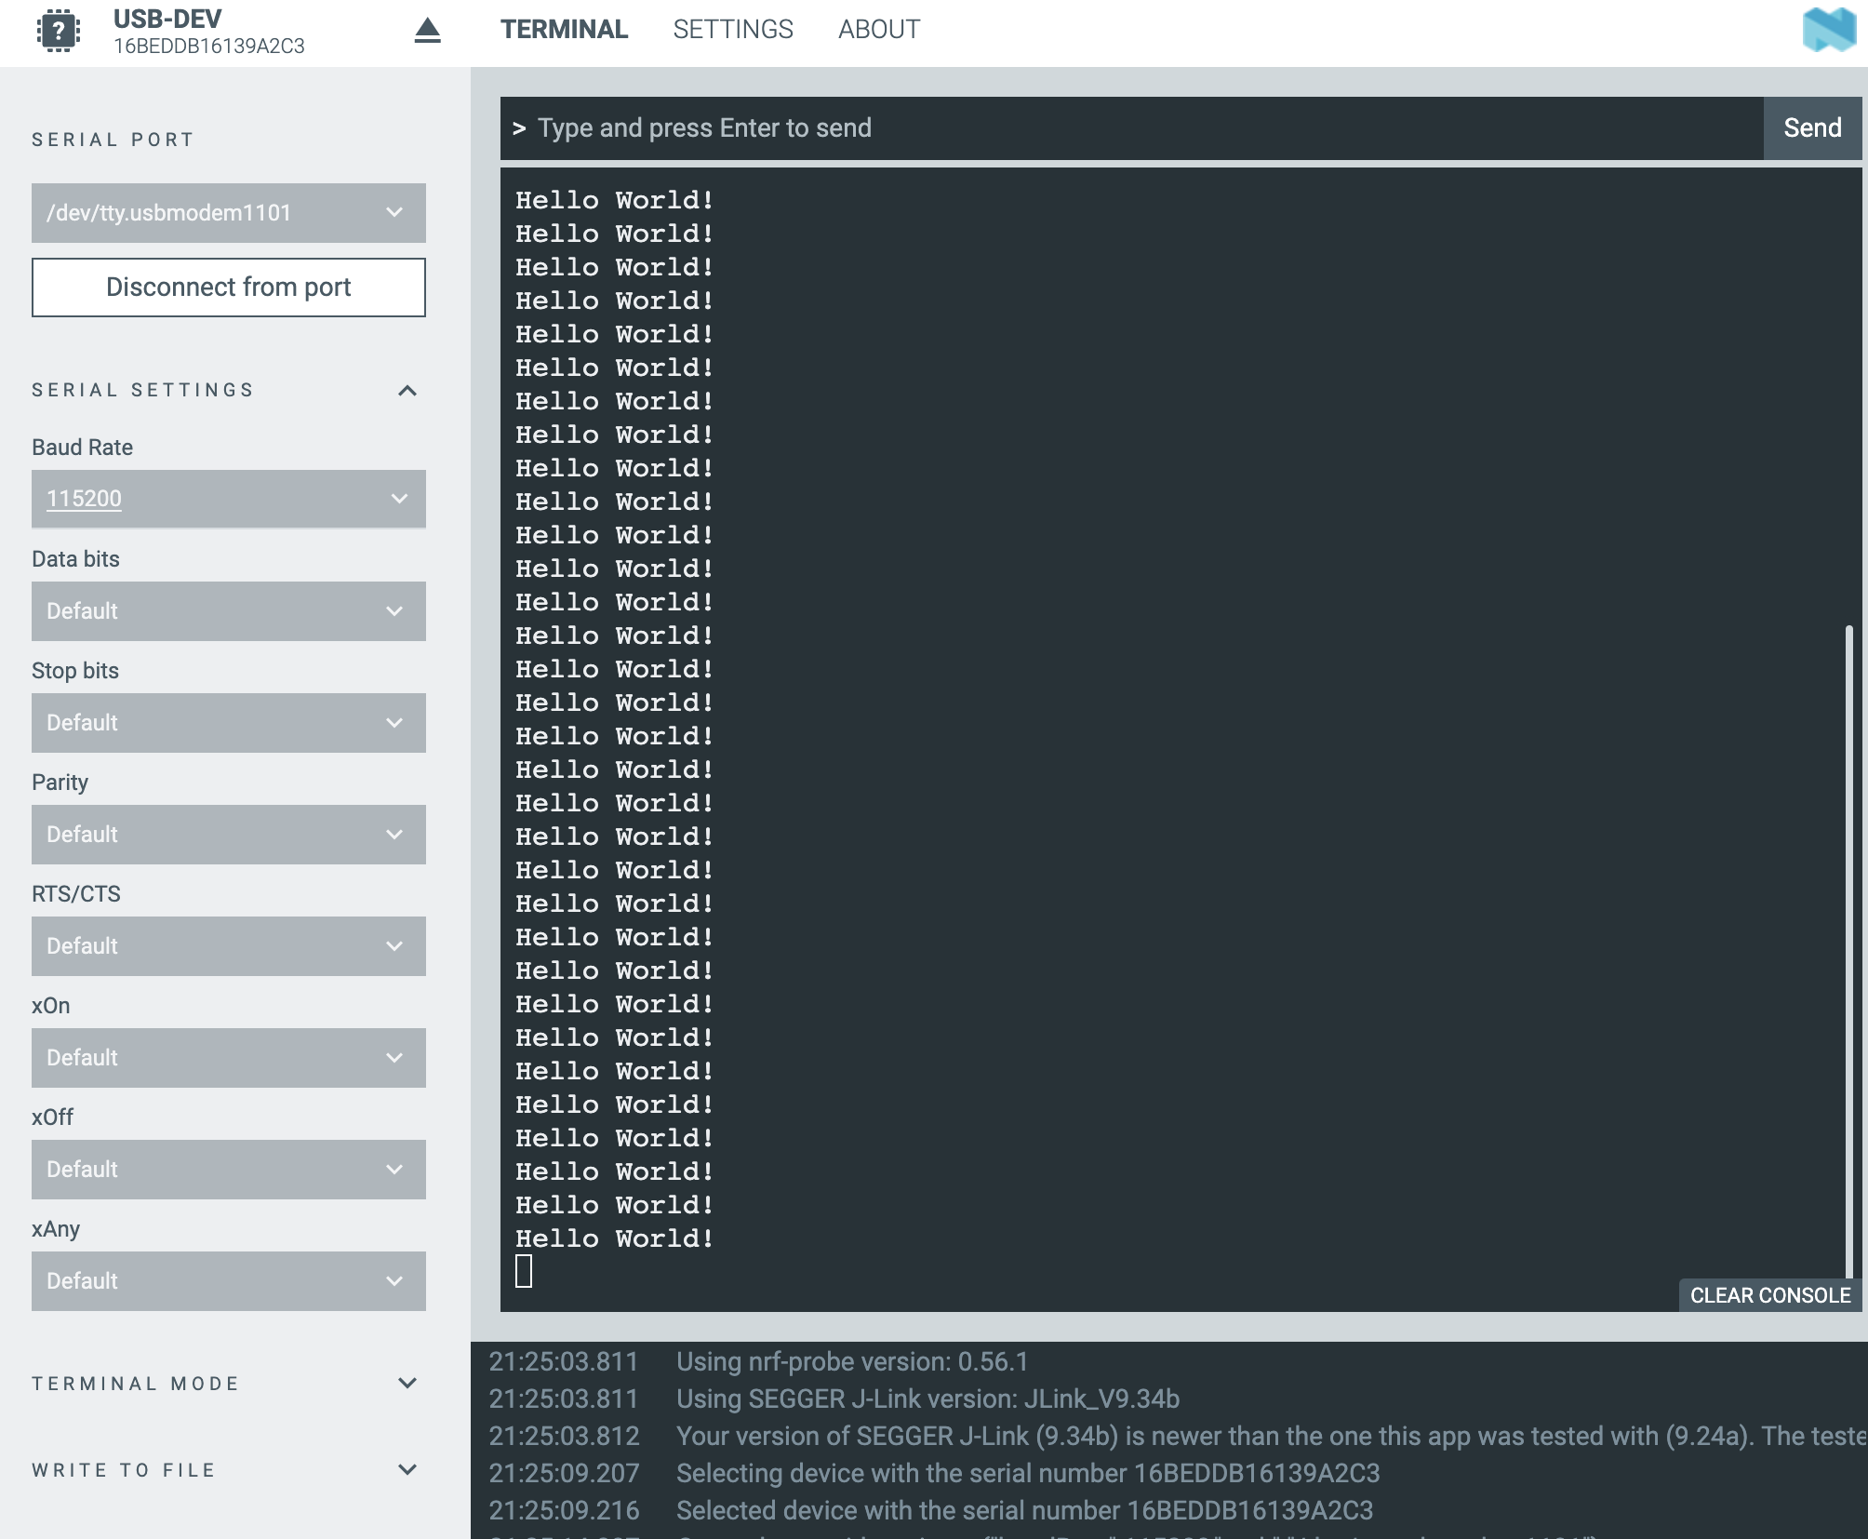

Task
The default UART configuration is defined in the board's device tree with baud rate equal to 115200 Bd with configuration: 8N1 (8 data bits, no parity, 1 stop bit)

GenAI Statement
Generative AI tools were used to support study and writing during the workshops and in the preparation of this report.

In particular, these tools have been used to:
- improve the presentation quality of the report, making the text clearer, more structured and coherent;
- facilitate understanding of the technical documentation relating to the various course modules (e.g. nRF Connect SDK and Toolchain);
- support the translation and reformulation of content, in order to obtain more precise technical terminology;
- assist in solving practical problems, particularly related to compatibility between the system used (personal computer), the software tools and the board used in the laboratories.
All content generated with the support of GenAI tools has been critically reviewed, verified, and adapted based on personal understanding of the topics covered.

