Embedded System
Francesco De Patre – 382760

Introduction
The fifth lab introduces serial communication in embedded systems via the I2C protocol, using the nRF Connect SDK and Zephyr OS. Unlike previous labs, where UART communication was primarily used for debugging and printing to a terminal, this lab focuses on communication between the microcontroller and external peripherals.
In particular, the I2C protocol is analyzed as a mechanism for communicating with sensors integrated into the Thingy:53 platform. This approach allows the microcontroller to configure devices and acquire data through register read and write operations.
The lab also highlights how communication in embedded systems is not always synchronized, introducing issues related to timing and data management, fundamental aspects in the development of real-world applications.

Methodology
The lab was conducted by initially analyzing the structure of the I2C bus by studying the hardware schematics of the Thingy:53 device, in order to understand the connection between the microcontroller and sensors.
Next, we used the I2C driver provided by Zephyr to communicate with the BH1749 ambient light sensor, configuring it and periodically reading data. During this step, we consulted the sensor documentation to identify the registers and values needed for configuration.
The approach adopted was experimental: reading and writing tests were carried out on the sensor registers, observing the system's behavior and verifying the correctness of the acquired data.

LAB Section

Technical objective
Understand how the I2C protocol works and how it can be used in embedded systems for communication between microcontrollers and peripherals, using the Zephyr I2C driver to interact with a real sensor.

What was done during the laboratory
The I2C bus structure of the Thingy:53 device was analyzed and then communication with the BH1749 sensor was implemented via the I2C driver.
The sensor was configured by writing to registers and the measurement data was read periodically and displayed via serial output.

What can be understood
This lab clarified the practical operation of the I2C protocol and the role of the microcontroller as a bus controller.
In particular, communication occurs through read/write operations on registers, the devicetree simplifies access to devices without having to manually specify addresses, furthermore, multiple devices can share the same bus thanks to unique addresses.
An important aspect related to synchronization also emerged: the microcontroller and the sensor operate with different clocks, so the read data may not be updated in real time.
This introduces a delay that, in critical applications, must be handled with more advanced techniques such as interrupts.

Problems encountered
The problems encountered concern the initial difficulty in understanding the hardware schematics such as the need to consult the sensor datasheet to identify the correct registers and the management of the asynchronous communication between the MCU and the sensor as well as the interpretation of the data read from the sensor.

Possible improvements
A significant improvement would be to use an interrupt-based approach to synchronize data readout with the availability of sensor measurements.
Additionally, more advanced timing management could reduce latency and improve the accuracy of the acquired data.

Evidence
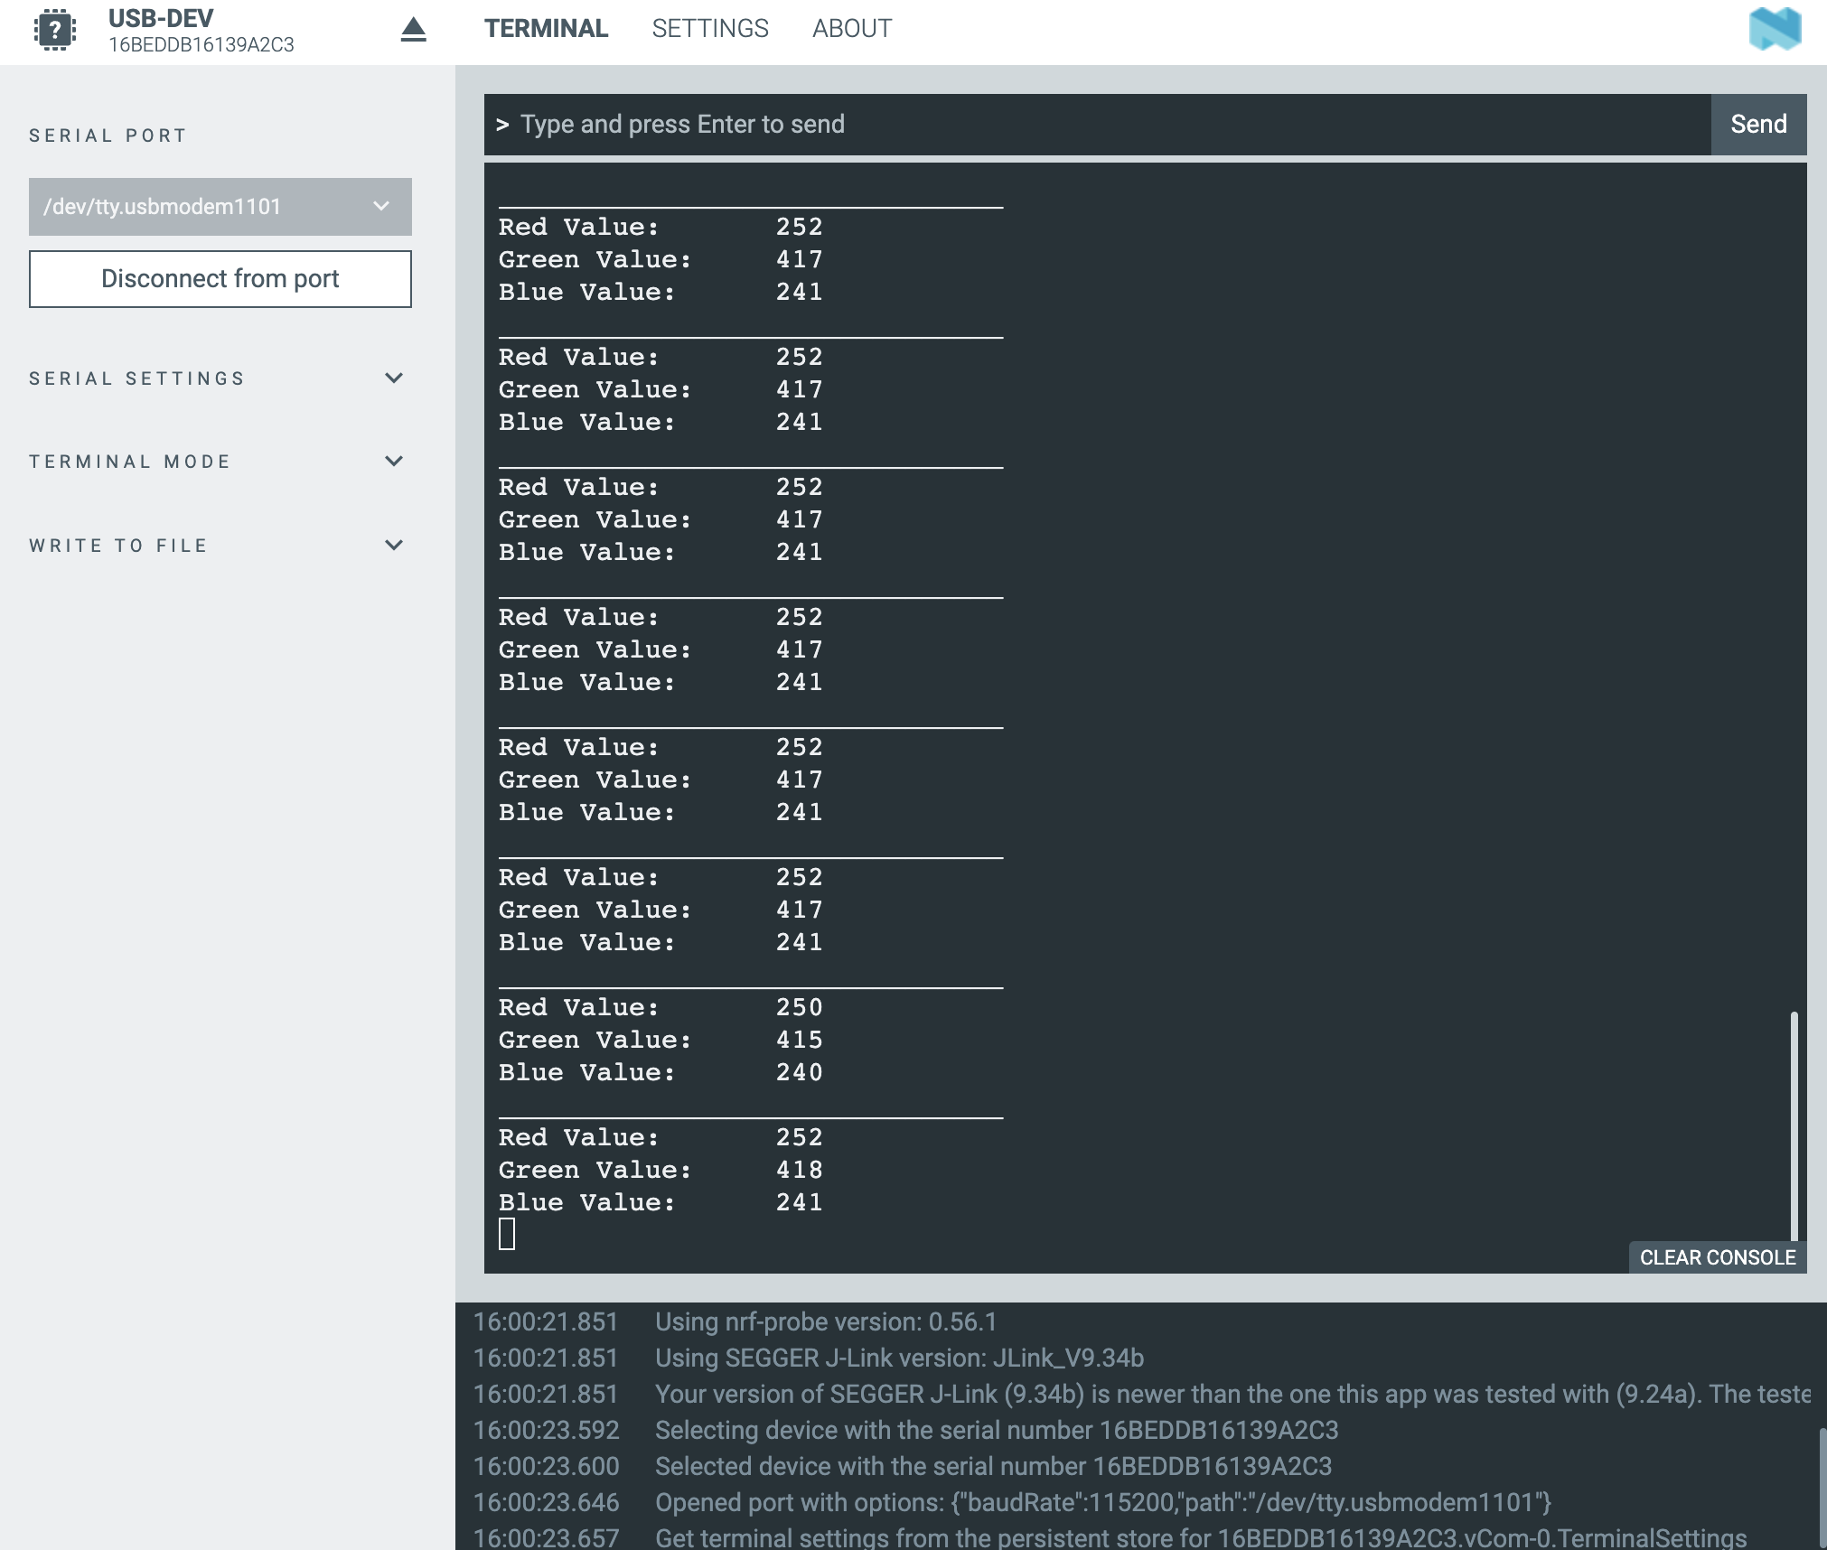

Task
To understand the structure of the Thingy:53's I2C bus, it was necessary to analyze the board's hardware schematics.
The analysis shows that the architecture allows multiple devices to share the same bus thanks to the use of distinct addresses, with the microcontroller managing the communication as the central controller.

GenAI Statement
Generative AI tools were used to support study and writing during the workshops and in the preparation of this report.

In particular, these tools have been used to:
- improve the presentation quality of the report, making the text clearer, more structured and coherent;
- facilitate understanding of the technical documentation relating to the various course modules (e.g. nRF Connect SDK and Toolchain);
- support the translation and reformulation of content, in order to obtain more precise technical terminology;
- assist in solving practical problems, particularly related to compatibility between the system used (personal computer), the software tools and the board used in the laboratories.
All content generated with the support of GenAI tools has been critically reviewed, verified, and adapted based on personal understanding of the topics covered.

