Embedded System
Francesco De Patre – 382760

Introduction
The sixth lab introduces the Bluetooth Low Energy (BLE) protocol, used in embedded systems for low-energy wireless communication.
Unlike wired communications explored in previous labs, BLE enables device-to-device interaction without physical connections, making it particularly suitable for IoT applications.
The lab provides an overview of the fundamental concepts of BLE, such as device roles, communication modes, and data representation, and then applies them to a practical case of connecting the board to a smartphone.

Methodology
The lab was conducted using predefined examples provided by the nRF Connect SDK, without modifying the source code. The focus was on observing the system's behavior and the interaction between the board and the mobile device via BLE applications.
BLE scanning tools on smartphones were used to monitor the connection and verify that the system was functioning correctly.

LAB Section

Technical objective
Understand the basic concepts of BLE and verify a connection between an embedded device and a smartphone.

What was done during the laboratory
A BLE example was compiled and run to establish a connection between the Thingy:53 and a smartphone, using the phone to control the device's LED.

What can be understood
BLE is designed for low-power, intermittent communications where distinct roles (peripheral/central) exist and communication occurs via services and characteristics (GATT)

Problems encountered
The issues encountered are with the connection between the Thingy:53 board and the nRF Connect app for iOS.

Possible improvements
Learn more about configuring BLE services and customizing features for specific applications.

Evidence
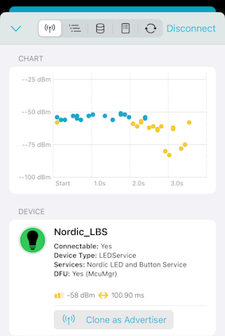 | 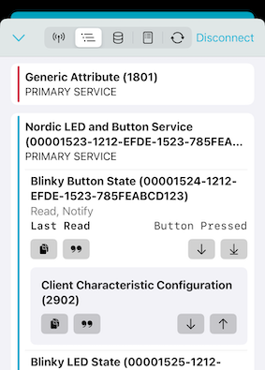 | 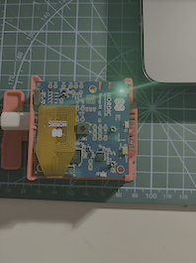

GenAI Statement
Generative AI tools were used to support study and writing during the workshops and in the preparation of this report.

In particular, these tools have been used to:
- improve the presentation quality of the report, making the text clearer, more structured and coherent;
- facilitate understanding of the technical documentation relating to the various course modules (e.g. nRF Connect SDK and Toolchain);
- support the translation and reformulation of content, in order to obtain more precise technical terminology;
- assist in solving practical problems, particularly related to compatibility between the system used (personal computer), the software tools and the board used in the laboratories.
All content generated with the support of GenAI tools has been critically reviewed, verified, and adapted based on personal understanding of the topics covered.

