Embedded System
Francesco De Patre – 382760

Introduction
The ninth and final lab introduces the concept of Embedded Artificial Intelligence (Embedded AI), which is the execution of machine learning models directly on resource-constrained embedded devices.
This represents a significant evolution over traditional embedded systems, which are limited to deterministic processing, instead allowing the interpretation of complex data in real time.
The lab is developing a motion recognition system using data from the accelerometer integrated into the Thingy:53 device. Using the Edge Impulse platform, an entire machine learning pipeline is implemented, from data collection to model deployment on the device.
This approach allows the integration of machine learning capabilities into low-power systems, paving the way for numerous applications in the IoT and wearables sector.

Methodology
The workshop was approached in several phases:
- Initial setup
  - Flashing Edge Impulse firmware
  - Connecting the Thingy:53 board to nRF Edge Impulse iOS
- Training data collection divided into 4 movement classes
  - Idle = Idle Device
  - Shake = Device shaken
  - Up/Down = Device that moves vertically
  - Rotating = Device that rotates
- Preprocessing and feature extraction on the Edge Impulse Studio platform
- Model training on Edge Impulse
- Testing and validating the model with test data obtained via iOS
- Install the model on the device and classify it in real time

LAB Section

Technical objective
Understand the entire development lifecycle of an embedded machine learning system, from data collection to running the model directly on the device.

What was done during the laboratory
During the lab, the Edge Impulse firmware was initially reinstalled on the Thingy:53.
Subsequently, a motion dataset was collected using the device's accelerometer, defining different motion classes.
The acquired data was then subjected to a preprocessing and feature extraction phase, which allowed them to be prepared for training.
At this point, a classification model was trained, which was then tested on new data to evaluate its performance.
An anomaly detection component was also implemented later to identify unexpected movements.
Finally, the model was deployed on the Thingy:53 device, allowing real-time inference to be run directly on-device.

What can be understood
This workshop highlighted how developing Embedded AI systems is significantly more complex than traditional embedded systems. A first key aspect concerns the importance of data: the quality of the model depends heavily on the dataset used, as insufficient data leads to inaccurate models, limited data variety reduces the ability to generalize, and unbalanced datasets introduce biases in predictions.
Furthermore, the development process is not limited to the training phase alone, but follows a complete pipeline that includes data acquisition, preprocessing, feature extraction, training, and validation, where each phase directly impacts the final performance of the model.
During testing, the difference between off-device inference, performed on the cloud or web, and on-device inference, performed directly on the embedded device, also emerged. The latter introduces significant constraints related to execution time, available memory, and power consumption.
Finally, the comparison between embedded systems and traditional AI highlights further substantial differences: embedded devices have limited resources and require more compact models, efficiency becomes a critical requirement, and latency reduction represents a significant advantage over cloud-based solutions.

Problems encountered
During the workshop, several operational difficulties typical of the development of Embedded AI systems emerged.
In particular, data collection proved to be a time-consuming and repetitive activity, requiring the acquisition of numerous samples for each class.
Ensuring consistency across samples was also challenging, as small variations in movement execution can significantly impact the quality of the dataset.
A further difficulty concerned the tuning of the model, which was not immediate and required several attempts to obtain satisfactory performance.
During data acquisition, BLE connection management was a critical point, especially due to potential disconnections or instability during recording sessions.
A difference was also observed between the performance achieved in the training phase and that in the testing phase, highlighting problems with the model's generalization. In general, it emerged that multiple iterations and trials were needed to achieve acceptable and consistent results.

Possible improvements
To improve the performance of the system developed during the lab, it is possible to intervene on various aspects of the pipeline.
First, it is essential to increase the quantity and variety of data collected, so as to make the model more robust and capable of generalizing better to different situations.
At the same time, it is important to more accurately balance the classes in the dataset, so as to avoid biases in the predictions.
Further improvement can be achieved by using more complex models, compatible with the resources available on the embedded device, in order to increase the learning capacity of the system.
The preprocessing phase also plays a key role and can be optimized to extract more representative and informative features.

Evidence
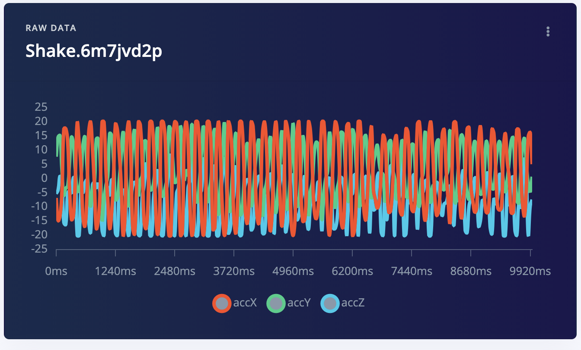 | 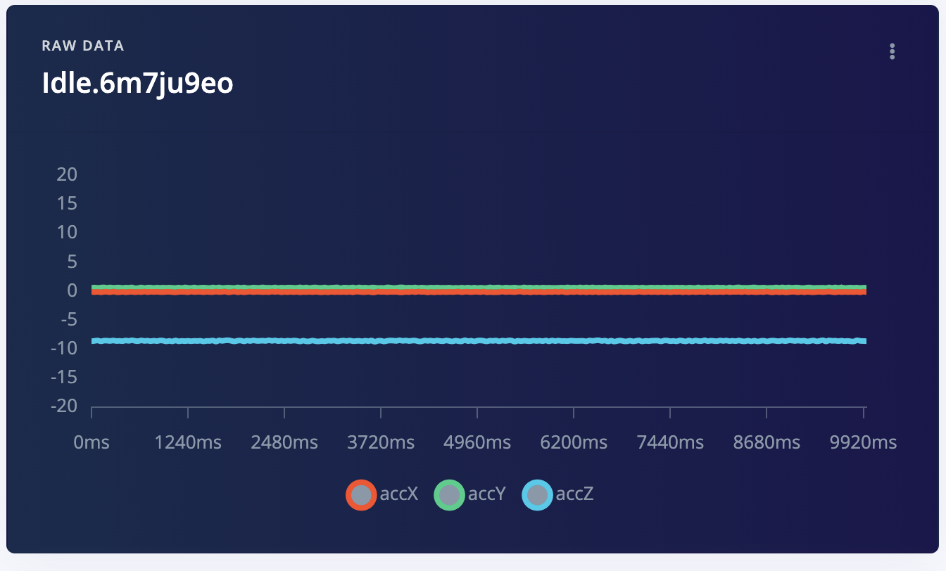
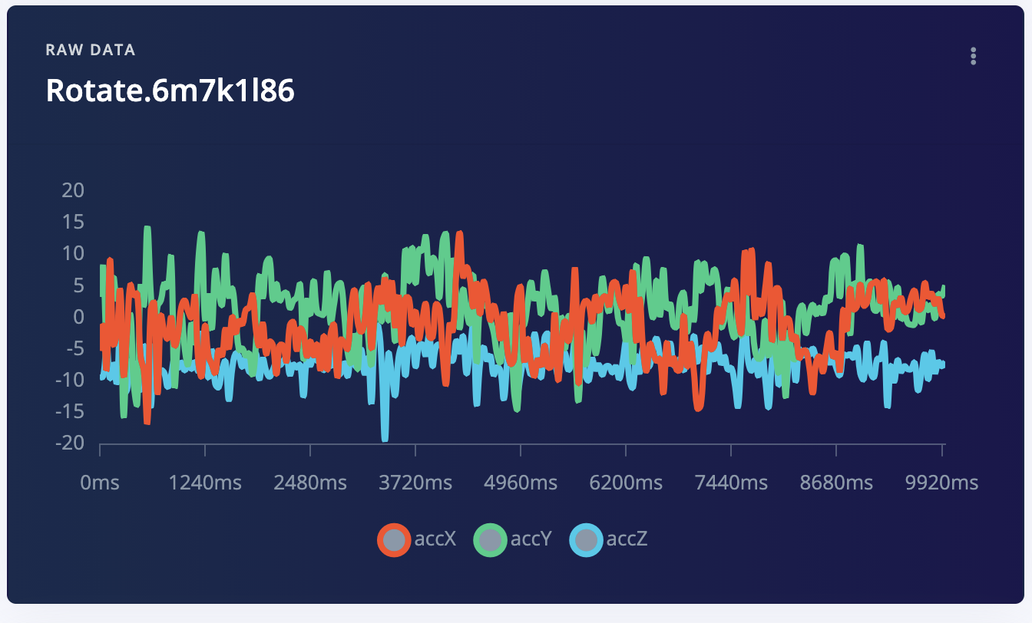 | 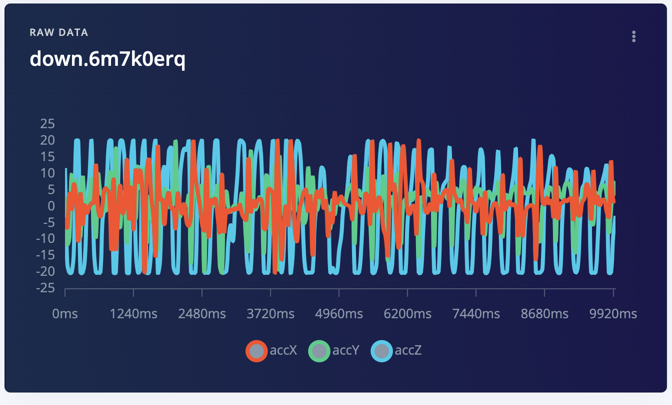

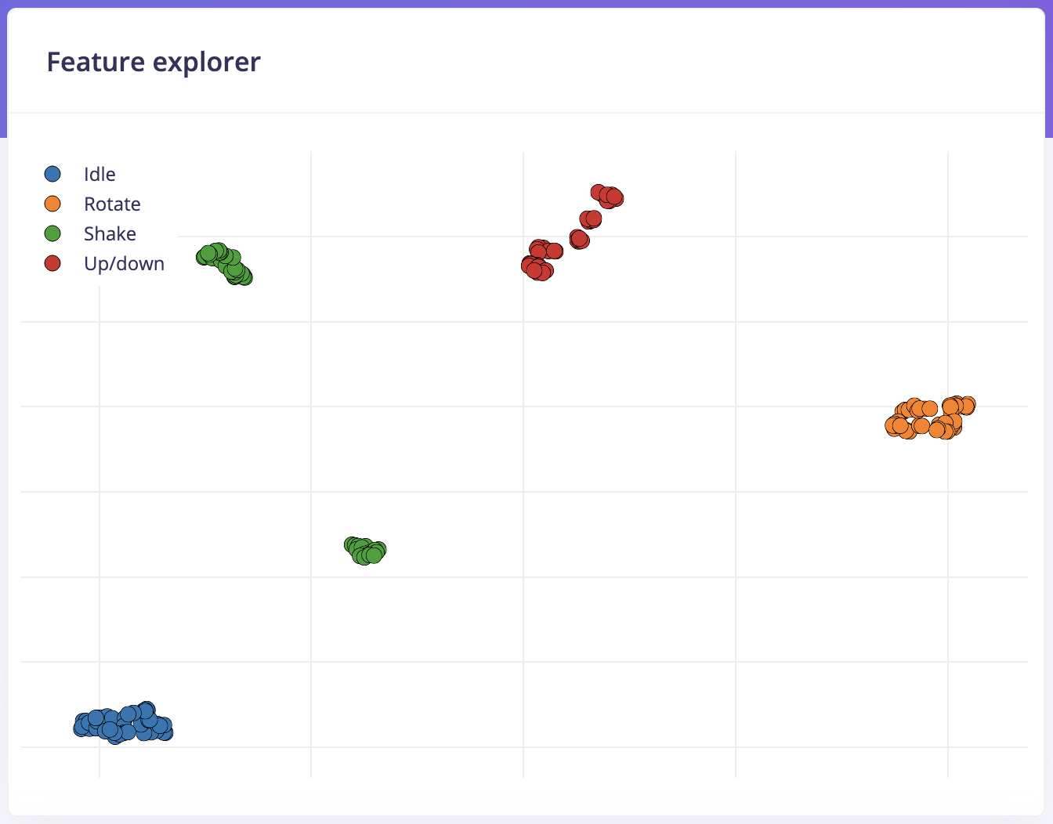
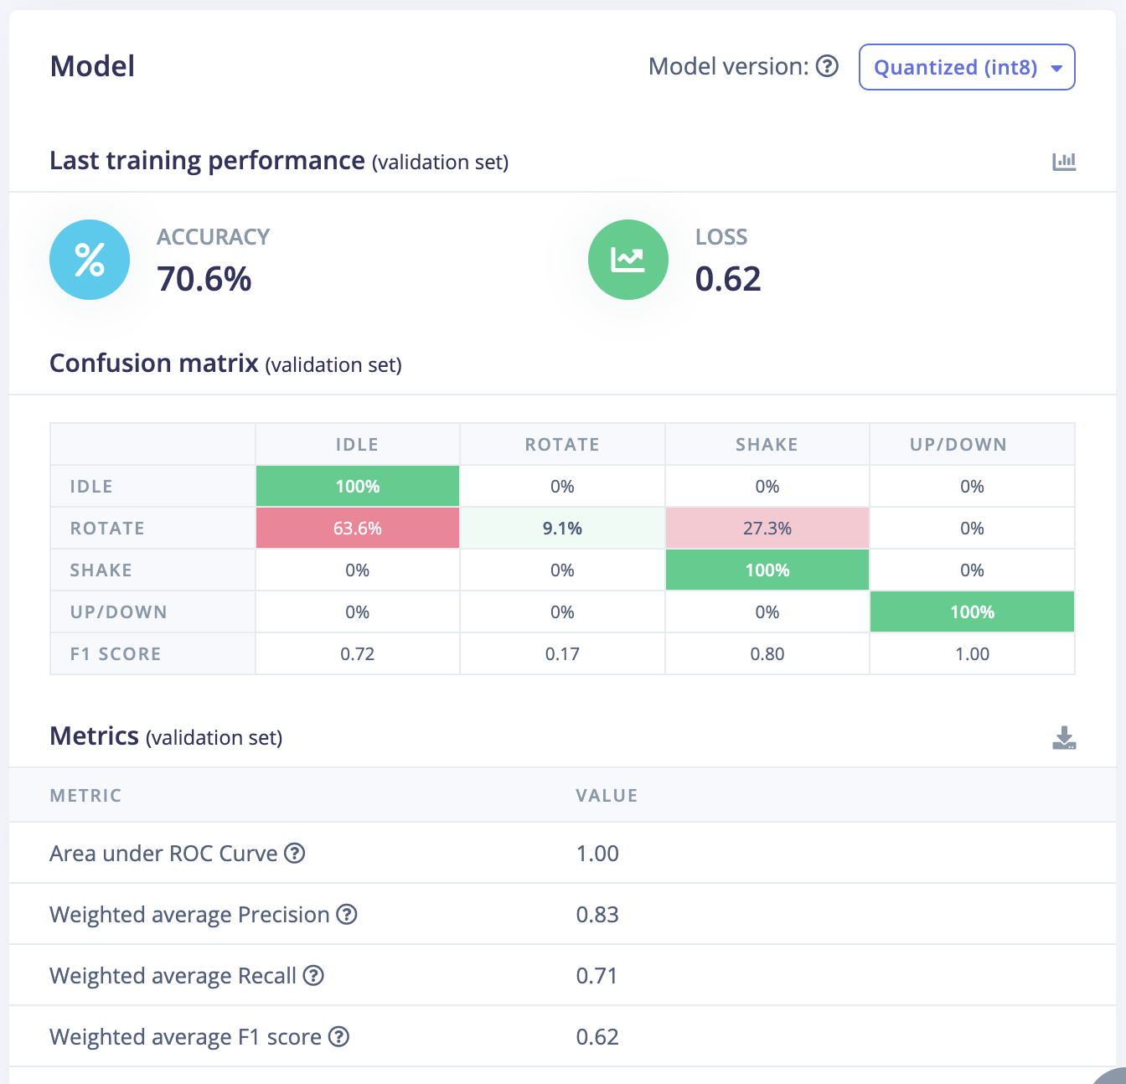
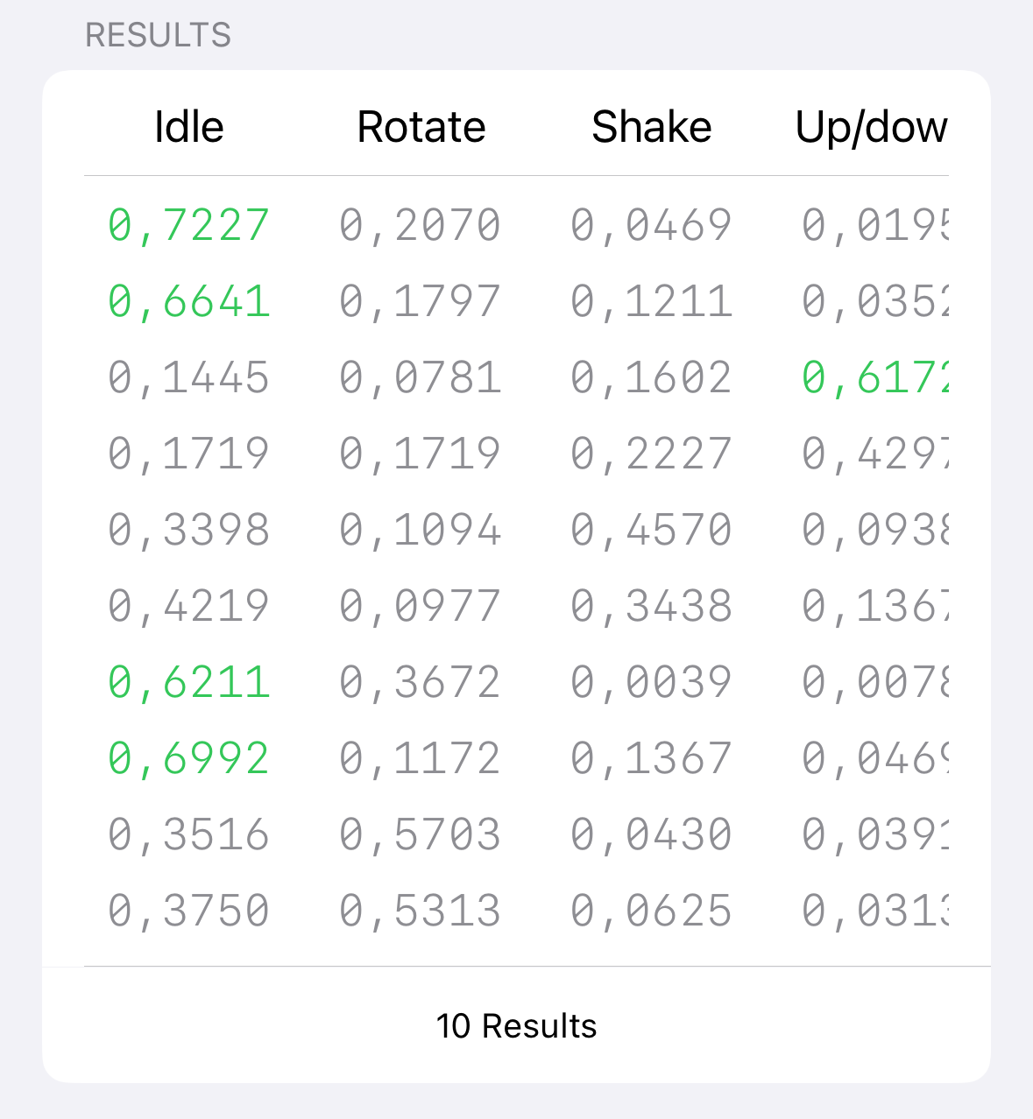

GenAI Statement
Generative AI tools were used to support study and writing during the workshops and in the preparation of this report.

In particular, these tools have been used to:
- improve the presentation quality of the report, making the text clearer, more structured and coherent;
- facilitate understanding of the technical documentation relating to the various course modules (e.g. nRF Connect SDK and Toolchain);
- support the translation and reformulation of content, in order to obtain more precise technical terminology;
- assist in solving practical problems, particularly related to compatibility between the system used (personal computer), the software tools and the board used in the laboratories.
All content generated with the support of GenAI tools has been critically reviewed, verified, and adapted based on personal understanding of the topics covered.

