Venture Capital
Explanatory notes · Bocconi, a.y. 2026/27
Second mid-term (class 27) · exam 21 December. Lessons from L13 onwards.

Contents
State of VC: Market Outlook Q3 2026 · Lesson 13 (28/10) explanatory notes
Deal Sourcing and Deal Screening · Lesson 14 (29/10, first part) explanatory notes
Early-Stage Valuation I: Berkus and Scorecard · Lesson 15 (29/10, second part) explanatory notes
Early-Stage Valuation II: Risk Factor Summation and the VC Method · Lesson 16 (03/11) explanatory notes
Later-Stage Valuation: Multiples, Prior Round, DCF and First Chicago · Lesson 17 (04/11 and 05/11) explanatory notes
Case: Square, Inc. — Financing a Unicorn · Case (weekend reading before class)

State of VC: Market Outlook Q3 2026
Lesson 13 (28/10) explanatory notes
Parts One and Two (Gigante and Bottazzi) built the foundations: how a fund works, the legal and fiscal frameworks and the economics of VC contracts (preferred stock, liquidation preferences, option pools, anti-dilution, down rounds). Part Three, taught by Marta Zava, follows the life cycle of a venture investment and, above all, how to value it. This first lecture (28/10) sets the rules of the class and then gives an umbrella: a macro picture of where money flows in Q3 2026, who gets it, who gets it back and when. Market figures are not examinable (the professor said so explicitly): only the mechanisms the numbers illustrate can be tested.

Course Logistics and the Exam
Three class rules: intervene (ask questions, bring news and cases), take ownership of your learning, no loitering (attendance is not mandatory, so come to learn). There is no textbook: each content class comes with slides with exercises, a separate solutions file and a ~20-page PDF of notes; solve the exercises yourself before looking at the solutions. Cases are short and discussed in class. The professor built an experimental AI exercise tool (on Claude) generating unlimited exercises with step-by-step solutions on the VC method, scorecard and Berkus, term-sheet mechanics and fund returns; screenshot anything that does not add up. The syllabus was reordered so that the reasoning-heavy topics (early-stage valuation, instruments such as the SAFE) come first, unicorns and exercises next, fund raising, ecosystems and late-stage valuation/exits later. VC valuation is more art than science: at seed you judge team and potential, not a balance sheet.
The exam (21 December 2026) combines multiple-choice questions (exactly one correct answer) and short five-minute exercises. For this lecture: why a megaround changes how a fund invests, what a power law is, why a big first-day jump signals underpricing, why LPs favour experienced managers, why VC/GDP is fairer than absolute totals.

Record Dollars on a Narrow Base
The quarter in one sentence: record dollars at the top, scarce cash at the exit, a boom on paper and a liquidity test in practice. Global VC in Q3 2026 was about $171bn, down ~28% quarter on quarter but up ~43% year on year. This is not a contradiction: Q1 and Q2 were inflated by a few frontier-lab rounds (one OpenAI round was $122bn of Q1's $317bn). Q3 had no such outlier, so it falls against Q2 while staying far above a normal quarter. Always ask which single deals sit behind a headline total.
Why 2021 is the benchmark. It was a record year (cheap companies after COVID, spectacular e-commerce and SaaS metrics, low rates) and there was a mechanical reason: a fund lives about ten years (7 + 3) and has two to three years to deploy; management fees and carry only make sense if capital is invested, so capital held back in 2020 was deployed in 2021. Uninvested commitments create pressure to deploy, sometimes at high prices.
VC is not private equity. PE buys businesses unlikely to fail and improves them; 5–7x is excellent. In VC about 8 companies out of 10 fail, so the winners must pay for the losses and a great outcome is ~100x. A solid company growing 20% a year is a good business but not VC material: a VC wants 100–300x potential (perhaps 50–60x in Europe).
Issue | Why it happens | Consequence
Providers disagree (Crunchbase ~159bn, PitchBook ~171bn, CB Insights ~187bn) | No disclosure mandate in private capital (friends and family never report); different perimeters (venture growth, convertibles, debt, tranches, country); late revisions | Usable for trends; always quote the provider and use one consistently
Round labels differ | Pre-seed, seed, Series A… are rules of thumb, not legal definitions | A Series A in New York (15–20m) is many times one in Italy (~1m)
Some providers count AI debt as VC | Perimeter choice | Totals inflated
Table 1 Why VC data must be read with care

Concentration: AI, Megarounds and the Power Law
AI took about 64% of global VC dollars in Q3 (over four fifths in the US) but under half of the deals: a higher share of value than of count simply means larger average rounds, not more deals. Such concentration was never seen before (not with dot-com, SaaS or crypto). A megaround is a very large round (often ≥ $100m; the extreme band is ≥ $1bn, 27 such rounds in one quarter, mostly AI labs and compute): a few of them can move a whole quarter and lift the share of the country where they happen.
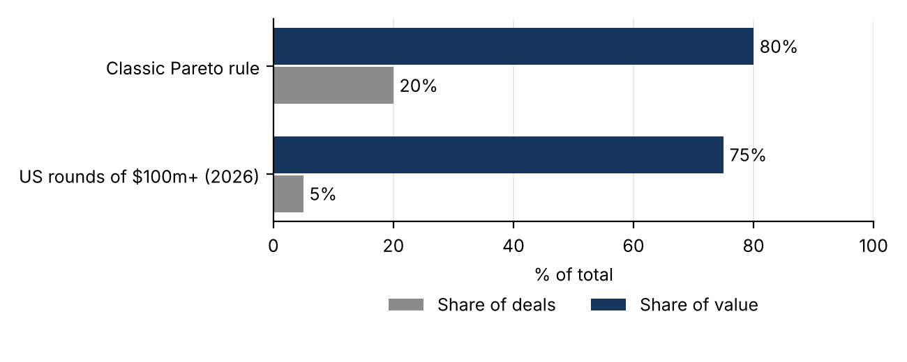
Figure 1 Share of deals vs share of value: the classic 80/20 rule vs US rounds of $100m+ in 2026 (figures not examinable)
In the US, deals of $100m+ were about 5% of deals but ~75% of value. A student called it Pareto; the precise answer is a power law, an extreme Pareto, more skewed than 80/20, where a tiny number of observations captures most of the total. It describes both the allocation of capital and returns: since most companies fail, a fund must be built so that one or two outliers return the whole fund (early ByteDance investors made about 3,000x).

From Spray-and-Pray to a Few Hands-On Bets
The classic answer to an 80% failure rate is diversification, spray-and-pray: a $40m fund writing cheques of $0.5–1m, keeping reserves for follow-ons, has about 40 shots. It still fits the AI application layer, where building a product is cheap. Megarounds break this logic: a fund cannot join a $200m round with $1m (no company keeps a thousand investors on its cap table), so it puts in, say, $20m, half the fund. Exposure is concentrated, so the manager has every incentive to be hands-on. The extreme form is pre-team investing: funding star researchers with hundreds of millions before a team or product exists. Through the professor's research lens of kingmaking, big rounds buy compute, talent and customers first and co-investors pile onto early winners (preferential attachment), so the power law is partly made by capital itself, not simply discovered.
 | Spray-and-pray | Megaround world
Cheques | Many, small | Few, large
Diversification | Wide | Concentrated exposure
Monitoring | Passive; founders figure it out | Active; the investor helps make the winner
Where it fits today | AI applications, cheap to start | Frontier labs, compute
Table 2 Two models of VC portfolio construction

Who Gets Paid, and When: Exits, Underpricing and LPs
In 2026 capital is abundant but liquidity is scarce. Exits (the two successful ones are IPO and M&A/trade sale) come in windows: when one opens you sell what you can before it closes. Listings restarted in 2026, but in Q3 only 18 US VC-backed companies listed, none AI (mostly healthcare), and the post-IPO record was poor: investors buy the story on day one and sell the numbers by day 120.

Underpricing: What the Company Actually Receives
First-day underpricing = (P_{close, day 1} − P_{offer}) / P_{offer} IPO proceeds = P_{offer} × shares sold in the primary offering
Worked example: the day-one pop
A company valued at $1bn sells 10% of its shares in the IPO at $1 per share (no selling shareholders). On day one the price rises tenfold, so the traded shares are worth $1bn. The company receives only the primary proceeds: 10% × $1bn = $100m. Underpricing = (10 − 1)/1 = 900%: about $900m of money left on the table goes to those who bought at the offer price.
Exam trap: a huge first-day gain does not prove the IPO was a success for the issuer; it measures how badly the bank priced it. A rise of around 15% is normal and healthy. A higher secondary price still helps (cheaper debt, more valuable remaining shares, better terms for later sales), but the cash received is fixed at the offer price.

Secondaries, LP Flows and the Flight to Experience
Outside a couple of giant listings, liquidity came from strategic M&A and secondaries (LPs selling fund stakes, GP-led continuation vehicles, tender offers). Secondaries now do the job IPOs used to do, but at a price: LP stakes traded at about 80% of NAV, a ~20% haircut; companies that last raised at 2021 peaks sell at discounts of 60–90% to their last round. Net cash flow to LPs (distributions received minus capital contributed) has been negative in the US by about $200bn since 2022: LPs (endowments, pension funds, HNWIs, funds of funds; portfolio theory suggests a 6–10% allocation to VC) fund the industry more than it pays them back. This is the DPI drought: paper returns (TVPI) are back, cash returns (DPI) are not.
About 88% of US fundraising went to managers on Fund IV or later: an index of uncertainty, as LPs back people who have already taken funds to maturity. Emerging managers are squeezed and the industry becomes a barbell of megafunds and micro-funds. The chain to remember: no exits → no distributions → cash-starved LPs → commitments concentrated on experienced managers and stakes sold at a discount. The scarce resource is liquidity, not capital.

Boom or Bubble?
A bubble is a pricing error, not a verdict on the technology: prices run ahead of the cash flows that can realistically justify them. A bubble can burst while the technology proves transformative: Amazon fell from above $100 to about $6 after the dot-com crash and became dominant. The useful question is who holds the risk when prices correct (funds, private credit, lenders financing the AI build-out). The professor's personal view: early websites were billboards and the internet's real power came later; today AI mostly substitutes existing functions, and she doubts LLMs will be the long-run paradigm.
Bull case | Bear case
Frontier-lab revenue compounding faster than any software wave; a first quarterly operating profit | IMF and Bank of England warn of a correction amplified by leverage and circular financing
Chip makers' revenue: compute is revenue | AI revenue a fraction of what data-centre capex needs (Sequoia's 1.5 trillion question)
AI spending large relative to the economy | Infrastructure impairments; neocloud bonds at very high yields
Table 3 The two cases in the slides
Circular financing: the most frequent investor in the top rounds is Nvidia, which invests in companies that then buy its chips. When the investor is also the supplier, part of each venture dollar is effectively a sales rebate, so headline rounds overstate independent demand and push valuations up. Debt is the other amplifier (venture debt, private credit, GPU-backed vehicles): watch credit spreads, not just valuations. In class, a heavily indebted AI cloud company was expected to list anyway, for credibility after one postponement rather than solidity, perhaps raising less; Anthropic's public S-1 was called the hinge of the next quarter (a well-traded large AI IPO could reopen the window and restart distributions).

Comparing Regions: VC over GDP
The top three markets are the US, Europe and China (Europe and China roughly a quarter of the US each: a two-and-a-half-pole world); the fourth, Israel, is about ten times smaller than the third. Absolute totals mostly reflect size: dividing by GDP or population turns a ranking of economies into a ranking of venture intensity, the right lens to compare Israel with continental blocks. Ecosystems are local: "US vs Europe" really means a few metropolitan hubs (the SF Bay Area alone took ~24% of global dollars vs ~17% for all of Europe), and Delaware-registered companies should be assigned to where they operate. Each ecosystem's VC feeds its dominant local industry (Silicon Valley software and models, Boston biotech, New York finance, which is why New York briefly overtook the Valley via fintech). European VC grew for eight quarters but on a few megarounds while deal counts fall; champions raise at home and list in New York, so the gap is in listing venues and late-stage capital. Italy shows the same pattern in miniature.

Exam Angle
- No exact figures; mechanisms only. QoQ and YoY can diverge because of outlier rounds.
- Providers disagree: no disclosure mandate, different perimeters, late reporting.
- Value share > count share ⇒ bigger average deals. A power law is more extreme than 80/20; returns follow it too.
- Megarounds make VCs concentrated and hands-on; kingmaking and circular financing can create winners and inflate demand.
- IPO proceeds = offer price × primary shares; a big pop is underpricing, money left on the table.
- Negative net cash flow to LPs, TVPI without DPI and the flight to Fund IV+ managers all signal a liquidity constraint.
- A bubble is a pricing error; compare regions with VC/GDP.
- The five-minute exercises will reuse the tools of the next lessons: post-money, ownership, exit value needed to return the fund, DPI/RVPI/TVPI.

Deal Sourcing and Deal Screening
Lesson 14 (29/10, first part) explanatory notes
Lesson 13 described the market from the outside: a power law of returns, extreme concentration on AI, megarounds. This lesson (first half of the double class of 29/10) steps inside a fund and follows a deal in the order it travels: first it must reach the investor (sourcing), then survive a sequence of filters (screening), and only then is it priced (early-stage valuation, started at the end and continued in Lesson 15). The answer, built on the survey of Gompers, Gornall, Kaplan and Strebulaev (2020) and its European counterparts: sourcing is above all a network activity, data tools change it without replacing it, and screening is a process of exclusion and prioritization driven by the team, fit with the fund and the plausibility of an outsized return. Exact figures are not tested (orders of magnitude and directions are); the two five-minute exercises (funnel diagnosis, fit decision) are reproduced below.

Where Deals Come From
VCs buy equity in companies about which almost nothing can be verified, and founders know far more than the investor. Three classic ideas frame the problem: Akerlof (1970), adverse selection (an investor who cannot tell teams apart attracts the weak ones); Spence (1973), the informed party reveals quality through signals costly to imitate (referrals, patents, prior exits); Knight (1921), risk (estimable probabilities) vs uncertainty (not estimable), the realm of early-stage decisions. Deal flow is the stream of opportunities reaching a fund: its quality matters more than its quantity, and depends on the relationships through which it arrives.
Gompers et al. surveyed 885 VCs at 681 firms (data 2015–2016: the professor stressed that a 2020 paper reflects older data, so the directions hold but the 2% of quantitative sourcing is surely much higher today). The average firm considered about 200 companies a year and closed about 4; partners spent 22 of 55 weekly hours on sourcing and networking. 49% named deal selection as the main source of value creation, 27% post-investment value added, 23% deal flow, but selection only works on what sourcing brings in. Late-stage investors generate 42% of their deals themselves vs 23% for early-stage ones.
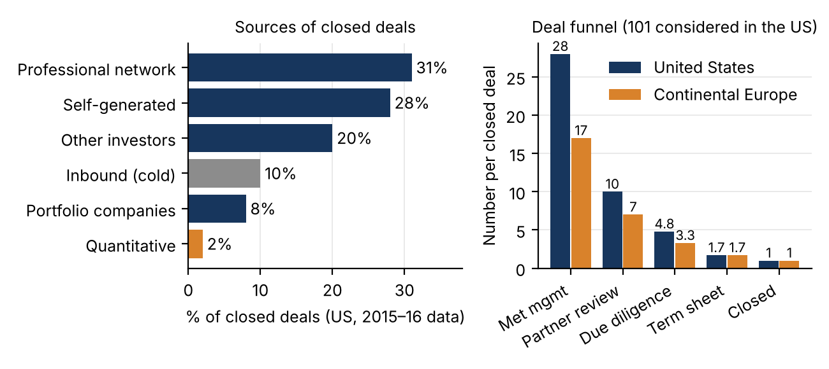
Figure 1 Sources of closed deals (left) and the deal funnel per closed deal (right), Gompers et al. (2020) and Le Pendeven et al. (2026)
Europe follows the same logic on a smaller scale (Söderblom et al. 2023; Le Pendeven et al. 2026, 611 managers): about 851 proposals a year per VC, funds averaging ~€100m vs $286m in the US, 17 teams met per closed deal vs 28. Smaller, denser ecosystems make reputation and local embeddedness count even more. In class: European and Asian ecosystems are mostly country-based, Latin American funds mostly cross-border with US exits; Continental Europe lacks late-stage capital and deep listing routes (stock market capitalisation ~200% of GDP in the UK vs ~35–38% in Italy), so exits rely on acquisitions and VCs cultivate corporate venture units.

Referrals, Proactive Search and the Network
What makes an e-mail worth reading is who sent it. A referral carries context (who the founders are, why the deal fits), an implicit endorsement (the referrer chose this company) and a reputational guarantee (a referrer who keeps recommending weak companies loses credibility): informative because costly (Spence), and a cure for adverse selection because cold proposals come disproportionately from companies that could not get an introduction (Akerlof). Its value depends on how well the referrer knows the company and the fund and what he stands to lose; check incentives (a lawyer may expect to be hired).
Company | Channel | Informational value
CirrusApps | Lawyer who worked with the founders (professional network) | High, though the lawyer may expect to be retained
EndorseYou | Former college classmate (personal network) | Low: vouches for the person, not the business
HearBaby | Founder follows up after a conference visit (proactive) | Moderate: no third party filtered the claims
VocalTier | Second-hand report (indirect referral) | Very low, plus time pressure to decide
Jimsamed | Already holds a term sheet (competitive round) | High but contested: validated and priced
Table 1 Five proposals received by Debbie Edwards, associate at Fareforward
The channel is evidence, not a verdict: treat it as a prior and revise it. Time pressure ("the round closes Friday") must never substitute for evidence. Proactive sourcing (conferences, academics, relationships with prospective founders before they raise) gives informational and relational advantages and makes access competitive and path-dependent: past success attracts better deals, consistent with the persistence of PE returns (Kaplan and Schoar 2005) and with Sørensen (2007), where sorting explains almost twice as much of experienced VCs' higher IPO rates as their post-investment help. Institutional channels (accelerators such as Y Combinator and Techstars, scout programs, universities, databases) trade exclusivity for coverage: everyone at a demo day sees the same companies, which pushes prices up. The VC network (portfolio companies, serial entrepreneurs, other VCs, LPs, experts, lawyers, acquirers) supplies information as well as deals: better-networked firms (centrality in syndication networks) perform better (Hochberg, Ljungqvist and Lu 2007), and absorptive capacity (Cohen and Levinthal 1990) speeds evaluation in familiar fields.
The professor's point from experience: sourcing is a small community (founders' dinners, enablers, reciprocity among VCs; founders who failed well are backed again), and the network is how you verify business reputation: she declined a deal after a trusted contact warned her the founder had scammed a former partner, and checked it herself. Even a YC label or a demo-day lead needs someone who can vouch for the person.

Data-Driven Sourcing: Algorithms Find, Humans Pick
Platforms monitor hiring, web traffic, launches, patents, code repositories and financing news: EQT's Motherbrain (2016), SignalFire's Beacon, relationship-intelligence tools such as Affinity. They automate first screening, rank companies on traction and timing, map who knows whom (so a data-found company can still get a warm introduction) and track sectors, promising wider coverage (founders outside hubs) and earlier engagement. Limits: sparse data on the earliest companies, herding (same signals → same companies → higher prices), team quality hard to measure, and, per Bonelli (2025), data-adopting VCs pick start-ups similar to past ones better but are less likely to fund the rare, genuinely novel outliers, a serious cost in a power-law world. In class: model the tails, not the mean; data mislead (the best engineers may not be on LinkedIn); the human component remains, because founders choose investors for value added, not money.

Selection Criteria: the Team First, but Not Alone
Asked for the single most important factor, 47% of US VCs named the management team (95% called it important), more than three times any other; fit with the fund 14%, product 13%, business model 10%, market 8%, industry 6%; valuation (1%) and ability to add value (2%) almost never. Teams also explain both successes (96%) and failures (92%). Europeans agree (93%) but focus more on individual founders' passion and commitment, Americans on the team as a whole and fundamentals. In the jockey vs horse debate, Kaplan, Sensoy and Strömberg (2009) followed 50 companies from business plan to IPO: business lines stayed stable while management changed, so the horse looked more durable. Practitioners still put the team first because before validation it is the main observable, and it signals adaptability (fewer than 30% of companies meet projections). Factors are not alternatives: a superb team where the fund cannot operate is still not an investment; what matters in the business model is how the founders think about it; market and industry are summarised by the TAM.
Italian survey (a former student, ~84 of ~120 VCs): more public VCs, many more early-stage and healthcare investors, smaller funds, about double the deals per opportunity (less competition). The professor "really did not like" that only ~1% named the TAM as top factor: many Italian VCs plan a secondary sale to a PE fund, leaving the TAM to the buyer.

The Deal Funnel and Its Conversion Rates
Per closed deal the average US firm considers 101 opportunities, meets 28 teams, reviews 10 at partner meetings, runs 4.8 due diligences and offers 1.7 term sheets; a deal takes 83 days, 118 hours of diligence and 10 reference calls. What matters are the conversion rates:
c_{i→j} = n_{j} / n_{i} e.g. meeting → partner review (US) = 10 / 28 ≈ 36%
Transition | United States | Continental Europe
Meeting → partner review | 36% (10/28) | 41% (7/17)
Partner review → due diligence | 48% (4.8/10) | 47% (3.3/7)
Due diligence → term sheet | 35% (1.7/4.8) | 52% (1.7/3.3)
Term sheet → closed | 59% (1/1.7) | 59% (1/1.7)
Table 2 Funnel conversion rates
Europeans meet fewer teams but convert more meetings and many more diligences into term sheets; the closing rate is identical. A term sheet is no guarantee: with ~60% closing, many deals are contested, not proprietary. Competition grows with maturity (2.3 term sheets per deal late-stage vs 1.5 early-stage); IT specialists consider ~151 opportunities per deal vs ~78 in healthcare (costlier evaluation). Surveys understate the top of the funnel (five-minute pitches are not recorded).
Worked example: diagnosing a funnel (Exercise 3)
A European early-stage fund, per closed deal: 90 considered, 36 met, 8 partner reviews, 4.0 due diligences, 3.4 term sheets, 1 closed.
Conversions: term sheet → close = 1/3.4 ≈ 29% (benchmark ~59%); DD → term sheet = 3.4/4.0 = 85% (35–52%); considered → met = 36/90 = 40%; met → partner review = 8/36 ≈ 22% (36–41%).
Anomaly 1 (bottom): twice the benchmark term sheets and only 29% closed: the fund loses competitive deals after diligence (price, terms, brand), the costly anomaly because diligence costs are sunk. Anomaly 2 (top): 36 meetings per deal (vs 17) means a loose first screen, wasting partner time, hence only 22% reach review. Partner review (8) and DD (4.0) are within range: flagging them is the common error.

The Two Screening Questions: Fit and Return Potential
First, fit with the fund: stage, round and ticket size, industry, geography. Fit is a hard constraint, not one criterion among many: LPs committed on the stated strategy, and investing outside it (style drift) changes the risk profile they think they hold. It is also cheap to check (one e-mail reveals it), so it comes first. Ticket size follows mechanically from fund size (Altamarea case):
Average first cheque = investable capital × (1 − reserve share) / number of companies = 100 × 0.45 / (35 to 40) ≈ €1.1–1.3m
(€120m fund, ~€100m investable after fees, ~55% reserved for follow-ons.) A company asking €100k would not put enough money to work; one needing €20m next round needs more than the fund can provide. Second, the potential for a substantial return: about a quarter of investments lose money and only ~9% return more than 10x, so a deal capped at 2–3x adds little however likely; the question is whether a large outcome is plausible. This requires sizing the opportunity, an independent evaluation of key assumptions (internal consistency, not accounting compliance), risks, competition and the team's adaptability and resources (relationships with suppliers, clients and acquirers carry over when the product changes). Screening outputs a decision on how to allocate the team's time, not a valuation.
Worked example: fit with the fund (Exercise 4)
Fareforward Fund IV: seed and Series A, primarily US, IT/software/healthtech, checks consistent with a $100–300m fund, disciplined valuations. Inbound: MediSense, Series B medical imaging in Berlin, €8m ARR growing 90%, raising €40m oversubscribed, star Stanford team.
Decline on fit, despite quality: (1) stage, Series B outside the mandate; (2) geography, Berlin vs US focus; (3) size and price, a €40m oversubscribed round conflicts with check size and valuation discipline. If pursued it would go to the healthtech partner (Edward Williams). Common error: letting company quality override the fit test.

From Screening to a Price: the Berkus Start
DCF is of little use when forecasts cannot be made. The toolkit: Berkus, Scorecard, Risk Factor Summation (12 risk categories) and the VC method; they rarely converge, and the valuation is a balance among them. The Berkus method values five dimensions independently and adds them: sound idea (concept risk), prototype (technical risk), management team (execution risk), strategic relationships (market access risk), product rollout/sales (commercial risk); classic cap $500k each, $2.5m total (use this in MCQs; rescale in richer ecosystems). Learn the five by heart. Top scores: a real problem people pay to solve, a filed patent, founders with a prior exit, advisors/clients/suppliers, pilots and a credible go-to-market.
Dimension | Assessment | Value
Idea | "Reference letter for the 21st century": sound and clear | $0.4m
Prototype | Not described, not tested | $0.2m
Team | Founder + one + part-timer; relocation shows commitment | $0.3m
Relationships | Some personal network, looks desperate for investors | $0.1m
Rollout | No customers or revenue | $0.2m
Total pre-money | Generous (range $1.0–1.3m) | $1.2m
Table 3 Berkus scoring of EndorseYou (notes' reference solution)

Exam Angle
- Network embeddedness, not fund size, drives deal-flow quality; referrals are signals, never guarantees; weakly networked VCs get noisier flow.
- Proactive sourcing widens the set before competitors but never replaces diligence; sourcing advantage is path-dependent.
- Data tools: wider coverage and speed, but herding and missed outliers (Bonelli): algorithms find, humans pick.
- Team is the top single factor; jockey vs horse (Kaplan, Sensoy, Strömberg).
- Fit (mandate, stage, size, sector, geography) is a constraint; LPs do not approve individual deals.
- Power-law screening asks whether an outlier is plausible, not whether a moderate return is likely.
- Funnel exercises: compare conversion rates, flag only out-of-range stages; fit exercises: one line per dimension, then route to the right partner.

Early-Stage Valuation I: Berkus and Scorecard
Lesson 15 (29/10, second part) explanatory notes
Lesson 14 ended at the top of the funnel: screening produces a short list (EndorseYou, HearBaby, VocalTier, CirrusApps, Jimsamed), not a valuation. This second half of the double class of 29/10 asks what such a company is worth when there are no cash flows to discount. Three steps: why DCF breaks down before revenue, the toolkit of structured-judgment methods, and the first two in detail, the Berkus Method and the Scorecard Method (Risk Factor Summation and the VC Method follow in Lesson 16). Both are ideal material for the five-minute exercises of the second mid-term: a Berkus table filled with justified numbers, a Scorecard factor computed and multiplied by a baseline. The professor spent most of the class scoring cases live; her reasoning is reproduced below.

Why DCF Fails Before Revenue
For a mature company, history (revenues, margins, investment) disciplines the forecast. For a pre-revenue start-up there are no cash flows to extrapolate, the probability of failure is high but unknown, successful outcomes are extremely skewed and founders' projections are systematically optimistic: the inside view of Kahneman and Lovallo (1993), which neglects the base rates of comparable ventures (Berkus: fewer than 1 start-up in 1,000 meets its projected revenues). A DCF inherits this optimism and its precision to the dollar hides what is Knightian uncertainty, not risk: false precision.
Practice agrees (Gompers et al. 2020): only 22% of VCs use NPV; 63% use the cash-on-cash multiple and 42% the IRR; 31% of early-stage investors do not forecast cash flows at all, and 63% of early-stage investors set the valuation from the amount invested and a target stake. Valuation is driven by the anticipated exit, comparables and the desired ownership.

The Toolkit of Structured Judgment
Method | Logic | Anchor | Fits
Berkus | Five capped, additive risk silos | Internal: risks already reduced | Pre-revenue, minimal information
Scorecard (Payne 2011) | Baseline × weighted adjustment factor | External: comparable local deals | Seed stage in a known ecosystem
Risk Factor Summation | Baseline adjusted over 12 risks | External, same baseline | Same as Scorecard
VC Method (Sahlman 1990) | Works back from exit value at target return | The exit and fund economics | Series A onward
Table 1 Four methods, chosen by how much information exists and whether comparables exist
None yields an objective value: they make assumptions explicit, comparable and open to negotiation, so in an exam answer the justification of each number counts as much as the total. Berkus needs no comparables but its caps should be calibrated to the ecosystem. Le Pendeven et al. (2026): European VCs lean on market conditions, comparables and ownership targets, US VCs more on growth and exit projections.

The Berkus Method
Developed by angel investor Dave Berkus in the mid-1990s (popularised in Winning Angels, 2001), it values a pre-revenue start-up as the sum of capped amounts for the main risks already reduced by observable evidence: before revenue, value lies in progress in reducing risk, not in projected profits. No forecasting is needed.
Dimension | Risk | Raises the value | Lowers it
Sound idea | Concept | Clear problem, defined customer, willingness to pay | Solution in search of a problem
Prototype / technology | Technical | Working prototype, proof of concept, patent | Untested assumptions
Management team | Execution | Domain expertise, shipped products, complementary skills | Single founder, narrow expertise
Strategic relationships | Market access | Credible partners, advisors, investors | Founders' enthusiasm only, generic MoUs
Product rollout / sales | Commercial | Pilots, waiting lists, repeat usage, go-to-market | No market interaction
Table 2 The five Berkus dimensions
V_{pre} = Σ_{k=1..5} v_{k}, 0 ≤ v_{k} ≤ cap (classic $500k) ⇒ V_{pre} ≤ $2.5m ($2.0m on the first four, before rollout)
A preliminary filter: only companies that could plausibly reach ~$20m revenue by year five. The caps are the heart of the method: they limit false precision (no dimension dominates) and counteract optimism (no story breaches the ceiling). Simple example: 400 + 500 + 450 + 300 + 200 = $1.85m. Procedure: read everything first (information about one silo sits in another: "these things are not silos"), score each silo, rebalance the table, add and check the caps. Third-party actions (customers who pay, investors who commit, signed partners) weigh more than founders' claims; a non-binding MoU costs the counterparty little and reduces market-access risk only marginally. Exam trap: the TAM is not a Berkus dimension (it enters only indirectly via idea and rollout; it is an explicit Scorecard factor); never put a silo above its cap or a team at the cap when commercial capability is missing.

Calibrating the Caps
Cap per dimension ≈ upper end of typical pre-revenue valuation in the ecosystem / 5
The $500k caps reflect the US angel market of the 1990s. With an average seed pre-money of $6m, caps of $1–1.5m are appropriate; Berkus suggested up to $1.5m per element for a Silicon Valley big-data start-up vs $500k in Nebraska. Dimensions can be adapted (e.g. FDA approval risk for a medical device). Uncalibrated caps produce valuations that diverge from market prices.

The Three Seed Cases
Dimension | EndorseYou | HearBaby | VocalTier
Sound idea | 0.4 | 0.5 | 0.5
Prototype / technology | 0.2 | 0.5 | 0.4
Management team | 0.3 | 0.3 | 0.3
Strategic relationships | 0.1 | 0.1 | 0.3
Rollout / sales | 0.2 | 0.3 (class 0.2) | 0.2
Pre-money ($m) | 1.2 | 1.7 (class 1.6) | 1.7
Table 3 Berkus valuations of the seed cases ($m)
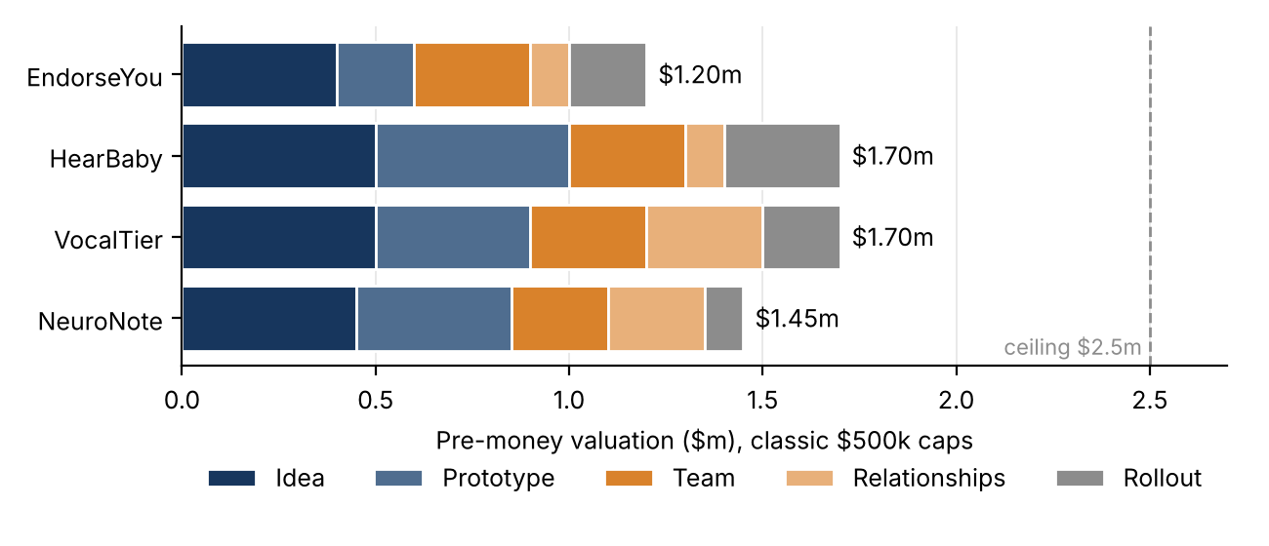
Figure 1 Composition of the Berkus valuations: similar totals, different risk profiles
EndorseYou (endorsements as a digital reference letter; Australia, founder willing to relocate, three people, one part-time) gets a generous $1.2m (range $1.0–1.3m; slide MCQ $0.8–1.2m): strategic relationships contribute least, since no partners or investors are mentioned. HearBaby (patented noise-detection baby monitor, free app plus subscription) reaches the cap on idea and prototype because the patent is observable evidence; it falls short of the ceiling for commercial, not technical, reasons (thin team, no partnerships, no sales plan). VocalTier (Boston text-to-speech, raising a $750k seed with $250k already committed) gets the same $1.7m with a different composition: more for relationships, since the commitment is the only third-party validation. Judge each case in its own era: text-to-speech was an achievement in the early 2010s and is a commodity today. Because caps compress outcomes, Berkus discriminates through composition more than total: its main output is an inventory of risks for due diligence.

The Scorecard Method
Codified by Bill Payne (2011), it adds what Berkus lacks: an anchor in market prices. Start from the baseline, the average pre-money of comparable deals at the same stage and region; score seven factors against the average peer (1.0 = parity, 0 = very poor, up to 2.0 = excellent); weight and sum them into the adjustment factor; multiply.
V_{pre} = V_{base} × Σ_{i=1..7} w_{i} r_{i}, Σ w_{i} = 1, r_{i} = 1 at parity
Factor | Weight | Typical scores
Management team | 30% | 130–160% strong, 60–90% weak
Size of the opportunity | 25% | 120–150% for a large market
Product / technology | 15% | Patent, prototype, product traction
Competitive environment | 10% | 50–90% for a saturated market (strong competition lowers it)
Marketing and sales channels | 10%
Need for additional funding | 5%
Other factors | 5% | Location, network, anything else
Table 4 Scorecard weights
Mnemonic: "team is the most important"; team + opportunity = 55%, + product = 70%. The baseline reflects stage, sector (AI, biotech, fintech command more), ecosystem maturity, investor competition and macro conditions. Because it comes from recent deals, the method transmits market conditions into the valuation: strength (consistent with prices paid) and weakness (it cannot tell whether those prices are justified). Weights decide how strengths offset weaknesses: team at 80% (−20 × 0.30 = −0.06) and product at 160% (+60 × 0.15 = +0.09) net +0.03; other weights could reverse it, so weights embody judgments.

Choosing the Comparables
In exercises the baseline may come from a list mixing true and false comparables. Keep only companies with the same business model, customer and stage (and region); exclude the rest in one line each; average the survivors. Constellation (small-satellite launch): VectorNova 22, AstraLink 19, OrbitalGrid 18, StellarPath 20 → (22 + 19 + 18 + 20)/4 = $19.75m; habitation modules, in-orbit robotics, space tourism and lunar manufacturing are excluded. HomeStake (automated housing construction): 53, 51, 52, 54 → $52.5m. Averaging the whole list is the classic error.

CirrusApps and Jimsamed: the Baseline Does the Heavy Lifting
Factor (weight) | CirrusApps score → weighted | Jimsamed score → weighted
Team (30%) | 2.0 → 0.60 (serial founders, two exits) | 2.0 → 0.60
Opportunity (25%) | 1.8 → 0.45 | 1.8 → 0.45
Product (15%) | 1.2 → 0.18 | 1.6 → 0.24 (superior but unprotected)
Competition (10%) | 0.9 → 0.09 (Dropbox, Box) | 1.1 → 0.11
Marketing and sales (10%) | 1.3 → 0.13 | 1.5 → 0.15
Need for funding (5%) | 1.0 → 0.05 | 1.2 → 0.06
Other (5%) | 1.5 → 0.075 (Silicon Valley) | 1.3 → 0.065
Adjustment factor | 1.575 ≈ 1.58 | 1.675 ≈ 1.68
Baseline → pre-money | $6.0m → ≈ $9.5m | $12.0m → ≈ $20.2m
Table 5 Scorecard valuations (notes' scores)
CirrusApps (data sync across devices, 15 employees, seeking a Series A of $8–10m; baseline = typical 2012 SaaS Series A pre-money): the team contributes most (0.60, over a third of the factor). The professor would score competition nearer 0.6: factor 1.545, value $9.27m, little change because competition weighs 10%. (In the recording she read 1.68 and $10.08m; use the official 1.58 and $9.5m.) Jimsamed (Microsoft-tool developers building iOS/Android apps; $400k revenue in March 2012; already holding a term sheet) has a higher $12m baseline because of revenue and a competing offer; the class scores give 1.765 and ≈ $21.2m. Similar factors, but Jimsamed is worth more than double: doubling the baseline doubles the value, while the higher scores add ~6%. The same $8–10m request is at parity for CirrusApps and above parity for Jimsamed, which depends less on future financing. The baseline is the most consequential judgment and must be documented as carefully as the scores.

Worked Exam Exercises
Dimension | Value | Justification
Sound idea | $450k | Clinicians spend 2h+/day on documentation; defined buyer (clinics)
Prototype | $400k | In daily use by 12 pilot clinicians, in-house engine; not at scale
Team | $250k | Physician + ML engineer; no commercial hire, no start-up record
Relationships | $250k | Signed but non-binding LOI, talks with two EHR vendors
Rollout | $100k | Pilots, but no pricing or channel evidence
Pre-money | $1.45m | Accepted range $1.2–1.7m
Table 6 Exercise 1: Berkus valuation of NeuroNote (AI note-taking for clinicians, $500k caps)
Exercise 2: Scorecard valuation of LoopKit
Seed developer-tools start-up, baseline $5.0m. Scores: team 150%, opportunity 120%, product 130%, competition 90%, marketing 100%, funding 110%, other 100%.
Factor = 0.30×1.50 + 0.25×1.20 + 0.15×1.30 + 0.10×0.90 + 0.10×1.00 + 0.05×1.10 + 0.05×1.00 = 0.450 + 0.300 + 0.195 + 0.090 + 0.100 + 0.055 + 0.050 = 1.24. Pre-money = 5.0 × 1.24 = $6.2m.
Common error: averaging the scores (8.0/7 = 1.14 → $5.7m). Other traps: forgetting the weight (1.20 on team contributes 0.36, not 1.20); a value below the baseline with a factor above 1; a stake computed on the pre-money ($2m at $6m pre is 25% of post-money $8m, not 33.3%).

Full marks go to evidence-tied numbers, not to matching the reference: any NeuroNote total in $1.2–1.7m with consistent justifications is accepted. An MCQ variant with scores 140, 130, 110, 80, 120, 100, 100% gives 0.42 + 0.325 + 0.165 + 0.08 + 0.12 + 0.05 + 0.05 = 1.21.

The Professor's Live Scoring
Arditia Lab (AI coding agent): 30 buyer interviews, 70% willing to pay 6,000 a month → idea at the top; only mock-ups → prototype 100–200; a solo founder working evenings → team near 0, rebalanced to ~100 because he landed a listed partner; that signed partnership with a framework contract under negotiation → relationships 350–400 (full points need variety: suppliers, clients, investors); rollout ~250. Total roughly $1.1–1.35m. Cobalto System (warehouse robots): validated idea ~450; working tested product without a patent (not needed to sell, but a crowded field can copy) ~450; strong team with the sales role open (not worrying at the angel stage, it would be from Series A) 400–450; a signed partnership ("already 300 plus") 350–450; paid pilots without a sales plan 350–400: about $2.1m, near the ceiling. On HearBaby she asked whether the device sale alone covers product, acquisition and fixed costs; if so the subscription is pure upside (total $1.6m). For the Scorecard her scale is 0 (poor), 1 (average), 2 (maximum): baseline $10m with scores 2, 1, 2, 0, 2, 2, 1 → 0.60 + 0.25 + 0.30 + 0 + 0.20 + 0.10 + 0.05 = 1.50 → $15m. "You look for money before you need money."

Exam Angle
- No comparables and minimal information → Berkus; known ecosystem with comparable deals → Scorecard.
- The TAM is a Scorecard factor, not a Berkus dimension; know the five Berkus risks and the seven Scorecard weights (30/25/15/10/10/5/5).
- Berkus: keep every silo under its cap, add all five, justify each number; any value inside the defensible range is accepted if justified.
- Scorecard: weight, don't average; factor > 1 ⇒ value > baseline; build the baseline only from true comparables.
- Each MCQ has one correct answer: read all options and choose the one fitting the scoring logic most completely.
- Calculator allowed: "it's not a math class". Next: Risk Factor Summation (12 risks) and the VC Method.

Early-Stage Valuation II: Risk Factor Summation and the VC Method
Lesson 16 (03/11) explanatory notes
Lesson 15 replaced DCF with structured judgment: Berkus (capped credits for risks already reduced) and the Scorecard (baseline × weighted factor, team 30%). This lesson (03/11) completes the toolkit. The class first finished the Scorecard of Constellation Space, then Professor Zava introduced Risk Factor Summation (RFS), which adds a fixed dollar amount per point across twelve risks to the same kind of baseline, and the Venture Capital Method, which works backwards from an exit scenario and the fund's target return and must be corrected for dilution. Goal for the exam: run an RFS and a VC-method valuation with dilution in about five minutes each, and explain where the four methods agree and diverge.

Finishing the Scorecard: Constellation Space
Constellation launches small commercial satellites and sells services around them; it raises $5m on a SAFE with a $30m valuation cap, treated as a seed round in early 2022. Comparable transactions are not competitors: they are companies in the same space that raised a round of comparable size, stage (same or adjacent: a weak Series A resembles a large seed, a Series B is too far) and time (valuations drift: the average seed was ~$2m some years ago, ~$3.6m today). Of eight listed deals, only the four launch businesses survive (VectorNova 22, AstraLink 19, OrbitalGrid 18, StellarPath 20); habitation modules (closer to real estate), in-orbit robotics, suborbital tourism and lunar manufacturing are excluded, and they were also the larger, capital-heavy deals. Baseline = (22 + 19 + 18 + 20)/4 = $19.75m.
Factor | Weight | Score | Weighted | Reasoning
Team | 30% | 2.0 | 0.60 | Serial founders with exits, top schools, complementary skills
Opportunity | 25% | 2.0 | 0.50 | Very large, growing market (1.8 also fine)
Product | 15% | 1.5 | 0.225 | Six patents at seed, but no rockets, infrastructure or DoD approval
Competition | 10% | 0.7 | 0.07 | Many launchers; high entry barriers; poor competitor slide
Marketing and sales | 10% | 0.5 | 0.05 | No LOIs, vague go-to-market, over-optimistic roadmap
Need for funding | 5% | 0 | 0 | No prior raise, no MVP: unclear funding strategy
Other | 5% | 1.0 | 0.05 | NASA background already counted in the team
Factor / value |  |  | 1.495 ≈ 1.5 | 19.75 × 1.5 ≈ $29.6m
Table 1 Scorecard valuation of Constellation Space
$29.6m against a $30m cap is "very much in line". The 15–20% rule: since every valuation rests on assumptions partly wrong in both directions, you need a gap of at least 15–20% before calling a deal over- or under-priced. The deck listed Virgin Orbit, Boeing, SpaceX and Blue Origin as competitors: giants are not real competitors of a $30m start-up, and listing them is a red flag about judgment. The right question: why would a large player not simply copy you? Historically the answer was that entering a niche cost Google or Amazon too much; with AI applications that answer has weakened (OpenAI or Anthropic can enter a vertical with a few experts coordinating agents).

Risk Factor Summation
RFS sits "in between" Berkus and Scorecard. Like the Scorecard it starts from an external baseline (average pre-money of comparable pre-revenue companies in the region), but it adds or subtracts a fixed dollar amount for each of twelve risks: the Scorecard evaluates strengths relative to peers, RFS evaluates exposure to risk. Described by the Ohio TechAngels and popularised by Payne (2011b).
1–4 | 5–8 | 9–12
Management | Sales and marketing | Litigation
Stage of the business | Funding and capital raising | International risk
Legislation / political risk | Competition | Reputation
Manufacturing | Technology | Potential lucrative exit
Table 2 The twelve RFS risk factors
V = V_{base} + Σ_{i=1..12} s_{i} × Δ, s_{i} ∈ {−2, −1, 0, +1, +2}, classic Δ = $250,000 (V_{base} = $2m)
Scores are relative to the typical start-up at the same stage, so the neutral score is 0 (not 1 as in the Scorecard): +2 adds $500k, −2 subtracts $500k; the net score lies in [−24, +24], the adjustment in [−$6m, +$6m]. RFS is additive, unweighted (management is worth exactly as much as international risk) and symmetric. Its contribution is breadth: legislation, manufacturing, litigation, international, reputation and lucrative exit appear in neither Berkus nor Scorecard, so it is most useful when operational and legal risks matter. Mapping: management = team; stage (how developed within the stage) + technology ≈ Scorecard product; competition, sales, funding mirror Scorecard factors; manufacturing matters for physical products; legislation for CBD or therapeutics; litigation = how likely to be sued (constant AI lawsuits). An irrelevant factor scores 0. The classic $2m / $250k pair reflects the average seed when the method spread; with a ~$3.6m average seed today, rescale in proportion, as with Berkus caps.
Factor | Score | Evidence
Management | +1 | Technical founder, no commercial experience
Stage | 0 | Early product, typical
Legislation | −1 | Infant safety, compliance, children's data
Manufacturing | −1 | Hardware supply chain and unit cost
Sales and marketing | −1 | No channels or distribution partners
Funding / Competition | 0 / 0 | Standard request; crowded but differentiated
Technology | +2 | Patented detection technology
Litigation | +1 | Patent gives defensive protection
International / Reputation | 0 / 0 | Not addressed; no track record
Lucrative exit | +1 | Active acquirers in the category
Net / value | +2 | 1.5 + 2 × 0.25 = $2.0m pre-money
Table 3 RFS valuation of HearBaby (baseline $1.5m, consumer hardware)
Berkus gave $1.7m and RFS $2.0m: together they define a negotiation range. The method is sensitive to classification: treating HearBaby as software (it runs on standard phones) makes manufacturing 0, the net score +3 and the value $2.25m, before even switching to a software baseline. In baseline methods classification determines both the anchor and the scores.
Worked exercise: GreenGrid (Exercise 6)
Pre-revenue energy-analytics software; baseline $2.5m, $250k per point. Scores: management +1, stage +1, legislation 0, manufacturing 0, sales −1, funding 0, competition −2, technology +1, litigation 0, international −1, reputation 0, exit +1.
Net score = 1 + 1 − 1 − 2 + 1 − 1 + 1 = 0 → adjustment 0 → pre-money = $2.5m (the baseline).
Due diligence should start from competition (−2, the only very negative factor, −$500k alone) and sales and marketing (a go-to-market gap that compounds the threat); international is secondary pre-revenue. Grading: 2 points for net score and value, 3 for the two factors with a rationale.
Trap: a zero is not "no risk": strengths and weaknesses offset dollar for dollar and can hide a fatal flaw. Also: no weights, dollar steps (not % of baseline), neutral 0 (not 1).

The Venture Capital Method
The VC Method (Sahlman and Scherlis 1987; Sahlman 1990) values a company by discounting its exit value at the fund's target return and adjusting for dilution. Unlike the three present-evidence methods it prices a future scenario, and it is the first that ties the entry price to the economics of the fund. Steps: (1) exit value in year N (revenue or earnings × comparable multiple); (2) post-money = exit / target multiple; (3) pre-money = post − investment; (4) required stake = I / post, adjusted for dilution.
V_{post} = V_{exit} / (1 + r)^{N} = V_{exit} / M V_{pre} = V_{post} − I required stake = I / V_{post} = I × M / V_{exit}
The exit value is an educated guess; the target multiple is decided, not found. Napkin math: use M rather than (1 + r)^N in quick exercises (10x in 5 years ≈ 58% a year, 8x ≈ 52%). Read as a willingness-to-pay test, exit / M minus the pre-money asked tells how much the syndicate can invest and still meet its target. Target rates run 30–70% a year (3x to 10x+); surveys report an average required IRR of 31% and multiple of 5.5x (7.5x early stage; Gompers et al. 2020); for very early seed the professor cited ~50x, and VCs who want three digits "because all the companies die". These rates do not reflect CAPM systematic risk; they compensate for the probability of total loss, illiquidity, value added and founders' optimism.
(1 + r)^{N} = (1 + k)^{N} / p N = 5, k = 15%, p = 1/3 ⇒ (1 + r)⁵ = 2.011 × 3 = 6.03 ⇒ r ≈ 43%
The exit value is a success scenario, not an expected value: a target that looks extreme largely prices failure.
Step | Computation | Result
Required proceeds at exit | $3.0m × 10 | $30m
Required stake at exit | 30 / 100 | 30%
Post-money | 3.0 / 0.30 (= 100 / 10) | $10.0m
Pre-money | 10.0 − 3.0 | $7.0m
Rate version (50%) | 1.5⁵ ≈ 7.6 → 100 / 7.6 | post $13.2m, pre $10.2m
With retention 0.72 | 30% / 0.72 = 41.7% → 3.0 / 0.417 | post $7.2m, pre $4.2m
Table 4 VC method: $3.0m Series A, exit $100m in 5 years (5 × $20m revenue), target 10x
Lowering the target from ~58% to 50% raises the pre-money by almost one half: the target return is the most powerful lever.

Dilution and the Retention Ratio
Later rounds dilute the investor, so the stake bought today is not the stake held at exit. The retention ratio is the share of today's ownership still held at exit: rounds selling d_{j} give Π(1 − d_{j}); two rounds of 15% give 0.85 × 0.85 ≈ 0.72.
stake_{today} = stake_{exit} / retention V_{post} = V_{exit} × retention / M
In the example above, ignoring dilution would overstate the pre-money by two-thirds ($7.0m vs $4.2m): with retention below 1 the investor must buy more today, not less, which is why investors scrutinise the dilution assumptions behind a founder's valuation.
Step | Jimsamed ($9m, exit $300m, 8x, R = 0.75) | DataForge ($4m, exit $150m, 8x, R = 0.80)
Proceeds at exit | 9 × 8 = $72m | 4 × 8 = $32m
Stake at exit | 72 / 300 = 24% | 32 / 150 = 21.3%
Stake today | 24% / 0.75 = 32% | 21.3% / 0.80 = 26.7%
Post-money | 9 / 0.32 = $28.1m | 4 / 0.267 = $15.0m
Pre-money | $19.1m | $11.0m
Lower exit | $200m: 36% → 48%, post $18.8m, pre $9.8m | $100m: 32% → 40%, post $10m, pre $6.0m (−45%)
Table 5 VC method with dilution: Jimsamed and DataForge (Exercise 5)
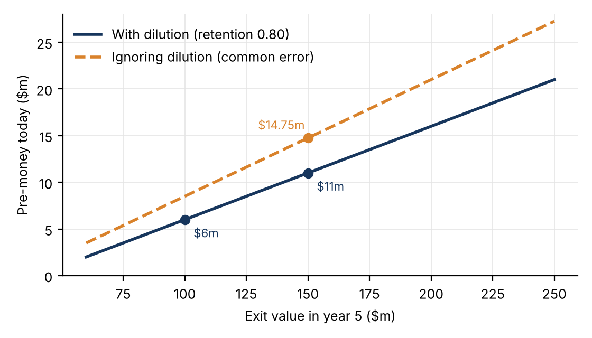
Figure 1 DataForge: pre-money as a function of the exit assumption, with and without dilution (I = $4m, M = 8x)
Jimsamed's $19.1m is within $1.1m of its Scorecard value ($20.2m). But a one-third cut in the exit value roughly halves the pre-money, because the investment is fixed: the pre-money is a leveraged function of the exit assumption. DataForge without dilution would give 21.3%, post $18.75m, pre $14.75m (the common error). Grading: 1 point for the exit stake, 2 for stake today and pre-money, 2 for the $100m scenario with a one-line interpretation.
Every valuation ends in an allocation of ownership: post = pre + new money, stake = I / post (CirrusApps at $9.5m pre with $3m invested: post $12.5m, 24%). Berkus, Scorecard and RFS produce a pre-money from which the stake follows; the VC method starts from the required stake and derives the valuation. A founder seeking a higher pre-money is seeking to give a smaller share. Traps: dividing by pre-money (2/6 = 33.3% instead of 2/8 = 25%); stopping at post-money when pre is asked; multiplying by retention instead of dividing; treating a multiple as an annual rate.

Comparing the Four Methods and Triangulating
 | Berkus | Scorecard | RFS | VC Method
Anchor | Internal: risks reduced | External baseline | External baseline | Future: exit and target return
Adjustment | Capped additive, $500k each | Baseline × Σ w·s | ±$250k per point, 12 unweighted | Exit / M, × retention
Best for | Pre-revenue, little information | Seed with comparables | As Scorecard, legal/operational risk | Series A on; fund target
Main limit | Arbitrary caps, no market anchor | Baseline transmits booms; weights are judgment | Equal points; false completeness | Exit and rate unverifiable; dilution ignored
Table 6 The four early-stage methods
Rule: without reliable comparables start with Berkus; as information accumulates the external-anchor methods become usable; near a revenue-generating Series A the VC method becomes indispensable. Limits have behavioural roots: anchoring (Tversky and Kahneman 1974: whoever sets the first figure influences the outcome) and optimism (Kahneman and Lovallo 1993), which caps, market baselines and high targets act as safeguards against. All four methods are compensatory, yet real risks often are not: a dominant incumbent or a founders' conflict cannot be offset by a high technology score. Triangulate: express valuations as ranges, use at least two methods, document every score. When present-evidence methods and the VC method agree (Jimsamed at a $300m exit) negotiate with confidence; when they diverge, the gap measures the optimism of the exit scenario and shows what due diligence must establish. The methods define the range within which a disciplined investor agrees on a price.

Exam Angle
- Second mid-term (21/12): MCQs plus five-minute exercises. RFS: sum twelve scores, × point value, + baseline, then name the factors to investigate. VC method: proceeds, stake at exit, stake today, post, pre, often repeated for a lower exit with a one-line interpretation.
- Know RFS structure (no weights, dollar steps, neutral 0, unique factors) and why target returns are so high (failure, illiquidity, optimism; not CAPM).
- Dilution: divide by retention; more stake today, lower pre-money.
- Scorecard: never forget Other (weights 30/25/15/10/10/5/5); comparables ≠ competitors; a gap below 15–20% is noise.
- Practitioner materials on SAFEs and convertible notes are for review only, not part of Professor Zava's exam; cases are for learning to value, not for recall.

Later-Stage Valuation: Multiples, Prior Round, DCF and First Chicago
Lesson 17 (04/11 and 05/11) explanatory notes
Lessons 15–16 valued pre-revenue start-ups with judgment (Berkus, Scorecard, RFS) or a hypothetical exit (VC Method). This lesson (04/11 and 05/11; notes follow the professor's revised deck, Lecture 19) crosses into the later stage: a Series C company has revenue, margins, retention data and a financing history, and there are listed peers and acquisitions that look like it. The running case: an investor is offered 11.8% of Orvalis Software (hypothetical Milan vertical SaaS) for €60m at €450m pre-money. Is €450m fair? On 04/11 the market-based methods (trading multiples, precedent transactions, calibration to the previous round); on 05/11 the forecast-based ones (multi-stage DCF, First Chicago), the effect of a 1x liquidation preference, and a football field. The professor's lens: the formulas are simple and learned by heart; the skill is in the assumptions and the comparables; and the final price is negotiated inside the range, and the terms are part of the price. (She opened with the birth of Silicon Valley: Shockley, the "Traitorous Eight", Fairchild and its "Fairchildren", later the PayPal mafia: ecosystems grow through people who become founders, employees and then investors.) Revised deck: same Orvalis numbers; the step-by-step growth-adjusted slide is gone (14.4x kept only as a comparison that overstates); new: required multiple 3.2x vs 7.5x, evidence on which multiples price best; the calibration slide is unchanged (€24.0m).

From Early to Later Stage
Three things change: operating data are observed, not guessed (and the team has survived); market prices of listed peers and acquisitions are visible; and, as a minus, a complex capital structure (several preferred classes with preferences, anti-dilution, ratchets). Private shares are also illiquid, so a discount is needed. Judgment gives way to evidence, but the evidence must be adjusted before use. Late-stage VCs behave differently (Gompers et al. 2020): 60% use the IRR (26% early), 74% call valuation important (47%), only 7% do not forecast cash flows (31%); required IRR 29% vs 33% and required multiple 3.2x vs 7.5x (less risk, lower return). The deck sorts the methods into two anchors: market-based (what investors pay: trading multiples, precedent transactions) and forecast-based (what must happen: DCF, First Chicago).
Item | Orvalis | Item | Orvalis
Revenue LTM | €36.0m | Gross margin | 76%
Revenue NTM (forecast) | €54.0m | Net revenue retention | 118%
ARR | €42.0m | NTM FCF margin | −10%
NTM growth | 50% | Net cash before Series C | €22.0m
Series B (June 2025) | €30m at €210m post | Series C offer | €60m at €450m pre → €510m post, 60/510 = 11.8%
Table 1 Orvalis Software: key data (hypothetical)

Enterprise Value, Equity Value and the Multiple
EV = equity value + debt − cash Equity value = EV − debt + cash = EV + net cash
"Remember it for your whole life… get a tattoo": a multiple of revenue or EBITDA gives EV, not equity; to price the shares add cash, subtract debt. The metric depends on the business: EV/EBITDA or P/E if profitable, EV/NTM revenue or EV/ARR for growth software, EV/GMV for marketplaces, EV per user for consumer platforms. Orvalis burns cash, so EV/NTM revenue: enterprise value, not equity (neutral to cash balances), forward beats trailing (NTM captures growth), not yet profitable, and the evidence that forecast-based multiples price best and sales multiples worst (Liu, Nissim & Thomas 2002; Kim & Ritter 1999). Revenue multiples ignore profitability and must be adjusted. Check your multiples against Damodaran's published industry averages and be able to explain any gap. The formula of the whole lesson (pre-money, because multiple and metric are pre-money):
Equity value = m × X × (1 − d) + net cash (d = DLOM, applied to EV only, before adding cash)

Trading Multiples
Eight listed vertical-software peers grow 14–45% (median 28%) with EV/NTM revenue 5.6x–9.6x: the median is 7.6x (average of the middle values 7.4x and 7.8x; the median limits outliers). Listed peers are more mature and grow more slowly (it is easier to grow 50% from a small base). Computing a median is trivial; choosing the set is the skill: document why each peer belongs. Two screens: the Rule of 40 (NTM growth + NTM FCF margin ≥ 40; Orvalis 50 − 10 = 40 vs peer median 38.5) justifies burning cash to buy growth (the food-delivery voucher wars); well below 40 means spending without revenue, far above for a young firm may mean under-investing. Net revenue retention (recurring revenue today from last year's customers ÷ their revenue a year ago; >100% means growth without new customers): Orvalis 118% vs 112.5%; it matters most when acquisition costs are high.
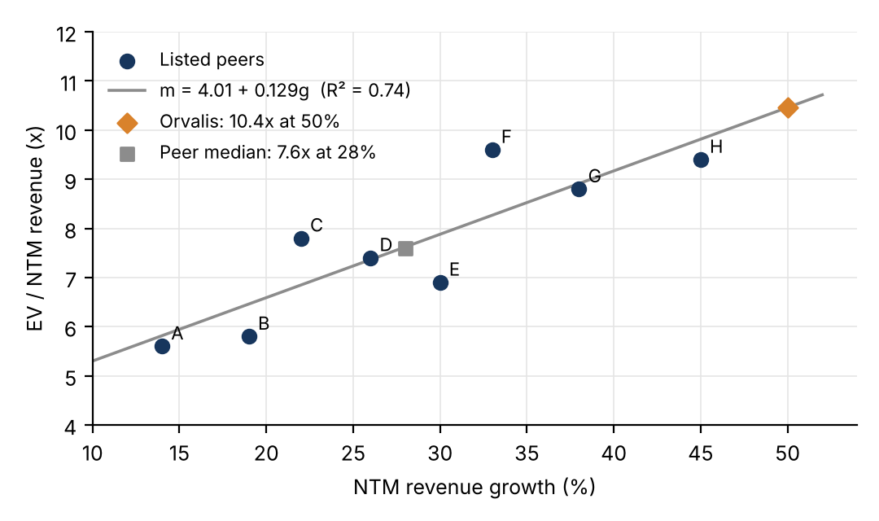
Figure 1 Peer EV/NTM revenue against NTM growth: regression m = 4.01 + 0.129g (R² = 0.74) and Orvalis at 50% growth
Approach | Multiple | EV listed (€m) | × (1 − 0.20) | + net cash = pre-money (€m)
Median | 7.6x | 410.4 | 328.3 | 350.3
Regression on growth | 10.4x | 564.0 | 451.2 | 473.2
Growth-adjusted (0.288 × 50; comparison only) | 14.4x | 777.0 | 621.6 | 643.6
Table 2 Trading multiples applied to Orvalis (NTM revenue €54.0m; slide uses unrounded multiples)
The median understates (ignores Orvalis's faster growth); the growth-adjusted multiple (PEG-like: median m_{i}/g_{i} = 0.288 × growth), which the revised deck shows only as a comparison point, overstates, because it assumes proportionality ("regression, not proportionality"). The regression sits in between and is retained: a positive intercept means multiples are not proportional to growth; each growth point adds ~0.13 turns (at 30%: 4.01 + 0.129 × 30 ≈ 7.9x); Orvalis's point is an extrapolation. Rule of 40 and NRR checks call for no further adjustment to the growth-based multiple. Why regress on growth, not FCF margin? Management can cut spending at will, while revenue must be earned from customers, and empirically growth explains multiples best. The DLOM (discount for lack of marketability) reflects that a private minority stake can be sold only at an IPO, a sale or a secondary: it grows with time to liquidity and volatility (Longstaff 1995; Silber 1991, restricted blocks >30%); usual range 15–25%, Orvalis 20%. Trading-multiples value €473m (range €411–540m).

Precedent Transactions and the Control Premium
Acquirers buy control and synergies; a minority investor gets neither. Bids for US listed targets 1980–2008 carried an average premium of 46% (median 38%) (Malmendier, Opp and Saidi 2016). Acquisition multiples are control prices: the premium must be divided out before valuing a minority stake.
m_{minority} = m_{acquisition} / (1 + CP) DLOC = 1 − 1/(1 + CP) = 1 − 1/1.35 ≈ 26%
Six SaaS targets (2023–2026) have a median of 13.2x at 42% growth; 13.2 / 1.35 = 9.8x (cross-check: the peer regression at 42% gives 9.4x); 9.8 × 0.80 × 54.0 + 22.0 = €444m (range €391–507m with CP 25–45%, DLOM 15–25%). Caveats: acquirer-specific synergies, undisclosed terms, small samples, different market conditions. If the buyer wanted control, compute the clean value and multiply by (1 + CP). The professor separated valuation (value of the company cleaned of biases) from willingness to pay, which may add extras for preferences, anti-dilution, a board seat, co-investing with top funds; a strategic buyer can pay more than a financial one: a company has a different value for each buyer.

Calibration to the Previous Round
A headline post-money = newest preferred price × fully diluted shares, assuming all shares have equal rights. They do not: Gornall and Strebulaev (2020) found that 135 US unicorns' post-money valuations exceed fair value by 48% on average (common shares overvalued by 56%; 65 of 135 worth < $1bn). A reported post-money is an upper bound on equity value. Calibration (IPEV Guidelines, Dec 2025) carries forward the divergence between the company and its peers observed at the last round:
m_{today} = m̂_{today} × m_{round} / m̂_{round}
Step | Computation | Result
EV implied by Series B | 210.0 − 35.0 (net cash after the round) | €175.0m
Series B multiple | 175.0 / 24.0 (NTM revenue expected in June 2025) | 7.3x
Peer regression in June 2025 | at Orvalis's growth then | 8.6x
Calibration factor | 7.3 / 8.6 | 0.85 (≈15% below the line)
Calibrated multiple today | 10.4 × 0.85 | 8.9x
Pre-money equity | 8.9 × 54.0 + 22.0 (no DLOM) | €500m (range 461–539)
Table 3 Calibration of Orvalis to its Series B
No DLOM: the Series B was paid for private, illiquid preferred shares, so the factor already embeds the discount; applying it again counts it twice. The value inherits a preferred-share price, hence an upper bound for common equity. Main drawback: any bias in the previous price is carried into today's value. The professor said the €24.0m must be the NTM revenue expected in June 2025 and promised to fix the slide, but the revised deck keeps it unchanged (7.3x, 0.85, 8.9x, €500m): read it as that forecast (today's €36.0m LTM at 50% growth taken back one year). The exam will give both the net cash and the NTM revenue at the round.

The Multi-Stage DCF
EV = Σ_{t=1..T} FCF_{t} / (1 + r)^{t} + TV_{T} / (1 + r)^{T} TV_{T} = FCF_{T} × (1 + g) / (r − g)
A later-stage start-up passes through growth regimes (very high growth with negative FCF, slower growth on a larger base, then steady state), so the forecast is split before the terminal value. Here r is the cost of capital (in the VC Method it was the target IRR). g is perpetual growth from year 11, not a forecast-year rate, and must not exceed long-run economic growth: ~4% by default. Base case 2027–2036: revenue €54m → €258m, growth 50% → 6%, FCF margin −10% → 28%, r = 13%, g = 4%.
Block | PV at 13% (€m)
FCF 2027–28 (negative: −5.4, −1.5) | −6.0
FCF 2029–31 (steep growth) | +27.4
FCF 2032–36 (regular growth) | +103.8
TV = 72.2 × 1.04 / 0.09 = 834.3; / 1.13¹⁰ | +245.8 (66% of EV)
Enterprise value | 371.1
+ net cash = pre-money equity | 393.1
Table 4 Orvalis DCF by growth regime
One block or three gives the same number, but blocks show which regime creates value: the first five years contribute only €21.5m. A TV near two-thirds of EV is normal. Failure must enter once (Damodaran 2009): expected-case cash flows → cost of capital; success-case cash flows → raise the rate (VC Method) or model failure as a scenario (First Chicago); never both. Sensitivity: r 12–14% × g 3–5% gives €322–505m (one point less on r adds 17%). The reverse DCF solves for what a price implies: €473m requires r ≈ 11.8% or a long-run FCF margin ≈ 34% instead of 28%.

The First Chicago Method
One forecast hides failure: the VC Method values success and hides failure in a high rate; a single DCF ignores it or pushes it into r. First Chicago (First Chicago Corporation; Sahlman and Scherlis 1987) values a few exit scenarios (success, base/sideways, failure), weights them by explicit probabilities and discounts at the cost of capital. N is the years to the expected exit window ("reading the wind before sailing"). Default probabilities in class: 30/50/20.
V₀ (post-money) = Σ_{s} p_{s} V_{s,N} / (1 + r)^{N}, Σ p_{s} = 1 Pre-money = V₀ − new money
Scenario | Revenue 2031 × multiple | Exit value (€m) | p | Weighted (€m)
Success (category leader, ~44% growth) | 220.0 × 7.0x | 1,540.0 | 30% | 462.0 (56% of value)
Base (DCF case, ~33% growth) | 152.1 × 4.5x | 684.4 | 50% | 342.2 (42%)
Failure (sub-scale sale) | 80.0 × 1.0x | 80.0 | 20% | 16.0 (2%)
Expected exit value |  |  | 100% | 820.2
Post-money / pre-money | 820.2 / 1.13⁵ = 820.2 / 1.842 | 445.2 |  | 385.2
Table 5 First Chicago valuation of Orvalis (exit end-2031, N = 5, r = 13%)
Rules: probabilities sum to 100% ("there is only one reality"); each exit multiple matches its scenario (2031 multiples are lower than today's because the company will be older and slower); the base case is a good outcome; discount at the cost of capital. A 30% chance of success yields 56% of the value: the upside drives the price. Backwards: €510m post requires 510 × 1.13⁵ = €939.6m expected exit; with failure at 20%, p(success) ≈ 44% vs 30% assumed (each 5 points ≈ €23m): negotiate over probabilities, not a single number.
First Chicago and the VC Method are twins (exam trap)
The VC Method discounts only the success exit (€1,540m) at r_{VC}. It gives the same €445.2m post-money if (1 + r_{VC})⁵ = 1,540 / 445.2 = 3.46, i.e. r_{VC} ≈ 28.2%, close to the 29% late-stage required IRR. Decomposition: 3.46 = 1.13⁵ (1.84) × 1,540/820.2 (1.88): the target rate = time value × the cost of not succeeding. It is not an expected return.
Trap: discounting the expected exit at the VC rate gives 820.2 / 3.46 ≈ €237m post and €177m pre, less than half the correct €385m: failure counted twice.

Liquidation Preferences: the Terms Are Part of the Price
Non-participating: payoff = max(L, s × Exit) Participating: payoff = L + s × (Exit − L) conversion above Exit = L / s = 60 / 0.1176 = €510m
Scenario (p) | Exit (€m) | As common (11.8%) | 1x non-participating | 1x participating (comparison)
Success (30%) | 1,540.0 | 181.2 | 181.2 (converts) | 234.1
Base (50%) | 684.4 | 80.5 | 80.5 (converts) | 133.5
Failure (20%) | 80.0 | 9.4 | 60.0 (preference) | 62.4
Expected payoff |  | 96.5 | 106.6
Expected 5-year IRR |  | (96.5/60)^{1/5} − 1 = 10.0% | (106.6/60)^{1/5} − 1 = 12.2%
Table 6 Series C investor's payoff (€60m, s = 11.8%)
The preference matters only in failure, turning €9.4m into €60m, so the other holders get €20m instead of €70.6m: it transfers downside value to the investor. Even then the investor is not happy (five years of opportunity cost and inflation), and founders, employees and angels are less so. Same €450m headline, but cheaper for the preferred investor and worth less to common: this is why a headline post-money overstates common equity.

The Football Field: Is €450m Fair?
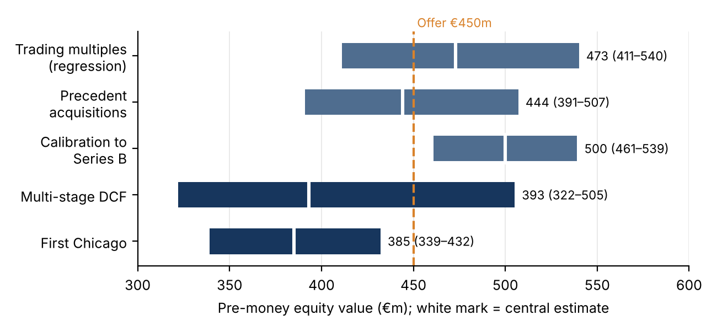
Figure 2 Football field: pre-money ranges and central values by method vs the proposed €450m
Market-based methods say what investors pay; forecast-based methods say what must happen. Do not average the bars: understand why one method reaches €540m and another €322m. Answer ("it depends"): €450m sits inside three of five ranges (trading, acquisitions, DCF), above First Chicago and below calibration. It is consistent with market prices but requires beating the base case (implied success probability ~44% vs 30%), and the 1x preference lowers the effective price for the Series C investor: the final price is negotiated inside the range, and the terms are part of the price.

Exam Angle
Second mid-term (21/12): 20 MCQs + 4 five-minute exercises; the deck's practice set (Veltra, Kestrel, HelioGrid, a preference exercise) mirrors it. In MCQs the assumption (DLOM, CP) is given; in open valuations choose DLOM 15–25%, CP 25–45%. Traps: forgetting net cash or adding debt; DLOM on cash or after adding it; acquisition multiple not divided by 1 + CP, or subtracting the premium (13.2 × 0.65) instead of dividing; DLOM on a calibrated multiple; mixing LTM and NTM; First Chicago gives a post-money (subtract the investment); discounting TV by (1 + r)^{T+1} or using a forecast rate as g; probabilities ≠ 100%; non-participating = max, not sum; scenarios at a VC rate (failure twice). Order of operations: multiple → DLOM → cash. Read the case uploaded on 05/11 before next class.

Case: Square, Inc. — Financing a Unicorn
Case (weekend reading before class)
Lesson 17 showed that a reported post-money valuation prices every share at the newest preferred price and is therefore an upper bound on equity value (Gornall and Strebulaev, 2020: unicorn post-moneys exceed fair value by 48% on average), and the professor announced the Square case as the reality check. This is the Ivey case Square, Inc.: Financing a Unicorn (9B17N021), assigned as weekend reading before the class discussion: there is no recording yet, so these notes come from the case and its five exhibits only and will be updated after class. Facts outside the case (the 2015 IPO) are public record. The question, set in September 2014: should Goldman Sachs and Sapphire Ventures buy $150m of Series E preferred at $15.46345 per share, a $6bn headline, and what do its terms do to everyone else? For the exam focus on the round arithmetic, the IPO ratchet and the liquidation waterfall.

The Story and the Decision
Square (San Francisco, 2009, co-founded by Jack Dorsey of Twitter) let anyone accept card payments on a smartphone with a free app and a free reader, targeting small sellers ignored by banks. By September 2014 it had raised $371m in five rounds; early funds, near the end of their ten-year life, wanted an exit. Apple offered about $3bn, half the $6bn Square wanted; an IPO was judged unable to support $6bn. So Square sought a sixth, Series E round from late-stage funds. Context: unicorns (post-money > $1bn, Aileen Lee, 2013) went from two in 2009–2013 to 62 by July 2014 (46 in the US; Square 17th at $3.3bn). Andreessen denied a bubble; critics warned that start-ups gave later investors generous terms "for the sake of appearances", because a flat or down round signals distress.
The business grew fast but earned little. On a 2.75% fee Square kept about $0.93 per $100; adjusted revenue was 1.1% of gross payment volume (GPV) in 2013, and PayPal (2.5%) and Amazon (1.75%) were undercutting it. GPV grew 127% in 2013 to $14.8bn; adjusted EBITDA was −$51.5m (−32% of adjusted revenue). Cash used before financing: −$90.7m (2012), −$71.4m (2013), −$69.1m (H1 2014), i.e. about $138m a year against $138.6m of cash: a one-year runway. Fred Wilson called it a valuation trap; Sequoia's Botha said Square "could be profitable tomorrow morning" if it stopped growing.

Financing History Round by Round
Round | Date · lead | Price ($) | Raised ($m) | Post-money ($m) | Step-up
Series A | Nov 2009 · Khosla | 0.21627 | 10.1 | 47 | n.a.
Series B-1 | Jan 2011 · Sequoia | 0.71977 | 10.0 | 167 | 3.33x
Series B-2 | Jun 2011 · Kleiner Perkins | 0.95368 | 25.8 | 247 | 1.33x
Series C | Dec 2011 · R. Branson | 5.79817 | 103.0 | 1,605 | 6.08x
Series D | Sep 2012 · (Starbucks $25m) | 11.01402 | 222.1 | 3,270 | 1.90x
Series E | Oct 2014 · Goldman, Sapphire | 15.46345 | 150.0 | 6,000 (headline) | 1.40x
Table 1 Square's venture rounds (Exhibits 1 and 5; post-money = price × fully diluted shares, common held at 171.3m)
Raised = shares × price V_{post} = p × N_{fully diluted} V_{pre} = V_{post} − I stake = I / V_{post}
Exhibit 1 is the cap table after the Series D: 296.9m fully diluted shares, of which common 57.7% (founders, employees, options), Series A 15.7%, B-1 4.7%, B-2 9.1%, C 6.0%, D 6.8%. Totals check: $10.1m + 10.0 + 25.8 + 103.0 + 222.1 = $371.0m, and 11.01402 × 296.9m = $3.27bn post-money ($3.05bn pre). Earlier post-moneys hold the common constant (an approximation) and match the case's "around $50m" for the Series A. Every round was an up round; the Series C crossed $1bn. The Series A's $10.1m was worth $514m (51x) at the Series D price. Each round sold 6–10%, so common fell from 78.6% to 57.7%. The case gives no founders' stake: we only know common and options hold 57.7%, behind $371m of preferences.
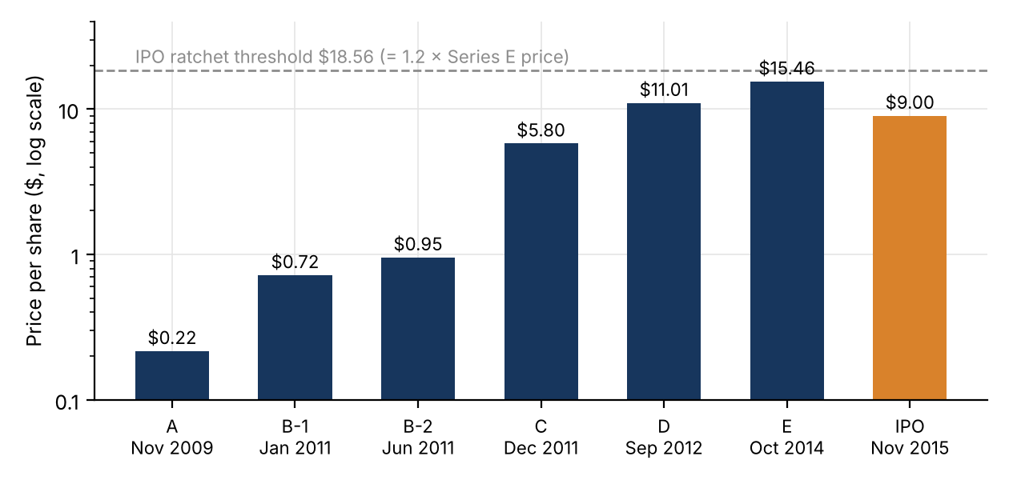
Figure 1 Price per share by round and at the IPO, with the Series E IPO-ratchet threshold

The Series E Terms
9,700,289 shares at $15.46345 = $150m, a 40% step-up on the Series D and 71.5x the Series A price (the case's "7,050 per cent increase"). A $6bn post-money implies 6,000 / 15.46 ≈ 388m fully diluted shares (Exhibit 1 plus the new shares give only 306.6m, i.e. $4.74bn: the rest must be options and later issues); the Series E buys about 2.5% at a $5.85bn pre-money. Terms: 1:1 conversion, automatic at an IPO of at least $50m; 1x non-participating liquidation preference, senior to all other preferred (A to D, all 1x non-participating, are paid after it); votes as converted but no board seat (Series B and C elect one director each); a weighted-average anti-dilution clause for private down rounds (standard: 95% of 2014 deals); and the novelty, an IPO ratchet.
Extra shares = n × (18.55614 − P) / P for P < 18.55614 Value at IPO = n × 18.55614 = $180m = 1.2 × $150m
Because 18.55614 = 1.2 × 15.46345, the ratchet guarantees the Series E stock worth 1.2x its investment at any IPO price below the threshold, paid in extra shares, i.e. by diluting everyone else. (The case text and Exhibit 5 phrase the trigger slightly differently; the threshold is $18.55614.) Why accept it? To keep the headline above $3.27bn and avoid a down round that would trigger earlier anti-dilution clauses and scare employees: the terms are the price of the price.

What the Terms Pay
IPO price | Extra shares (m) | Series E shares (m) | Value ($m) | Multiple
$20.00 | 0 | 9.70 | 194.0 | 1.29x
$18.56 | 0 | 9.70 | 180.0 | 1.20x
$15.46 | 1.94 | 11.64 | 180.0 | 1.20x
$12.00 | 5.30 | 15.00 | 180.0 | 1.20x
$9.00 | 10.30 | 20.00 | 180.0 | 1.20x
Table 2 Series E payoff at the IPO under the ratchet (n = 9,700,289)
Worked example: a $3bn sale to Apple
All classes are 1x non-participating, so each takes max(preference, as-converted value); 306.6m shares.
Series E: as converted ≈ $9.70/share < $15.46, so it takes $150.0m. Series D: as converted ≈ $9.60/share < $11.01, so it takes $222.1m. Everyone else converts: (3,000 − 150.0 − 222.1) / 276.7m = $9.50 per share, above the A, B and C prices. Common (171.3m shares) gets $1,627m against $1,677m pro rata; the Series A still makes about 44x. A $6bn headline that needs only $3bn to return the last two rounds' money shows why it overstates the common shares.

The IPO: the Reality Check
Public record, not in the case. Square listed on the NYSE on 19 November 2015 at $9 (below its $11–13 range), about $2.9bn: less than half the $6bn headline and below the Series D. Gaps: 9 / 15.46345 − 1 = −41.8% vs the Series E, −18.3% vs the Series D, still 41.6x the Series A price. The ratchet was triggered: 9,700,289 × (18.55614 − 9)/9 = 10.3m extra shares worth $92.7m, so the Series E got exactly $180m. The first day closed around $13 (+45%). The IPO, a price set by many buyers, confirmed Apple's $3bn: the $6bn priced a senior, ratchet-protected security, not the company, and the cost fell on common and earlier preferred holders through dilution.

Link to Lesson 17
(1) Post-money is an upper bound: p × N gives every share the price of the most protected preferred; Gornall and Strebulaev find 48% average overstatement, 56% for common, 65 of 135 unicorns below $1bn. (2) Calibration inherits the last round's bias: calibrating to the Series E would carry its ratchet and preference into the value of the whole company. (3) Multiples: $6bn is about 25x run-rate adjusted revenue ($238m) for a loss-making firm with a 1.1% take rate. (4) The terms are part of the price, as in the Orvalis 1x-preference example. On the founders, the professor recalled that they ended with a very small stake; the case does not give it (common plus options hold 57.7% after the Series D), and IPO filings reportedly show Dorsey with roughly a quarter: check in class.

Questions to Prepare for Class
- Invest at $15.46345? Yes on these terms: on fundamentals $6bn is rich (25x revenue, losses, Apple at $3bn), but the investors buy a senior, IPO-protected security: $180m in any IPO below $18.56, $150m back first in a sale above $150m. Main risks: no exit, liquidation, lock-up.
- What does the Series E imply? $150m, +40%, $6bn post / $5.85bn pre, about 2.5% (3.2% and $4.74bn on Exhibit 1 shares alone).
- How does the ratchet work and who pays? n(18.55614 − P)/P extra shares; at $9, 10.3m worth $92.7m; paid by the other existing holders through dilution, not by IPO buyers.
- Who gets what at $3bn? E $150m, D $222.1m, the rest convert at about $9.50 per share; common $1,627m.
- Why accept such terms? To avoid a flat or down round (signal of distress, anti-dilution of earlier rounds, employee morale): headline up, value transferred from common.
- What was Square worth? About $3bn on market evidence (Apple, Series D, the IPO); $6bn was the price of a protected security times all shares.
- Alternatives? Sell to Apple, IPO in 2014, cut costs to profitability, venture debt, a down round; with one year of runway, waiting was not one.
Exam angle: amount = shares × price; post-money = price × fully diluted shares; step-up = price ratio; IPO ratchet extra shares and their value; 1x non-participating waterfall (max of preference and conversion); why a headline post-money overstates common equity and who bears the cost of protective terms.

