REQUIREMENTS:

* Android Studio
* Xampp (you can dowload it here <https://www.apachefriends.org/it/download.html>)
* DibApp source code

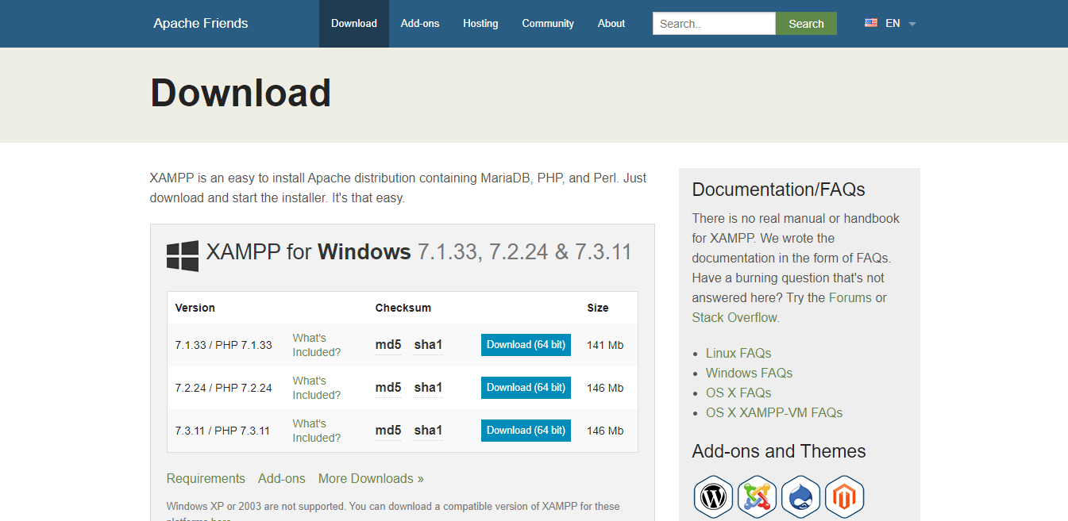

HOW TO GET STARTED:

* Copy the directory called “sms-dibapp-server” from DibApp project in “...\xampp\new\htdocs”
* Run XAMPP Control panel and click on Start button for Apache and MySQL

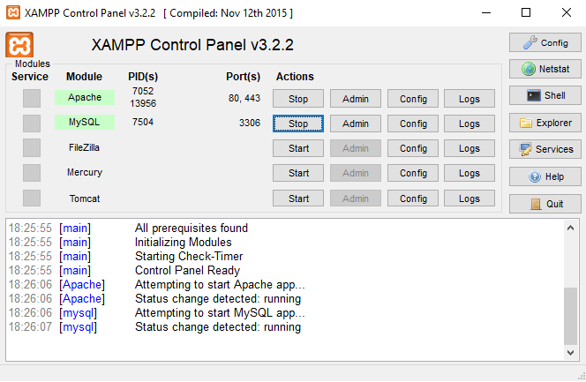

* Click Admin button in MySQL line and create a new DB called dibapp
* Import in the newly created DB “dibapp.sql” from “sms-dibapp-server” directory
* Get your internal ipv4 address (please use this guide <https://lifehacker.com/how-to-find-your-local-and-external-ip-address-5833108> )
* Set your internal ipv4 in AsyncTaskConnection on line 27 as shown in figure

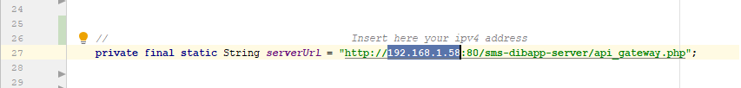

* Build and run DibApp using your Android emulator