E/R Schema

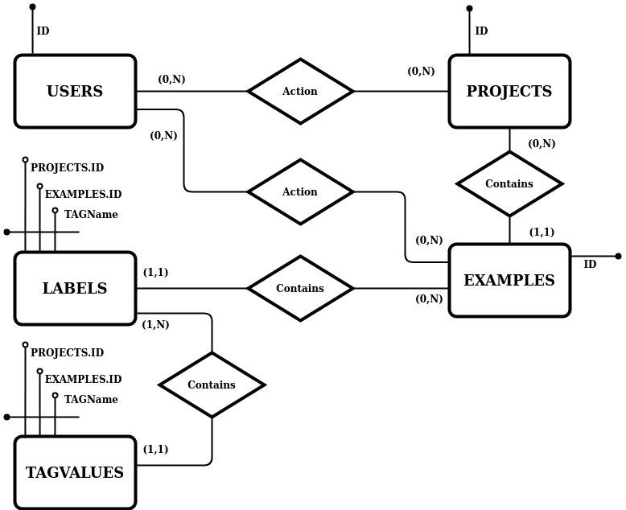

Logical Schema

USERS (ID, Nickname, Email, Password, RegistrationDate)

PROJECTS (ID, Title, InputType)

EXAMPLES (ID, PROJECTS.ID, InputType, InputValue)

LABELS (PROJECTS.ID, EXAMPLES.ID, TAGName)

TAGVALUES (PROJECTS.ID, EXAMPLES.ID, TAGName, TAGValue)

LOGS (ID, EXAMPLES.ID, PROJECTS.ID, USERS.ID, ActionType, Details, TimeStamp)

