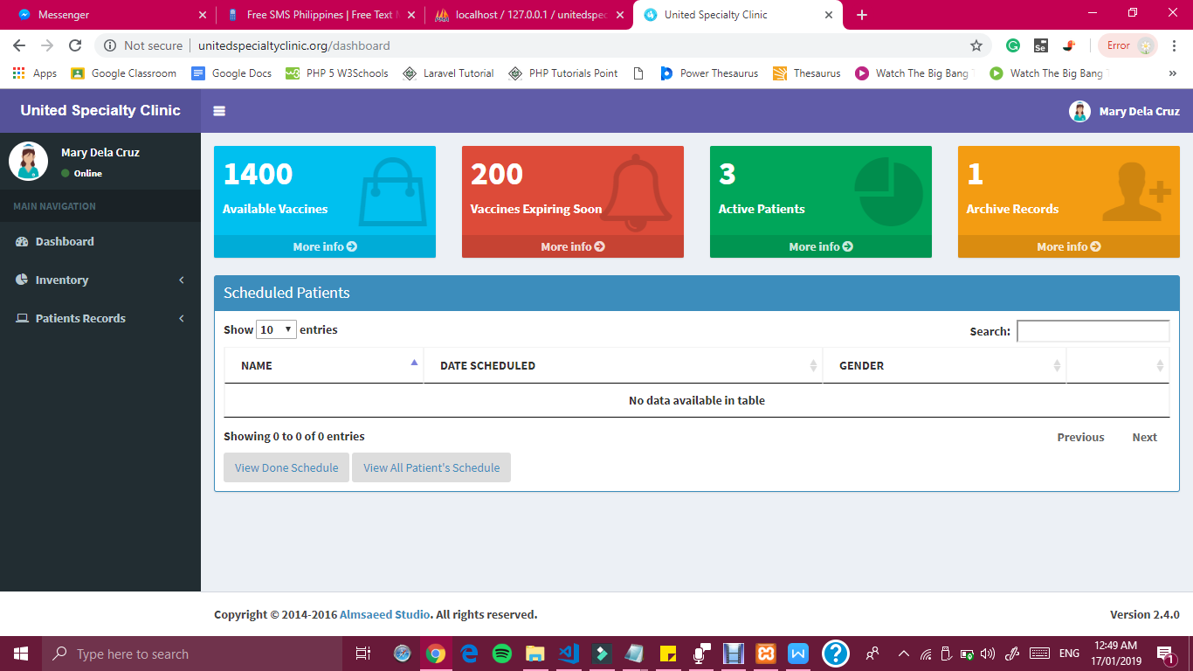

***Figure -- Dashboard Interface of United Specialty Clinic***

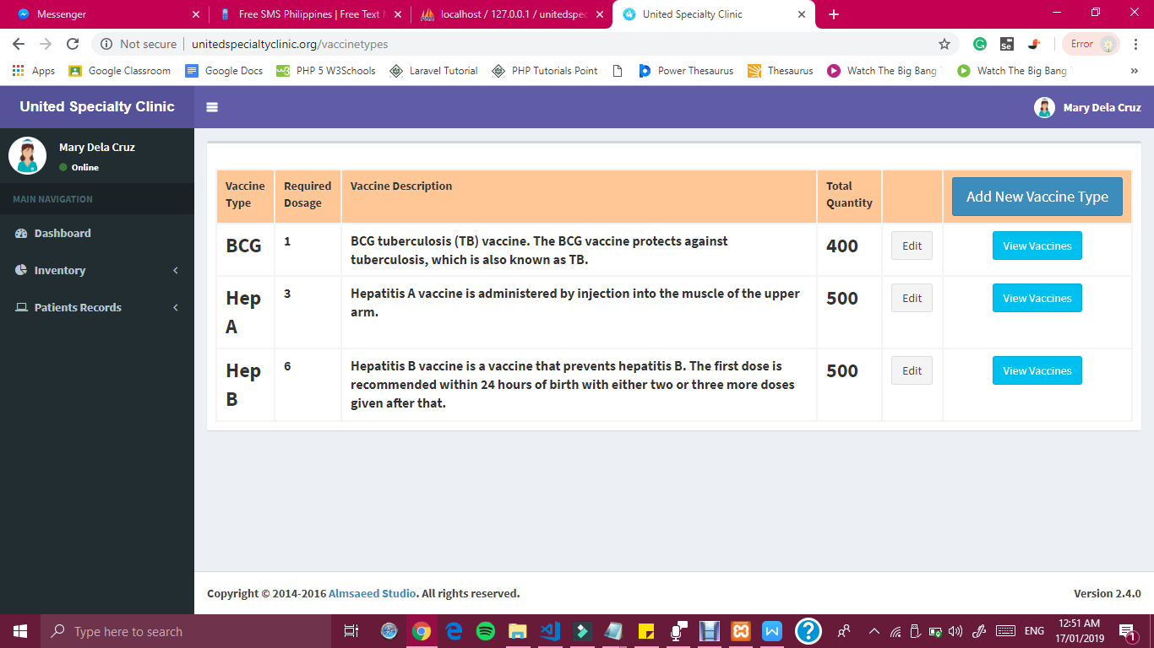

***Figure 21 Inventory Interface of United Specialty Clinic***

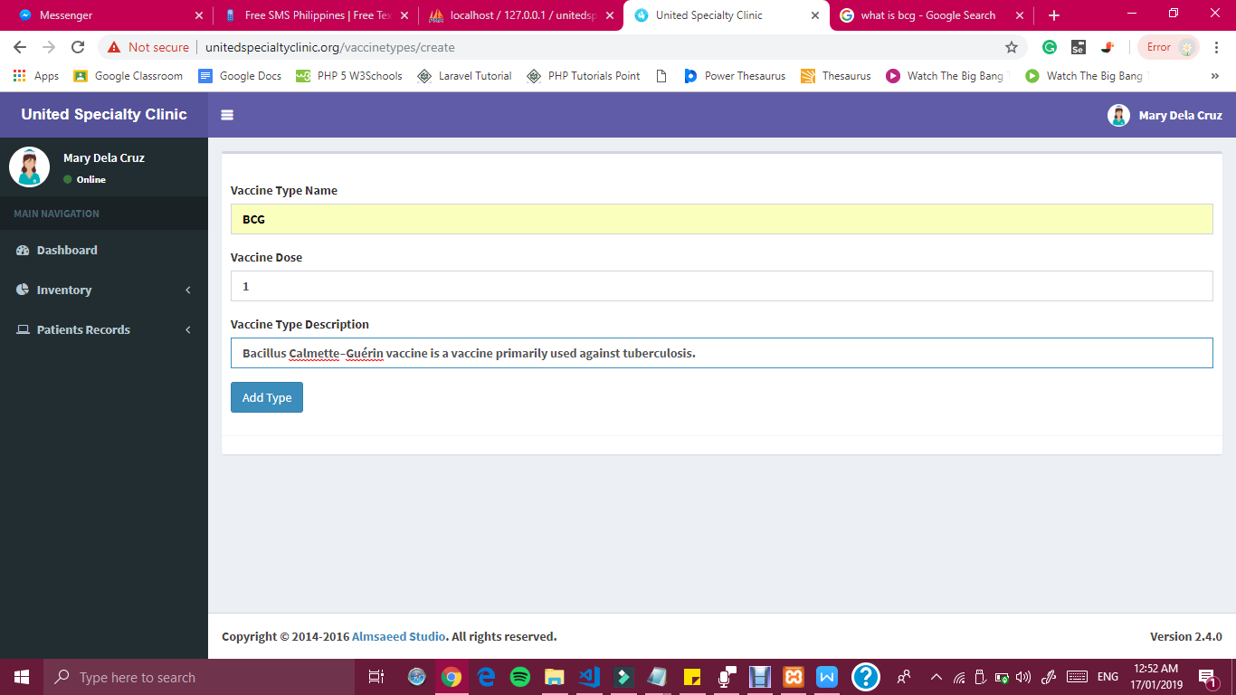

***Figure 22 Add New Vaccine Type Interface of United Specialty Clinic***

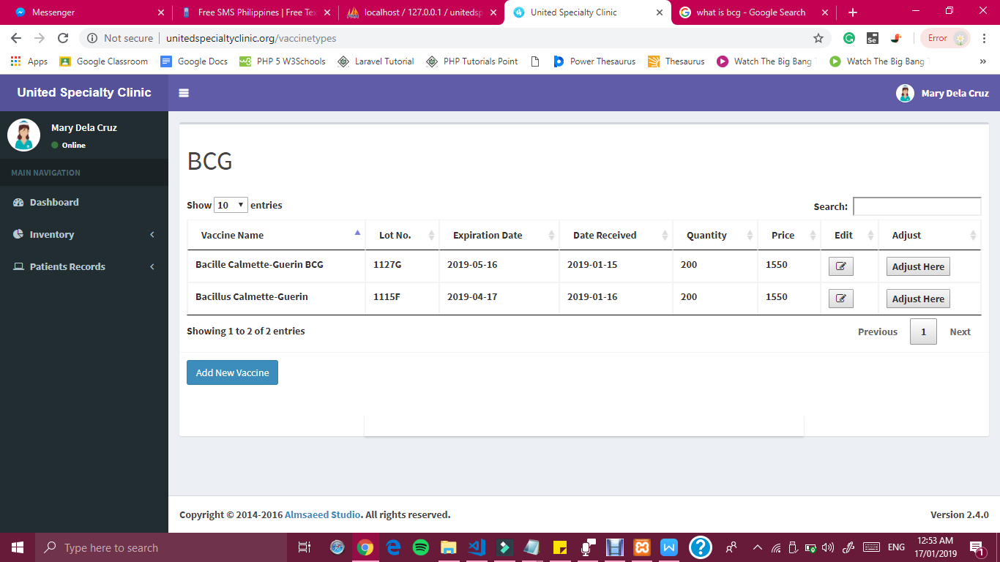

***Figure 23 VaccineType Interface of United Specialty Clinic***

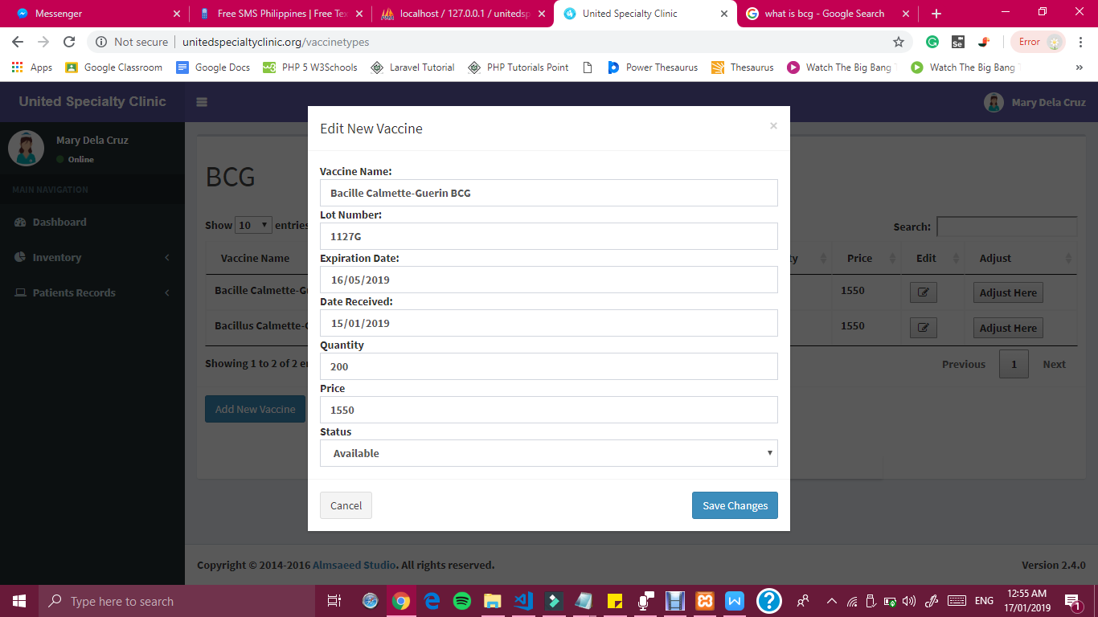

***Figure 24 Edit Vaccine Interface of United Specialty Clinic***

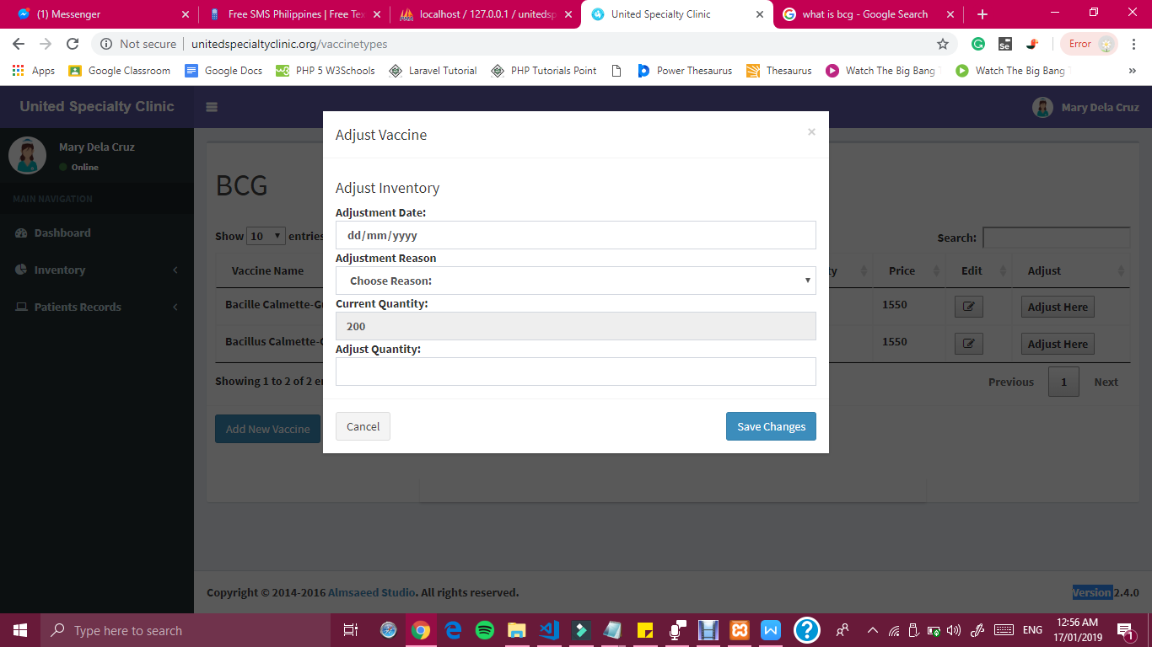

***Figure 25 Adjust Vaccine Interface of United Specialty Clinic***

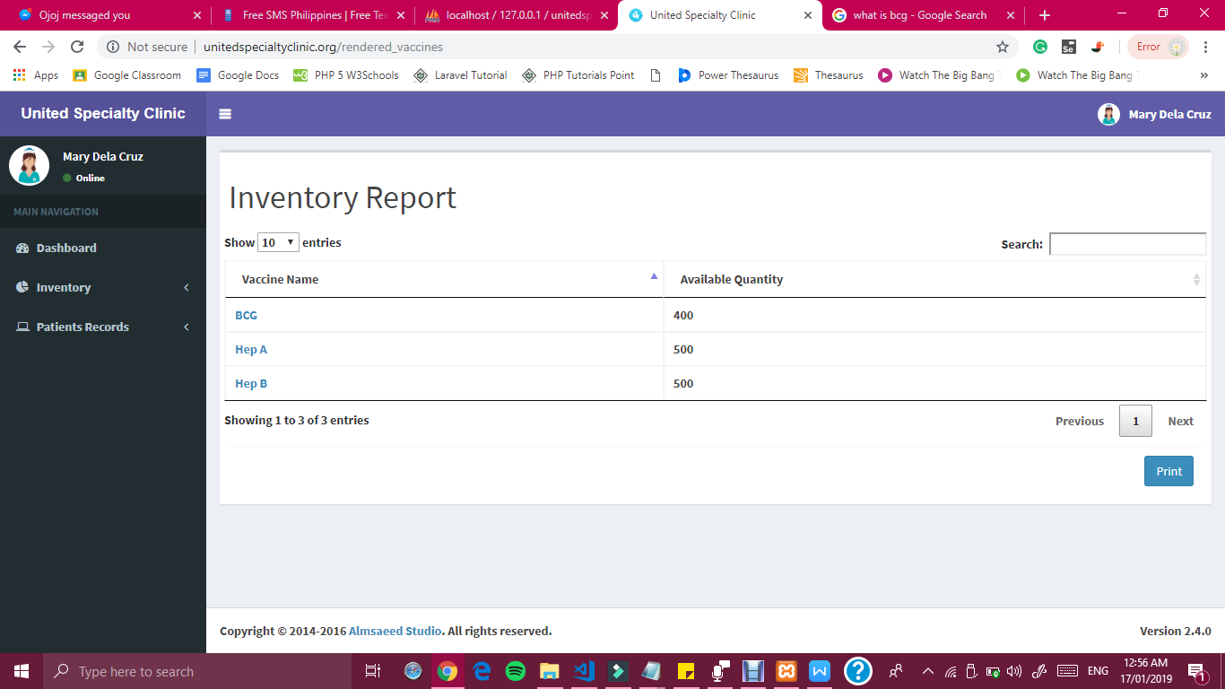

***Figure 26 Adjust Vaccine Interface of United Specialty Clinic***

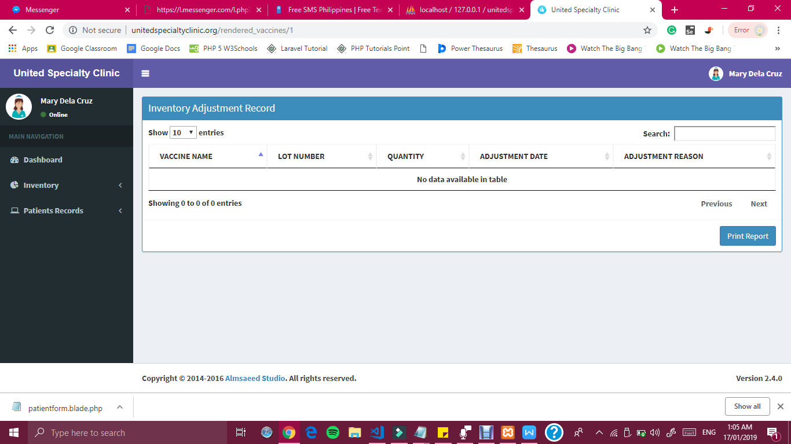

***Figure 27 Inventory Adjustment Record Interface of United Specialty Clinic***

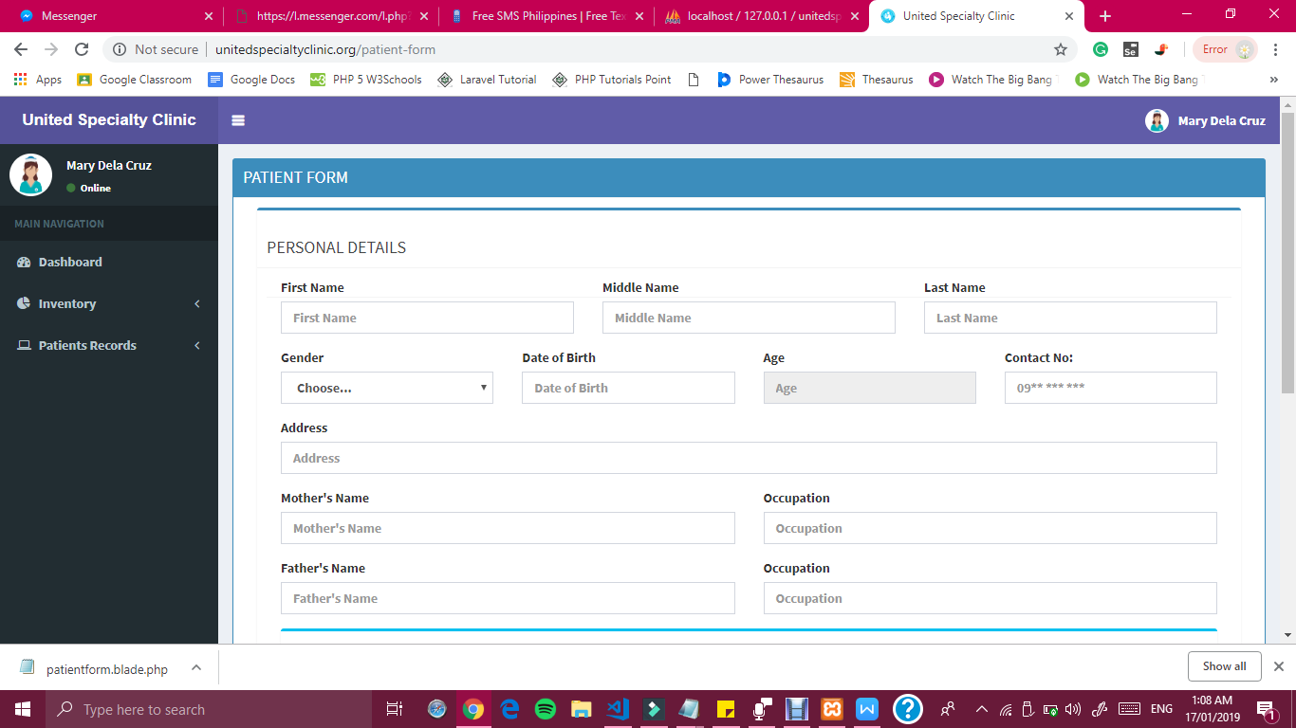

***Figure 28 Register New Patient Record Interface of United Specialty Clinic***

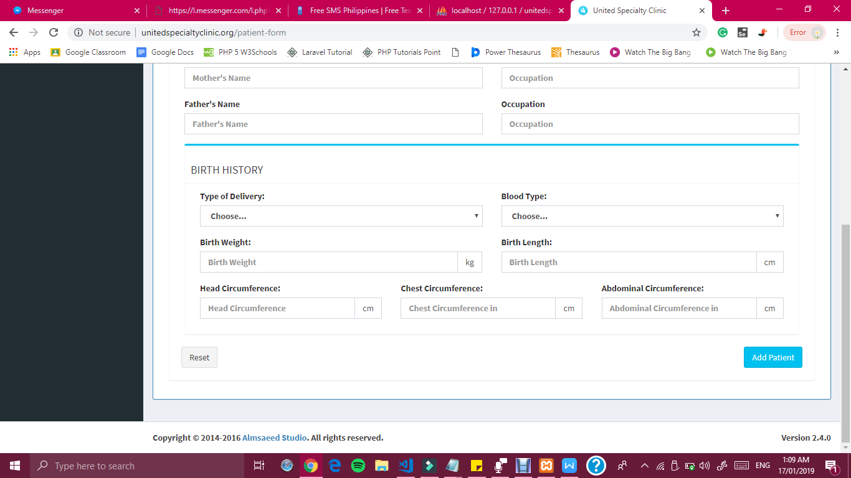

***Figure 29 Register New Patient Record Interface of United Specialty Clinic***

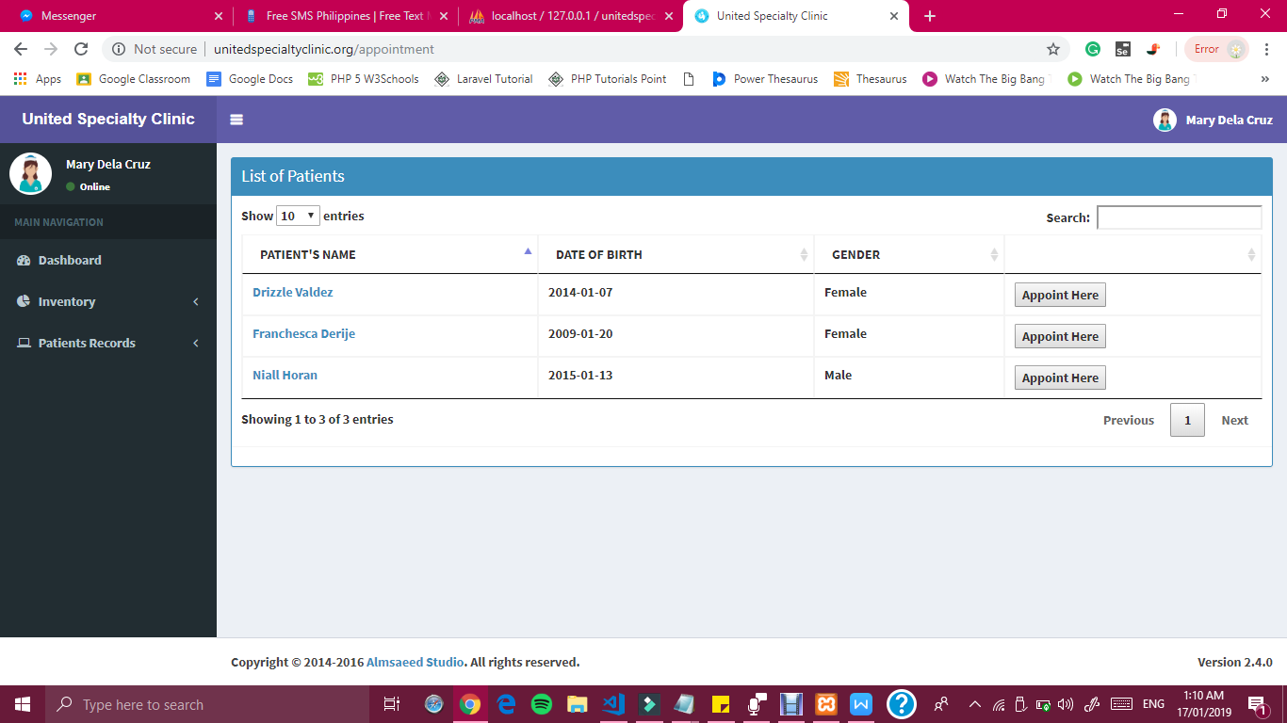

***Figure 30 List of Patient Records Interface of United Specialty Clinic***

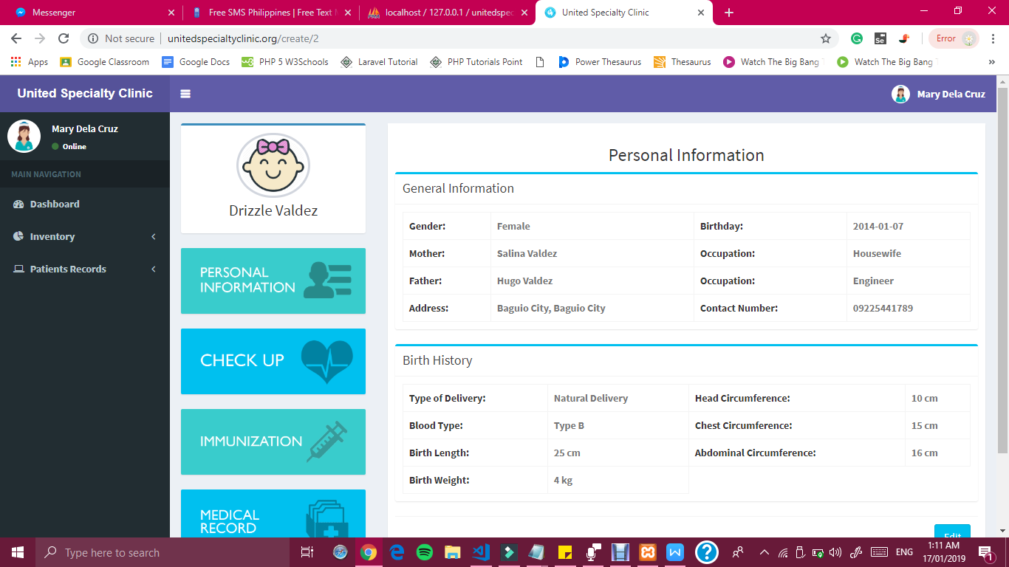

***Figure 31 Patient Profile Interface of United Specialty Clinic***

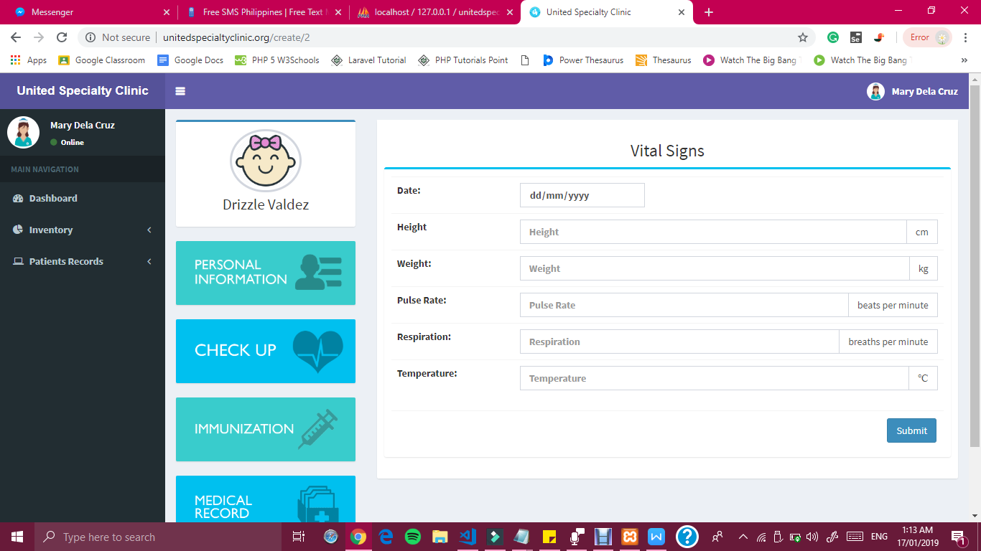

***Figure 32 Add Patient Vital Signs Interface of United Specialty Clinic***

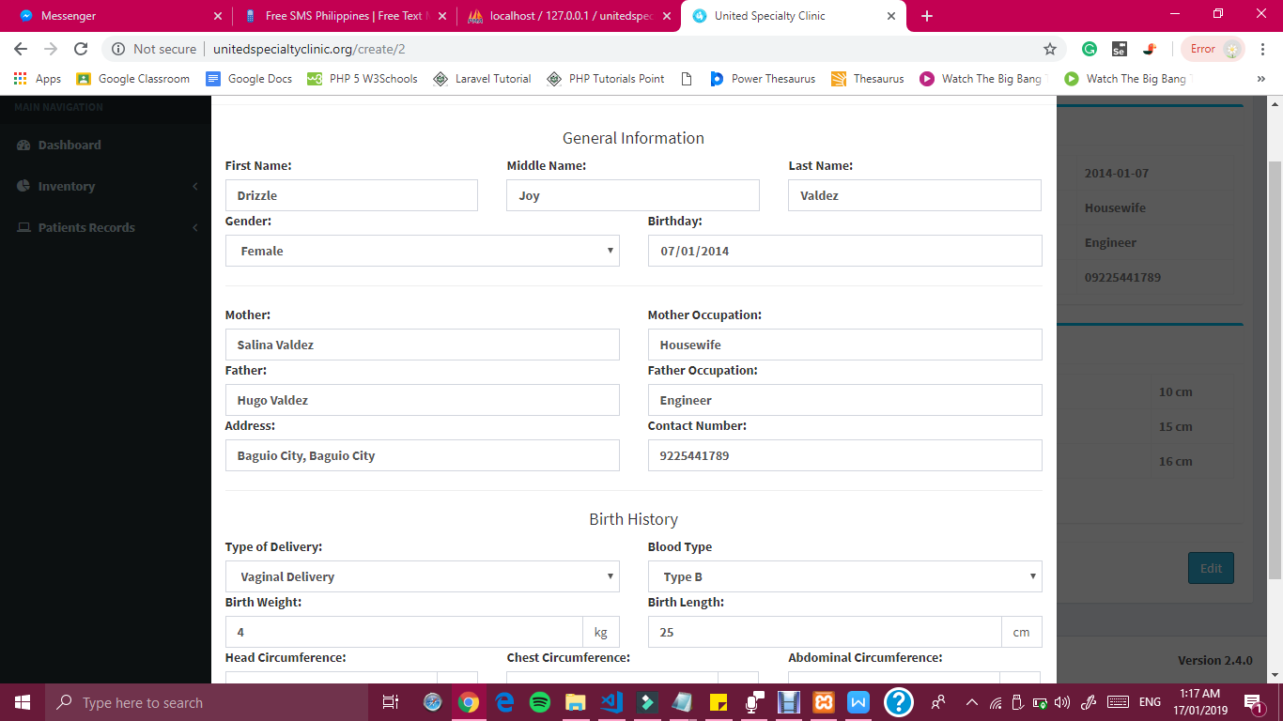

***Figure 33 Edit Patient Record Interface of United Specialty Clinic***

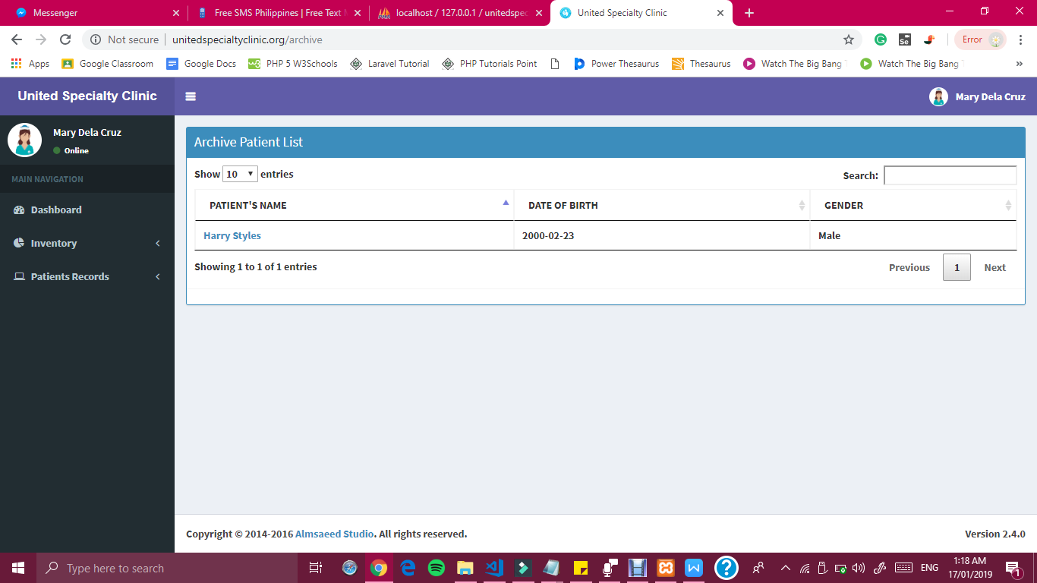

***Figure 34 Archive Patient Record List Interface of United Specialty Clinic***

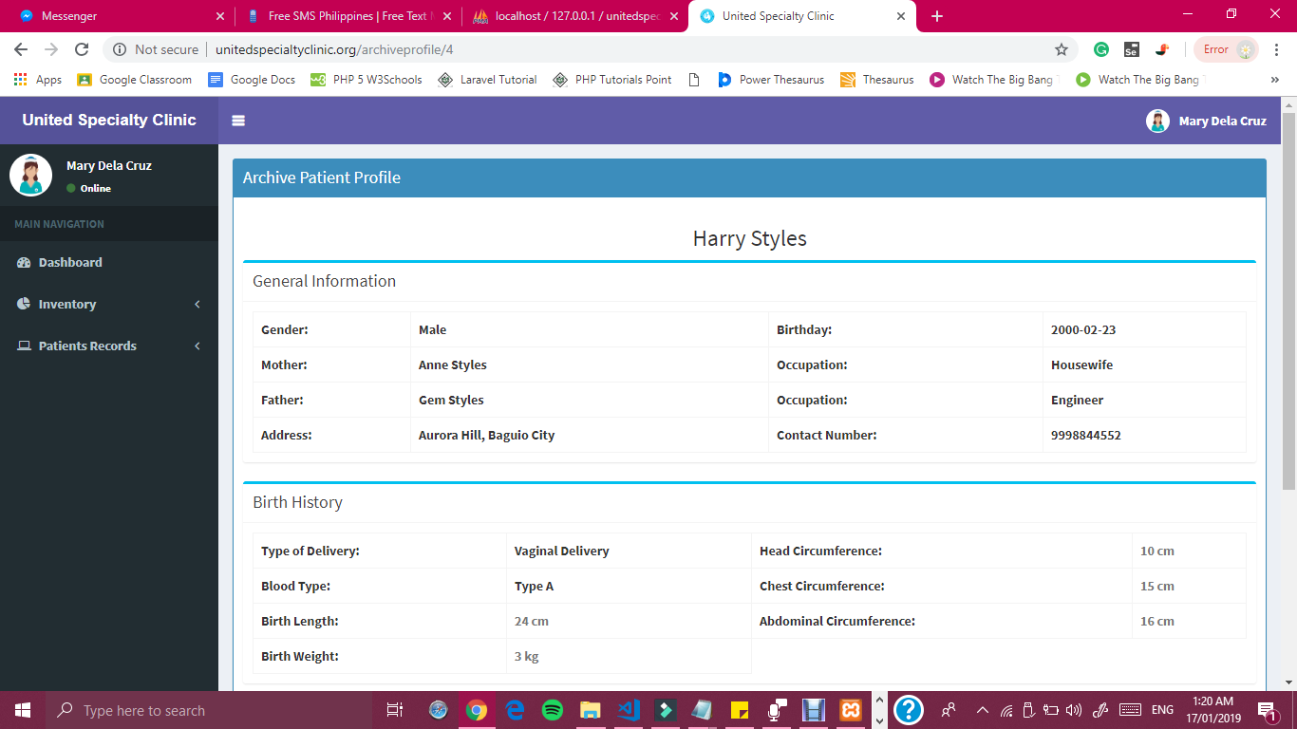

***Figure 35 Archive Patient Profile Interface of United Specialty Clinic***

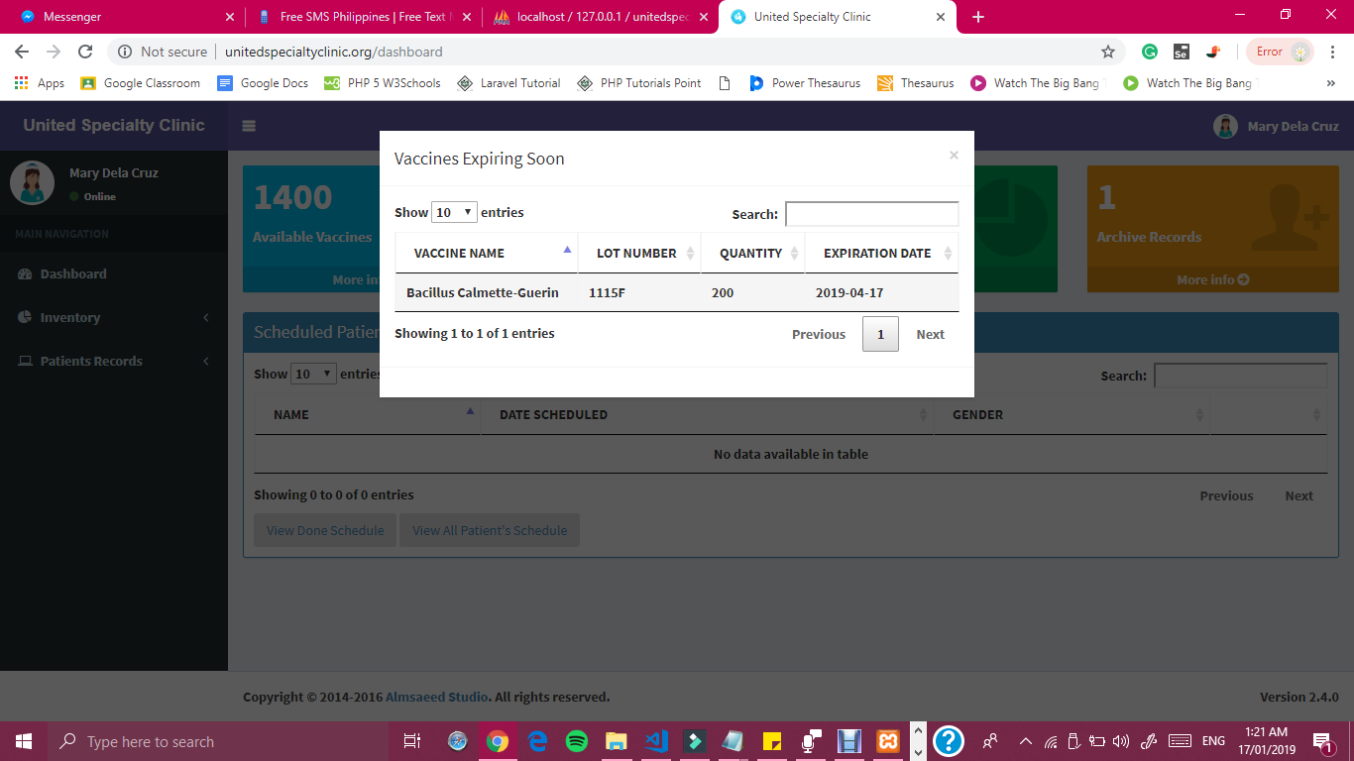

***Figure 36 List of Expiring Vaccine Interface of United Specialty Clinic***

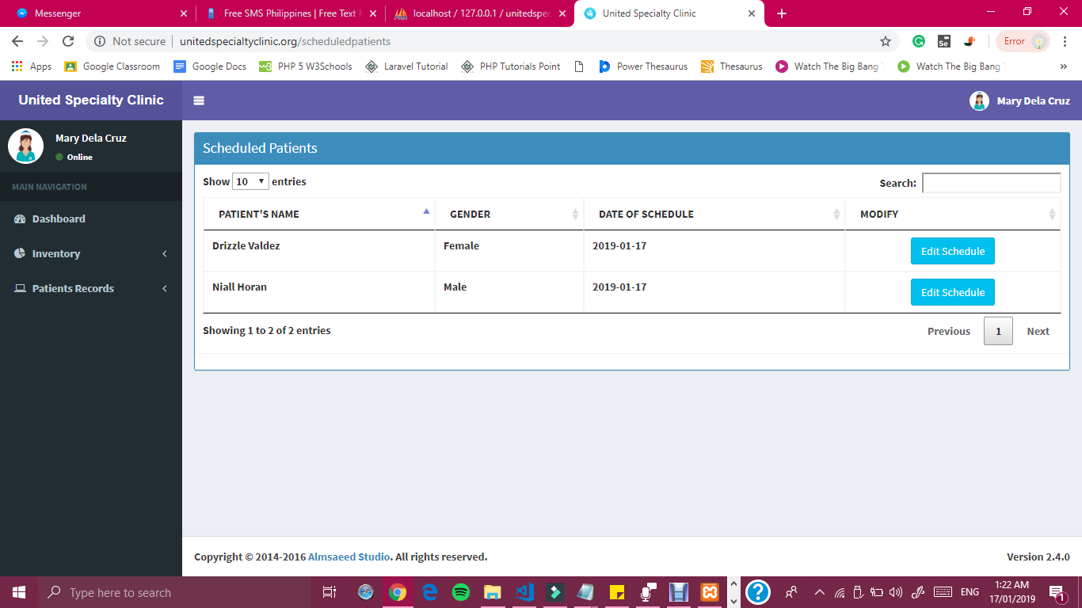

***Figure 37 List of Scheduled Patient Interface of United Specialty Clinic***

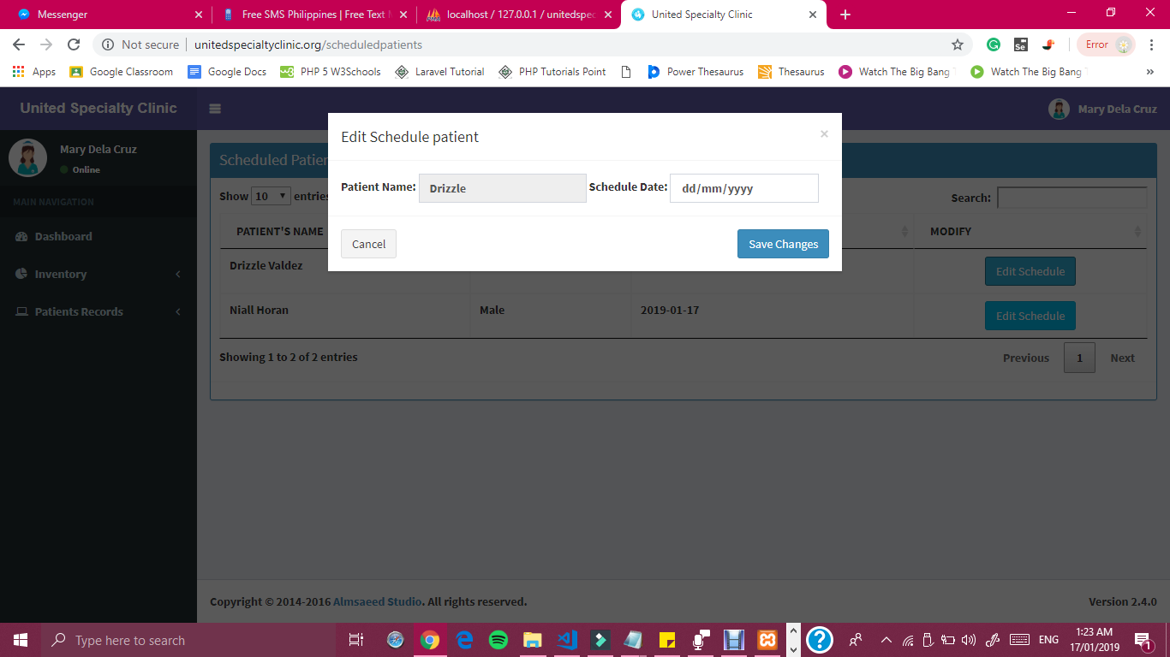

***Figure 38 List of Edit Patient’s Schedule Interface of United Specialty Clinic***

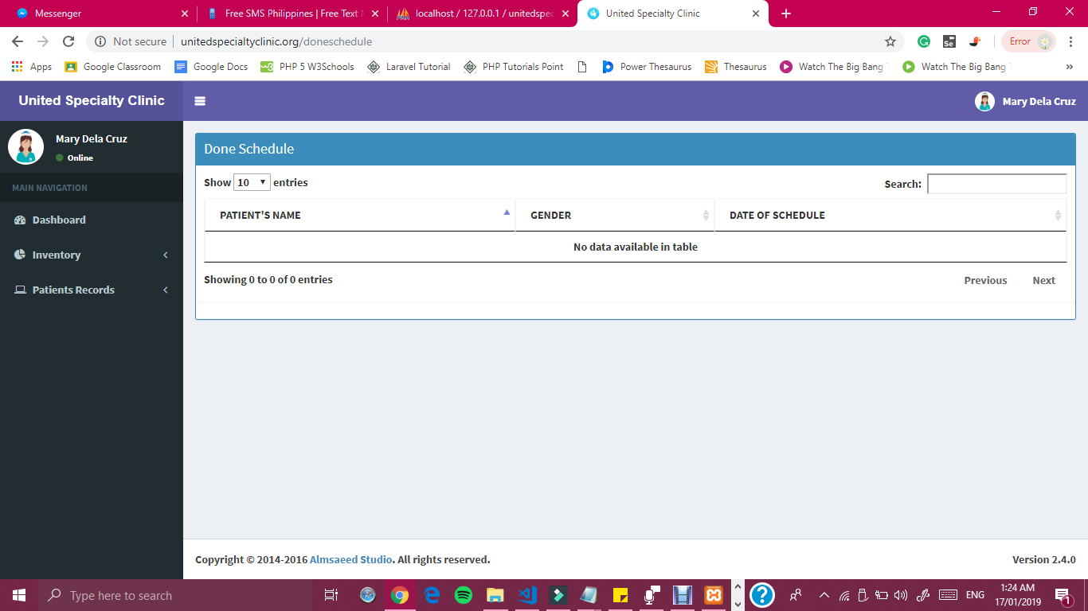

***Figure 39 List of Done Patient’s Schedule Interface of United Specialty Clinic***

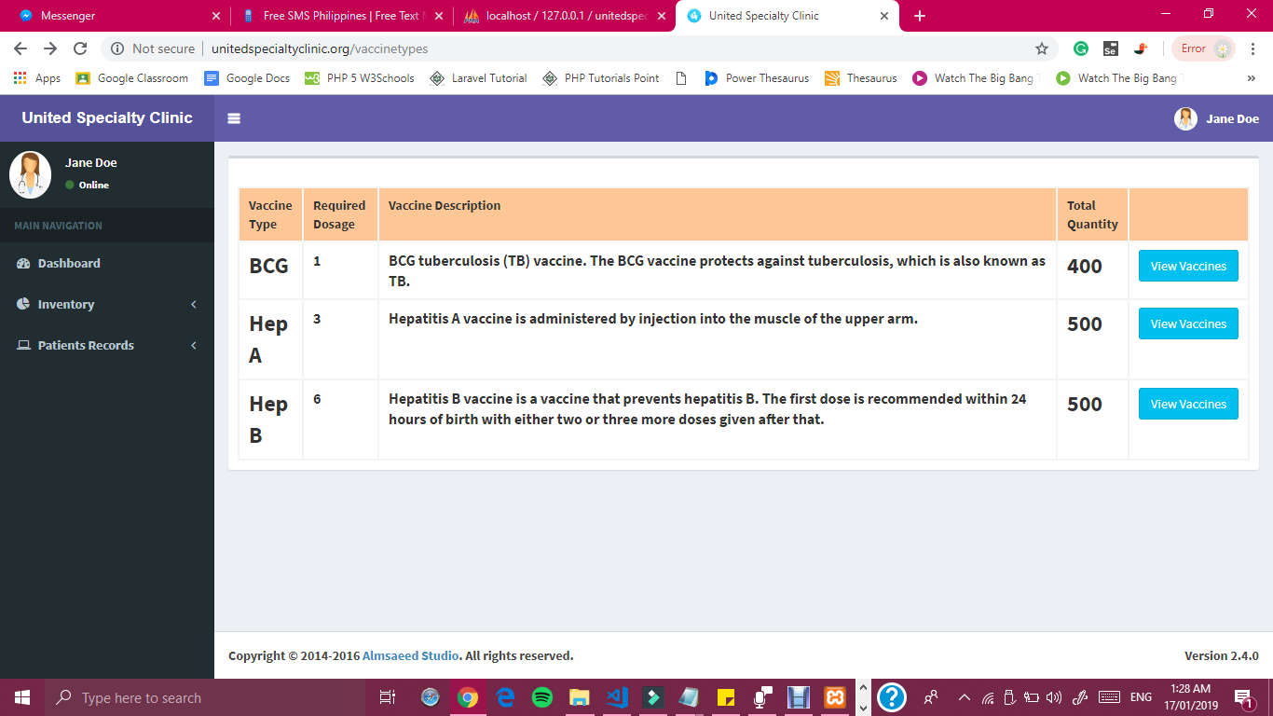

***Figure 40 Inventory Interface of the Doctor of United Specialty Clinic***

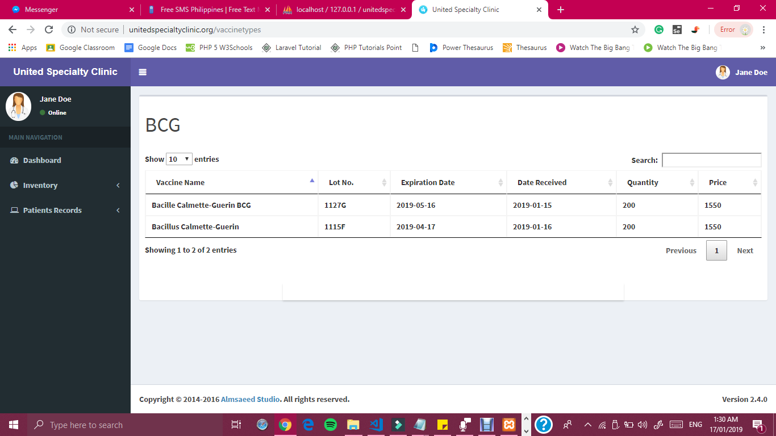

***Figure 41 Inventory Interface of the Doctor of United Specialty Clinic***

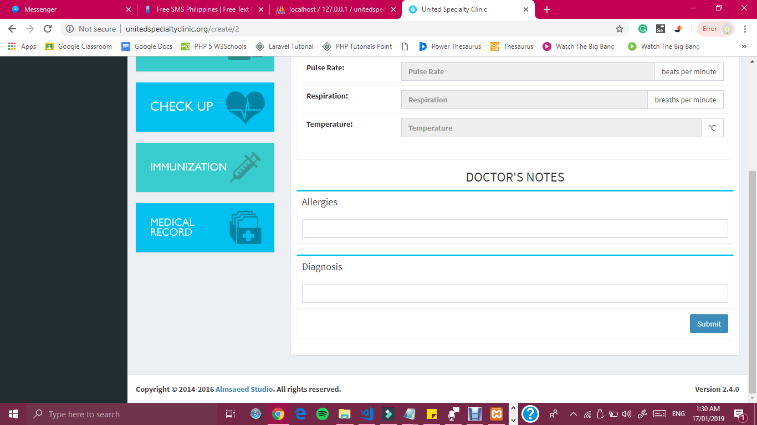

***Figure 42 Check Up Interface of the Doctor of United Specialty Clinic***

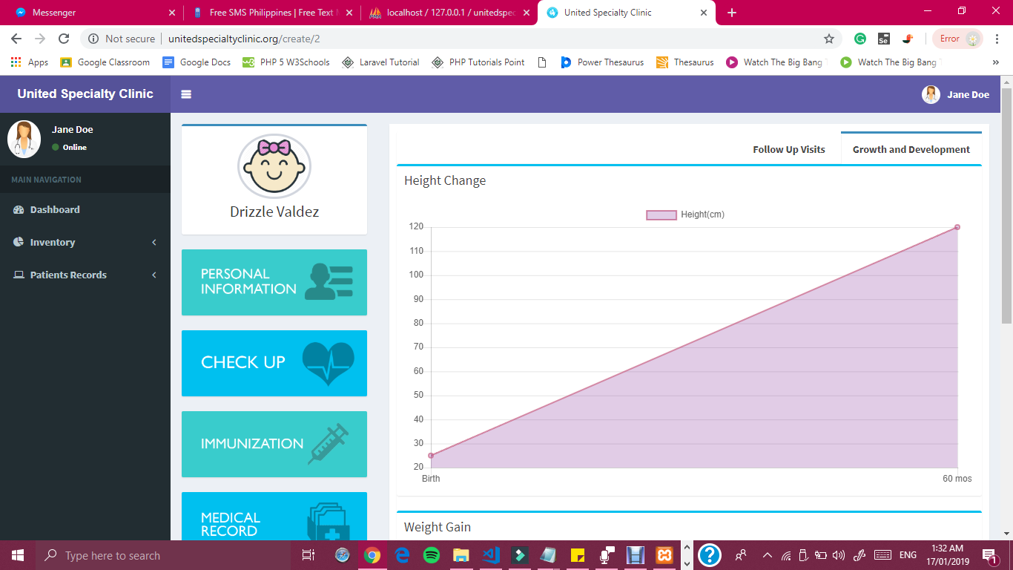

***Figure 43 Growth and Development Interface of the Doctor of United Specialty Clinic***

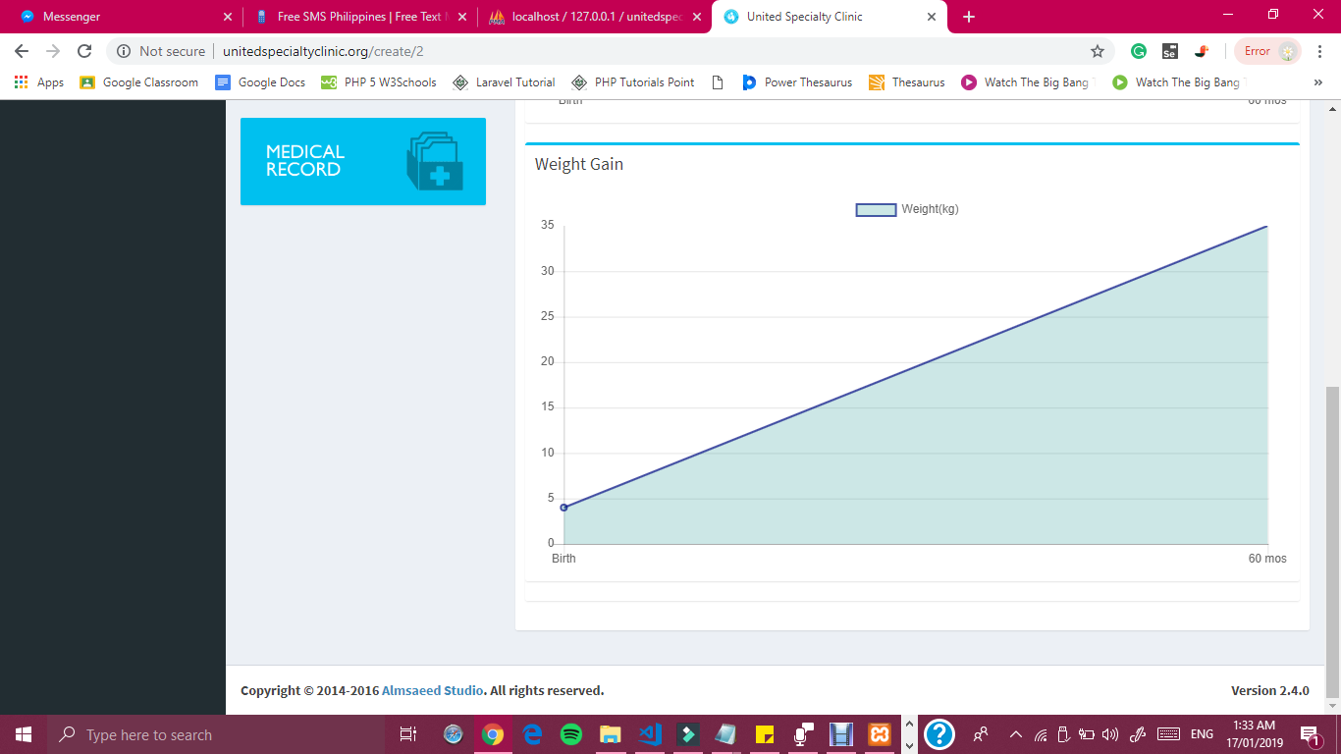

***Figure 44 Growth and Development Interface of the Doctor of United Specialty Clinic***

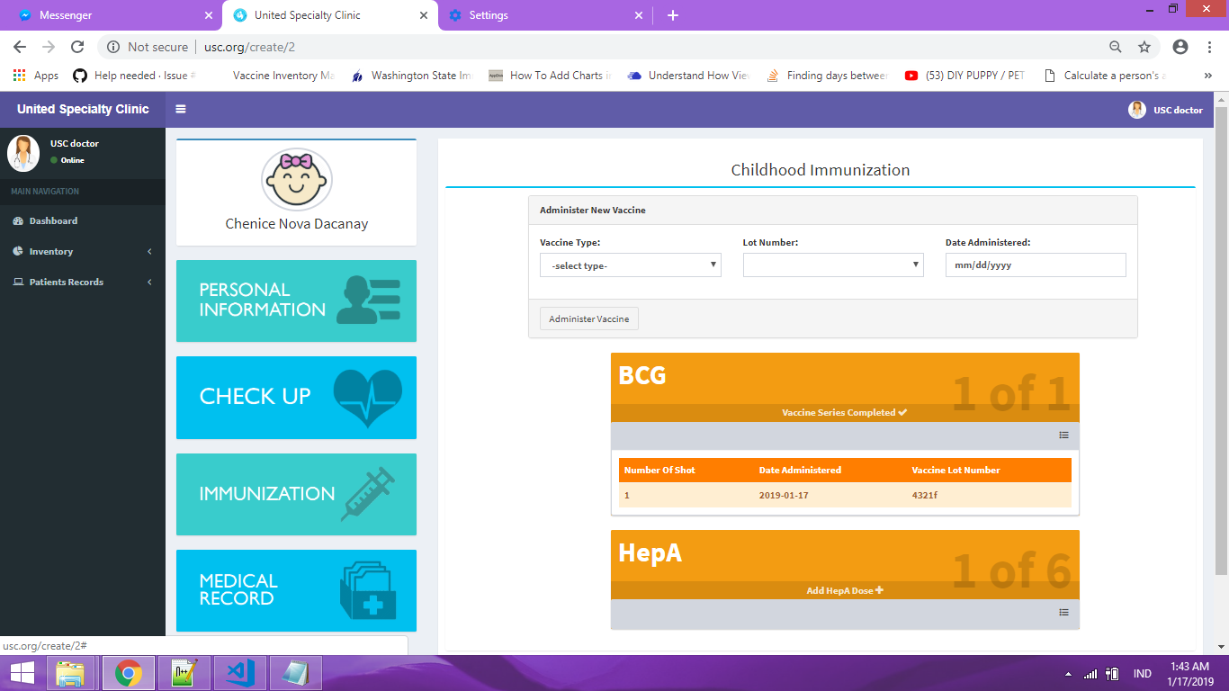

***Figure 45Childhood Immunization Interface of the Doctor of United Specialty Clinic***