BINARY ANNOTATION

# Goal of this interface :

The goal of this interface is to make a binary annotation (true or false) on a list of images according to a criteria the user choose (ex: dog or cat). These annotations will train a modeling which will show you images that should be annotated true by calculating the probability and send it to the user.

# Installation :

-clone the github repo

-open a command terminal

-change direction to ‘reactcode’ folder

-type ‘npm i’ to install all the modules

-then type ‘npm run build2’ to be sure that you have the last version of the frontend

-change direction to ‘backend’ folder

-type ‘bash launch.sh IP PORT BOOL PATH’ where IP and PORT are the address where you want to run the interface (ex: localhost and 8000). Then BOOL will determine if you want to launch the app with docker (true or false) and PATH is the path to the images you want to annotate.

When everything is done, open a browser and go to the address you decided in the last command and you will see the interface.

# Use

## 1st part: the informations

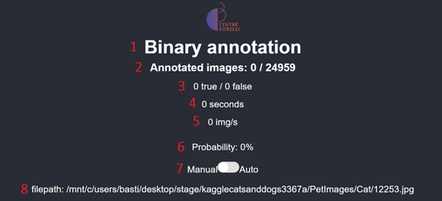

|  |  |
| --- | --- |
| 1 | Name of the application |
| 2 | Number of annotated images / total number of images to annotate |
| 3 | Number of true and false annotated images |
| 4 | Time spent since the beginning of the session |
| 5 | Speed of the annotation |
| 6 | Probability that the image is true |
| 7 | Button to switch between manual and auto mode |
| 8 | Name of the current image |

## 2nd part : the annotation

To annotate, there is 2 modes that are available: the manual mode and the automatic mode. The manual mode allows the user to choose the value (true or false) by pressing a key or a button. The automatic mode will annotate every X seconds (X is chosen by the user) false and if the user wants to annotate true, he has to press a key for each true images.

### Manual mode

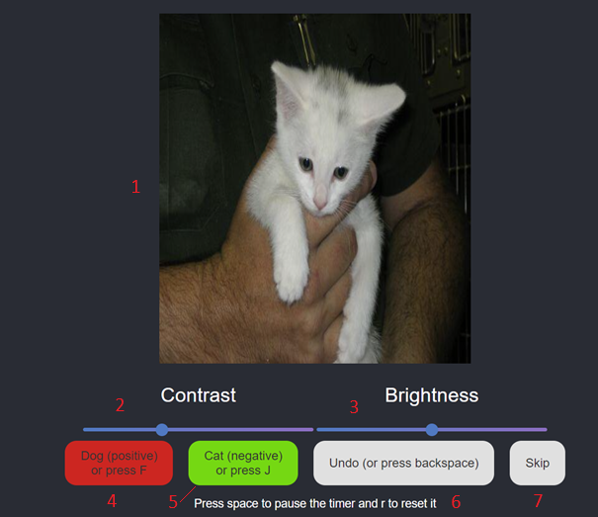

|  |  |
| --- | --- |
| 1 | Current image to annotate |
| 2 | Slider to change the contrast of the image (only visually) |
| 3 | Slider to change the brightness of the image (only visually) |
| 4 | Button to annotate true (or press F) |
| 5 | Button to annotate false (or press J) |
| 6 | Bouton to undo the annotation (or press return) |
| 7 | Button to skip an image |

The colors of the buttons depend of the probability. More the probability is high, more the color of the true button will be green.

Notate also that skip an image move it in a file named ‘skipped.pickle’ and remove it of the images to annotate.

### Automatic mode

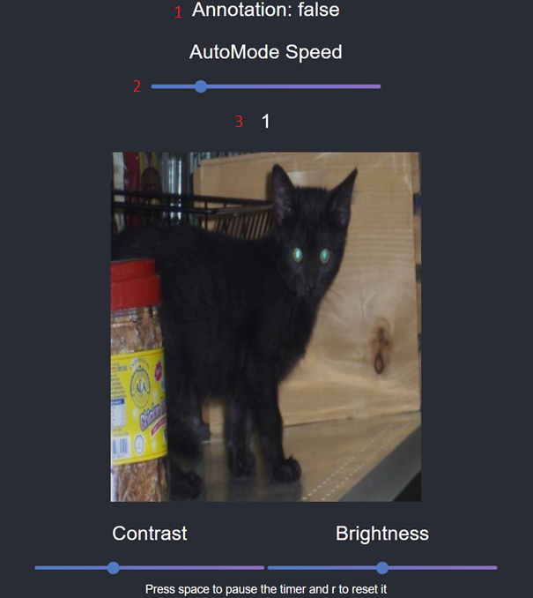

|  |  |
| --- | --- |
| 1 | Value of the automatic annotation |
| 2 | Slider to change the speed of the automatic annotation |
| 3 | Speed of the automatic annotation (in seconds) |

## 3rd part : the vizualisation of the modelling

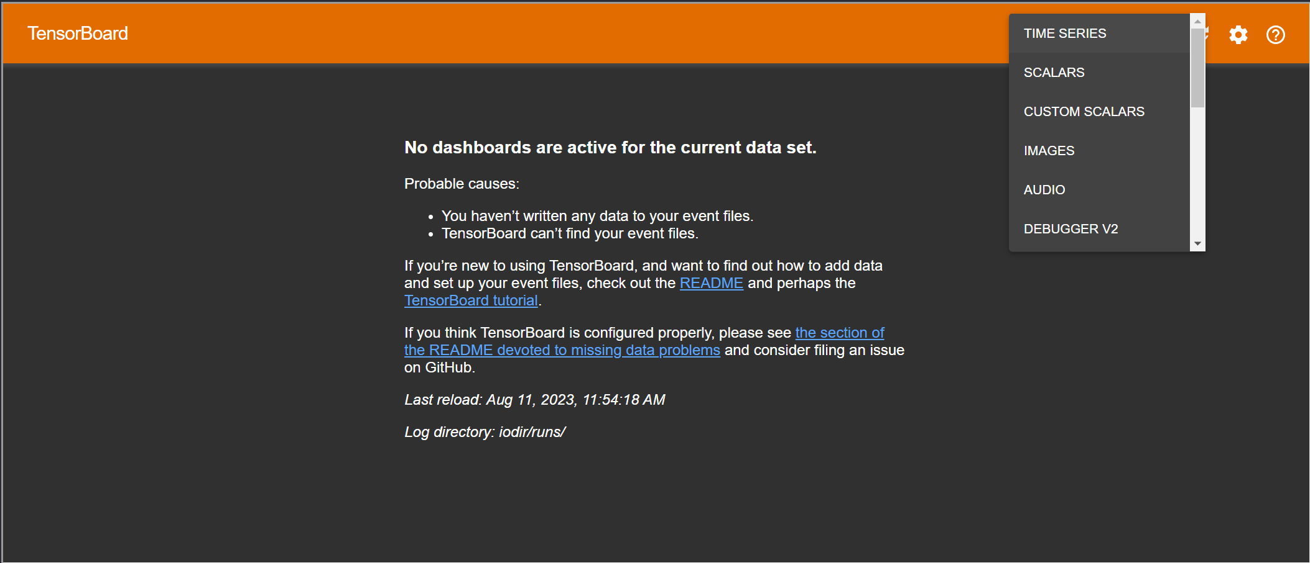

This last part is to visualize how the modelling is trained with all the annotations the user make. There is different types of the graphic, (the scalars is the best one???).