Lab14

Q1.

I do not have access to a Linux.

Q2.

A = a/20, b /15, c/5, d/15, e/45

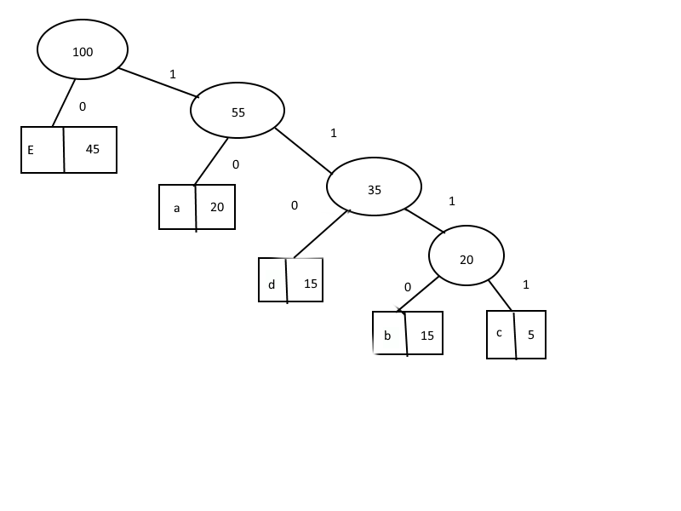

E – 0

A – 10

D – 110

B – 1110

C - 1111

Q3.

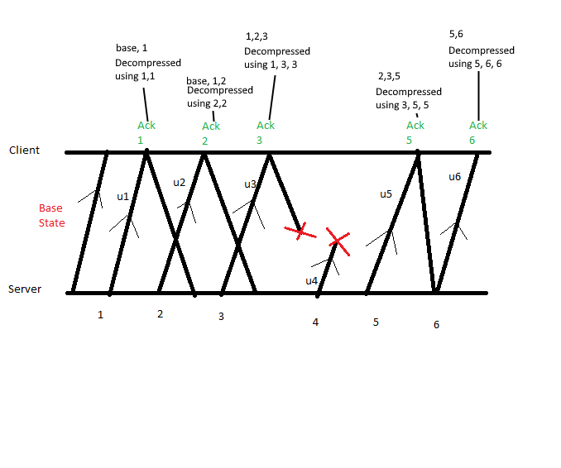

Q4.

String BABAABAAA

Code - 10560

Dictionary:

A – 0

B – 1

C – 2

D – 3

BA – 5

AB - 6

BAA – 7

ABA - 8

BAAA – 9

AA – 10

B – 1

BA not in dict

A – 0

AB not in dict

BA – 5

BAA not in dict

AB – 6

ABA not in dict

A – 0

AA not in dict