**Online Gaming**

# **Lab2**

## **IP Header**

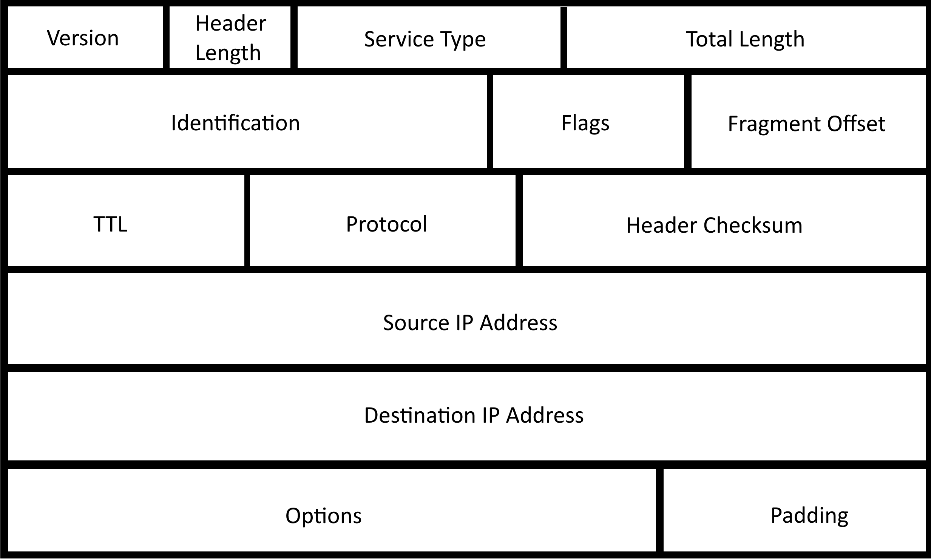

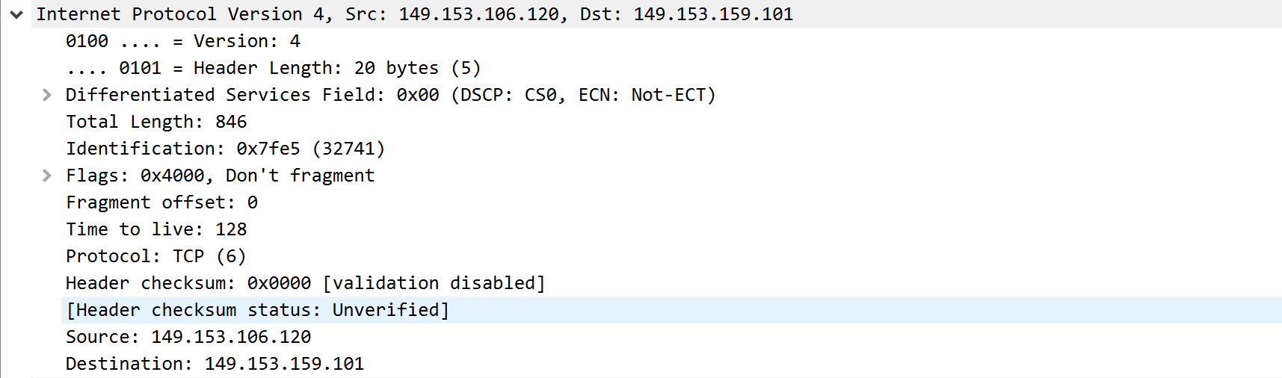

## **Explain packet fields**

* Time
  + Time took to retrieve and capture the packet.
  + Used to see the retrieval time.
* Source
  + The IP address from which the packet was sent.
  + Used to identify the source of the packet.
* Destination
  + The IP address that will receive the packet.
  + Used to identify where to send the packet.
* Protocol
  + The protocol is the set of rules that the IP address follows.
  + Used so that the packet can follow the protocol of the network.
* Length
  + The size of the packet.
* Info
  + Some information about the contents of the packet.

## **Difference between packets**

* Each packet is numbered.
* It uses protocols that differ from the packets I captured.
* The IP address that it uses are internal testing IP’s.
* It now has information for the fragment field.
* There is a server ping that requests to see if the server is active and the server reply’s with an answer to this request.

## **Technical/Design Highlights of Games.**

* 1. Dark Souls
* Creates a new technical system that is known and replicated for its difficult combat system.
  1. Genshin Impact
* The layout of the open world is very innovative and looks graphically amazing. As well as this it incorporates a ‘gatcha’ mechanic, for obtaining in-game items and characters, into an open world RPG game, which is relatively new based on the games scale. This seems like a very successful free to play model.
  1. The Witcher 3: The Wild Hunt
* Is extremely good in many ways. The main thing that it is know for is its amazing and large open-world, the quest system and combat with enemies.