Lab 5

1. TCP Header

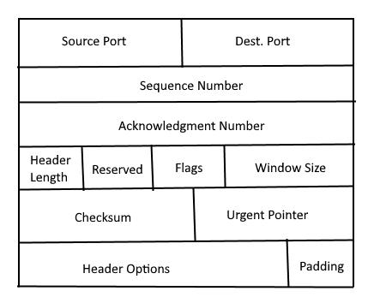

* 1. Source Port

Specifies the port number of the sending host

* 1. Destination Port

Specifies the port number of the receiving host

* 1. Sequence Number

Specifies the amount of data that is sent during a TCP session

* 1. Acknowledgment Number

Used by the receiver to request the next TCP segment

* 1. Header Length

Indicates the size of the TCP header

* 1. Reserved

This is the reserved field; this will always be zero

* 1. Flags

These are used for establishing and terminating connections between sending and receiving host

* 1. Window Size

Indicates the number of bits the receiver can receive

* 1. Checksum

This is used to check if the header has errors or not

* 1. Urgent Pointer

This bit is used to indicate where the urgent data in the packet ends

* 1. Header Options

This field Is optional and contains additional information about the TCP header

* 1. Padding

This field is composed of zeros. This is used to indicate that the packet is done

1. UDP Header

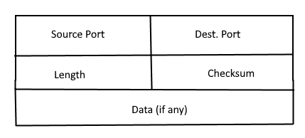

* 1. Source Port

This is the senders port number

* 1. Destination Port

This is the receiver port number

* 1. Length

This is the size of the header

* 1. Checksum

This is used to identify if there are errors in the header

* 1. Data (if any)

Optional field used for additional information

1. Checksum Number: e86a

Source IP 1

Source IP 2

=

Destination IP 1

=

Destination IP 2

=

Protocol

=

header length

=

Source Port

=

Destination Port

=

header checksum

=

flags

=

1. TCP is used in the streaming application. UDP would be used for the real time quick communication.
2. A three-way handshake is used to establish a reliable connection between host and end host.

Example of Three-way handshake

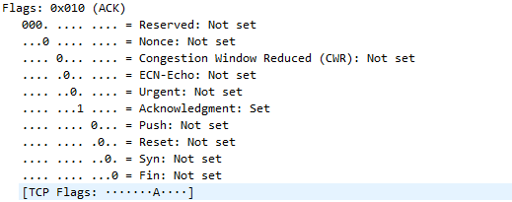

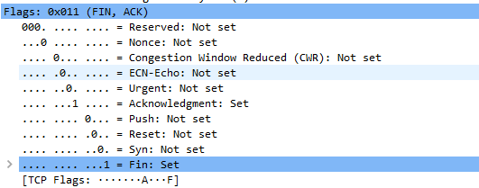



1. A TCP four-way teardown is termination of a connection made during a three-way handshake.