# Task 2 — Query Results

## MySQL Queries

### Query 1: Latest record
```sql
SELECT s.symbol, p.trade_date, p.close_price, p.volume
FROM price_history p
JOIN stocks s ON p.stock_id = s.stock_id
ORDER BY p.trade_date DESC
LIMIT 1;
```
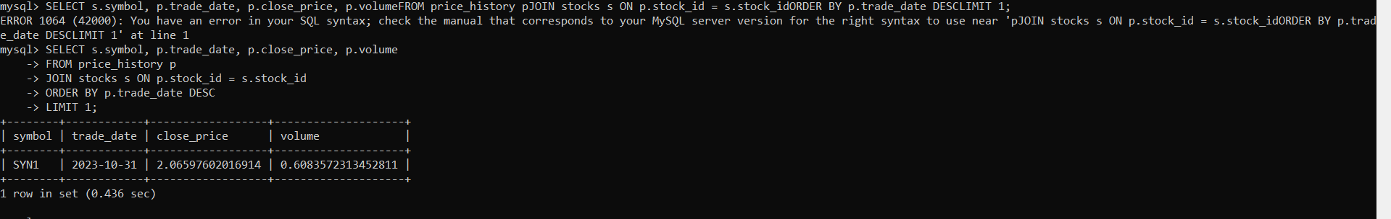

### Query 2: Records by date range
```sql
SELECT p.trade_date, p.open_price, p.close_price, t.rsi, t.macd
FROM price_history p
JOIN technical_indicators t ON p.price_id = t.price_id
WHERE p.trade_date BETWEEN '2020-06-01' AND '2020-06-30'
ORDER BY p.trade_date;
```
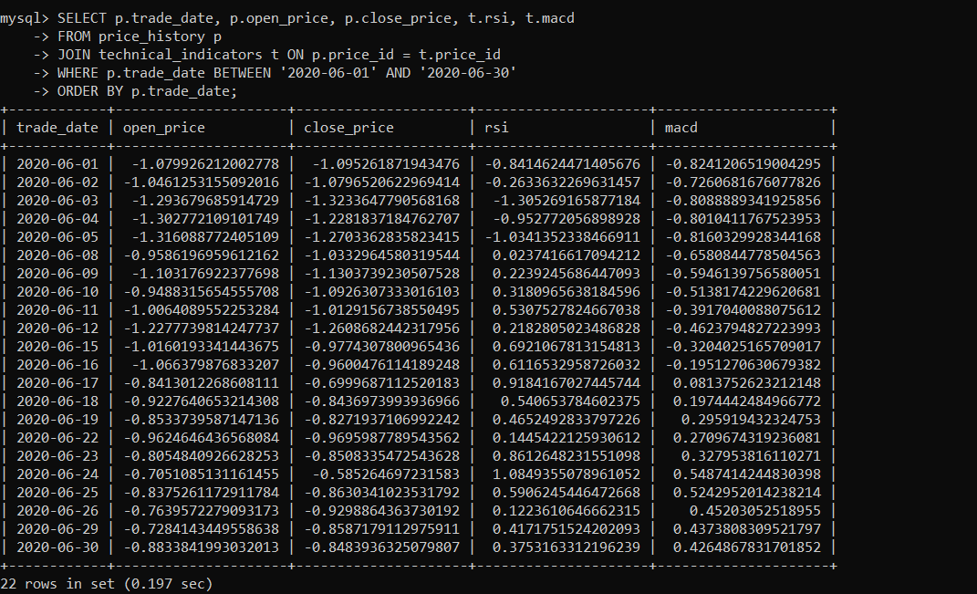

### Query 3: Price and sentiment join
```sql
SELECT p.trade_date, p.close_price, n.sentiment_label, n.sentiment_score
FROM price_history p
JOIN news_sentiment n ON p.price_id = n.price_id
WHERE n.sentiment_label = 'positive'
ORDER BY p.trade_date
LIMIT 20;
```
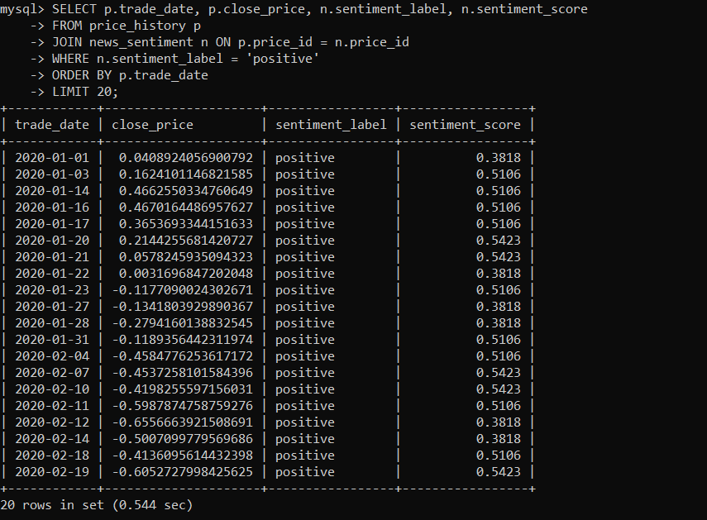

---

## MongoDB Queries

### Query 1: Latest record
```javascript
db.stock_records.find().sort({date: -1}).limit(1)
```
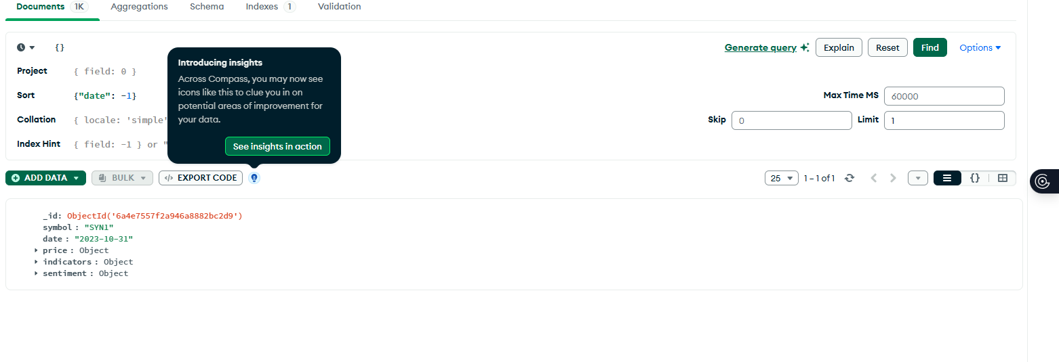

### Query 2: Records by date range
```javascript
db.stock_records.find({
date: { $gte: "2020-06-01", $lte: "2020-06-30" }
})
```
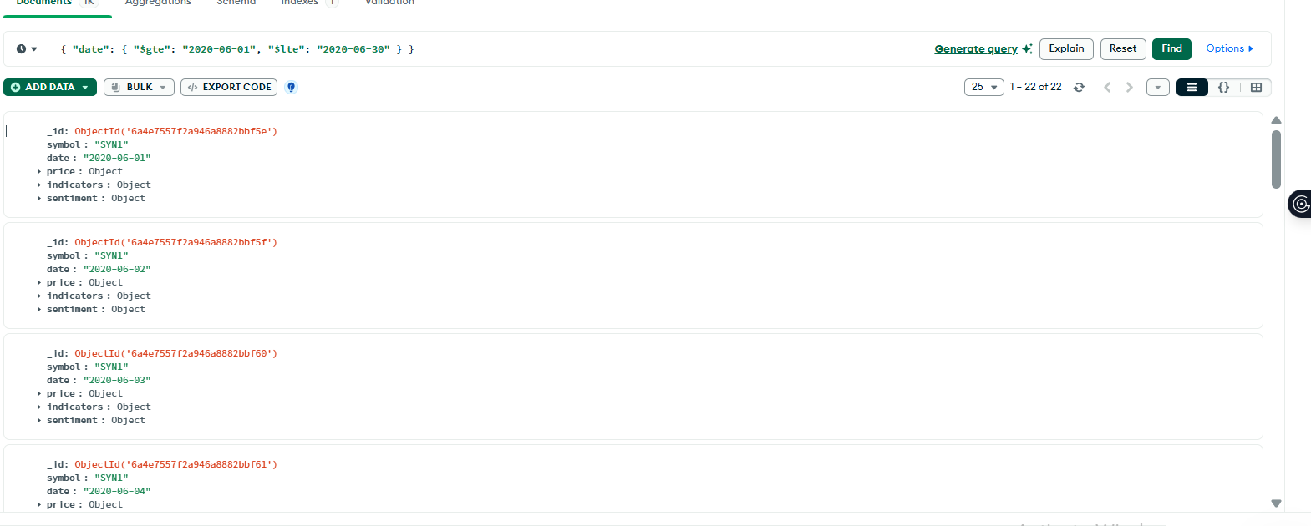

### Query 3: Average close price on positive-sentiment days
```javascript
db.stock_records.aggregate([
{ $match: { "sentiment.label": "positive" } },
{ $group: { _id: "$sentiment.label", avg_close: { $avg: "$price.close" }, count: { $sum: 1 } } }
])
```
