Temperature Monitoring System High-Level Design (HLD)
Version: 1.0
Date: 02-01-2026
Prepared by: Francis V D, Trenser Technology Solutions

1. Purpose
The document provides a high-level design overview for a temperature monitoring system. The temperature monitoring system will read the temperature every p second and store it in a shared memory. Then it will compare it with a predefined temperature threshold level of t. An alarm will be activated for n second if the measured temperature exceeds the threshold level, otherwise no action will be taken.
This design document provides a traceability to the system requirements and provides a foundation for the detailed low-level design.

2. System Overview
The system monitors the temperature in every p second and activates an alarm for n second if the measured temperature exceeds a predefined threshold level otherwise no action will be taken.
Key components in the system are :
- Sensor module
The sensor module will read the output from sensor and convert it to the proper output format based on the conversion rules of the sensor. But as of now as we are designing the sensor module to return a random value with in the range of sensor output level Rmin and Rmax.

- Temperature monitoring module
The module will read the sensor data in every p second and then save the data in a shared memory

- Alarm manager module
The module will read the current temperature value from the shared memory and then compares it with a predefined threshold level t. An alarm will be activated for n seconds if the measured temperature is above the threshold level. Otherwise, no action will be taken.

High-level architecture diagram

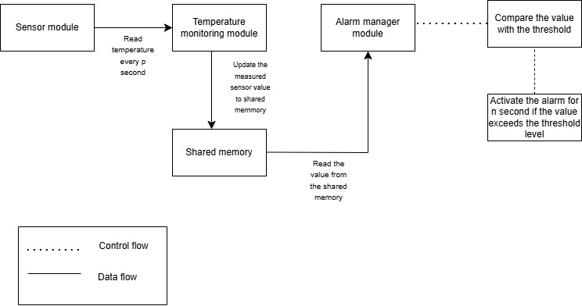

3. Software Architecture
The system implementation consists of three major modules such as sensor, temperature monitoring and alarm manager modules.
- Sensor module:
Sensor module reads the output value from the sensor. In case if sensor is not available the output is generated by using random number generation with limits from Rmin to Rmax.
Data flow: Function call from temperature monitoring to the sensor module will return the measured temperature. In case if sensor is not available the output is generated by using random number generation with limits from Rmin to Rmax.

Control flow: The temperature monitoring will poll the sensor value in every p second

- Temperature monitoring: The temperature monitoring module will poll the temperature from sensor module every p second and update the value in a shared memory.

Data flow: The value returned from the sensor module while calling the function to read the temperature will be stored in a shared memory.
Control flow: The temperature monitoring module will poll the sensor data in every p second.

- Alarm management module: The alarm management module will read the updated temperature value from the shared memory, then compare it with the threshold value t. If the measured temperature is greater than the threshold level, then the alarm will be activated for n seconds. Otherwise, no action will be taken.

Data flow: The alarm management module will read the temperature value by reading the shared memory which is being updated by the temperature monitoring module.

Control flow: The alarm management module will compare the temperature value read from the shared memory with the predefined threshold level of t. If the measured temperature is greater than the threshold level, then the alarm will be activated for n seconds. Otherwise, no action will be taken.

- Interactions between the modules :
The temperature monitoring module will read the temperature with a polling frequency (p) of p seconds by making a corresponding function call to the sensor module. The sensor module will return the current temperature and the temperature monitoring module then save that value into a shared memory.

The alarm manager module reads the temperature value updated by the temperature monitoring module by reading the shared memory. Then it compares the temperature value with the threshold value t. If the measured temperature is greater than the threshold level, then the alarm will be activated for n seconds. Otherwise, no action will be taken.
Sensor module: Handles communication with the temperature sensor.
Temperature management module: Read the temperature value in every p second and update the value to the shared memory.
Alarm manager module : Access the temperature value by reading the shared memory then compare it with the threshold level and activate an alarm for n second if and only if the temperature exceeds the threshold level.

4. Module Descriptions
- Sensor module: Reads temperature values from hardware
- Temperature monitoring module: The module will read the temperature in every p second. The expected temperature output is with the range of 0 (Rmin) to 100 (Rmax).
- Alarm manager module: The module will compare the measured temperature which will be the output of Temperature monitoring module and then compare it with the threshold level (t). And then activate an alarm for n (alarm on time) seconds if the measured temperature exceeds the threshold.
Key interfaces:

  - Sensor module : API to read temperature value
uint32 sensorReadTemperature (void);

  - Temperature monitoring module: API to create thread to poll temperature every p second and update the value to the shared memory.
bool temperatureMonitoringThreadCreate (void);

Alarm manager module: API to read the temperature value from shared memory and do the comparison with threshold level t and to activate the alarm accordingly.
bool alarmManagerThreadCreate (void);

5. Interface Design
Note: Type definitions used in this project
Type | Type Definitions
unsigned char | uint8
unsigned short | uint16
unsigned long | uint32
signed char | int8
signed short | int16
signed long | int32

- Sensor API:
uint32 sensorReadTemperature (void)
It will return the measured temperature
- Temperature Monitoring API:
bool temperatureMonitoringThreadCreate (void)
It will create a thread which will read the temperature and save it in a shared memory every p second. It would return true if thread created successfully else returned false.
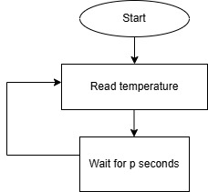
- Alarm Manager API:
bool alarmManagerThreadCreate (void);
It will create a thread which will read the temperature value from the shared memory. The value read is then compared with threshold and trigger the alarm if condition met. It would return true if thread created successfully else returned false.

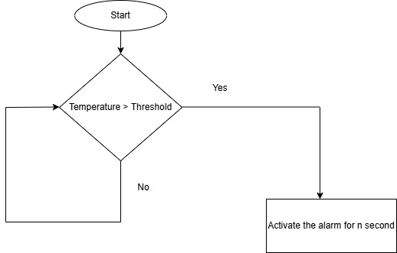

6. Data Flow
The temperature reading is measured continuously with a polling frequency (p) of p seconds. If the temperature exceeds the threshold level (t) then an alarm will be turned on for a duration of n seconds.
Logical Data Flow:
- Sensor module reads temperature.
- Temperature monitoring module reads the temperature every p seconds and saves it in shared memory.
- Alarm manager reads the temperature from the shared memory and then compares it to the threshold and activate an alarm for n second if condition met

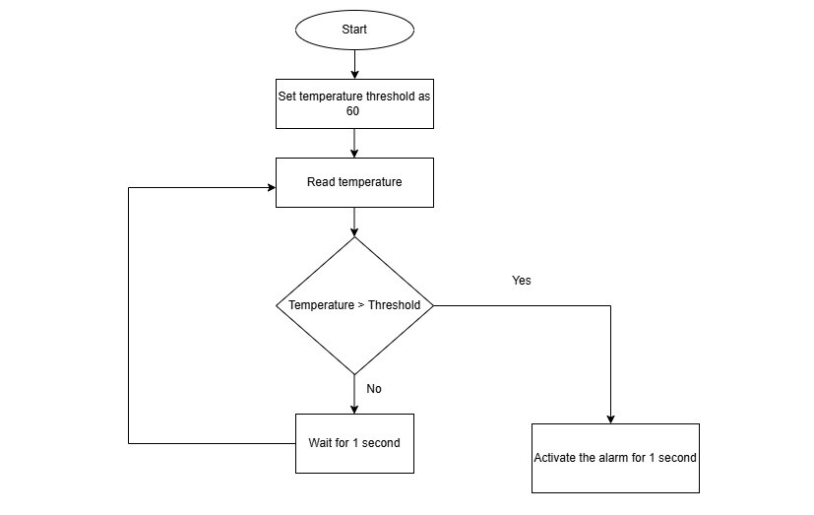

7. Error Handling & Fault Management
The measured temperature range is expected to be within a range of Rmin to Rmax. In which Rmin is assumed to be 0 and Rmax as 100. The alarm must be activated if and only if the measured temperature exceeds the threshold level. The temperature threshold level (t) assumed as 60. If the sensor is not responding to the call to read data due to hardware error then it will return zero indicating an hardware errors, else return true.

8. Traceability
- Requirement mentioned in SRS section 2.1 Functional requirement 1:
Read temperature every p second → temperature monitoring module
- Requirement mentioned in SRS section 2.2 Functional requirement 2:
Compare current temperature with threshold → temperature monitoring module
- Requirement mentioned in SRS section 2.2 Functional requirement 2:
If temperature is above threshold, then activate alarm for n second → alarm manager module

