Software Requirement Specification
Temperature Monitoring System

Author : Francis V D
Date : 16-12-2025

1 Introduction

Purpose
The document provides the software requirements for a system to monitor the temperature and to activate an alarm if the measured temperature goes beyond the preset threshold level.

1.2 Project Overview
The system will poll the current temperature in every p (polling frequency) second, and if the measured temperature goes beyond the preset temperature threshold (t) level it will activate an alarm for n (alarm on time) seconds.
Polling frequency for temperature measurement is considered as 1 second and the turn on time for alarm will be considered as 1 second. The preset temperature threshold level is set to a value of 60.
The sensor will read the temperature within the range of 0 (Rmin) to 100 (Rmax).
Note:
p : Polling frequency, the frequency at which temperature is measured.
t : Temperature threshold level, if the measured temperature is above this value alarm will be activated.
n : Alarm on time, if the measured temperature is above temperature threshold level alarm will be activated for w seconds.
R_{min} : The minimum temperature the sensor can detect.
R_{max} : The maximum temperature the sensor can detect.

1.3 Project Scope
To monitor the temperature every p second and to activate an alarm for n second if the measured temperature goes beyond the preset threshold of t.
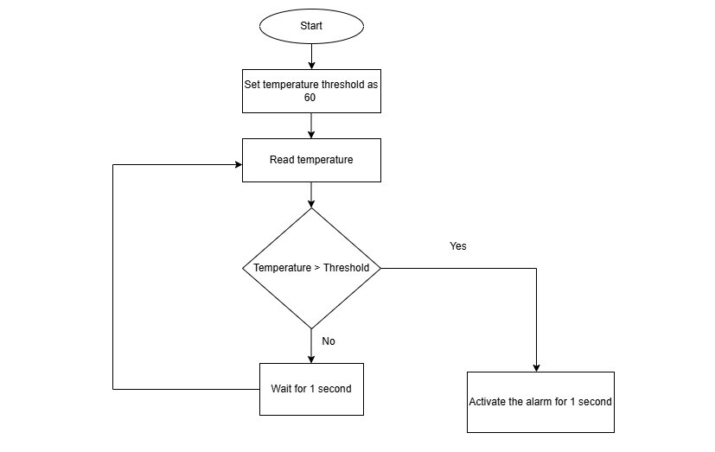

1.4 Assumptions, Constraints and Limitations
Assumptions:
Polling frequency: The system will poll the temperature in every p second from the sensor
Alarm on time: The alarm will be activated for n second if the measured temperature goes beyond the threshold level
Temperature threshold: The temperature threshold level is assumed as t.
If the measured temperature at any point goes beyond the preset threshold of t the alarm will be activated for n second.
The function call to measure temperature will return an unsigned integer value which will vary from Rmin to Rmax.
Note: If sensor is not available the output is generated by using random number generation with limit from Rmin to Rmax.

Constraints:
Temperature is measured in every p second.
The output of reading temperature will be an unsigned integer within the range of Rmin to Rmax.
If the measured temperature is more than the specified temperature threshold level of t then the alarm will be activated for n second.

Limitations:
The system is implemented to measure the temperature range from Rmin to Rmax.

2 Functional Requirements
On startup will create the thread to read temperature every p second and thread to check the measured temperature with threshold and enable the alarm for n second if the measured temperature is greater than the threshold level of t.

2.1 Functional requirement 1
Functionality to read the temperature with a polling frequency of p seconds with unsigned integer value of within the range of Rmin to Rmax.
The measured temperature is stored in a shared memory and used across the functions to activate alarm as well.
The measured temperature which is in shared memory will be locked by mutex implementation to ensure that the shared data is properly secured.

2.2 Functional Requirement 2
Functionality to activate the alarm.
It will compare the measured temperature with the threshold temperature and if the measured temperature is above the threshold temperature the alarm will be activated for n second. If not, no action will be taken.

3 Data Requirements
The threshold temperature which is defined by the user based on which the alarm will get activated.
The measured temperature is shared among the threads which implement the temperature read process and the alarm activation process.
The alarm on time which is defined by the user based on which the alarm turned on for n second when the measured temperature go beyond the threshold level.

4 Testing
- Verify that the temperature read function always returns a value between the range from Rmin to Rmax.
- Test the system for temperature below the threshold level and ensure that the alarm is not triggered.
- Test the system for temperature equal to the threshold level and ensure that the alarm is not triggered.
- Test the system for temperature above the threshold level and ensure that the alarm is triggered for n second.
- Test the system for temperature below the threshold level and ensure that the alarm is deactivated.

5 Acceptance Criteria
- The system is supposed to read the temperature in every p second.
- The alarm must be activated for n second if the measured temperature at any given point of time is above the threshold temperature level.
- The alarm must be turned off after n second once it is turned on.
- The alarm will turn on if and only if the measured temperature is above the threshold temperature level.

