High-Level Design (HLD)
Version: 1.0
Date: 02-01-2026
Prepared by: Francis V D, Trenser Technology Solutions

1. Purpose
The document provides a high-level design overview for a temperature monitoring system.

2. System Overview
The system continuously monitors the temperature and activates an alarm if the measured temperature exceeds a predefined threshold level.
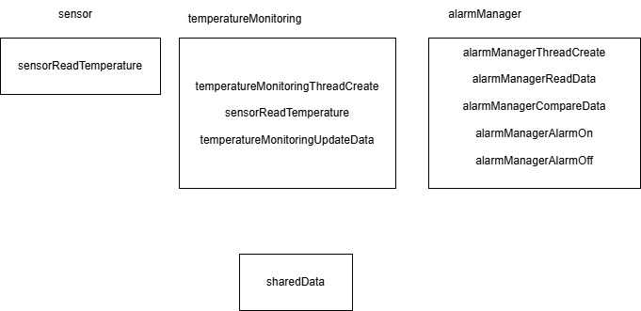

3. Software Architecture
The system implementation consists of sensor, temperature monitoring and alarm manager modules. The module to read temperature with a polling frequency (p) of p seconds and another module to compare the measured temperature with the threshold level (t) and to activate an alarm if the measured temperature exceeds the threshold.
- Sensor interface layer: Handles communication with the temperature sensor.
- Control logic layer: Implements comparison logic and alarm activation.

Data flow:
Sensor → Read sensor value every p second and update data → Threshold Check → Alarm Trigger.
Control flow:
  - Thread to read temperature executes every p second.
  - If condition met, alarm is activated for n second

4. Module Descriptions
- Sensor module: Reads temperature values from hardware
- Temperature monitoring module: The module will read the temperature in every p second. The expected temperature output is with the range of 0 (Rmin) to 100 (Rmax).
- Alarm manager module: The module will compare the measured temperature which will be the output of Temperature monitoring module and then compare it with the threshold level (t). And then activate an alarm for n (alarm on time) seconds if the measured temperature exceeds the threshold.

5. Interface Design
Note: Type definitions used in this project
Type | Type Definitions
unsigned char | uint8
unsigned short | uint16
unsigned long | uint32
signed char | int8
signed short | int16
signed long | int32

- sensor API:
uint32 ucTemperatureValue sensorReadTemperature (uint8 ucTemperatureSensorPin)
It will receive the pin to which the sensor is connected as input argument.
And will return the measured temperature
- temperatureMonitoring API:
bool temperatureMonitoringThreadCreate (void)
It will create a thread which will read the temperature and save it in a shared memory every p second. It would return true if thread created successfully else returned false.
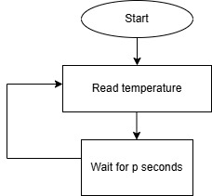
- alarmManager API:
bool alarmManagerThreadCreate (void)
It will create a thread which will read the temperature value from the shared memory. The value read is then compared with threshold and trigger the alarm if condition met. It would return true if thread created successfully else returned false.

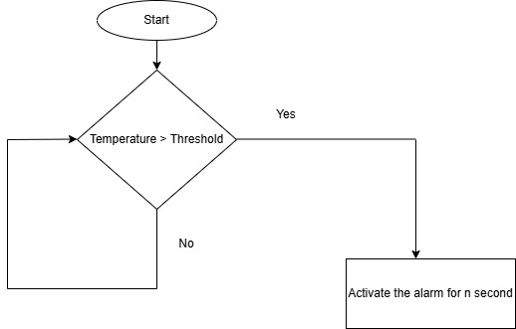

6. Data Flow
The temperature reading is measured continuously with a polling frequency (p) of p seconds. If the temperature exceeds the threshold level (t) then an alarm will be turned on for a duration of n seconds.
Logical Data Flow:
- sensor module reads temperature.
- temperatureMonitoring module reads the temperature every p seconds and saves it in shared memory.
- alarmManager reads the temperature from the shared memory and then compares it to the threshold and activate an alarm for n second if condition met

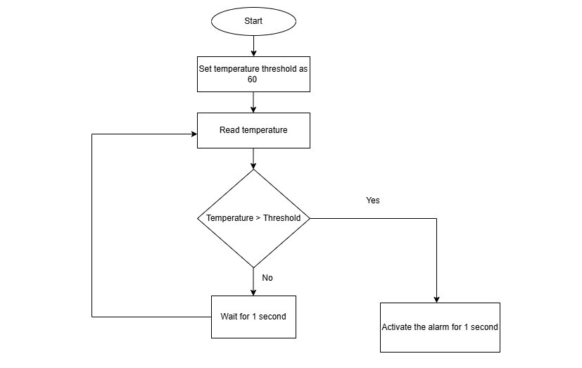

7. Error Handling & Fault Management
The measured temperature range is expected to be within a range of Rmin to Rmax. In which Rmin is assumed to be 0 and Rmax as 100. The alarm must be activated if and only if the measured temperature exceeds the threshold level. The temperature threshold level (t) assumed as 60.

8. Traceability
- Requirement: Read temperature every p second → temperatureMonitoring module
- Requirement: Compare current temperature with threshold → temperatureMonitoring module
- Requirement: If temperature is above threshold, then activate alarm for n second → alarmManager module

