Software Requirement Specification
Temperature Monitoring System

Author : Francis V D
Date : 16-12-2025

1 Introduction

1.1 Purpose
A system to monitor the temperature and to activate an alarm if the measured temperature goes beyond the preset threshold level

1.2 Project Overview
The system will poll the current temperature in every n second, and if the measured temperature goes beyond the preset temperature threshold level it will activate an alarm for n seconds.
Polling frequency for temperature measurement is considered as 1 second and the turn on time for alarm will be considered as 1 second. The preset temperature threshold level is set to a value of 60.

1.3 Project Scope
To monitor the temperature every 1 second and to activate an alarm for 1 second if the measured temperature goes beyond the preset threshold of 60
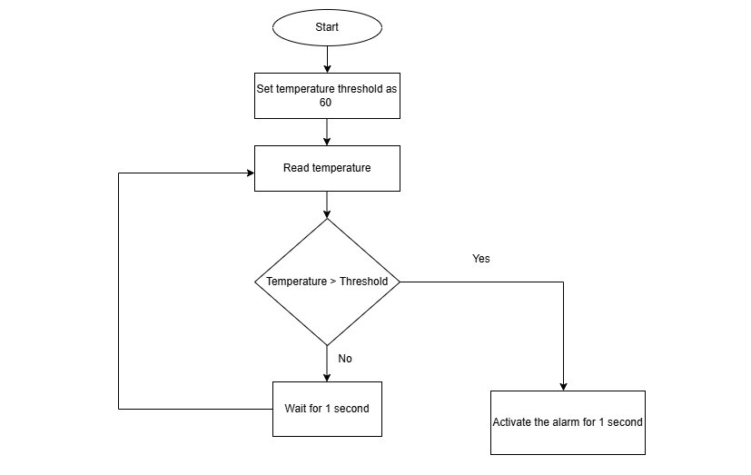

1.4 Assumptions, Constraints and Limitations
Assumptions:
Polling frequency: The system will poll the temperature in every 1 second from the sensor
Alarm on time: The alarm will be activated for 1 second if the measured temperature goes beyond the threshold level
Temperature threshold: The temperature threshold level is assumed as 60.

If the measured temperature at any point goes beyond the preset threshold of 60 the alarm will be activated for 1 second
The function call to measure temperature will return an unsigned integer value which will vary from 0 to 100.
Note: If sensor is not available the output is generated by using random number generation with limit from 0 to 100.

Constraints:
Temperature is measured in every 1 second
The output of reading temperature will be an unsigned integer within the range of 0 to 100
If the measured temperature is more than the specified temperature threshold level of 60 then the alarm will be activated for 1 second

Limitations:
The system is implemented to measure the temperature range from 0 to 100.

2 Functional Requirements
On startup we will create the thread to read temperature every 1 second and thread to check the measured temperature with threshold and enable the alarm for 1 second if the measured temperature is greater than the threshold level of 60

2.1 Functional requirement 1
Functionality to read the temperature with a polling frequency of 1 seconds with unsigned integer value of within the range of 0 to 100.
The measured temperature is stored in a shared memory and used across the functions to activate alarm as well.
The measured temperature which is in shared memory will be locked by mutex implementation to ensure that the shared data is properly secured.

2.2 Functional Requirement 2
Functionality to activate the alarm.
It will compare the measured temperature with the threshold temperature and if the measured temperature is above the threshold temperature the alarm will be activated for n second. If not, no action will be taken.

3 Data Requirements
The threshold temperature which is defined by the user based on which the alarm will get activated.
The measured temperature is shared among the threads which implement the temperature read process and the alarm activation process.
The alarm on time which is defined by the user based on which the alarm turned on for n second when the measured temperature go beyond the threshold level.

4 Testing
- Verify that the temperature read function always returns a value between the range from 0 to 100.
- Test the system for temperature below the threshold level and ensure that the alarm is not triggered.
- Test the system for temperature equal to the threshold level and ensure that the alarm is not triggered.
- Test the system for temperature above the threshold level and ensure that the alarm is triggered for n second.
- Test the system for temperature below the threshold level and ensure that the alarm is deactivated.

5 Acceptance Criteria
- The system is supposed to read the temperature in every n second
- The alarm must be activated for n second if the measured temperature at any given point of time is above the threshold temperature level
- The alarm must be turned off after n second once it is turned on
- The alarm will turn on if and only if the measured temperature is above the threshold temperature level

