In this workshop project, assume that last joint is parallel to ground plane. This is to let end effector perpendicular to cylinder surface and allow better gripping.

Since M2,M3,M4 are on side plane, performing inverse kinematics starting from here.

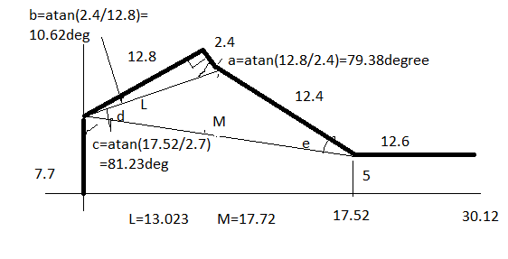

$$L={√((12.8)}^{2}+{2.4}^{2})=13.023$$

$$M={√((30.12-12.6)}^{2}+{(7.7-5)}^{2})=17.72$$

Using Cosine rule:

$$d=\operatorname{acos}\left(\frac{(M^{2}+L^{2}-{12.4}^{2})}{2ML}\right)=44.38deg=0.7747rad$$

$$e=\operatorname{acos}\left(\frac{(M^{2}+{12.4}^{2}-L^{2})}{2M(12.4)}\right)=47.27deg=0.825rad$$

M2=90-(b+c+d-90)=43.77deg=0.7639rad

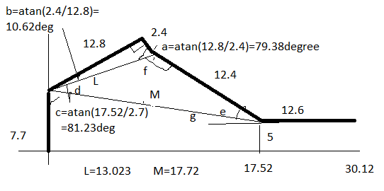

f=180-d-e=88.35deg

M3=180-f-a=12.27deg=0.2141rad

g=atan(2.7/17.52)=8.76deg

M4=-(e+g)=-56.03deg=-0.9779rad

M1=0 at the beginning (starting position)

After starting the simulation using Gazebo, M1 is set to 1.57rad (90 degree position)

To avoid collision, keep M2 to -0.5radian and M3/M4 to 0 radian so to avoid any cylinder to be collided by the robotic arm.

Once reaching the beginning position, M2,M3,M4 goes to the intended position presented in inverse kinematics portion.

After a delay, close the gripper (M5)

To ensure free collision movement, M2 set to -0.5radian, M3/M4 back to 0 radian.

After a delay, M1 set to -1.57radian (to the destination). (To ensure steady movement, set via point where M1 is set to 0, keep M2/M3/M4 the same angle)

Finally, goes to the destination with M1 set to -1.57radian, M2/M3/M4 to angles calculated thru inverse kinematics.

After a delay, open the gripper and release the cylinder.