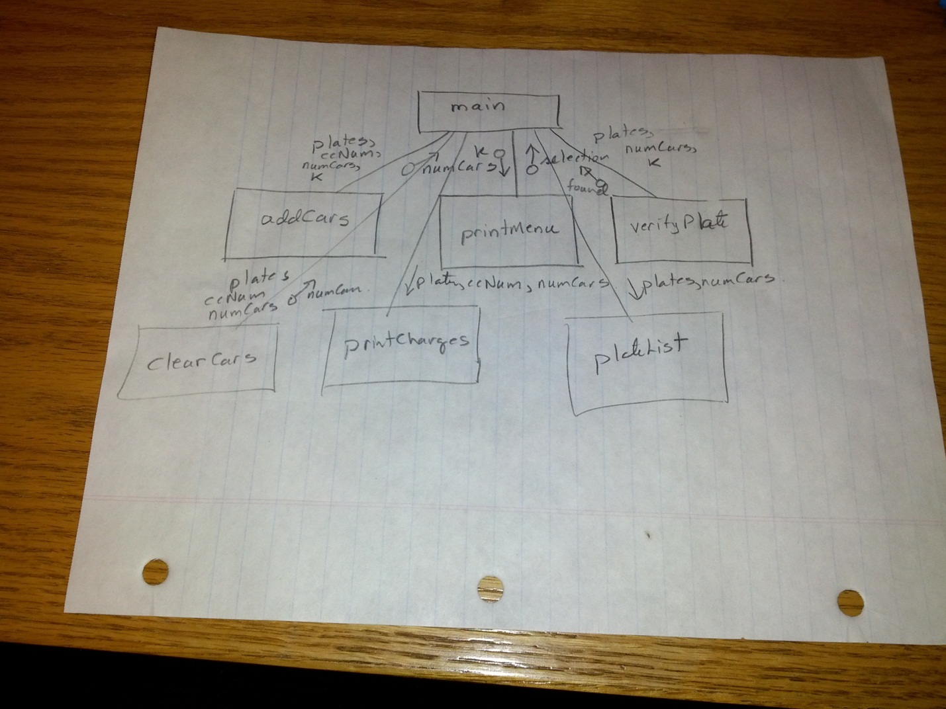

**function: main**

create String array of 50 plates

create String array of 50 ccNums

numCars = 0

selection = printMenu()

while selection is not 22359

switch selection

case 1

numCars = addCar (plates, ccNums, numCars, k)

case 2

found = verifyPlate (plates, numCars, k)

if found

print “You are registered in lot”

else

print “You are not registered!”

endif

case 22351

// create a file with all of the plate information

plateList (plates, numCars);

case 22352

// create a daily billing summary

printCharges (plates, ccNumbers, numCars)

case 22353

// empty all the cars from the parking lost

numCars = clearCars (plates, ccNumbers, numCars)

endSwitch

select = printMenu()

endWhile

**function: printMenu**  
Header: public static int printMenu(Scanner k)   
Function: Clears the screen, display the menu, allows the user to enter their selection and then return the integer value of that selection.

k – Scanner Object attached to the keyboard  
  
Psuedocode

print "Welcome to Park and Go Parking"

print "Park from 6 - Midnight for a flat fee of $4.00"

print "1. Register your vehicle"

print “2. Verify vehicle registration"

print “"Hello enter a Selection: "

input selection using Scanner k

return selection

**function: addCars**

Header: public static int addCars (String [] plates,String [ ] ccNumbers, int numCars, Scanner k) { ... }  
 Function: Prompts the user for their license plate number and credit card number and places that information at the end of the two arrays. Returns the new number of cars in the lot (e.g. numCars incremented by one).

* + plates – is an array of all license plates of people that have paid to park in the lot
  + ccNumbers – is a parallel array to license plates and shows the credit card number that is to be charged the flat $4 fee for evening parking
  + numCars – is the num of cars that have paid to park
  + k – a Scanner object attached to the keyboard in the main function

Psuedocode:

print “Register you vehicle”

print “Enter your plate number”

input plate using Scanner k

print “Enter your credit card number: “

input ccNum using Scanner k

// append the plate and credit card number to the arrays (at position ‘top’)

plates at position top = plate

ccNumbers at position top = ccNum

// increment top to indicate there is one more element in the array

increment top

return top

**function: verifyPlate**

Header: public static boolean verifyPlate (String [] plates, int numCars, Scanner k) { ... }  
Function: Allows the user to enter a plate number and then searches to see if the plate is found the array ‘plates’, if so return ‘true’ otherwise, return ‘false’.

* + plates – is an array of all license plates of people that have paid to park in the lot
  + numCars – is the num of cars that have paid to park
  + k – a Scanner object attached to the keyboard in the main function

Psueocode:

print “Verifying your registration”

input searchPlate using Scanner k

// start by assuming that you won’t find the plate

found = false

i = 0

while i < top and !found

if searchPlate equals plate at position i

found = true

endif

increment i

endWhile

return found

**function: plateList**

Header: public static void plateList (String [] plates, int numCars) throws IOException { ... }  
Function: Print a report of license plates of all registered vehicles to the file registered.txt. User enters secret code 22351 to invoke this function.

* + plates – is an array of all license plates of people that have paid to park in the lot
  + numCars – is the num of cars that have paid to park

Psuedocode:

open output file out attached to c:/temp/registered.txt

write “Plate list for “

write today’s date to file out

write headers for report

for i = 0 to numCars step 1

write plates at position i

endFor

close out

**Function: printCharges**Header: public static void printCharges (String [] plates, String [ ] ccNumbers, int numCars) { }  
Function: Print a report of license plates and credit card numbers that need to be manually charged for parking on a specific evening to the file dailyCharges.txt. User enters secret code 22352 to invoke this function.

* + plates – is an array of all license plates of people that have paid to park in the lot
  + ccNumbers – is a parallel array to license plates and shows the credit card number that is to be charged the flat $4 fee for evening parking
  + numCars – is the num of cars that have paid to park

Psuedocode:

eveningCharge = 4.00  
totalCharge = 0

open output file out attached to c:/temp/dailyReport.txt

write “Daily parking summary for “ + todays date

// loop through all elements of the arrays 0 to top

write headers to the report

for i = 0 to numCars step 1

write plates at position i, ccNumbers at position i, charge

totalCharge = totalCharge = eveningCharge

endFor

write “Total charge” + totalCharge

close out

**Function: clearCars**Header: public static int clearCars (String [] plates,String [ ] ccNumbers, int numCars) { }  
Function: Clears out all the elememts in the plates and ccNumbers arrays (set them to “”. It returns 0, which is the number of cars now stored in the arrays. User enters secret code 22353 to invoke this function.

* + plates – is an array of all license plates of people that have paid to park in the lot
  + ccNumbers – is a parallel array to license plates and shows the credit card number that is to be charged the flat $4 fee for evening parking
  + numCars – is the num of cars that have paid to park

Psuedocode:

// erase all data in the arrays from 0 to numCars

for i = 0 to numCars step 1

plates at position i = “”

ccNumbers at position i = “”

endFor

// reset the number of cars in the lot

numCars = 0

return numCars