



INTEGRATED CLASSROOM ATTENDANCE MANAGEMENT SYSTEM

Presented to the Faculty of Information Technology
School of Engineering, Computer Studies and Architecture

In Partial Fulfillment

Of the Requirements for the Degree of
BACHELOR OF SCIENCE IN INFORMATION TECHNOLOGY

by:

CAYAO, JOHN LIAN
MANGUERRA, ALEXANDER
MUJAL, KURT ADRIAN

ANDICO, LORIEJOY P.
Adviser

December 2025
Table of Contents

- Introduction
  - Background of the Study 1
  - Statement of the Problem 3
  - Objectives of the Study 4
  - Significance of the Study 5
  - Scope and Limitations 5
  - Definition of Terms 5
- Review of Related Literature
  - Related works 7
  - Theoretical Framework 11
    - Type of System (Decision Support System) 11
  - Conceptual Framework 20
- Materials and Methods
  - Materials 22
    - Hardware 22
    - Software 22
  - Methods 22
    - SDLC – (Models example: Agile, Waterfall, Spiral, etc.) 23
    - Research Design 23
    - Data Gathering Procedures 23
    - Research Respondents 23
    - Research Instruments 23
    - Software Requirements 23
    - Hardware Requirements 23
    - Software Requirements 23
    - Data Flow Diagram 23
    - Use Case Diagram 23
    - Data Dictionary 23
    - Entity Relationship Diagram 23
    - Prototypes 23
- Results and Discussion
  - Results and Discussion 32
  - System Evaluation 33
- Conclusion and Recommendation 35
  - Summary and Findings 32
  - Conclusions
  - Recommendations 33
References
Appendices 35
Appendix A - Gantt Chart 32
Appendix B - Communications
Appendix C - Evaluation Tool and Test Document 32
Appendix D - User Manual 32
Appendix E - Picture Showcasing the data gathering, investigation, etc. 33
Appendix F - Proposed System Budget 34
Appendix G - Curriculum Vitae 35

List of Figures

Figure 1. IPO ( Input Process Output) 16
Figure 2. Data Flow Diagram level 0. 24
Figure 3. Data Flow Diagram level 1. 25
Figure 4. Use Case Diagram 26
Figure 5: ERD (Entity Relationship Diagram) 27
Prototype
Figure 6 28
Figure 7 28
Figure 8 29

List of Tables

Table 1 . SoftwareRequirements. 23
Table 2. Hardware Requirements. 23
Table 3. Data Dictionary 27
28
29

Abstract

Write your abstract here, in one whole page

Chapter 1
Introduction
The management of student and teacher records is a fundamental component of any attendance system, as it ensures that all user information is accurate, organized, and readily accessible. However, in many educational institutions, record management is still handled manually or through unstructured digital files, which can reduce efficiency and increase workload [13]. This study focuses on the Records/Profile Management Subsystem of the Integrated Classroom Attendance Management System, which aims to improve how user information is stored, updated, and maintained.
Currently, the existing methods of managing records present several unsatisfactory conditions. These include difficulties in updating student and teacher information, duplication of records, and data inconsistency, which are common issues related to poor data integrity and management [6]. Without a centralized and well-organized system, administrators may struggle to maintain accurate profiles, which can affect other system functions such as attendance tracking. These issues clearly indicate the need for a more efficient and reliable records management solution.
The rationale of this study lies in the need to enhance data management practices within educational systems. Accurate and centralized profile management is essential to ensure that all related subsystems function correctly. Studies have shown that centralized systems improve data consistency and efficiency in managing records [1]. By developing a dedicated Records/Profile Management Subsystem, institutions can reduce errors, improve efficiency, and ensure that all user information is consistent and up-to-date. This is important not only for administrative purposes but also for supporting the overall effectiveness of the attendance management system.
From a historical perspective, record management in schools has evolved from paper-based filing systems to basic digital storage such as spreadsheets and standalone applications. While these methods have improved data storage, they still lack integration, as many systems operate independently without connection to other modules [11]. As a result, many institutions continue to face challenges in maintaining reliable and accessible records.
This study seeks to gain a deeper understanding of the current issues in managing student and teacher profiles, particularly in relation to data organization, accessibility, and accuracy. By examining existing practices, the researchers aim to identify the gaps and limitations that hinder effective record management. Moreover, this study reflects a desire for improvement by proposing a subsystem that allows administrators to efficiently add, update, view, and delete records within a centralized database, following standard CRUD operations used in web-based systems [14]. The subsystem is designed to enhance the organization and management of user profiles, making it easier to support other components of the integrated system.
In addition, the researchers aim to discover more effective approaches to handling profile data by exploring the use of centralized databases that support multi-user access and system coordination. The study will investigate how proper management of user records can contribute to improved system performance and reduced operational errors. With these considerations, this study leads to the formulation of specific questions that address the challenges and requirements of the Records/Profile Management Subsystem, which are presented in the Statement of the Problem.
  - Background of the Study
Managing student and teacher records is an important part of any school because it helps with attendance tracking, monitoring performance, and keeping reports organized. Most schools still use manual methods, like paper files and logbooks, to keep these records. While this worked in the past, it can be slow, confusing, and prone to mistakes, especially as the number of students grows and information needs to be accessed quickly.
Some schools have tried using spreadsheets or separate applications to store records. These tools are helpful, but they also have problems. Records can be scattered across different files, making it hard to keep information accurate. Updating data can take a lot of time, and mistakes or duplicates can easily happen, especially when more than one person handles the same records. These problems become even bigger when the system is supposed to work with other parts of the school system, like taking attendance, where having correct and up-to-date profiles is very important.
One reason for these issues is the lack of an integrated system that keeps all student and teacher information in one place. Often, data is managed separately from other systems, which leads to poor coordination and extra work for administrators. There are also limited access controls and no standard process for managing records, which can cause mistakes or lost information.
Because of this, schools need a better way to manage records — one that is organized, centralized, and easy to use. Modern educational systems are moving toward digital solutions that can make information accurate, accessible, and simple to manage. A good records management system should allow administrators to store, update, and retrieve student and teacher information easily, while also supporting other parts of the system like attendance tracking.
The Integrated Classroom Attendance Management System aims to solve these problems. Its Records/Profile Management Subsystem is designed to be the core part of the system where all student and teacher information is stored. Accurate profiles ensure that attendance and other records are correctly linked to each person. This study started because the researchers noticed that current record management methods are often slow, inefficient, and prone to errors. There is a clear need for a subsystem that organizes and maintains profiles in a central and systematic way. This study will be conducted in one classroom to focus on a specific group of users and to allow easier testing and evaluation of the subsystem.
Therefore, this study focuses on developing the Records/Profile Management Subsystem. The subsystem will allow administrators to easily add, update, view, and delete records in one centralized database. By doing this, the system will improve how information is organized, accurate, and accessible. In the end, it will make the whole Integrated Classroom Attendance Management System work better and help schools run more smoothly.
  - Statement of the Problem
Managing student and teacher records is very important for schools, but current methods like paper files or separate digital tools are slow, confusing, and prone to mistakes. This study focuses on finding a better way to manage these records through the Records/Profile Management Subsystem of the Integrated Classroom Attendance Management System, specifically conducted in one classroom.
General Problem:
How can the management of student and teacher records be improved to make attendance tracking more accurate and efficient?
Specific Problems:
1. How can student and teacher profiles be stored and organized in one central database?
2. How can administrators easily add, update, view, and delete records without making mistakes?
3. How can student profiles be correctly linked to their attendance records?
4. How can the system make sure that only authorized administrators can modify records?
5. How can using this subsystem make record management faster and more organized compared to traditional manual methods?
  - Objective of the Study
General Objective:
To develop a Records/Profile Management Subsystem that improves the organization and management of student and teacher records, ensuring accurate and efficient attendance tracking.

Specific Objectives:
1. To design a centralized database for storing and organizing student and teacher profiles.
2. To develop a user-friendly interface that allows administrators to add, update, view, and delete records accurately.
3. To implement a system that correctly links student profiles with their attendance records.
4. To establish access controls that allow only authorized personnel to modify records.
5. To evaluate the efficiency and accuracy of the subsystem compared to traditional manual methods of record management.
  - Significance of the Study
The development of the Records/Profile Management Subsystem for the Integrated Classroom Attendance Management System will provide several benefits to different groups in the educational and IT community:
Students – Students will benefit from more accurate and organized records. This ensures that their attendance and profile information are correctly maintained, reducing errors that might affect their academic performance or participation tracking.
Administrators and School Staff – School administrators and staff will save time and effort in managing student and teacher records. The subsystem allows easy adding, updating, viewing, and deleting of profiles, making record management faster, more accurate, and less prone to mistakes.
Classroom Environment – The classroom will benefit from a more efficient system that centralizes and organizes records. This improves overall management within the classroom, supports accurate reporting, and ensures smooth integration with attendance monitoring.
IT Students – IT students will benefit by learning how to design and implement real-world record management systems. This study provides a practical example of using databases, system integration, and user-friendly interfaces to solve problems in educational institutions.
  - Scope and Limitations
Scope
The study focuses on developing the Records/Profile Management Subsystem for the Integrated Classroom Attendance Management System. Specifically, it covers:
1. Coverage Area – The subsystem will manage student and teacher profiles, including personal information, IDs, and class details.
2. Included Variables – Adding, updating, viewing, and deleting user records; linking student profiles with attendance records; ensuring access control for authorized administrators.
3. Target Respondents – School administrators and staff who will use the system to manage student and teacher information.
4. Time Frame – The study and development of the subsystem will be conducted within the academic semester, including system testing and evaluation.
Limitations
While the study aims to improve record management, the following constraints are recognized:
1. The subsystem will not handle direct attendance recording; it only manages profiles and links to attendance data.
2. Only authorized administrators can modify records; students and teachers will have view-only access where applicable.
3. The system relies on internet or local network access to communicate with other modules of the Integrated Classroom Attendance Management System.
4. Advanced analytics, reports, or decision-making features are not included in this subsystem.
5. Budget, time, and technical resources may limit the scope of testing, meaning the system will be primarily evaluated in a controlled school environment rather than across multiple institutions.
  - Definition of Terms
The following terms are defined as used in this study:
Administrator – A school staff member authorized to manage student and teacher records, including adding, updating, viewing, and deleting profiles in the system.
Attendance Record – The data that shows whether a student was present, absent, or late in a class, linked to the student’s profile in the subsystem.
Centralized Database – A single storage system where all student and teacher profiles are kept, allowing easy access, updating, and management of information.
Integrated Classroom Attendance Management System – The main system that combines attendance tracking, record management, and other school administrative tasks into one platform.
Profile Management – The process of storing, organizing, and maintaining student and teacher information in the system.
Records/Profile Management Subsystem – The part of the attendance system responsible for managing all user profiles, ensuring accuracy and organization, and linking them to attendance data.
User Access Control – A feature that ensures only authorized personnel (administrators) can modify or delete records, while others may have limited or view-only access.
User Profile – A digital record containing personal and academic information of a student or teacher stored in the subsystem.

Chapter 2
Review of Related Literature
  - Related Works
Foreign Studies
The development of a web-based student information management system demonstrated the effectiveness of centralizing student data, including personal profiles, enrollment details, and academic records. The system allowed administrators to perform CRUD operations and efficiently search and filter records. Findings showed improved data consistency and faster retrieval time; however, the lack of integration with modules such as attendance and grading was identified as a limitation. This supports the need for an integrated approach in the proposed subsystem [1].
A web-based student profile management system using PHP and MySQL enabled efficient registration, updating, and archiving of student records in secondary schools. The system significantly reduced data retrieval time compared to manual processes. However, it lacked teacher profile management, highlighting a gap that the proposed system aims to address while adopting a similar centralized database approach [2].
The use of open-source platforms for managing student records allowed efficient storage and updating of academic and personal information. The system reduced paperwork and improved accessibility, although challenges in integrating attendance systems were noted. This reinforces the importance of integration in the proposed subsystem design [3].
Digital records management systems were found to enhance accessibility and data accuracy through centralized databases. Although focused on academic libraries, the principles of centralized record-keeping and access control are applicable to managing student and teacher profiles in educational systems [4].
Computerized records management systems were shown to improve administrative efficiency, reduce data errors, and enhance information sharing in educational institutions. The study emphasized the importance of user authentication and access control, which are key features incorporated in the proposed subsystem [5].
Data integrity issues in student information systems highlighted the need for role-based access control (RBAC) to prevent unauthorized data modification. The study also stressed the importance of centralized databases, both of which are implemented in the proposed subsystem [6].
The digital transformation of student records using web-based systems significantly reduced the time required for data retrieval and updates. However, lack of system integration was identified as a major limitation, further justifying the integrated design of the proposed subsystem [7].
A unified information management portal demonstrated the effectiveness of managing both student and faculty profiles within a single system. Integration with academic records and attendance data enhanced system functionality, aligning with the objectives of the proposed subsystem [8].
A cloud-based student record management system enabled real-time data updates and multi-user access. Core features such as profile storage, CRUD operations, and access restrictions were emphasized, which are also present in the proposed subsystem despite differences in deployment architecture [9].
Integrated management systems were found to improve attendance accuracy by ensuring that student profiles are properly updated and linked to attendance records. This highlights the importance of direct integration between profile and attendance modules in the proposed system [10].
Local Studies
A school records management system was developed to digitize student enrollment data, personal information, and academic history. The system reduced manual processing time but operated as a standalone application without integration. This limitation is addressed in the proposed subsystem through system integration [11].
An integrated information system successfully managed both faculty and student profiles using role-based access control and audit trails. These features ensure data security and accountability, which are also implemented in the proposed subsystem [12].
The digitization of student records in state universities showed that centralized systems significantly reduce administrative workload and improve data retrieval efficiency. The study also recommended standardized data structures, which influenced the database design of the proposed subsystem [13].

A web-based enrollment and records management system enabled authorized personnel to perform CRUD operations on student data using PHP and MySQL. However, it lacked teacher profile management and attendance integration, which are key enhancements in the proposed subsystem [14].
A combined student information and attendance management system emphasized the importance of linking accurate student profiles with attendance records. The study also highlighted the need for access control to maintain data integrity, supporting the core design principles of the proposed subsystem [15].

  - Theoretical Frameworks
The development of the Integrated Classroom Attendance Management System is grounded on systems integration concepts and database management principles. Systems integration concepts suggest that individual subsystems, when properly connected, can operate as a unified whole, improving coordination and system functionality [8]. This serves as the basis for connecting the Records/Profile Management Subsystem with modules such as attendance tracking and reporting.
On the other hand, database management principles support the use of centralized storage to ensure that data is consistently organized, easily retrievable, and properly maintained across the system [6]. These principles emphasize the importance of data integrity, access control, and efficient data handling, which are essential in managing student and teacher records.
    - Security
Security in the context of this system refers to the mechanisms that control access to sensitive student and teacher data. Only authorized administrators are permitted to create, edit, or delete records in the system, preventing unauthorized modifications. Role-based access control ensures that each user can only perform functions appropriate to their access level within the integrated system.

  - Conceptual Frameworks
The conceptual framework of this study follows an Input-Process-Output (IPO) model. The input consists of student and teacher information such as names, IDs, and class details. The process involves the storage, updating, retrieval, and deletion of these records through the web-based interface. The output is a well-maintained, centralized profile database that supports attendance tracking and reporting modules.
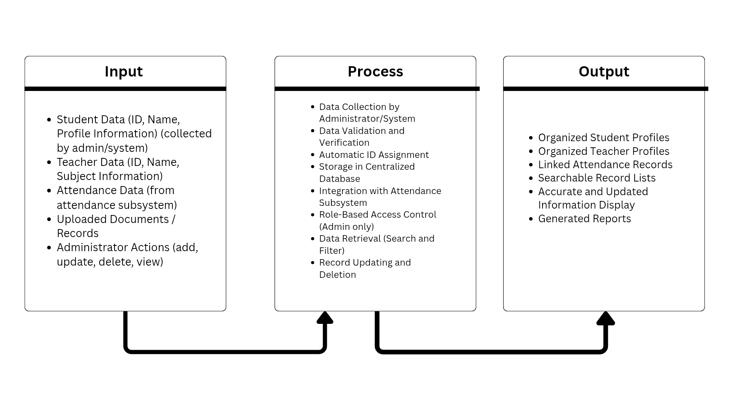
Figure 1. IPO Model

    - Input
The inputs to the Records/Profile Management Subsystem include student profile data such as name, student ID, and class section, as well as teacher profile data such as name, employee ID, and assigned subjects. These inputs are entered by authorized administrators through the web-based interface and stored in the centralized MySQL database for use by other subsystems.
2.3.2. Process
The process involves the steps performed by the system to handle the input data. In the Records/Profile Management Subsystem, the administrator encodes student and teacher information into the system. The system then validates the data to ensure that it is complete and accurate. After validation, the system processes the data through operations such as adding new records, viewing existing records, updating information, and deleting unnecessary or incorrect data. Once processed, the information is stored in a centralized database and integrated with other system components, such as attendance tracking.
2.3.3 Output
The output is the result of the processed data. After all operations are completed, the system produces organized and updated student and teacher profiles. The data becomes securely stored and easily retrievable within the database. It also allows administrators to view accurate records and ensures that attendance information is correctly linked to each profile. Overall, the output provides clean, reliable, and accessible information that supports efficient classroom record management.

Chapter 3
Research Methodology
3.1 Software Life Cycle Model - Iterative Process Model
The study will adopt the Iterative Process Model as the Software Development Life Cycle (SDLC) approach. This model focuses on developing the system through repeated cycles (iterations), allowing continuous refinement and improvement after each version.
The Iterative Process Model is chosen because it enables the gradual development of the Records/Profile Management Subsystem. Instead of building the entire system at once, the system will be developed in smaller parts such as student records, teacher records, subjects, and classroom management. This approach allows early detection of errors, incorporation of feedback, and enhancement of system features over time.
This model fits the system development because it allows a step-by-step implementation of system modules, provides flexibility in modifying features based on feedback, ensures continuous testing and improvement, and reduces risks by identifying issues early in each iteration.
Application of SDLC Phases for this Project
Planning
In this phase, the researchers will set the goals and objectives of the subsystem. They will identify the problems in the current system and define the scope of the project. The needed resources, schedule, and overall plan for development will also be prepared for each iteration.
Analysis and Design
During this phase, the researchers will collect and examine the system requirements. This includes determining the needed data such as student, teacher, subject, and classroom information. The needs of the users and the functions of the system will be identified. At the same time, the system structure will be planned by creating the database, designing the user interface, and organizing the system architecture. Diagrams like DFD and ERD will serve as a guide.
Implementation
In this phase, the system will be developed step-by-step through iterations. Each part of the system, such as managing students, teachers, subjects, or classrooms, will be coded and implemented one at a time. Each iteration will produce a working part of the system.
Testing
Every module developed in each iteration will be tested to ensure that it works properly. Any errors or issues found will be fixed before proceeding to the next iteration. Testing will also include checking how new features work with previously developed parts.
Evaluation and Review
After testing, the system will be evaluated, and feedback will be gathered from users. The performance of the system will be assessed, and necessary improvements will be identified. These improvements will be applied in the next iteration to continuously enhance the system.
3.2 Research Design
This study will use a quantitative research design to evaluate the effectiveness of the Records/Profile Management Subsystem. A survey method will be used to collect data from respondents, as it allows the researchers to gather measurable feedback regarding the system’s usability, functionality, and efficiency.
The quantitative approach is suitable for this study because it focuses on collecting numerical data that can be analyzed to determine how well the system performs. It helps in measuring user satisfaction and identifying whether the system meets its intended objectives.
The respondents of the study will include the administrator and users within the classroom who are responsible for managing student and teacher records. These individuals are selected because they are the primary users of the subsystem and have direct experience with record management processes.
The setting of the study will be conducted in Comlab A, where record management is performed using manual or existing digital methods. The system will be tested within this classroom environment in a controlled setup before actual implementation.
The data gathering tool to be used is a structured questionnaire. The questionnaire will contain questions related to system usability, accuracy, efficiency, and overall performance. A Likert scale will be used to measure the respondents’ level of agreement with each statement.
For data analysis, the collected responses will be summarized and analyzed using statistical methods such as frequency count, percentage, and mean. These methods will help interpret the results and determine the effectiveness of the system based on user feedback.
3.3 Data Gathering Procedure
In this study, data will be gathered using the survey method to assess the effectiveness of the Records/Profile Management Subsystem. The respondents will be the administrator and users within Comlab A who handle student and teacher records.

The data gathering process will be done through the following steps:
Preparation of Questionnaire
The researchers will prepare a structured questionnaire that focuses on evaluating the system’s usability, accuracy, efficiency, and overall performance.
- Validation of the Instrument
The questionnaire will be checked and reviewed by the adviser or an expert to make sure that the questions are clear, relevant, and suitable for the study.
- Selection of Respondents
The researchers will choose the administrator and selected users within Comlab A who will use or evaluate the system.
- Distribution of Questionnaire
The questionnaire will be given to the selected respondents, either through printed copies or online forms.
- System Demonstration
Before answering the questionnaire, the respondents will be shown how the subsystem works so they can better understand its features.
- Collection of Responses
Once the respondents finish answering, the questionnaires will be collected and organized.
- Data Organization
The collected data will then be arranged and prepared for statistical analysis.
3.4 Research Respondents
The respondents of this study will be composed of the administrator and selected users within Comlab A who are responsible for managing student and teacher records. A total of 3–5 respondents will be selected to participate in the evaluation of the Records/Profile Management Subsystem.
These respondents were chosen because they are the ones who directly handle record management tasks within the classroom, making them the most suitable individuals to assess the functionality, usability, and effectiveness of the system.
The study will use purposive sampling, where the researchers will intentionally select participants based on their roles and experience related to the system. This method is appropriate because it ensures that only those who have relevant knowledge and involvement in record management are included in the study.
3.5 Research Environment
The study will be conducted in Comlab A, where computers and other necessary equipment are available for system testing and demonstration. This setting provides a controlled environment where the researchers can present the Records/Profile Management Subsystem to the respondents.
The respondents, including the administrator and selected users within Comlab A, will use the available computers to explore the system, perform tasks such as encoding and updating records, and evaluate its functionality.
This environment is suitable for the study because it allows the respondents to interact directly with the system using proper facilities. It also ensures that the researchers can guide the respondents during the evaluation process, making the data collected more accurate and reliable.
3.6 Research Instrument
The main instrument that will be used in this study is a survey questionnaire. The questionnaire will be designed to evaluate the effectiveness of the Records/Profile Management Subsystem in terms of usability, accuracy, efficiency, and overall performance.
The questionnaire will consist of structured questions with a rating scale, allowing the respondents within Comlab A to give their feedback based on their experience while using the system. This will make it easier for the researchers to collect and analyze the data.
This instrument is appropriate for the study because it allows the researchers to gather information directly from the respondents in a simple and organized way. It also helps measure the users’ level of satisfaction and identify possible areas for improvement in the system. Additionally, the use of a questionnaire makes the data collection process faster and more efficient.
3.7 Software Requirements
To develop and run the Student Attendance Monitoring System, the following software is required:
Operating System | Windows 10 or 11 (Development); Any OS with a browser (User).
Development Environment | XAMPP (Apache Server).
Programming Language | PHP(Back-end), HTML/CSS/JavaScript (Front-end).
Database Management: | MySQL.
Web Browser: | Google Chrome, Mozilla Firefox, or Microsoft Edge.

Table 1. Software Requirements

3.8 Hardware Requirements
The minimum hardware specifications to ensure smooth performance are:

Processor | Intel Core i3 or higher (or equivalent AMD).
Memory (RAM) | Minimum 4GB (8GB recommended).
Storage | 256GB SSD or HDD (to store the database and project files).
Input Devices | Keyboard, Mouse, and a QR Code Scanner (or Smartphone camera).
Network | : Local Area Network (LAN) or Wi-Fi for web access.

Table 2. Hardware Requirements
3.9 Data Flow Diagram
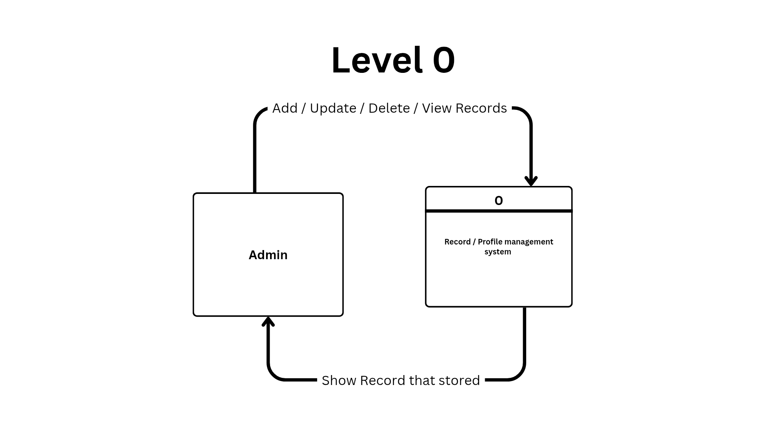
Figure 2. Data Flow Diagram level 0

The DFD Level 0 shows how the Records/Profile Management System interacts with the Admin. In this diagram, the Admin is the external entity who sends requests to the system such as adding, updating, deleting, and viewing records. These actions serve as input to the system. The system, represented as Process 0, processes these requests and returns the output, which is the stored and updated records. The arrows indicate the flow of data between the Admin and the system. This diagram provides a general overview of the system and does not include internal processes or databases, as those are shown in the next level of the DFD.
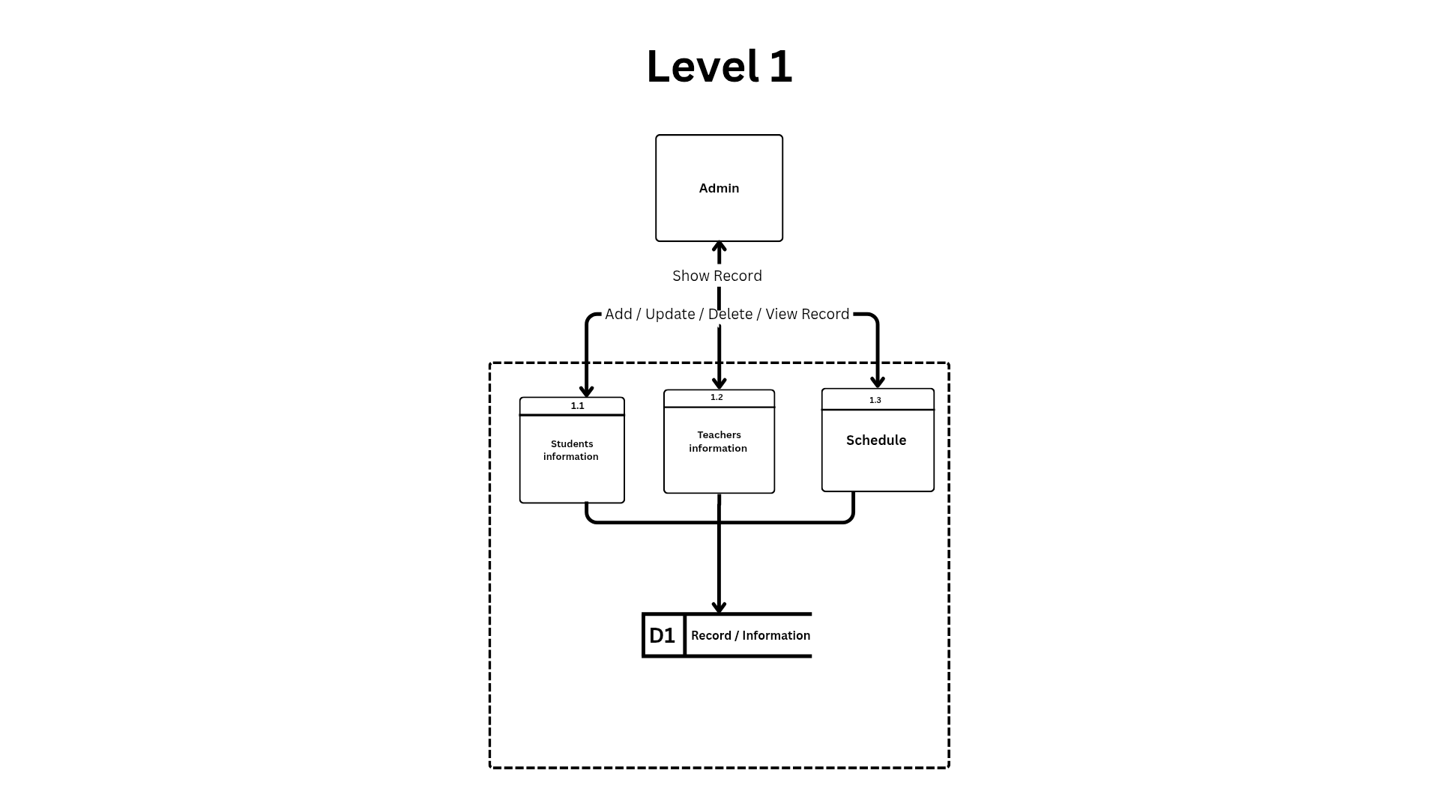
Figure 3. Data Flow Diagram level 1
The DFD Level 1 shows a more detailed view of how the Records/Profile Management System works internally. In this diagram, the Admin is still the main user who interacts with the system by performing actions such as adding, updating, deleting, and viewing records. These inputs are then processed by different parts of the system.
The system is divided into three main processes: managing student information, teacher information, and schedule. Each process handles specific data. The student information process stores and retrieves data from the student database (D1), while the teacher information process interacts with the teacher database (D2). The schedule process manages scheduling data and stores it in the schedule database (D3).
When the Admin sends a request, the system processes it in the appropriate module and stores the data in the corresponding database. After processing, the system sends back the updated or requested records to the Admin.
This diagram shows how the system is organized into smaller processes and how data flows between the Admin, the processes, and the databases, providing a clearer understanding of how the system operates internally.

3.10 Use Case Diagram
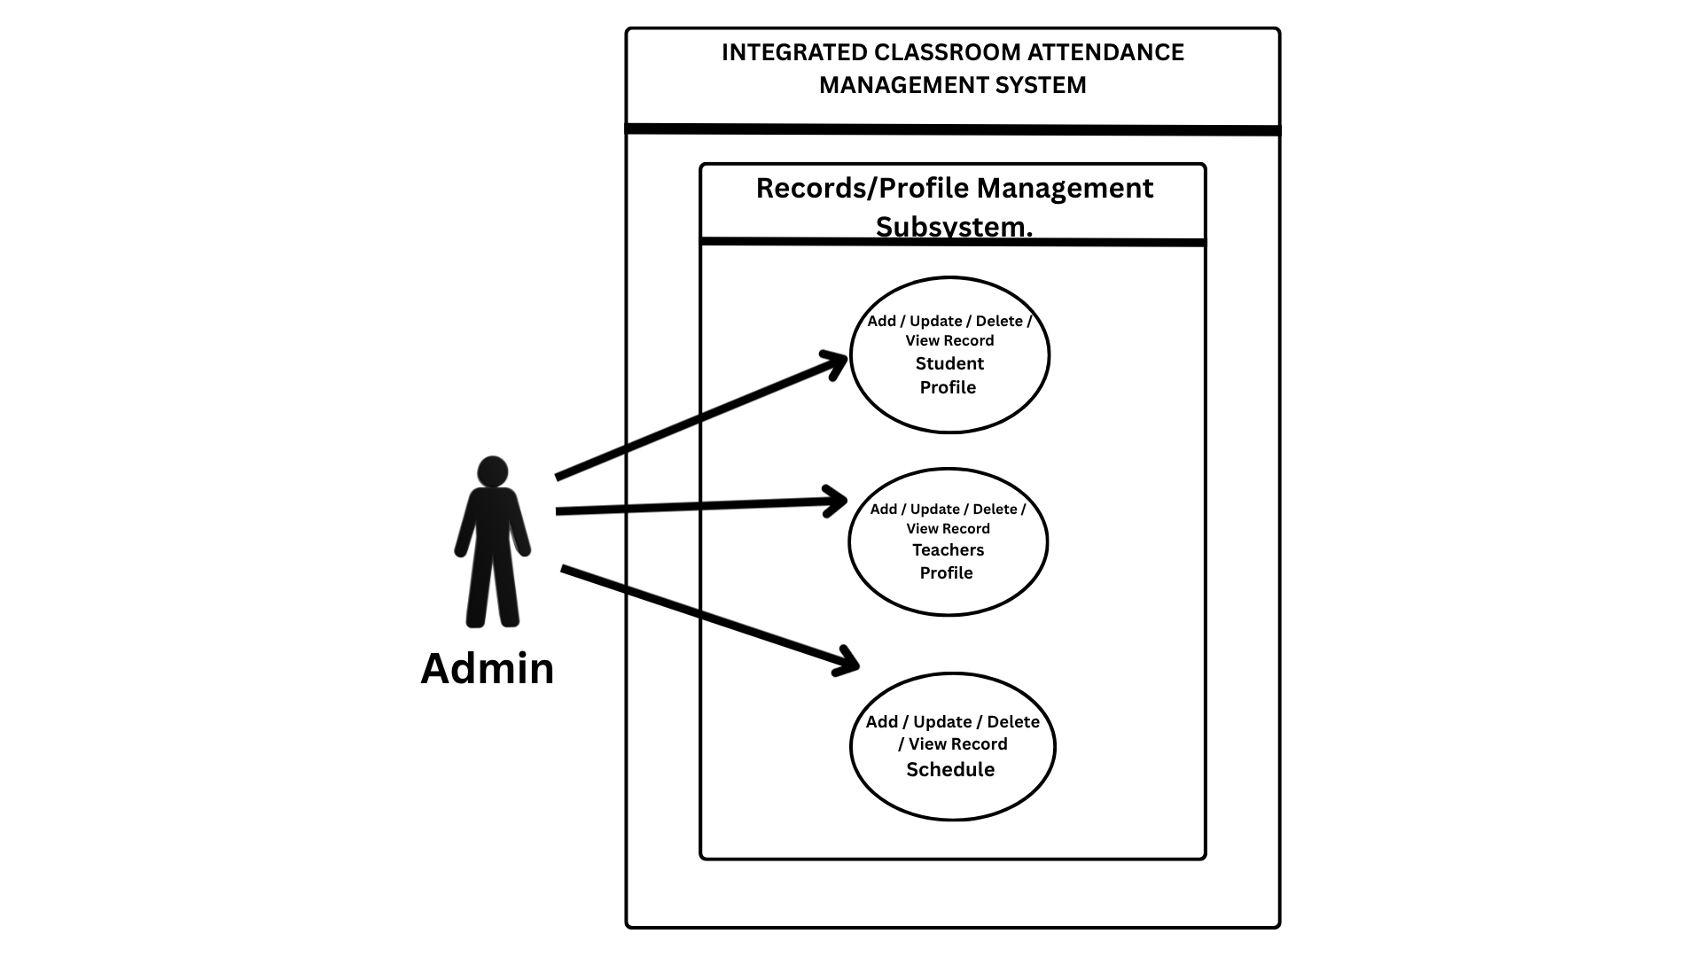
Figure 4. Use Case Diagram.
The Admin starts by accessing the Integrated Classroom Attendance Management System, usually by logging into the system interface. Once inside, the admin is directed to the main dashboard, where different system modules are available.
From there, the admin selects the Records/Profile Management Subsystem, which is a specific part of the system designed for managing data. After entering this subsystem, the admin can perform actions such as adding, updating, deleting, and viewing records for student profiles, teacher profiles, and schedules.
3.11 Data Dictionary

Stores information about classes, including class code, section, and subject details.
Classes table
Name | Type | Field size | Purpose
class_id | int | 11 | Unique identifier for each class.
class_code | varchar | 10 | Stores the class code.
section | varchar | 20 | Indicates the class section.
subject_code | varchar | 20 | Stores the subject code.
subject_name | varchar | 100 | Stores the subject name.

Stores class schedule information, including day, time, room, and instructor details.
Schedule table
Name | Type | Field size | Purpose
schedule_id | int | 11 | Unique identifier for each schedule.
class_code | varchar | 10 | Stores the class code for the schedule.
day | varchar | 20 | Indicates the scheduled day of the class.
time | varchar | 50 | Stores the class time schedule.
room | varchar | 20 | Indicates the assigned classroom or room.
instructor | varchar | 100 | Stores the name of the class instructor.

Stores student information, including personal, academic, and contact details.
Students table
Name | Type | Field size | Purpose
id | int | 11 | Unique identifier for each student record.
student_id | varchar | 20 | Stores the student’s official ID number.
full_name | varchar | 100 | Stores the full name of the student.
gender | varchar | 10 | Indicates the student’s gender.
course | varchar | 20 | Stores the student’s course or program.
year_level | int | 11 | Indicates the student’s year level.
contact | varchar | 20 | Stores the student’s contact number.
email | varchar | 100 | Stores the student’s email address.
parent_name | varchar | 100 | Stores the parent or guardian’s name.
parent_contact | varchar | 20 | Stores the parent or guardian’s contact number.

Stores the assigned schedules and classes of students.
Student_schedule table
Name | Type | Field size | Purpose
id | int | 11 | Unique identifier for each record.
student_id | int | 11 | Stores the student’s ID reference.
schedule_id | int | 11 | Stores the schedule reference.
class_id | int | 11 | Stores the class reference.
created_at | timestamp |  | Records the date and time the record was created.
updated_at | timestamp |  | Records the date and time the record was last updated.
Table 3.
In this part, list and describe all the data elements used in your system — such as tables, fields, data types, and descriptions.
Include the field name, data type, field size, and purpose of each item. This helps in understanding how data is stored, organized, and used in your database.
3.12 Entity Relationship Diagram
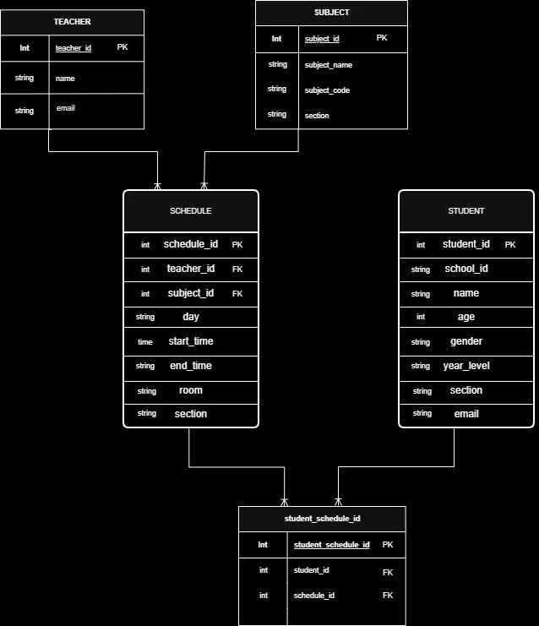
Figure 5: ERD (Entity Relationship Diagram)
3.13 Prototypes

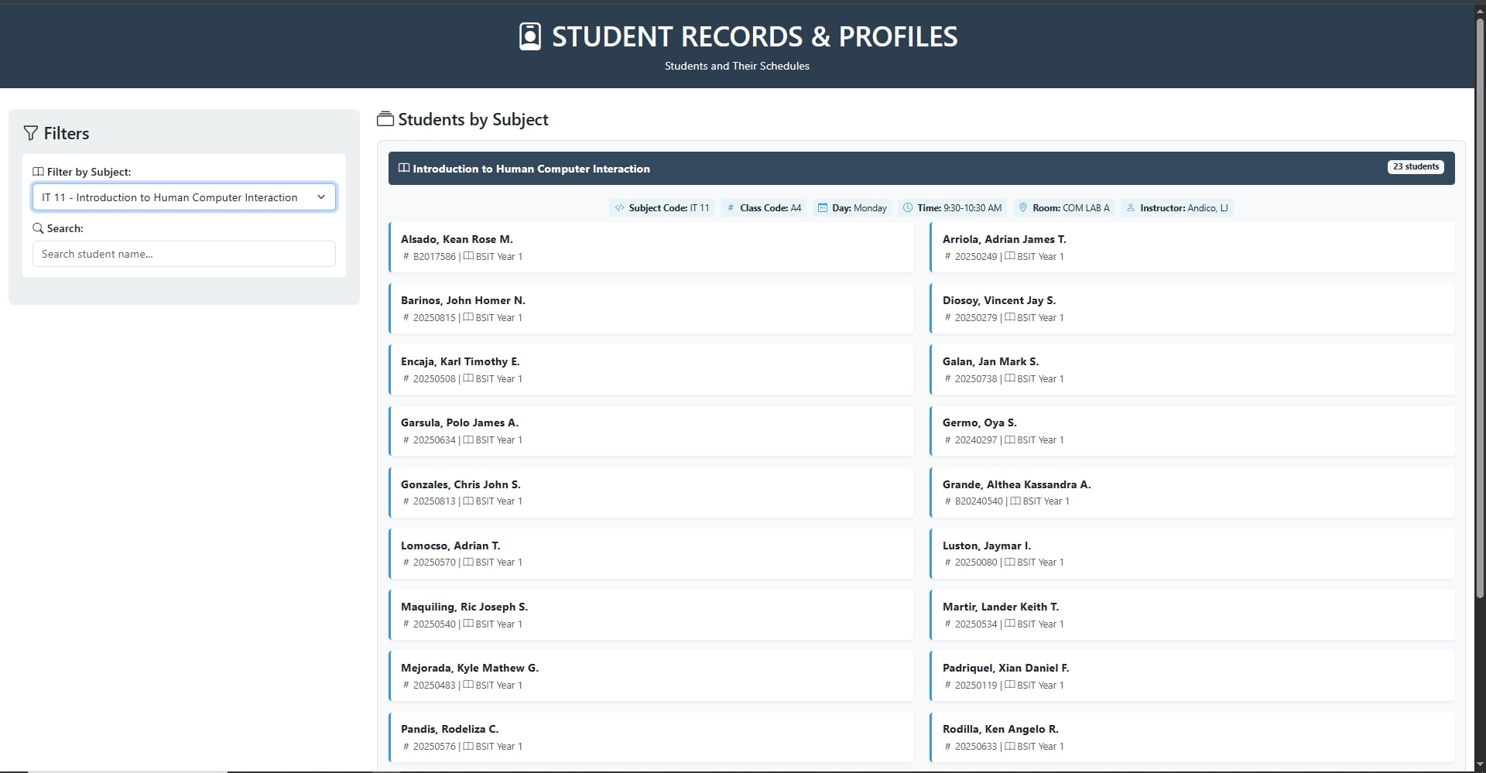
Figure 6.

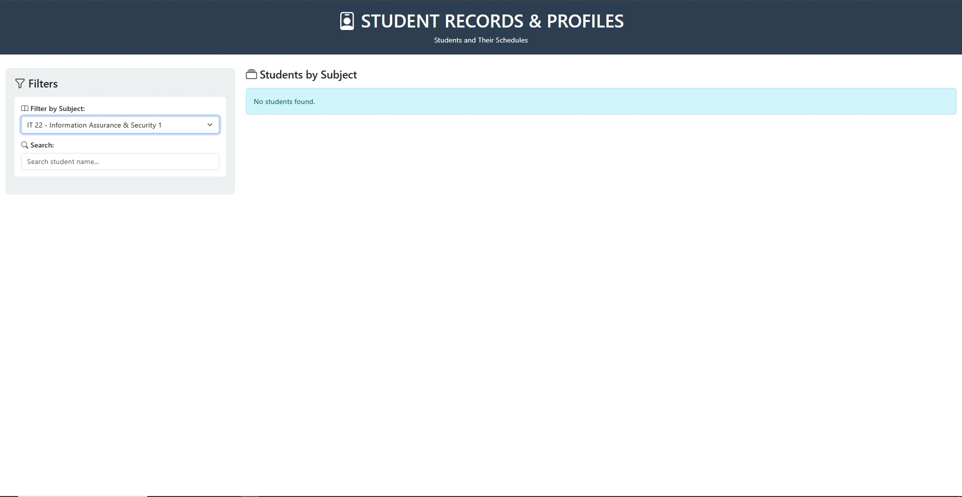
Figure 7

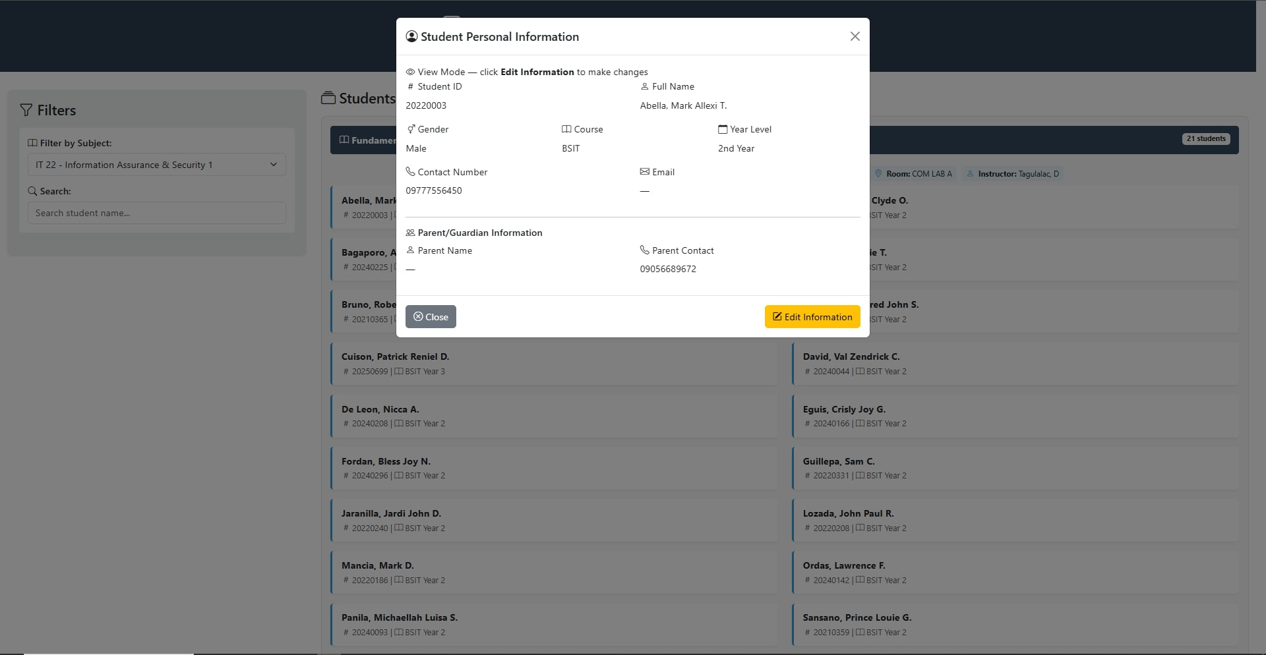
Figure 8

Chapter 4
Results and Discussion
4.1 Results and Discussions
In this part, present the data you gathered from surveys, tests, or system evaluation. Use tables, charts, or figures to show results clearly. Then, discuss what the results mean—relate them to your objectives, and explain any patterns, findings, or unexpected outcomes.
4.2 System Evaluation
In this part, describe how you assessed the performance of your system. Include feedback from users or evaluators using criteria such as usability, functionality, reliability, and efficiency. Present the results of the evaluation (e.g., survey ratings or comments) and explain how well the system met the objectives.

Chapter 5
Summary Findings, Conclusion and Recommendation
5.1 Summary Findings
In this part, highlight the key results of your study.
Summarize the most important findings based on your data and system evaluation. Keep it clear and focused on how your objectives were met or addressed.
5.2 Conclusion
In this part, summarize the overall outcome of your study.
State whether your objectives were achieved, and briefly explain the impact or significance of your system. You may also mention any lessons learned during the development process.
5.2 Recommendation
In this part, suggest ways to improve the system or how it can be implemented effectively. You may also recommend future enhancements, additional features, or areas for further study based on your findings.
References
[1] S. A. Hameed and A. O. Sorour, “A web-based student information management system for Iraqi universities,” International Journal of Advanced Computer Science and Applications, vol. 6, no. 10, pp. 155–162, 2015.
[2] R. Kumar and P. Sharma, “Web-based student profile management system for secondary schools,” International Journal of Computer Applications, vol. 181, no. 45, pp. 12–18, 2019.
[3] M. Al-Saqqa, S. Saad, and H. Abdel-Nabi, “Student records and profile management in higher education using open-source platforms,” Journal of Information Technology Education: Research, vol. 18, pp. 221–240, 2019.
[4] A. Tella and A. Issa, “Library information and records management systems in academic libraries,” Library Hi Tech, vol. 34, no. 2, pp. 298–315, 2016.
[5] G. Osei-Bonsu, “The effect of computerized records management systems on the performance of educational institutions in Ghana,” African Journal of Education and Practice, vol. 3, no. 2, pp. 34–47, 2017.
[6] Z. Liu, J. Wang, and H. Zhang, “Data integrity and access management in student information systems,” IEEE Transactions on Learning Technologies, vol. 11, no. 3, pp. 312–323, 2018.
[7] B. O. Akinyele, A. A. Olorunfemi, and S. Bankole, “Digital transformation of student records in Nigerian tertiary institutions,” Journal of Education and Practice, vol. 11, no. 6, pp. 55–63, 2020.
[8] Y. Kim and J. Park, “Development of a unified student and faculty information management portal for Korean universities,” Computers in Education Journal, vol. 12, no. 1, pp. 44–57, 2021.
[9] T. Alqahtani and F. Alharbi, “Cloud-based student record management system for Saudi Arabian schools,” International Journal of Advanced Research in Computer Science, vol. 13, no. 2, pp. 88–97, 2022.
[10] P. Nwosu, C. Eze, and K. Okeke, “Improving student attendance and profile accuracy through integrated management systems in West African secondary schools,” African Educational Research Journal, vol. 10, no. 3, pp. 177–189, 2022.
[11] J. M. Reyes, R. C. Santos, and M. A. Cruz, “Development of a school records management system for public high schools in Laguna,” Unpublished undergraduate thesis, Laguna State Polytechnic University, Philippines, 2018.
[12] L. B. Santos and R. P. Dela Cruz, “Integrated faculty and student information system for a private college in Metro Manila,” Unpublished undergraduate thesis, Polytechnic University of the Philippines, 2021.
[13] M. B. Garcia and A. L. Flores, “Digital student records management for state universities in the Philippines,” Philippine Journal of Science and Technology, vol. 14, no. 2, pp. 45–58, 2020.
[14] R. T. Villanueva, J. C. Bautista, and K. M. Pascual, “Development of a web-based enrollment and records management system for secondary schools in Cavite,” Unpublished undergraduate thesis, Cavite State University, 2019.
[15] C. A. Mendoza and P. R. Aquino, “Implementation of a student information and attendance management system for technical-vocational schools in the Philippines,” Asia Pacific Journal of Education, Arts and Sciences, vol. 9, no. 1, pp. 72–81, 2022.
Appendices
Appendix A - Gantt Chart
Appendix B - Communications
Appendix C - Evaluation Tool and Test Document
Appendix D - User Manual
Appendix E - Picture Showcasing the data gathering, investigation, etc.
Appendix F - Proposed System Budget
Appendix G - Curriculum Vitae

