40266742 - Rebecca Barnett

**─**

**Character Art**

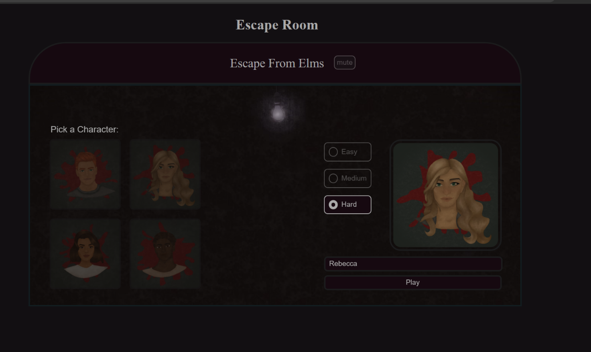 Using Procreate (an Apple art app) and my iPad, I drew four characters. I attempted to keep them as diverse as possible in order to attempt to make the game as accessible to as many people as possible.

Each character is 100% original and created from scratch for this game and any resemblance to real people/characters is completely coincidental.

The characters serve to make the game more personalised for each new player.

**Level 5**

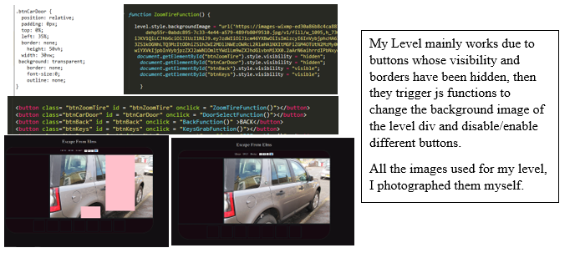

**Inventory Boxes**

