Individual Summary Report

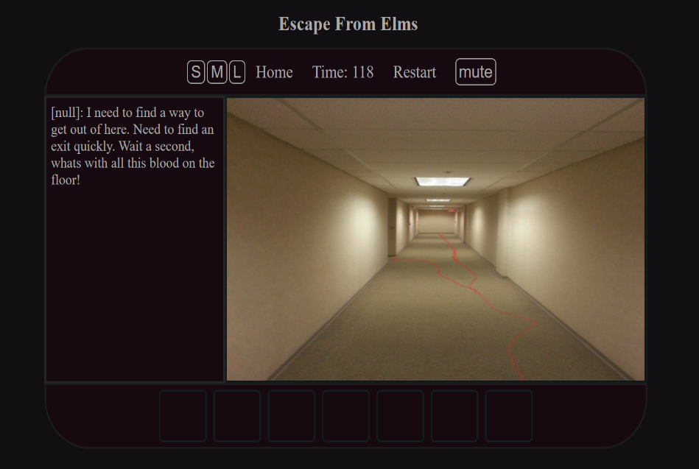**Web Theme** – At the start of the project design brief we had concluded that we were going to use my CSS design format for the entire website.

**Audio & Mute –** I have also added on click event listeners to most of the web pages that will initiate any audio files upon user interaction.

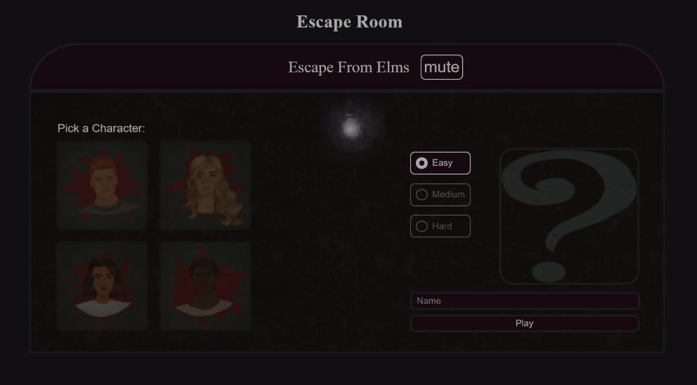**Home page –** I am also the developer for the home page in which the user selects a character, player name and a difficulty. Each difficulty corresponds to a set number of levels the player interacts with. The easy difficulty will have the player complete two relatively easy levels. Medium difficulty will have 4 available levels and the hard difficulty will allow the player to go through a total of 5 levels. The user input found on this page is passed along through the other pages and levels using the local storage which can be accessed and manipulated by the other pages such as the difficulty variable.

**Page responsiveness & accessibility** – Another major role I have had in the project is the implementation of page responsiveness. The vision was to allow users across multiple platforms to have access to the game without any shortcomings such as a lack of page responsiveness which can outright make the game unplayable. Therefore, a lot of the CSS was designed to accommodate the player’s viewport which requires relative positioning and the use of view height and view width CSS commands. Furthermore, as the game is best played in a landscape view rather than a vertical view, 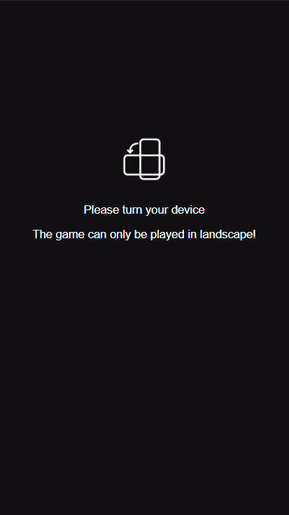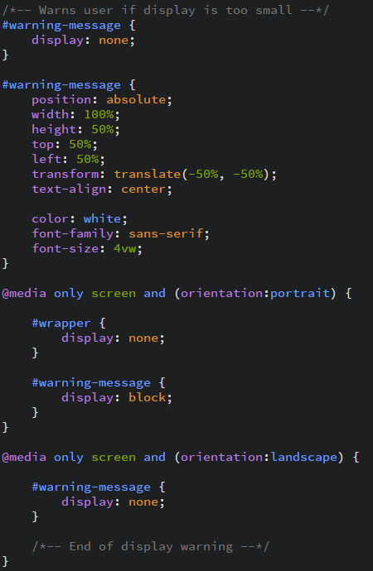the following code will show the following output.

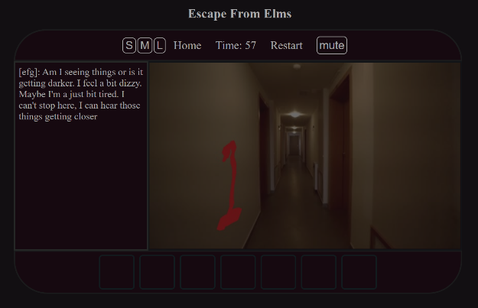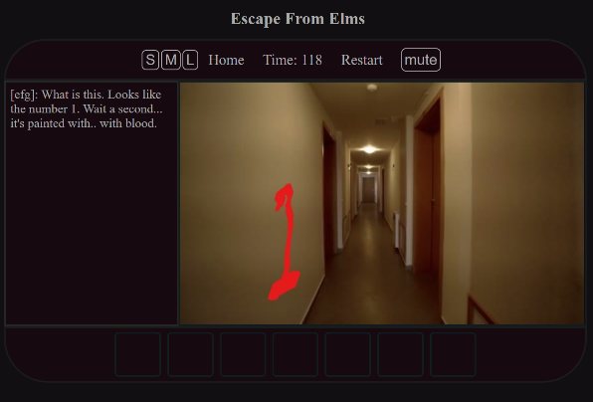**Level 4 –** I am also the developer for the 4th level of the game which can be played on medium and hard difficulty. This level is also the longest level in the game with a total of 2 minutes of playtime. The level will have the player navigate a long maze of corridors which will have numbers that the player must remember in the correct order that they found them at in order to proceed to the next level. A timed event/animation is also used to make the screen darker every second to obscure the player’s vision which will the level significantly harder the longer it is played.