Thermodynamic characterization of the marine boundary layer during fog and dew occurrences in the hyperarid coastal climate of the Atacama Desert
F.M. Narbona, S. Acevedo, C. Del Río, A. Siegmund, F. Lobos-Roco
2026-10-10
Abstract
In the hyperarid coastal Atacama Desert, fog and dew are the main water sources for ecosystems and local communities; however standard atmospheric water collectors cannot separate both phenomena because their collection periods overlap. We distinguish fog from dew occurrences and characterize the thermodynamic structure of the marine boundary layer under each regime, using 10-min observations from 2024 along a nine-station topographic transect at Cerro Oyarbide, coastal Atacama (48 to 1354 m a.s.l.), combined with horizontal visibility and GOES-16 fog and low cloud (FLC) detection. Occurrences are classified as fog when visibility is below 1000 m and as dew otherwise, using GOES-16 FLC when visibility is unavailable. Atmospheric water is collected in 8.6% of the 10-min records of the year. Within this window, and according to our classification fog occurs xx% over the year and dew XX% over the year. Fog developed under a more well-mixed boundary layer than dew, with mean potential temperature gradients at the main station of 2.57×10⁻³ K m⁻¹ under fog and 3.34×10⁻³ K m⁻¹ under dew, compared with 9.4×10⁻³ K m⁻¹ without occurrences, although the fog and dew distributions overlapped. Humidity and wind speed gradients separated active occurrences from periods without occurrences better than fog from dew. Specific humidity increased after fog records (+0.47 g kg⁻¹ after 180 min) but remained nearly unchanged after dew records (+0.07 g kg⁻¹), so no humidity sink was detected under dew. Thus, standard collectors strongly underestimate dew, and thermal stability is the main thermodynamic signature separating fog from dew.
Keywords: Fog; Dew; Marine boundary layer; Atmospheric stability; GOES-16; Atacama Desert

1. Introduction
In the coastal Atacama Desert, precipitation is almost null (Houston, 2006), thus fog and dew are the main water sources sustaining hyperarid ecosystems and local communities (Lobos-Roco et al., 2024; Río et al., 2021). In this area, Tillandsia landbeckii is a classic example of fog- and dew-dependent vegetation, which localised within 900 and 1200 m a.s.l. received fog during afternoon (Cereceda et al., 2008; García et al., 2021), and dew at night during periods of reduced fog (Jabbusch & Koch, 2025; Latorre et al., 2011). Other species share this dependence, including congeneric Tillandsia (Pinto et al., 2006) and biological soil crusts (Jung et al., 2019). Regarding dew specifically, the cactus Copiapoa cinerea var. haseltoniana shows differential radiative cooling across its stem and spines, a property exploited in biomimetic dew harvesting designs (Malik et al., 2023), suggesting some desert plants may rely preferentially on this water source. Coastal communities have also used fog water for drinking supply and small scale greenhouse vegetable production (Albornoz et al., 2023; Fessehaye et al., 2014).
Coastal fog and dew are condensation processes that occurs within the marine boundary layer (MBL), governed by turbulent mixing, advection and thermal stratification (Lobos-Roco et al., 2024; Stull, 1988). Fog forms when a moist air parcel saturates, then reaching the dew point ($T_{air}≤T_{dew}$) (Gultepe et al., 2007). In the Atacama, fog results from the advection of marine stratocumulus clouds, which are formed over the South East Pacific (SEP) Ocean under high subsidence promoted by the South Pacific Anticyclone (Cereceda et al., 2002; Cereceda et al., 2008; Rutllant & Montecino, 2002). This subsidence contrasts with the cold Humboldt Current and the cold water upwelling forming a strong thermal inversion (~20 K) that limits vertical mixing, driving the stratocumulus cloud formation (Espinoza et al., 2024). The anticyclonic circulation in the SEP transports these well-formed stratocumulus up to 50–60 km inland (Lobos-Roco et al., 2024; Río et al., 2021). Here, clouds get in contact with the coastal mountain range between 600 and 1200 m asl, forming a fog belt. One of the main thermodynamic characteristic of stratocumulus cloud-fog in the Atacama is that it develops under a well-mixed (turbulent) MBL, with low potential temperature gradients (∂θ/∂z < 3.1×10⁻³ K m⁻¹) (Lobos Roco et al., 2018) and continuous positive moisture advection (∂q/∂t ≈ +0.016 g kg⁻¹ h⁻¹) (Lobos-Roco et al., 2024).
In contrast, dew forms over surfaces, which driven by nocturnal radiative cooling, reach the dew point ($T_{surf}≤T_{dew}$), condensing directly on solid surfaces under clear, calm, humid conditions (Jacobs et al., 2006; Monteith, 1957). In terms of thermodynamics, dew forms under a more stable surface layer (∂θ/∂z > 3.8×10⁻³ K m⁻¹) and a net negative vapour tendency (∂q/∂t ≈ −0.25 g kg⁻¹ h⁻¹) (Lobos-Roco et al., 2024). This contrast shows that atmospheric thermal stability is a reliable variable to distinguish between fog and dew, unlike the moisture gradient, which is limited by MBL humidity homogeneity (Lobos-Roco et al., 2024). Contrary, since dew formation reduces the air humidity by transferring it to the surface, the ∂q/∂t also might play a role in distinguish dew from fog.
Fog and dew can be quantified by measuring their respective collection rates. For that purpose, standardized passive collectors have been developed. On the one hand, the Standard Fog Collector (SFC), collects fog droplets over a 1 m² polypropylene mesh (Schemenauer & Cereceda, 1994). In the Atacama, fog collects rates from 3 to 8 $L m^{−2} day^{−1}$ (Cereceda et al., 2008; Larrain et al., 2002). On the other hand, the Standard Dew Collector (SDC), collects dew by cooling a plate surface of a 1 m² by nocturnal radiative loss (Muselli et al., 2002). In the Atacama, collection rates of dew fall within the range observed in other arid regions worldwide, from 0.1 to 0.8 L m⁻² day⁻¹ (Lobos-Roco et al., 2024). Despite the effort of quantify fog and dew through the passive collection, they fail to distinguish between the two phenomena due to an instrumental overlap in their collection periods, which leaves their relative contribution highly uncertain (Lobos-Roco et al., 2024).
In hyperarid regions, accurately measuring their dynamics is essential to understanding their contribution to the hydrological cycle and the carbon balance of these ecosystems (Wang et al., 2016). Both processes provide the moisture upon which biological soil crusts and other surface organisms depend on, directly influencing their carbon-sequestering capacity. This underscores the need for methods that allow for the precise determination of each phenomenon’s individual contribution (Chamizo et al., 2021; Li et al., 2025). In contrast to fog, our understanding of dew remains very limited (Li et al., 2025). Beyond its ecological significance, this understanding could also benefit local communities by improving water-harvesting technologies and guiding appropriate water management in arid regions.
In the context of the highly uncertainty that fog and dew collectors produces, in this study we aim to distinguish fog from dew by analyzing their atmospheric thermodynamic characteristics. In particular we aim to answer: How do atmospheric stability and humidity tendency differ between fog and dew occurrences in the coastal Atacama Desert? To answer this question, we test three falsifiable hypotheses. Firstly, (occurrence): the frequency of dew occurrences compared to total occurrences exceeds the ones recorded by SDC. Secondly (structure): fog forms under a well mixed and turbulent marine boundary layer (lower ∂θ/∂z and higher ∂U/∂z), whereas dew forms under a more stratified and calm layer (higher ∂θ/∂z and lower ∂U/∂z), while ∂q/∂z would not allow discrimination between both regimes, since both require a well-mixed vapor column near saturation. Thirdly (dynamics): fog is marked by continuous humidity advection (∂q/∂t > 0), while dew by a surface humidity sink (∂q/∂t ≤ 0), reflecting opposite atmospheric water vapor tendency. To test these hypothesis, our research strategy was based a combination of in-situ meteorological observations from a topographic transect and satellite information retrieved from GOES satellite. This manuscript is structured as follows. Section 2 describes the study area and the methods used to quantify the variables required to test our three falsifiable hypotheses. In Section 3 we presents our results, which are organized into three sub-sections: (3.1) the occurrence of fog and dew, (3.2) the vertical thermodynamic structure of the boundary layer under each regime, and (3.3) the temporal evolution of specific humidity. Building upon our results, Section 4 discusses these findings in light of the existing literature. Finally, Section 5 offers conclusions and future prospects of this study.

2. Methods

2.1 Study area: Cerro Oyarbide
The observational data source used in this study are located over topographic transect placed at Cerro Oyarbide (~20.61°S, 70.07°W). This site is located in the Atacama coastal mountain range about 13 km inland from the coastline (Figure 1, B and D). The climate is hyper-arid, where almost no rain occurs and the sole water inputs to the surface comes from dew and fog. Such conditions only sustain Tillandsia landbeckii species, a rootless plant that locates between 900 and 1200 m above sea level, in the upper border of the fog belt (García et al., 2021; Koch et al., 2019). This site works as a natural laboratory for studying fog and dew, since the station transect overcome the vertical extent of the MBL (~1200 m a.s.l.), with a continuous topographic gradient of 9 stations (0 to 1354 m a.s.l) crossing exactly the band where regional stratocumulus fog concentrates (Figure 1, A). This band ranges from a cloud base as low as ~753 m a.s.l. to a cloud top as high as ~1400 m a.s.l. (Del Río et al., 2021). Within this gradient, our main station named OYA1211 located on the upper border of Tillandsia landbeckii fields (Figure 1, C), allowing direct characterization of the atmosphere-biosphere interaction at the same point where the classification protocol is anchored.
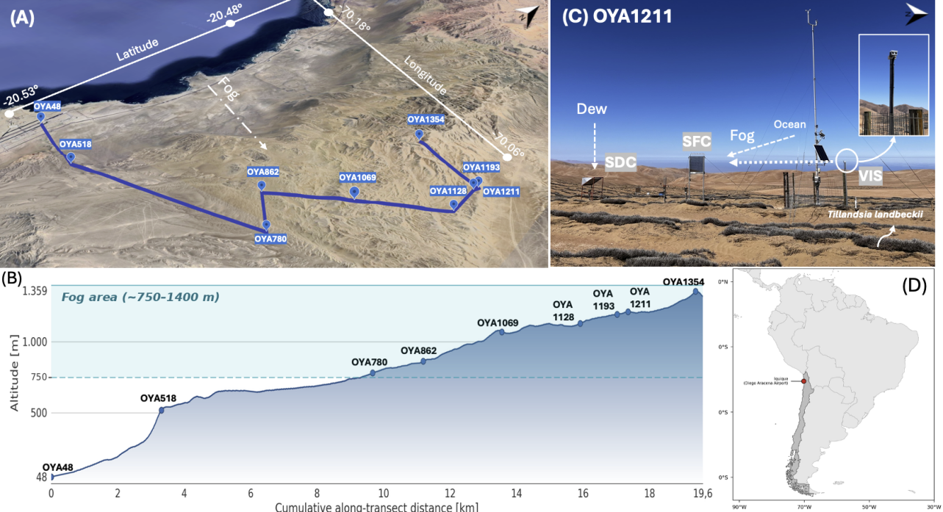
Figure 1: Overview of the study site at Cerro Oyarbide, Atacama Desert, Chile. (A) Satellite image showing a perspective view of the meteorological station topographic transect on Cerro Oyarbide taken from Google Earth Pro. The blue line connects the stations along the topographic transect. The dotted line traces the dominant fog advection direction indicated. (B) Topographic profile of the transect showing station elevation (z, m a.s.l.) over distance (km), illustrating how the stations are distributed across the vertical profile of the marine boundary layer and the stratocumulus fog band. (C) Photograph of station OYA1211, located at the upper border of the Tillandsia landbeckii fields, showing the main instrumentation setup: the visibility sensor (VIS), surface fog collector (SFC), and standard dew collector (SDC), together with the dominant fog and dew input pathways. Inset shows a detail of the VIS sensor mounted on the station mast. (D) South America. The red dot marks the location of the studio.

2.2 Data and instrumentation
The dataset used in this study spans the full year 2024 at a 10-minute interval, includes air temperature (°C), relative humidity (%), wind speed (m/s) and direction (°), horizontal visibility (m), air pressure (Pa), and fog and dew collection (mL m⁻²). Data availability varies by station and sensor (?@tbl-availability). For example, stations OYA518, OYA780, OYA1128, and OYA1211 maintain almost complete continuity throughout 2024, while station OYA1069 shows critical gaps due to sensor malfunction, including total data loss of temperature and only 16.7% availability in relative humidity and wind direction, which exclude it from most subsequent thermodynamic gradients. Among these stations, OYA1211 is the most fully equipped of the entire transect, including the standard dew collector (SDC), the standard fog collector (SFC), and the horizontal visibility sensor (Figure 1, C).
The main observations used in this study are the fog and dew collectors and the visibility sensor. The fog collector (SFC) is a 1 m² standard mesh that intercepts fog droplets (0.2 to 30 μm) advected by the wind. Droplets grow by coalescence and precipitate along the mesh into tipping bucket pluviometer, which measure the water volumes per time (Schemenauer & Cereceda, 1994). The dew collector (SDC) is a 1 m² tilted surface where water vapor condenses once surface temperature drops below the dew point; the water then flows by gravity into a tipping bucket pluviometer (Muselli et al., 2002). The SFC faces the prevailing fog advection from the ocean (west), the SDC captures vertical condensation toward the surface, and the visibility sensor is aligned perpendicular to the SFC for undisturbed optical measurements.
This ground-based network is further complemented by GOES-16 satellite observations, processed in Google Earth Engine at a spatial resolution of 2 km and synchronized every 10 minutes, which detect fog and low clouds (FLC) using a dual-band brightness temperature threshold algorithm, whose methodology can be found in Del Río et al. (2021) and Espinoza et al. (2024). These satellite data is used as a secondary layer and for regional validation of the fog or dew occurrence classification criteria. All data have been processed in R using the tidyverse ecosystem and under version control on GitHub (Muñoz-Narbona et al., 2026).
Percentage of data availability (%) for 2024 at a 10-minute temporal resolution across the ground monitoring network. The numeric suffix in each station’s name designates its operating altitude (m a.s.l.). Abbreviations: Temp (air temperature), HR (relative humidity), U (wind speed), DV (wind direction), Niebla (surface fog occurrence validation), Pres (atmospheric pressure), Rad (global radiation), Vis (visibility), Rocío (dew collection), Dist (distance to the coastline). Dashes (–) indicate that the variable is not monitored by the station. GOES-16 satellite images maintained 100% availability for low cloud (FLC) detection throughout the entire study period.
Station | Dist (km) | Temp (°C) | HR (%) | U (m/s) | DV (°) | Fog (mL m⁻²) | Pres (hPa) | Vis (m) | Dew (mL m⁻²)
OYA48 (AERP.) | 0.86 | 100% | 100% | 100% | 100% | – | 100% | 0% | –
OYA518 | 4.18 | 99% | 99% | 97% | 99% | 99% | 99% | 0% | –
OYA780 | 9.83 | 99% | 99% | 98% | 99% | 99% | 99% | 0% | –
OYA862 | 8.67 | 86% | 91% | 86% | 91% | 9% | 0% | 0% | –
OYA1069 | 10.75 | 0% | 17% | 0% | 17% | 17% | 0% | 0% | –
OYA1128 | 12.92 | 100% | 100% | 100% | 100% | 100% | 0% | 0% | –
OYA1193 | 13.12 | 90% | 92% | 90% | 92% | 92% | 0% | 0% | –
OYA1211 | 13.11 | 100% | 100% | 100% | 100% | 100% | 100% | 93% | 100%
OYA1354 | 11.41 | 83% | 83% | 83% | 83% | 92% | 0% | 0% | –

2.3 Data Processing
The research strategy has been divided into three specific objectives (SO), associated to each hypothesis: (1) characterize the temporal distribution of fog and dew occurrences and their co-occurrence from visibility and GOES observations; (2) evaluate the atmospheric stability under each occurrence type through potential temperature, specific humidity, and wind speed vertical gradients along the topographic station transect; (3) analyze the tendency on time of humidity, potential temperature and wind speed under fog and dew occurrences.

2.3.1 SO1: Hierarchical classification of fog and dew occurrences
To achieve the first SO, we used two criteria based on visibility and FLC detection, where visibility is the priority. Regardless of whether water is collected by the SFC or the SDC, the occurrence is classified as fog if visibility falls below 1000 m. The occurrence is classified as dew if visibility is equal to or above 1000 m. GOES-16 FLC served as a secondary criterion when visibility is unavailable, given its coarser spatial resolution and vertical uncertainty, since a detected low cloud pixel does not necessarily intersect the topography.
$$\text{Occurrence Type}\text{=}\left\{\begin{matrix}\text{fog}\text{,} & \text{if visibility}\text{<}1000\text{ m, or visibility is unavailable and GOES FLC}\text{=}1 \\ \text{dew}\text{,} & \text{if visibility}\text{≥}1000\text{ m, or visibility is unavailable and GOES FLC}\text{=}0\end{matrix}\right. (1)$$
In addition to the classification algorithm, a manual review is performed. The automatic classification is compared against the visibility curve and the GOES signal. Isolated errors are corrected, and days of atypical behavior are documented. For example, an abrupt drop and recovery of visibility within a short period is likely caused by sensor lens dew condensation, or debris such as dust particles or insects obstructing the sensor rather than an actual fog occurrence, and is reclassified as dew. Likewise, when a continuous occurrence is interrupted by an isolated 10-minute segment classified differently, this segment is corrected to match the surrounding occurrence.

2.3.2 SO2: Analyse the atmospheric stability through the thermodynamic vertical gradients
After reclassified fog and dew occurrences using the satellite and visibility criteria, we analyse the atmospheric stability of fog and dew reclassified occurrences. For analyzing the atmospheric stability we use two thermodynamic conserved variables of potential temperature (θ), specific humidity (q) and wind speed (U). Potential temperature is calculated as follows:
$$θ=T⋅{\left(\frac{P_{0}}{P}\right)}^{R/C_{p}} (2)$$
where T is the absolute air temperature (K), P0 is the pressure (hPa) measured at the lowest station, P is the atmospheric pressure level at every station (hPa), R is the constant gas of dry air (287.08 J kg⁻¹ K⁻¹) and cp is the specific heat of dry air (1004.67 J kg⁻¹ K⁻¹). Specific humidity (q) is approximated using the mixing ratio (r), since in the lower troposphere the water vapor mass is much smaller than the dry air mass and the total pressure greatly exceeds the vapor pressure, so that q ≈ r. ‘q’ is estimated using the following expression:
$$q≈r=ϵ\frac{e}{P−e} (3)$$
where ϵ is he ratio of the molecular weight of water vapor to that of dry air (ϵ=0.622 kg kg-1), e is the water vapor pressure (hPa), obtained from relative humidity and saturated vapor pressure.
To calculate the vertical gradients that are used as a proxy of atmospheric stability we used:
$$\frac{∂ϕ}{∂z}∼\frac{Δϕ}{Δz}=\frac{ϕ_{2}−ϕ_{1}}{z_{2}−z_{1}}, ϕ∈\{θ,q,U\} (4)$$
where $ϕ$ represents the conservative scalar of $θ$, q or U, z1 the reference altitude level (48 m asl) and z2 the altitude of each station. Both the vertical gradients and the temporal rates presented below correspond, in principle, to partial derivatives; however, given the finite number of observations available, they are approximated here as finite differences (Δ). Vertical gradients ∂φ/∂z are calculated along the 48–1354 m transect in relation to the coastal baseline, to determine the stability of the MBL, with φ ∈ {θ, q, U}.
The differences in the vertical gradients between fog, dew and no occurrence were tested with the Kruskal–Wallis test for the three groups and the Mann–Whitney test for each pair of groups, reporting the effect size r. The ability of ∂θ/∂z to separate fog from dew at OYA1211 was evaluated with the area under the receiver operating characteristic (ROC) curve and its optimal cut-off (Youden index). These tests were used to define the new thresholds proposed in this study.

2.3.3 SO3: Analyse the temporal tendency of conserved variables
To achieve the third SO, we calculated temporal rates ∂φ/∂t using forward finite differences, with φ ∈ {θ, q, U}. Fixed delays ranging from 10 min to 180 min are used to characterize the response to occurrence onset. Differences of 1 hour, with a tolerance of up to 2 hours, are used for the diurnal cycle and annual distribution statistics. This temporal rate operationalizes the third objective, associated with the dynamics hypothesis. All timestamps are processed in UTC (mainland Chile local time = UTC−4). The differences in the temporal rates between fog, dew and no occurrence were tested with the same Kruskal–Wallis and Mann–Whitney tests used for the vertical gradients.
$$\frac{∂ϕ}{∂t}∼\frac{Δϕ}{Δt}=\frac{ϕ_{2}−ϕ_{1}}{t_{2}−t_{1}}, ϕ∈\{θ,q,U\} (5)$$

3. Results
The complete observational dataset of the Cerro Oyarbide topographic transect allows us to reclassify the fog and dew occurrences detected by the passive collectors using visibility ground measurements and remote-sensing satellite observations (Section 3.1). This reclassification is then analysed through the vertical profiles of the thermodynamic variables (Section 3.2) and their temporal tendency during fog and dew occurrences (Section 3.3).

3.1 Fog and dew occurrences instrumental reclassification
Atmospheric water (AW: fog or dew) in Cerro Oyarbide is collected by at least one of the collectors in only 8.6% of the 10-min records of 2024, whereas the remaining 91.4% of the year had no AW ocurrances occurrences (Figure 2, A). These percentages reveals that the active window of atmospheric water collection is very short, thus each misclassified interval weighs proportionally more than its duration suggests. Within this window, the direct collectors detection reports 49.2% of fog occurrance, 46.8% mixed fog and dew, and only 4.0% dew occurance (Figure 2, B). However, by analysing visibility complemented by satellite observation of FLC, the reclassification shifts to 54.2% for fog occurance and 45.8% for dew occurance (Figure 2, C). This significative change evidences that fog and dew collectors overlap in 46.8% of the total atmospheric water inputs occurance. This instrumental overlap is not an isolated noise; once corrected, the fraction of dew ocurrance increases in one order of magnitude, from 4.0% to 45.8%. Considering the entire year 2024, the reclassified fog frequency reads 4.7% of the 10-min records and the dew frequency 3.9%. The fog frequency agrees with two observations that are independent of the collectors, namely the frequency of FLC detected by GOES-16 over the station (4.4% of the 10-min records of 2024) and the frequency of visibility below 1000 m (5.2% of the records with available visibility).
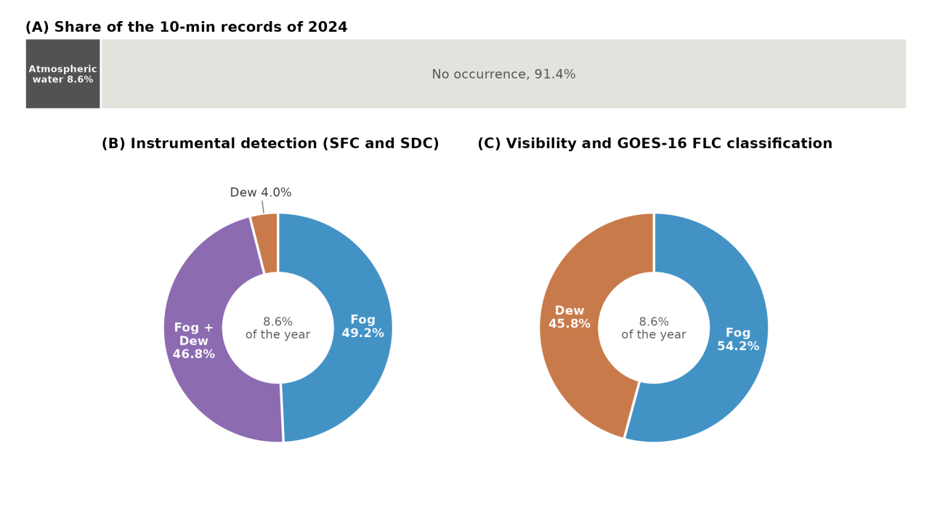
Figure 2: Classification of atmospheric water occurrences at station OYA1211 during 2024. (A) Proportion of the 10-min records of the year with atmospheric water (fog or dew collection) and without occurrences. (B) Internal distribution of the atmospheric water records according to the instrumental detection by the standard fog collector (SFC) and the standard dew collector (SDC). (C) Internal distribution after the classification based on visibility and GOES-16 fog and low clouds (FLC) detection.
The deepen the analysis shown in Figure 2, we focus in anlysing four specific days in Figure 3, which are example of typical fog and dew events. Typical fog days occur on April 28th and September 21st, 2024. On April 28th, visibility drops from 4000 m to near zero (minimum of 103 m) and remains below 1000 m from 04:40 to 12:00 UTC (00:40 to 08:00 local time). While visibility drops, GOES-16 indicates the presence of FLC (04:30 to 10:50 UTC) and both collectors registered water, so the occurrence is classified as fog. Likewise, on September 21st, visibility also drops below 1000 m during the collection period (minimum of 218 m), from 04:30 to 13:20 UTC (01:30 to 10:20 local time, UTC−3), and GOES-16 detects FLC from 04:30 to 13:50 UTC. In this case only the SDC registers water, so the collectors would assign the occurrence to dew, whereas the reclassification assigns it to fog. Conversely, typical dew days occur on April 24th and November 28th ,2024. On April 24th, visibility remains above 1000 m all day (minimum of 1110 m at 09:20 UTC) and GOES-16 does not detect FLC, while only the SFC registers water from 03:40 to 12:50 UTC (23:40 to 08:50 local time). This occurrence is classified as dew because visibility remains above 1000 m, although the collectors would assign it to fog. On November 28th, visibility remains above 3300 m all day long and only the SFC registers water, from 03:00 to 10:50 UTC (00:00 to 07:50 local time). During this period, GOES-16 detects FLC only at 04:00 UTC, and since visibility has priority over GOES-16 in the classification criteria, the occurrence is classified as dew. Days without occurrences and particular cases, such as May 17th, when erratic visibility alternates between fog and dew within the same day, are shown in Appendix A (Figure 8).
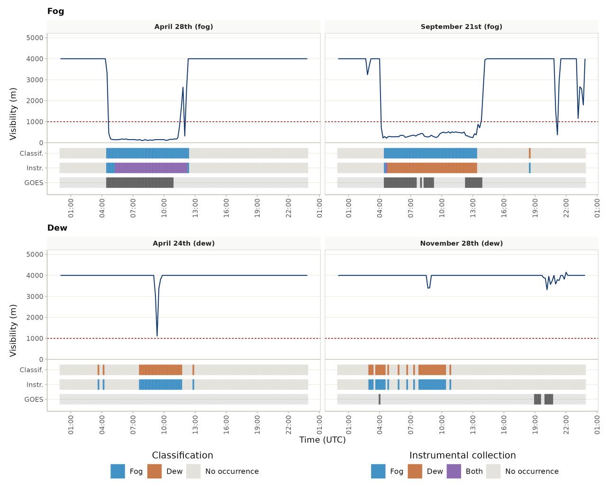
Figure 3: Typical fog and dew events at station OYA1211. Days classified as fog (April 28th and September 21st, 2024) and dew (April 24th and November 28th, 2024). The blue line shows horizontal visibility and the red dashed line the 1000 m threshold. Lower bands show, every 10 minutes, the final classification (Classif.), the instrumental collection before the classification (Instr.: fog collector only, dew collector only, both collectors, or no occurrence), and the GOES-16 fog and low clouds (FLC) detection. Times are in UTC.
Beyond these specific days, the reclassification also changes the seasonal and diurnal distribution of fog and dew occurrences, both in frequency and in collected water, which is shown in Figure 4. In terms of frequency, the SFC register water in 98% to 100% of the atmospheric water records of every month, except in August (70%) and September (63%), when the SDC is more frequent; 82% and 89%, respectively (Figure 4, A and B). This near-continuous signal of fog in the collector arises because the SFC registers water both when it is the only collector active (49.2% of the atmospheric water records) and simultaneously with the SDC (46.8%), so that only the 4.0% of the records collected exclusively by the SDC fall outside it (Figure 2, B). After the reclassification, this instrumental frequency is partitioned: the fog frequency retains only the records that visibility and GOES-16 identify as fog, whereas the records collected by the SFC under non-fog conditions are reassigned to dew. This results in that fog is more frequent than dew in eight of twelve months, reaching its maximum in June (83%, although based on only six records), whereas dew is more frequent in January (65%), February (57%), July (56%) and November (57%). At the diurnal scale (Figure 4, C and D), the reclassified dew is as frequent as or more frequent than the reclassified fog between 01:00 and 09:00 UTC (49% to 57% of the records), whereas fog dominates from 10:00 UTC onwards, exceeding 80% at 12:00 and 13:00 UTC and between 20:00 and 23:00 UTC. Between 14:00 and 17:00 UTC the atmospheric water records are scarce, so their frequencies in this interval are unstable.
In terms of collected water, after the reclassification the water of each occurrence is quantified as the amount actually measured by the collector designed to capture it, that is, the SFC for fog and the SDC for dew, even in the records in which both collectors registered water simultaneously (Figure 4, bars). The mean water collected during the reclassified fog exceeds that of the reclassified dew by more than one order of magnitude: across months it ranges from ~13 to ~172 mL, whereas the reclassified dew ranges from ~2 to ~12 mL. Over the whole year, the mean of the reclassified fog (~69 mL) is about 15 times the mean of the reclassified dew (~4.6 mL), and dew accounts for only ~1% of the total reclassified water, despite occupying 45.8% of the active window (Figure 2). This low contribution also reflects that only 16% of the records reclassified as dew registered water in the SDC, since most of them were collected only by the SFC. Compared with the instrumental detection, the mean of the reclassified fog exceeds the instrumental one in all twelve months, because the instrumental fog mean also includes the smaller amounts collected by the SFC during records reclassified as dew, whereas the mean of the reclassified dew is lower than the instrumental one in ten of the eleven months with dew records in the SDC. At the daily scale (Figure 4, C and D), the reclassified fog shows a nocturnal plateau of ~57 to 79 mL between 00:00 and 11:00 UTC and an afternoon peak of ~264 mL at 20:00 UTC, whereas the nocturnal reclassified dew remains between ~2.7 and 7.5 mL, and no dew water is registered between 15:00 and 22:00 UTC.
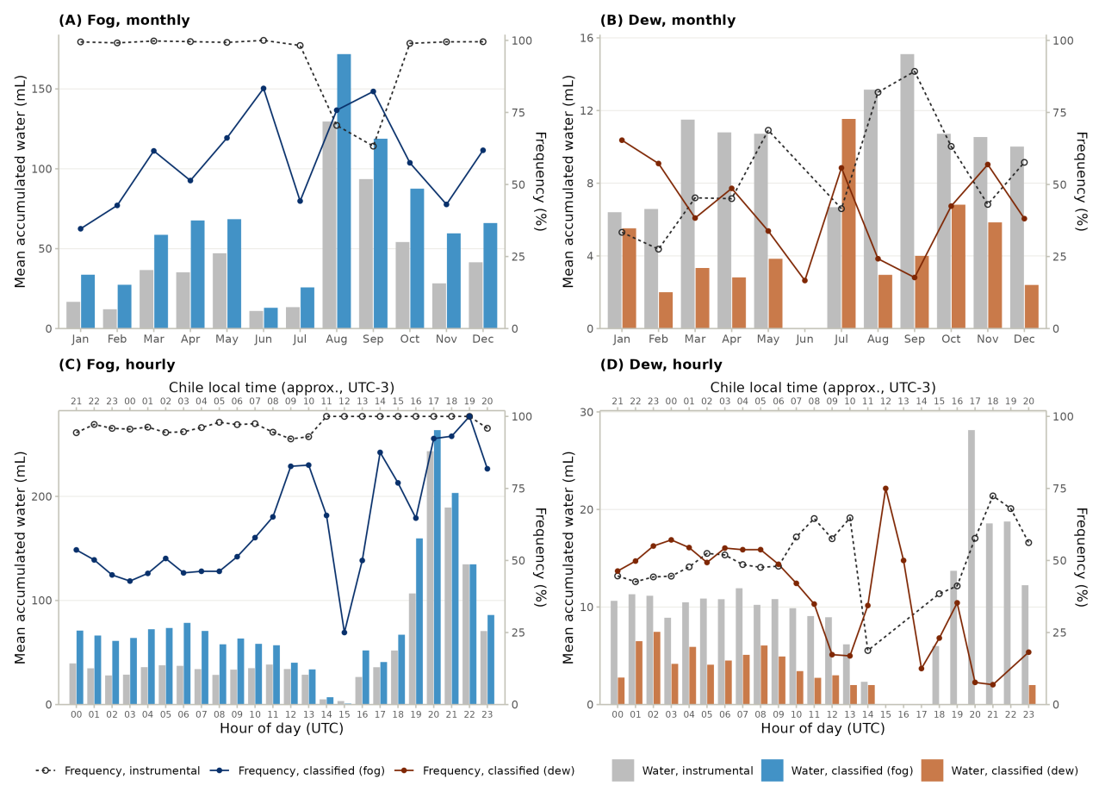
Figure 4: Seasonal and diurnal distribution of fog and dew occurrences at station OYA1211 during 2024, before (instrumental) and after (classified) the classification based on visibility and GOES-16 fog and low clouds (FLC) detection. (A) Fog and (B) dew monthly distribution; (C) fog and (D) dew hourly distribution. Bars show the mean accumulated water per 10-min record (values > 0; left axis): in grey for the instrumental detection (water of the standard fog collector, SFC, for fog and of the standard dew collector, SDC, for dew) and in blue (fog) or orange (dew) after the classification (water of the SFC in the records classified as fog and of the SDC in the records classified as dew). Lines show the frequency as percentage of the 10-min records with atmospheric water (right axis). For the instrumental detection (dashed line, open circles), it is the percentage of these records in which the SFC (A, C) or the SDC (B, D) registered water; since both collectors often register water at the same time, the instrumental fog and dew frequencies can add up to more than 100%. For the classification (solid line, filled circles), fog and dew add up to 100%. Note the different water scales of each panel. In (C) and (D), the lower axis is in UTC and the upper axis in approximate Chile local time (UTC-3).

3.2 Atmospheric stability under fog and dew occurrences
Once fog and dew occurrences are reclassified, we evaluate whether they develop under different atmospheric stability. Figure 5 shows vertical profiles of θ, q and U along the transect on April 28th (fog) and April 24th (dew). For each occurrence, it shows the hour with the most contrasting θ profile between both regimes, which is 11:00 UTC on both days, together with the hour without atmospheric water of the same day whose θ profile contrasts most with the occurrence (17:00 UTC on April 28th and 22:00 UTC on April 24th). On April 28th, θ increases by only ~2.1 K between 48 and 1211 m a.s.l. during the fog hour, compared with ~12.1 K during the hour without occurrence. On April 24th, θ increases by ~5.8 K over the same layer during the dew hour, an intermediate slope between the fog profile and the profiles without occurrence (~13.1 K on the same day). In contrast, q and U do not show a comparable difference between occurrence types, and q remains between ~8.6 and 10.5 g kg⁻¹ from 48 to 1211 m a.s.l. during both the fog and the dew hours. Above 1211 m a.s.l., the fog and dew profiles show a sharp increase in θ (~8.6 and 6.9 K, respectively), whereas the profiles without occurrence, already warmer below, increase by only ~1.9 to 2.8 K. Specific humidity decreases at 1354 m a.s.l. in all profiles (to ~2.3 to 6.6 g kg⁻¹), whereas the wind speed profiles do not follow a consistent pattern.
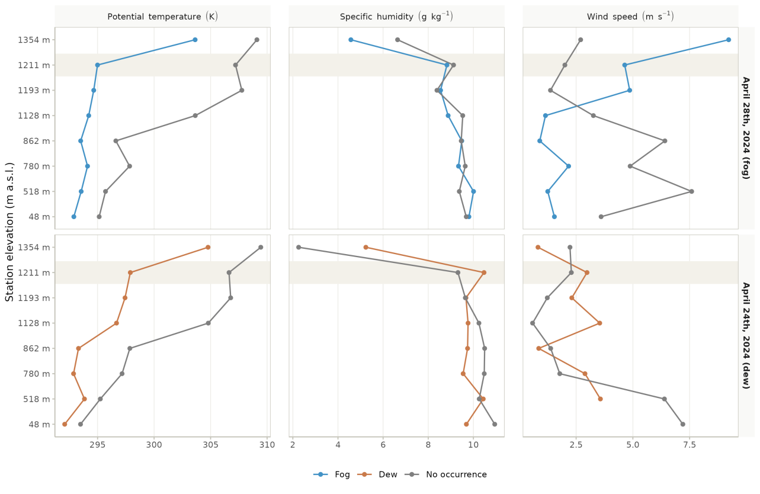
Figure 5: Vertical profiles on a typical fog day and a typical dew day. Potential temperature (θ), specific humidity (q) and wind speed (U) along the Cerro Oyarbide transect on April 28th, 2024 (fog, top) and April 24th, 2024 (dew, bottom), the same days shown in Figure 3. For each day, the hour of the occurrence with the most contrasting θ profile between both regimes (11:00 UTC on both days; fog in blue, dew in orange) and the hour without atmospheric water at OYA1211 with the most contrasting θ profile with the occurrence (17:00 UTC on April 28th and 22:00 UTC on April 24th; grey) are shown. Stations are ordered by elevation (vertical spacing not to scale), and the shaded band marks OYA1211. OYA1069 is not shown because it has no valid data in 2024.
To verify whether this contrast holds at the annual scale, Figure 6 summarizes the mean vertical gradients between the coastal reference station (48 m a.s.l.) and each station of the transect for fog, dew and no occurrence during 2024. Under fog, ∂θ/∂z remains low from 518 to 1211 m a.s.l. (1.3×10⁻³ to 3.2×10⁻³ K m⁻¹), with a mean of 2.57×10⁻³ K m⁻¹ at OYA1211. Under dew, it is higher at every station (2.0×10⁻³ to 3.7×10⁻³ K m⁻¹), with a mean of 3.34×10⁻³ K m⁻¹ at OYA1211, while under no occurrence it increases with elevation from 2.8×10⁻³ K m⁻¹ at 518 m a.s.l. to 9.4×10⁻³ K m⁻¹ at OYA1211. At 518 m a.s.l. the three regimes show similar gradients (1.9×10⁻³ to 2.9×10⁻³ K m⁻¹), but from 780 m a.s.l. upward dew lies much closer to fog than to no occurrence: at OYA1211, the dew mean exceeds the fog mean by 0.77×10⁻³ K m⁻¹, whereas the no-occurrence mean is almost three times the dew mean. The difference in ∂θ/∂z between fog and dew is statistically significant both at OYA1211 (Mann–Whitney, r = 0.25, p < 0.001) and along the transect (r = 0.20, p < 0.001), and the three groups differ globally (Kruskal–Wallis, χ² = 9116.2 at OYA1211 and χ² = 21627.5 along the transect, df = 2, p < 0.001). However, the fog and dew distributions of ∂θ/∂z overlap: at OYA1211, 54% of the fog records are below 2.6×10⁻³ K m⁻¹ and 31% exceed 3.1×10⁻³ K m⁻¹, whereas 52% of the dew records exceed 3.1×10⁻³ K m⁻¹. When used to separate fog from dew, ∂θ/∂z at OYA1211 reaches an area under the ROC curve of 0.64, with an optimal cut-off (Youden index) of 3.4×10⁻³ K m⁻¹ and an accuracy of 63%. The general threshold of 3.1×10⁻³ K m⁻¹ (Lobos Roco et al., 2018) falls between the fog and dew means at OYA1211, while 97% of the no-occurrence records at this station exceed it. At 1354 m a.s.l., ∂θ/∂z increases in all regimes (5.8×10⁻³, 6.6×10⁻³ and 9.8×10⁻³ K m⁻¹ for fog, dew and no occurrence, respectively), consistent with the sharp θ increase above 1211 m a.s.l. observed in Figure 5 and with the thermal inversion above the marine boundary layer.
Unlike θ, ∂q/∂z barely differs between fog and dew along the transect (e.g., −4.9×10⁻⁴ and −3.3×10⁻⁴ g kg⁻¹ m⁻¹ at OYA1211), with small effect sizes (r = 0.13 at OYA1211 and r = 0.04 along the transect). Under no occurrence, ∂q/∂z becomes more negative above 862 m a.s.l. (−2.0×10⁻³ g kg⁻¹ m⁻¹ at OYA1211), so ∂q/∂z separates active occurrences from no occurrence (r = 0.18 at OYA1211) better than fog from dew. At OYA1211, only 3.5% of the fog records and 4.9% of the dew records are below the threshold of −1.6×10⁻³ g kg⁻¹ m⁻¹ proposed by Lobos Roco et al. (2018), compared with 48% of the no-occurrence records. Averaging both regimes, active occurrences show a mean ∂q/∂z of −4.1×10⁻⁴ g kg⁻¹ m⁻¹ at this station, a value that we propose as a new threshold.
Finally, ∂U/∂z is negative at most stations, that is, wind speed is lower than at the coast, and it does not differ between fog and dew at OYA1211 (p = 0.63, r = 0.02), while along the transect the difference is small (r = 0.07). Only at 1354 m a.s.l. does the wind speed exceed that of the coast under fog and dew. Overall, ∂θ/∂z is the only gradient that separates fog from dew with a non-trivial effect size, and the three gradients separate active occurrences from no occurrence more clearly than fog from dew.
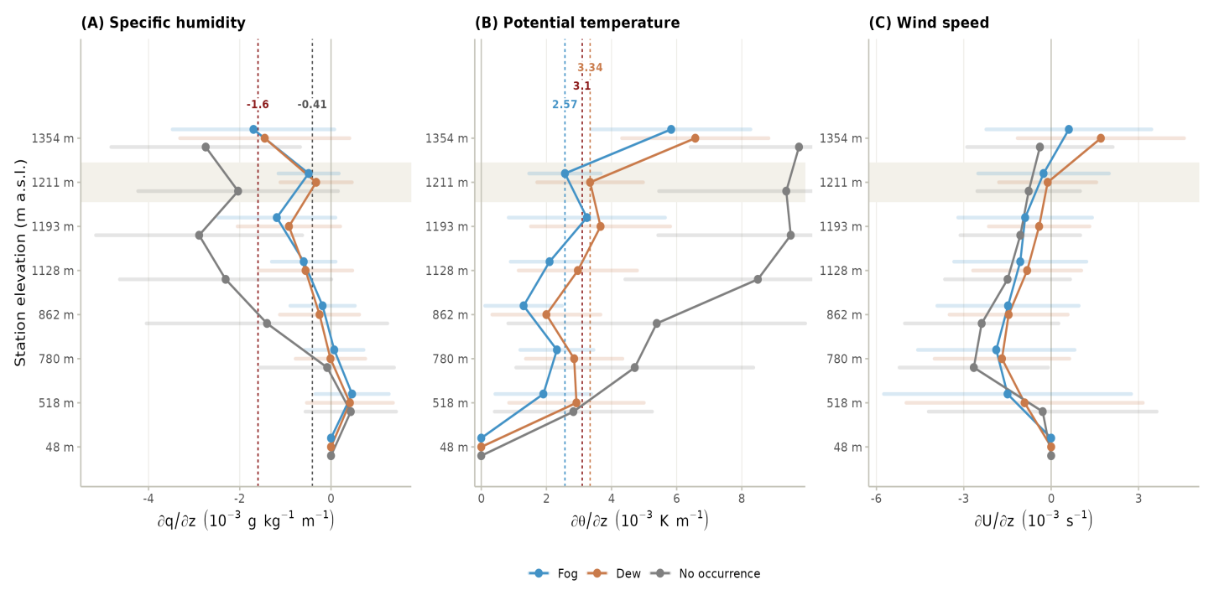
Figure 6: Mean vertical gradients of (A) specific humidity (∂q/∂z), (B) potential temperature (∂θ/∂z) and (C) momentum (∂U/∂z) between the coastal reference station (48 m a.s.l.) and each station of the Cerro Oyarbide transect, for fog (blue), dew (orange) and no occurrence (grey) during 2024. Points show the mean and shaded bars ±1 standard deviation of the 10-min records (hourly for ∂U/∂z, limited by the coastal wind record). Stations are ordered by elevation (vertical spacing not to scale), and the shaded band marks OYA1211, the station where the classification is anchored (n = 2086 fog, 1915 dew and 44187 no-occurrence records for ∂θ/∂z). OYA1069 is not shown because it has no valid temperature or wind data in 2024. The 48 m point is the reference station, where all gradients are zero by definition. In (B), the horizontal axis is limited to 9.95×10⁻³ K m⁻¹ to highlight the difference between fog and dew, so the standard deviation bars of no occurrence are partly cut. Dashed vertical lines show the thresholds of Lobos Roco et al. (2018) (dark red: 3.1×10⁻³ K m⁻¹ and −1.6×10⁻³ g kg⁻¹ m⁻¹), the mean ∂θ/∂z of fog (blue, 2.57×10⁻³ K m⁻¹) and dew (orange, 3.34×10⁻³ K m⁻¹) at OYA1211, and the mean ∂q/∂z of active occurrences at OYA1211 (grey, −4.1×10⁻⁴ g kg⁻¹ m⁻¹). Gradients are shown in units of 10⁻³.

3.3 Temporal evolution of humidity, heat and wind speed under fog and dew occurrences
- To evaluate the third hypothesis, Figure 7 shows how q, θ and U evolve at OYA1211 after each 10-min record classified as fog, dew or no occurrence, from 10 to 180 min (Figure 7, A to C), together with the distribution of their 1-h rates (Figure 7, D to F).
- Specific humidity increases steadily after fog records, by +0.17 g kg⁻¹ after 60 min and +0.47 g kg⁻¹ after 180 min, whereas after dew records it remains almost unchanged (+0.01 and +0.07 g kg⁻¹), and under no occurrence it decreases slightly (−0.03 g kg⁻¹ after 180 min) (Figure 7, A).
- At the 1-h scale, the median ∂q/∂t is positive under both regimes: 0.053 g kg⁻¹ h⁻¹ under fog (95% bootstrap confidence interval, 0.035 to 0.067) and 0.038 g kg⁻¹ h⁻¹ under dew (0.019 to 0.056), with largely overlapping interquartile ranges (−0.10 to 0.26 and −0.15 to 0.25 g kg⁻¹ h⁻¹, respectively) (Figure 7, D).
- Therefore, the humidity sink expected under dew (∂q/∂t ≤ 0) is not observed: the dew median is close to neutral but slightly positive, and the rate of −0.25 g kg⁻¹ h⁻¹ reported by Lobos-Roco et al. (2024) falls outside its confidence interval. Under fog, the median rate is about three times the +0.016 g kg⁻¹ h⁻¹ reported by the same study.
- Potential temperature increases after both fog and dew records, faster under dew: +0.70 versus +0.37 K after 60 min and +2.15 versus +1.89 K after 180 min, while under no occurrence it decreases slightly (−0.14 K after 180 min) (Figure 7, B). The median 1-h ∂θ/∂t is 0.16 K h⁻¹ under dew and 0.03 K h⁻¹ under fog, and the dew distribution is wider (interquartile range of −0.24 to 0.89 K h⁻¹, compared with −0.22 to 0.39 K h⁻¹ under fog) (Figure 7, E).
- Wind speed decreases after fog records (−0.13 m s⁻¹ after 60 min and −0.33 m s⁻¹ after 180 min), barely changes after dew records (−0.01 and −0.04 m s⁻¹) and remains nearly constant under no occurrence (+0.02 m s⁻¹ after 180 min) (Figure 7, C). The median 1-h ∂U/∂t is −0.19, −0.05 and +0.05 m s⁻¹ h⁻¹ under fog, dew and no occurrence, respectively, with widely overlapping distributions (Figure 7, F).
- The three groups differ for all variables (Kruskal–Wallis, p < 0.001), but the effect sizes between fog and dew are small (Mann–Whitney, r = 0.05 for ∂q/∂t, 0.12 for ∂θ/∂t and 0.05 for ∂U/∂t), lower than for ∂θ/∂z at OYA1211 (r = 0.25).
- Overall, the temporal tendencies agree with the expected behavior under fog (sustained moistening and deceleration), but not with the humidity sink expected under dew, and they separate fog from dew less clearly than the vertical gradient of θ.
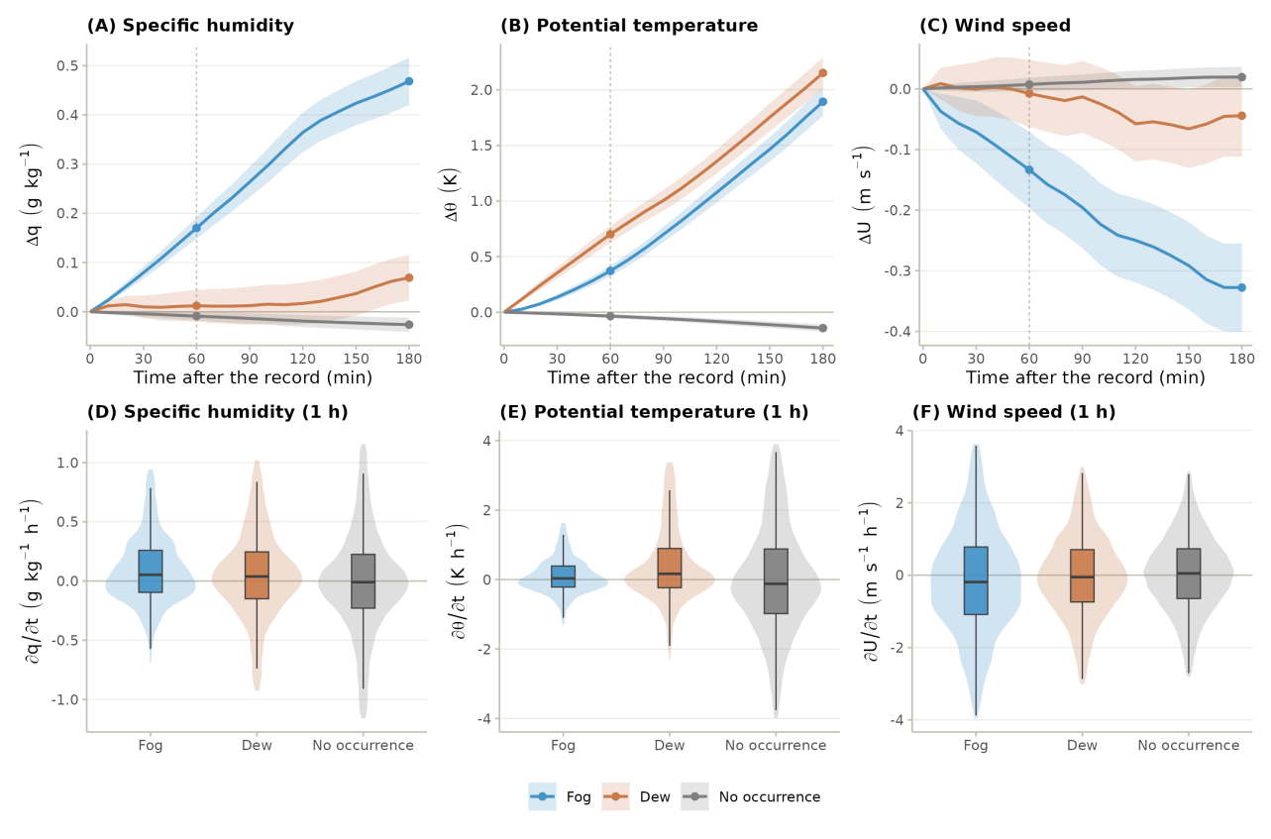
Figure 7: Temporal tendencies of specific humidity, potential temperature and wind speed at station OYA1211. (A to C) Mean change of specific humidity (Δq), potential temperature (Δθ) and wind speed (ΔU) from 10 to 180 min after each 10-min record classified as fog (blue), dew (orange) or no occurrence (grey) during 2024. Shaded bands show the 95% confidence interval of the mean, points mark 60 and 180 min, and the dashed vertical line marks the 1-h window used in the lower panels. (D to F) Distribution of the 1-h rates (∂q/∂t, ∂θ/∂t and ∂U/∂t), computed as forward finite differences with the first valid value between 1 and 3 h ahead, after removing values beyond 1.5 times the interquartile range. Violins show the distribution and boxes the median and interquartile range.

3.4 Extra
- All of these thresholds and rates were derived under the 2024 ENSO context (El Niño → neutral transition), so their interannual generalization to other phases remains an explicit open question rather than an implicit assumption.
- Although fog remains the dominant phenomenon in terms of volume (Figure 4), the ecohydrological relevance of dew rests not on its yield but on its temporal persistence, 45.8% of the active window (Figure 2), which is ultimately why it merits sustained study despite its modest volumetric contribution.

4. Discussion
- The result nonetheless has two limitations that should be acknowledged, although they do not invalidate it: the visibility sensor is itself affected by condensation during dew (a slight drop that never crosses the fog threshold, visible in the dew panels of Figure 3), and the coarser resolution of GOES-16 means that a detected low-cloud pixel does not necessarily intersect the topography.
- This day/night asymmetry is consistent with advection versus radiative cooling mechanisms.
- This repositions the general threshold of Lobos-Roco et al. (2018), 3.1×10⁻³ K m⁻¹: in this dataset, it falls within the dew range rather than at the boundary between dew and non-occurrence conditions, as previously assumed. That value separated fog from “everything else” without distinguishing, within that remainder, a dew regime in its own right.
- The physical reason is that both phenomena require a nearly saturated, well-mixed vapor column to initiate, so discrimination cannot be based on humidity; only thermal stability separates the regimes. As a secondary result, we also propose an updated Δq/Δz threshold to distinguish active occurrences from non-occurrence conditions (−4.1×10⁻⁴ g kg⁻¹ m⁻¹), which refines (without replacing) the primary θ-based criterion.

Appendix A. Particular cases of the classification
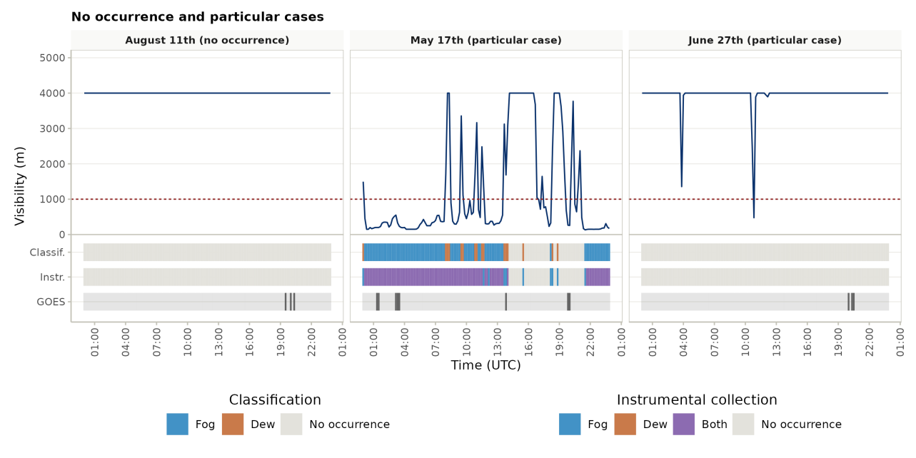
Figure 8: Particular cases of the classification at station OYA1211. A day without occurrences (August 11th, 2024) and two particular cases (May 17th and June 27th, 2024). Lines and bands as in Figure 3.

References
Albornoz, F., Río, C. del, Carter, V., Escobar, R., & Vásquez, L. (2023). Fog water collection for local greenhouse vegetable production in the atacama desert. Sustainability, 15(22), 15720. https://doi.org/10.3390/su152215720
Cereceda, P., Larrain, H., Osses, P., Farías, M., & Egaña, I. (2008). The spatial and temporal variability of fog and its relation to fog oases in the atacama desert, chile. Atmospheric Research, 87(3-4), 312–323. https://doi.org/10.1016/j.atmosres.2007.11.012
Cereceda, P., Osses, P., Larrain, H., Farı́as, M., Lagos, M., Pinto, R., & Schemenauer, R. S. (2002). Advective, orographic and radiation fog in the tarapacá region, chile. Atmospheric Research, 64(1-4), 261–271. https://doi.org/10.1016/s0169-8095(02)00097-2
Chamizo, S., Rodríguez-Caballero, E., Moro, M. J., & Cantón, Y. (2021). Non-rainfall water inputs: A key water source for biocrust carbon fixation. Science of The Total Environment, 792, 148299. https://doi.org/10.1016/j.scitotenv.2021.148299
Del Río, C., Lobos, F., Siegmund, A., Tejos, C., Osses, P., Huaman, Z., Meneses, J. P., & García, J.-L. (2021). GOFOS, ground optical fog observation system for monitoring the vertical stratocumulus-fog cloud distribution in the coast of the atacama desert, chile. Journal of Hydrology, 597, 126190. https://doi.org/10.1016/j.jhydrol.2021.126190
Espinoza, V., Lobos-Roco, F., & Río, C. del. (2024). Synoptic control of the spatiotemporal variability of fog and low clouds under ENSO phenomena along the chilean coast (17°-36° s). Atmospheric Research, 308, 107533. https://doi.org/10.1016/j.atmosres.2024.107533
Fessehaye, M., Abdul-Wahab, S. A., Savage, M. J., Kohler, T., Gherezghiher, T., & Hurni, H. (2014). Fog-water collection for community use. Renewable and Sustainable Energy Reviews, 29, 52–62. https://doi.org/10.1016/j.rser.2013.08.063
García, J.-L., Lobos-Roco, F., Schween, J. H., Río, C. del, Osses, P., Vives, R., Pezoa, M., Siegmund, A., Latorre, C., Alfaro, F., Koch, M. A., & Loehnert, U. (2021). Climate and coastal low-cloud dynamic in the hyperarid atacama fog desert and the geographic distribution of tillandsia landbeckii (bromeliaceae) dune ecosystems. Plant Systematics and Evolution, 307(5). https://doi.org/10.1007/s00606-021-01775-y
Gultepe, I., Tardif, R., Michaelides, S. C., Cermak, J., Bott, A., Bendix, J., Müller, M. D., Pagowski, M., Hansen, B., Ellrod, G., Jacobs, W., Toth, G., & Cober, S. G. (2007). Fog research: A review of past achievements and future perspectives. In Fog and boundary layer clouds: Fog visibility and forecasting (pp. 1121–1159). Birkhäuser Basel. https://doi.org/10.1007/978-3-7643-8419-7_3
Houston, J. (2006). Variability of precipitation in the Atacama Desert: Its causes and hydrological impact. International Journal of Climatology, 26(15), 2181–2198. https://doi.org/10.1002/joc.1359
Jabbusch, S., & Koch, M. A. (2025). Tillandsia landbeckii secures high phenotypic variation despite clonal propagation at the dry limits of plant life in the atacama desert. Perspectives in Plant Ecology, Evolution and Systematics, 66, 125846. https://doi.org/10.1016/j.ppees.2025.125846
Jacobs, A. F. G., Heusinkveld, B. G., Wichink Kruit, R. J., & Berkowicz, S. M. (2006). Contribution of dew to the water budget of a grassland area in the netherlands. Water Resources Research, 42(3). https://doi.org/10.1029/2005wr004055
Jung, P., Emrich, D., Briegel‐Williams, L., Schermer, M., Weber, L., Baumann, K., Colesie, C., Clerc, P., Lehnert, L. W., Achilles, S., Bendix, J., & Büdel, B. (2019). Ecophysiology and phylogeny of new terricolous and epiphytic chlorolichens in a fog oasis of the atacama desert. MicrobiologyOpen, 8(10). https://doi.org/10.1002/mbo3.894
Koch, M. A., Kleinpeter, D., Auer, E., Siegmund, A., Río, C. del, Osses, P., García, J.-L., Marzol, M. V., Zizka, G., & Kiefer, C. (2019). Living at the dry limits: Ecological genetics of Tillandsia landbeckii lomas in the Chilean Atacama Desert. Plant Systematics and Evolution, 305, 1041–1053. https://doi.org/10.1007/s00606-019-01623-0
Larrain, H., Velásquez, F., Cereceda, P., Espejo, R., Pinto, R., Osses, P., & Schemenauer, R. S. (2002). Fog measurements at the site “falda verde” north of chañaral compared with other fog stations of chile. Atmospheric Research, 64(1-4), 273–284. https://doi.org/10.1016/s0169-8095(02)00098-4
Latorre, C., González, A. L., Quade, J., Fariña, J. M., Pinto, R., & Marquet, P. A. (2011). Establishment and formation of fog-dependent <i>tillandsia landbeckii</i> dunes in the atacama desert: Evidence from radiocarbon and stable isotopes. Journal of Geophysical Research, 116(G3). https://doi.org/10.1029/2010jg001521
Li, H., Han, C., Yang, Y., & Chen, R. (2025). Advances and challenges in dew research on land surface: A review. Hydrology, 12(12), 320. https://doi.org/10.3390/hydrology12120320
Lobos Roco, F., Vilà-Guerau de Arellano, J., & Pedruzo-Bagazgoitia, X. (2018). Characterizing the influence of the marine stratocumulus cloud on the land fog at the atacama desert. Atmospheric Research, 214, 109–120. https://doi.org/10.1016/j.atmosres.2018.07.009
Lobos-Roco, F., Suárez, F., Aguirre-Correa, F., Keim, K., Aguirre, I., Vargas, C., Abarca, F., Ramírez, C., Escobar, R., Osses, P., & Río, C. del. (2024). Understanding inland fog and dew dynamics for assessing potential non-rainfall water use in the atacama. Journal of Arid Environments, 221, 105125. https://doi.org/10.1016/j.jaridenv.2024.105125
Malik, T., Gethin, D., Boy, F., Davies, G., & Parker, A. (2023). Re-engineering dew-harvesting cactus macrostructures to enhance water collection as an adaptive climate change strategy: An experimental comparison. Atmosphere, 14(12), 1736. https://doi.org/10.3390/atmos14121736
Monteith, J. L. (1957). Dew. Quarterly Journal of the Royal Meteorological Society, 83(357), 322–341. https://doi.org/10.1002/qj.49708335706
Muñoz-Narbona, F., Lobos-Roco, F., Del Río, C., & Acevedo, S. (2026). Thermodynamic characterization of fog and dew in the Atacama coastal desert (Version v1.0.0) [Computer software]. Zenodo. https://doi.org/10.5281/zenodo.21826557
Muselli, M., Beysens, D., Marcillat, J., Milimouk, I., Nilsson, T., & Louche, A. (2002). Dew water collector for potable water in ajaccio (corsica island, france). Atmospheric Research, 64(1-4), 297–312. https://doi.org/10.1016/s0169-8095(02)00100-x
Pinto, R., Barría, I., & Marquet, P. A. (2006). Geographical distribution of tillandsia lomas in the atacama desert, northern chile. Journal of Arid Environments, 65(4), 543–552. https://doi.org/10.1016/j.jaridenv.2005.08.015
Río, C. del, Lobos-Roco, F., Latorre, C., Koch, M. A., García, J.-L., Osses, P., Lambert, F., Alfaro, F., & Siegmund, A. (2021). Spatial distribution and interannual variability of coastal fog and low clouds cover in the hyperarid atacama desert and implications for past and present tillandsia landbeckii ecosystems. Plant Systematics and Evolution, 307(5). https://doi.org/10.1007/s00606-021-01782-z
Rutllant, J., & Montecino, V. (2002). Multiscale upwelling forcing cycles and biological response off north-central chile. Revista Chilena de Historia Natural, 75(1). https://doi.org/10.4067/s0716-078x2002000100020
Schemenauer, R. S., & Cereceda, P. (1994). A proposed standard fog collector for use in high-elevation regions. Journal of Applied Meteorology, 33(11), 1313–1322. https://doi.org/10.1175/1520-0450(1994)033<1313:apsfcf>2.0.co;2
Stull, R. B. (1988). An introduction to boundary layer meteorology. Kluwer Academic Publishers. https://doi.org/10.1007/978-94-009-3027-8
Wang, L., Kaseke, K. F., & Seely, M. K. (2016). Effects of non‐rainfall water inputs on ecosystem functions. WIREs Water, 4(1). https://doi.org/10.1002/wat2.1179

