Thermodynamic characterization of the marine boundary layer during fog and dew events in the hyperarid coastal climate of the Atacama Desert
F.M. Narbona, S. Acevedo, C. Del Río, A. Siegmund, F. Lobos-Roco
2026-09-11

Introduction
In the coastal Atacama Desert, precipitation is almost null (Houston, 2006), thus fog and dew are the main water sources sustaining hyperarid ecosystems and local communities (Lobos-Roco et al., 2024; Río et al., 2021). In this area Tillandsia landbeckii is a classic example of fog dependent vegetation, concentrated within the fog belt between approximately 750 and 1200 m a.s.l. (Cereceda et al., 2008; García et al., 2021), while dew is thought to buffer this species during periods of reduced fog (Jabbusch & Koch, 2025; Latorre et al., 2011). Other species share this dependence, including congeneric Tillandsia (Pinto et al., 2006) and fog oasis lichens (Jung et al., 2019). Regarding dew specifically, the cactus Copiapoa cinerea var. haseltoniana shows differential radiative cooling across its stem and spines, a property exploited in biomimetic dew harvesting designs (Malik et al., 2023), suggesting some desert plants may rely preferentially on this water source. Coastal communities have also used fog water for drinking supply and small scale greenhouse vegetable production (Albornoz et al., 2023; Fessehaye et al., 2014).
Fog and dew are condensation processes that occurs within the marine boundary layer (MBL), governed by turbulent mixing (fog), advection and thermal stratification (dew) (Lobos-Roco et al., 2024; Stull, 1988). Fog forms when a moist air parcel saturates, then reaching the dew point (Tair ≤ Tdew) (Gultepe et al., 2007). In northern Chile, fog results from the advection of marine stratocumulus clouds, which are formed over the South East Pacific (SEP) Ocean under high subsidence promoted by the South Pacific Anticyclone (Cereceda et al., 2002; Cereceda et al., 2008; Rutllant & Montecino, 2002). This subsidence contrasts with the cold Humboldt Current and the cold water upwelling forming a strong thermal inversion (~20 K) that limits vertical mixing, driving the stratocumulus cloud formation (Espinoza et al., 2024). The anticyclonic circulation in the SEP transports these well-formed stratocumulus up to 50–60 km inland (Lobos-Roco et al., 2024; Río et al., 2021). One of the main thermodynamic characteristic of stratocumulus cloud-fog in the Atacama is that it develops under a well-mixed MBL, with low potential-temperature gradients (∂θ/∂z < 3.1×10⁻³ K m⁻¹) (Lobos Roco et al., 2018) and continuous positive moisture advection (∂q/∂t ≈ +0.016 g kg⁻¹ h⁻¹) (Lobos-Roco et al., 2024).
In contrast, dew forms over surfaces, which driven by nocturnal radiative cooling, reach the dew point (Tsurf ≤ Tdew), condensing directly on solid surfaces under clear, calm, humid conditions (Monteith, 1957). In terms of thermodynamics, dew forms under a more stable surface layer (∂θ/∂z ≈ 3.8×10⁻³ K m⁻¹) and a net negative vapour tendency (∂q/∂t ≈ −0.25 g kg⁻¹ h⁻¹) (Lobos-Roco et al., 2024). This contrast shows that atmospheric thermal stability is a reliable variable to distinguish between fog and dew, unlike the moisture gradient, which is limited by MBL humidity homogeneity (Lobos-Roco et al., 2024). Contrary, since dew formation reduces the air humidity by transferring it to the surface, the ∂q/∂t also might play a role in distinguish dew from fog.
Fog and dew can be quantified by measuring their respective collection rates. For that purpose, standardized passive collectors have been developed. On the one hand, the Standard Fog Collector (SFC), collects fog droplets over a 1 m² polypropylene mesh (Schemenauer & Cereceda, 1994). In the Atacama, fog collects rates from 3 to 8 L m-2 day-1 (Cereceda et al., 2008; Larrain et al., 2002). On the other hand, the Standard Dew Collector (SDC), collects dew by cooling a plate surface of a 1 m² by nocturnal radiative loss (Muselli et al., 2002). In the Atacama, collection rates of dew fall within the range observed in other arid regions worldwide, from 0.1 to 0.8 L m⁻² day⁻¹ (Lobos-Roco et al., 2024). Despite the effort of quantify fog and dew through the passive collection, they fail to distinguish between the two phenomena due to an instrumental overlap in their collection periods, which leaves their relative contribution highly uncertain (Lobos-Roco et al., 2024).
In hyperarid regions, accurately measuring their dynamics is essential to understanding their contribution to the hydrological cycle and the carbon balance of these ecosystems (Wang et al., 2016). Both processes provide the moisture upon which biological soil crusts and other surface organisms depend, directly influencing their carbon-sequestering capacity. This underscores the need for methods that allow for the precise determination of each phenomenon’s individual contribution (Chamizo et al., 2021; Li et al., 2025). In contrast to fog, our understanding of dew remains very limited (Li et al., 2025). Beyond its ecological significance, this understanding could also benefit local communities by improving water-harvesting technologies and guiding appropriate water management in arid regions.
In the context of the highly uncertainty that fog and dew collectors produces, in this study we aim to distinguish fog from dew by analyzing their atmospheric thermodynamic characteristics. In particular we aim to answer how do atmospheric stability and humidity tendency differ between fog and dew eventsin the coastal Atacama Desert? We hypothesize that dew collection is systematically underestimated by standard collectors. Likewise fog and dew show marked difference in the atmospheric stability and specific humidity tendency. We test three falsifiable hypotheses. Firstly, (occurrence): the frequency of dew events compared to total events exceeds the ones recorded by SDC. Secondly (structure): fog forms under a well mixed and turbulent marine boundary layer (lower ∂θ/∂z and higher ∂U/∂z), whereas dew forms under a more stratified and calm layer (higher ∂θ/∂z and lower ∂U/∂z), while ∂q/∂z would not allow discrimination between both regimes, since both require a well mixed vapor column near saturation. Thirdly (dynamics): fog is marked by continuous humidity advection (∂q/∂t > 0), while dew by a surface huimidty sink (∂q/∂t ≤ 0), reflecting opposite atmospheric water vapor tendency. To test these hypothesis, our research strategy was based a combination of in-situ meteorological observations from a topographic transect and satellite information retrieved from GOES satellite. This manuscript is structured as follows. Section 2 describes the study area and the methods used to quantify the variables required to test our three falsifiable hypotheses. In Section 3 we presents our results, which are organized into three sub-sections: (3.1) the occurrence of fog and dew events, (3.2) the vertical thermodynamic structure of the boundary layer under each regime, and (3.3) the temporal evolution of specific humidity. Building upon our results, Section 4 discusses these findings in light of the existing literature. Finally, Section 5 offers conclusions and future prospects of this study.

Outline methods

Study area: Cerro Oyarbide
The research is being conducted on Cerro Oyarbide (~20.61° S, 70.07° W). It is located in the Coastal Range, above the Diego Aracena International Airport of Iquique and about 11 km inland from the coast, and its hyper-arid conditions allow the development of Tillandsia landbeckii hill fields between 900 and 1300 m above sea level. This site functions as a natural laboratory for studying fog and dew, since the station transect covers the vertical extent of the marine boundary layer, with a continuous topographic gradient of 8 stations (518–1354 m a.s.l.) crossing exactly the band where regional stratocumulus fog concentrates (~750 m a.s.l., Cereceda et al. 2008) and where fog and dew co-occur frequently, the ambiguity this study aims to resolve (Figure 1). Within this gradient, the main station OYA1211 is located within one of these Tillandsia landbeckii fields, allowing direct characterization of the atmosphere-biosphere interaction at the same point where the classification protocol is anchored. The coastal baseline is built from the records of the Diego Aracena International Airport of Iquique (48 m a.s.l.), a station aligned latitudinally with the transect.
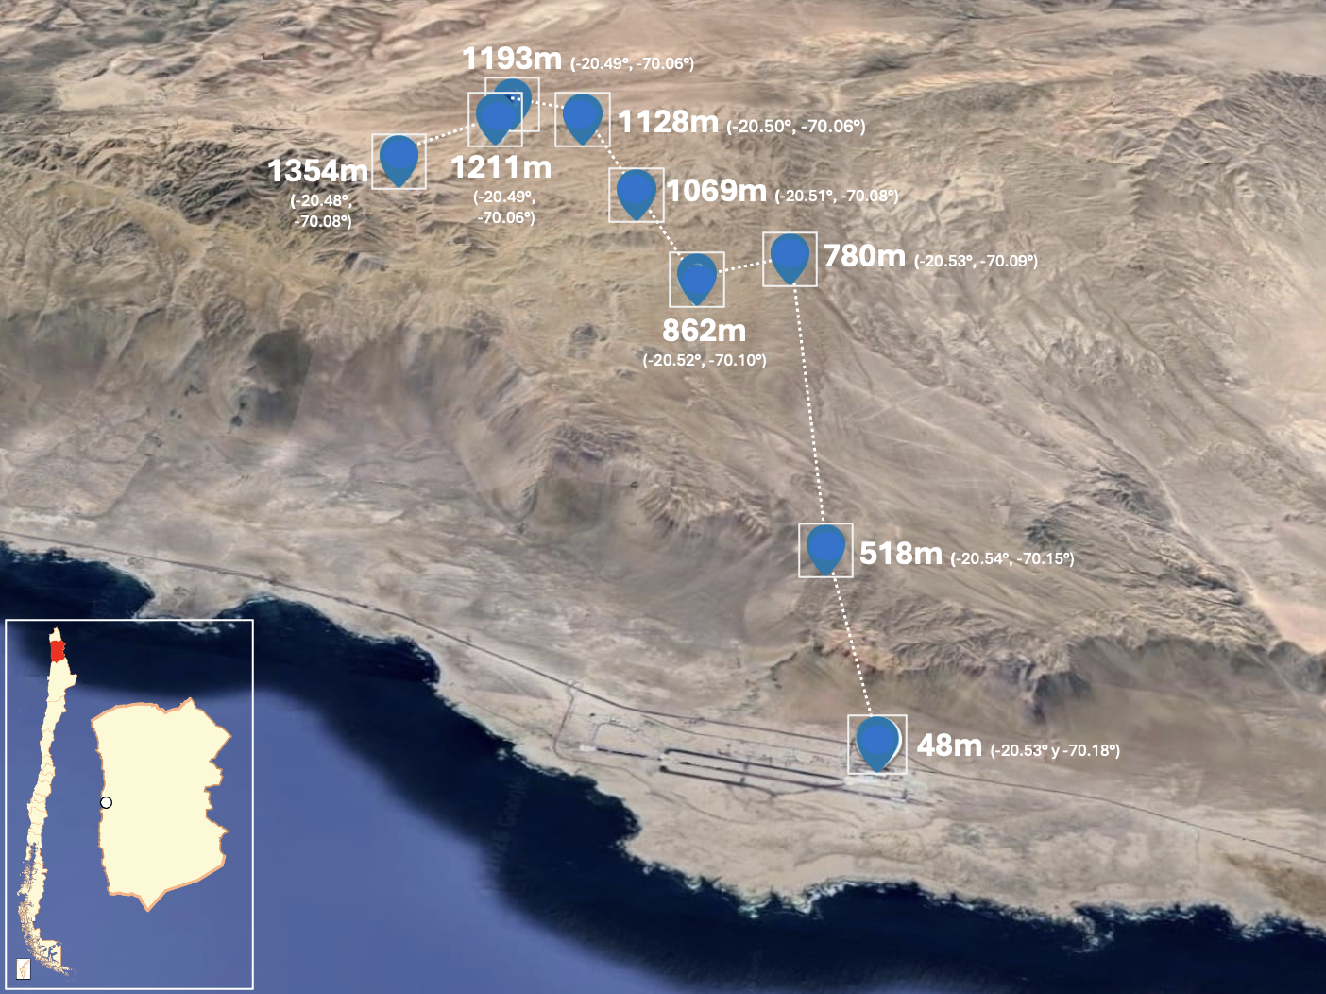
Figure 1: Three-dimensional perspective view of the altitudinal monitoring network along Cerro Oyarbide, Atacama Desert, northern Chile. Each station is labeled with its operating altitude (m a.s.l.) and its geographic position in decimal degrees (south latitude, west longitude), following the WGS84 reference system used throughout this study; the dotted line traces the transect from the coastal baseline at the Diego Aracena International Airport (48 m a.s.l.) up to the highest station (1354 m a.s.l.). The inset map (bottom left) situates the study area within continental Chile using a national scale reference frame, with the red marker indicating the region of interest and the circle marking the approximate location of Cerro Oyarbide relative to the country’s coastline.

Data and instrumentation
The dataset used in this study spans the full year 2024 at a 10-minute temporal resolution, processed in R with the tidyverse ecosystem, and includes air temperature (°C), relative humidity (%), wind speed (m/s) and direction (°), horizontal visibility (m), air pressure (Pa), global radiation (W/m²), and fog and dew collection (mL). Data availability varies by station and sensor (Table 1), OYA518, OYA780, OYA1128, and OYA1211 maintain almost complete continuity throughout 2024, while OYA1069 shows critical gaps due to sensor malfunction, including total loss of temperature and only 16.7% availability in relative humidity and wind direction, which exclude it from most subsequent thermodynamic gradients. Among these stations, OYA1211 is the most fully instrumented of the transect and the only one that brings together, within the same microenvironment, the standard dew collector (SDC), the standard fog collector (SFC), and the horizontal visibility sensor (Figure 2). This ground-based network is further complemented by GOES-16 satellite observations, processed in Google Earth Engine at a spatial resolution of 2 km and synchronized every 10 minutes, which detect low clouds (FLC) using a dual-band brightness temperature threshold algorithm; these satellite data are used as a secondary layer and for regional validation of the fog or dew event classification tree (Del Río et al., 2021; Espinoza et al., 2024).
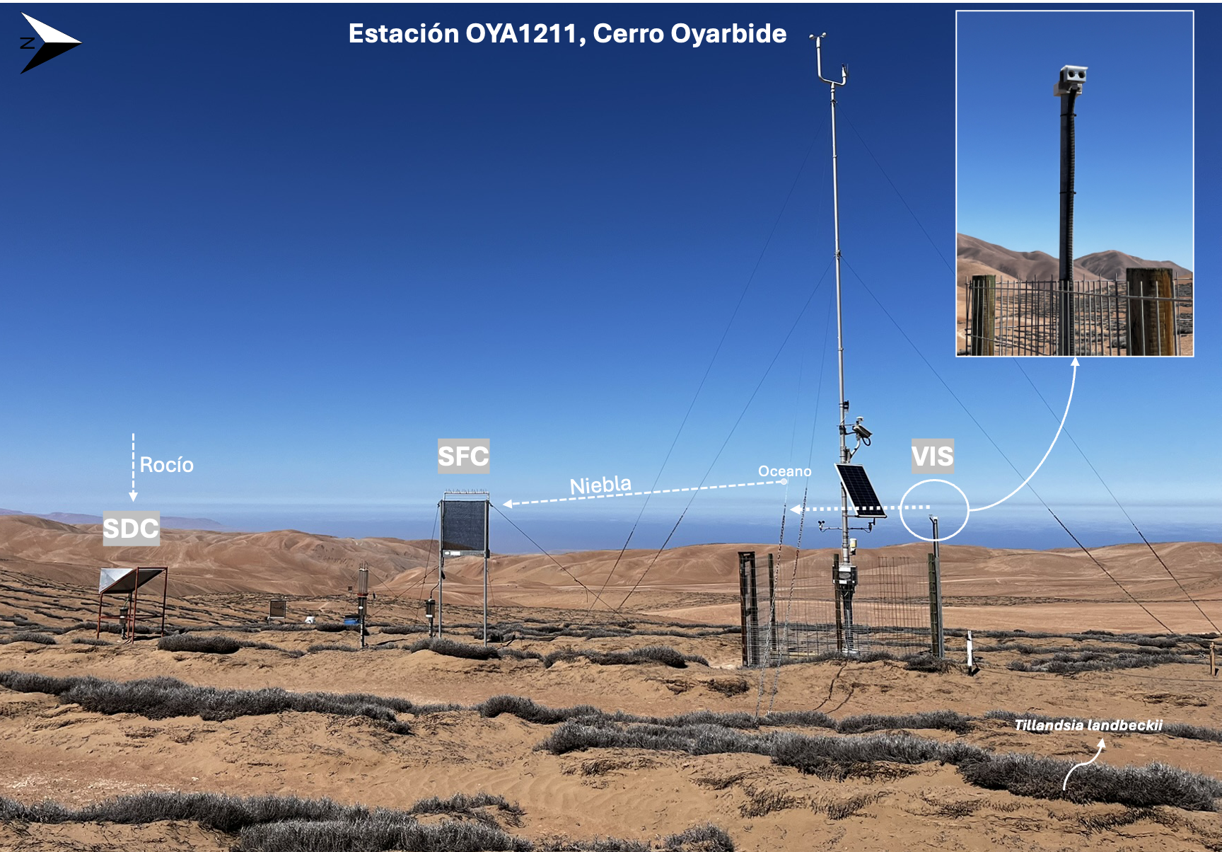
Figure 2: Field instrumentation setup at the main monitoring station, OYA1211, Cerro Oyarbide. The photograph shows the spatial arrangement of the Standard Dew Collector (SDC), the Standard Fog Collector (SFC), and the horizontal visibility sensor (VIS), all operating within the same local atmospheric microenvironment. Arrows indicate the direction of the relevant flows and instrument orientation: the SFC faces the prevailing fog advection arriving from the ocean, the SDC captures vertical atmospheric condensation toward the surface, and the VIS sensor (magnified in the inset) is aligned perpendicular to the SFC to ensure undisturbed optical measurements. Tillandsia landbeckii patches are visible in the foreground, surrounding the instrumentation.

Table 1: Percentage of data availability (%) for 2024 at a 10-minute temporal resolution across the ground monitoring network. The numeric suffix in each station’s name designates its operating altitude (m a.s.l.). Abbreviations: Temp (air temperature), HR (relative humidity), U (wind speed), DV (wind direction), Niebla (surface fog event validation), Pres (atmospheric pressure), Rad (global radiation), Vis (visibility), Rocío (dew collection), Dist (distance to the coastline). Dashes (–) indicate that the variable is not monitored by the station. GOES-16 satellite images maintained 100% availability for low cloud (FLC) detection throughout the entire study period.
Estación | Dist (km) | Temp (°C) | HR (%) | U (m/s) | DV (°) | Niebla (mm) | Pres (hPa) | Rad (W/m²) | Vis (m) | Rocío (mm)
AEROP. |  | 100% | 100% | 100% | 100% | – | 100% | 0% | 0% | –
OYA518 |  | 99% | 99% | 97% | 99% | 99% | 99% | 99% | 0% | –
OYA780 |  | 99% | 99% | 98% | 99% | 99% | 99% | 0% | 0% | –
OYA862 |  | 86% | 91% | 86% | 91% | 9% | 0% | 0% | 0% | –
OYA1069 |  | 0% | 17% | 0% | 17% | 17% | 0% | 0% | 0% | –
OYA1128 |  | 100% | 100% | 100% | 100% | 100% | 0% | 0% | 0% | –
OYA1193 |  | 90% | 92% | 90% | 92% | 92% | 0% | 0% | 0% | –
OYA1211 |  | 100% | 100% | 100% | 100% | 100% | 100% | 100% | 93% | 100%
OYA1354 |  | 83% | 83% | 83% | 83% | 92% | 0% | 0% | 0% | –

Data Processing

Hierarchical classification of fog and dew events
A decision tree anchored at OYA1211 was used, whereby visibility below 1000 m is classified as fog and visibility equal to or above 1000 m is classified as dew, with GOES-16 FLC serving as a secondary criterion when visibility is unavailable, given its coarser spatial resolution and vertical uncertainty, since a detected low cloud pixel does not necessarily intersect the topography.
$$\text{Event Type}=\left\{\begin{matrix}\text{Fog}, & \text{if Visibility}<1000\text{ m or GOES FLC}=1 \\ \text{Dew}, & \text{if Visibility}≥1000\text{ m or GOES FLC}=0\end{matrix}\right. (1)$$
In addition to the classification algorithm, a manual review is performed to verify that the results are consistent, for each day of 2024, comparing the automatic classification with the visibility curve and the GOES signal, correcting isolated errors and documenting days of atypical behavior.

Calculation of thermodynamic gradients and temporal rates
Potential temperature (θ) was derived using the pressure recorded at the airport station as the reference pressure (P0), together with the hypsometric equation for pressure at missing levels, anchored to the coastal baseline. Specific humidity (q) was approximated using the mixing ratio (r), since in the lower troposphere the water vapor mass is much smaller than the dry air mass and the total pressure greatly exceeds the vapor pressure, so that q ≈ r; it was thus derived using the equation for saturation and actual vapor pressure, with the specific heat of dry air Cp = 1004.67 J kg⁻¹ K⁻¹. Wind speed (U, m/s) is used directly as recorded in the dataset, without further calculation.
$$θ=T⋅{\left(\frac{P_{0}}{P}\right)}^{R/C_{p}} (2)$$
$$q≈r=ϵ\frac{e}{P-e} (3)$$
Both the vertical gradients and the temporal rates presented below correspond, in principle, to derivatives; however, given the finite number of observations available, they are approximated here as finite differences (Δ). Vertical gradients Δφ/Δz were calculated along the 48–1354 m transect in relation to the coastal baseline, to determine the stability of the MBL, with φ ∈ {θ, q, U}, where z1, θ1, q1, and U1 correspond to the reference station at the airport.
$$\frac{Δϕ}{Δz}=\frac{ϕ_{2}-ϕ_{1}}{z_{2}-z_{1}}, ϕ∈\{θ,q,U\} (4)$$
Time rates Δφ/Δt were calculated using forward finite differences, with fixed delays of 10 min to 180 min for the response to event start, and differences of 1 hour, with a tolerance of up to 2 h, for the diurnal cycle and annual distribution statistics, the quantity that will operationalize the third objective associated with dynamics. All timestamps are processed in UTC (mainland Chile local time = UTC−4).
$$\frac{Δϕ}{Δt}=\frac{ϕ_{2}-ϕ_{1}}{t_{2}-t_{1}}, ϕ∈\{θ,q,U\} (5)$$

References
Albornoz, F., Río, C. del, Carter, V., Escobar, R., & Vásquez, L. (2023). Fog water collection for local greenhouse vegetable production in the atacama desert. Sustainability, 15(22), 15720. https://doi.org/10.3390/su152215720
Cereceda, P., Larrain, H., Osses, P., Farías, M., & Egaña, I. (2008). The spatial and temporal variability of fog and its relation to fog oases in the atacama desert, chile. Atmospheric Research, 87(3-4), 312–323. https://doi.org/10.1016/j.atmosres.2007.11.012
Cereceda, P., Osses, P., Larrain, H., Farı́as, M., Lagos, M., Pinto, R., & Schemenauer, R. S. (2002). Advective, orographic and radiation fog in the tarapacá region, chile. Atmospheric Research, 64(1-4), 261–271. https://doi.org/10.1016/s0169-8095(02)00097-2
Chamizo, S., Rodríguez-Caballero, E., Moro, M. J., & Cantón, Y. (2021). Non-rainfall water inputs: A key water source for biocrust carbon fixation. Science of The Total Environment, 792, 148299. https://doi.org/10.1016/j.scitotenv.2021.148299
Del Río, C., Lobos, F., Siegmund, A., Tejos, C., Osses, P., Huaman, Z., Meneses, J. P., & García, J.-L. (2021). GOFOS, ground optical fog observation system for monitoring the vertical stratocumulus-fog cloud distribution in the coast of the atacama desert, chile. Journal of Hydrology, 597, 126190. https://doi.org/10.1016/j.jhydrol.2021.126190
Espinoza, V., Lobos-Roco, F., & Río, C. del. (2024). Synoptic control of the spatiotemporal variability of fog and low clouds under ENSO phenomena along the chilean coast (17°-36° s). Atmospheric Research, 308, 107533. https://doi.org/10.1016/j.atmosres.2024.107533
Fessehaye, M., Abdul-Wahab, S. A., Savage, M. J., Kohler, T., Gherezghiher, T., & Hurni, H. (2014). Fog-water collection for community use. Renewable and Sustainable Energy Reviews, 29, 52–62. https://doi.org/10.1016/j.rser.2013.08.063
García, J.-L., Lobos-Roco, F., Schween, J. H., Río, C. del, Osses, P., Vives, R., Pezoa, M., Siegmund, A., Latorre, C., Alfaro, F., Koch, M. A., & Loehnert, U. (2021). Climate and coastal low-cloud dynamic in the hyperarid atacama fog desert and the geographic distribution of tillandsia landbeckii (bromeliaceae) dune ecosystems. Plant Systematics and Evolution, 307(5). https://doi.org/10.1007/s00606-021-01775-y
Gultepe, I., Tardif, R., Michaelides, S. C., Cermak, J., Bott, A., Bendix, J., Müller, M. D., Pagowski, M., Hansen, B., Ellrod, G., Jacobs, W., Toth, G., & Cober, S. G. (2007). Fog research: A review of past achievements and future perspectives. In Fog and boundary layer clouds: Fog visibility and forecasting (pp. 1121–1159). Birkhäuser Basel. https://doi.org/10.1007/978-3-7643-8419-7_3
Houston, J. (2006). Variability of precipitation in the Atacama Desert: Its causes and hydrological impact. International Journal of Climatology, 26(15), 2181–2198. https://doi.org/10.1002/joc.1359
Jabbusch, S., & Koch, M. A. (2025). Tillandsia landbeckii secures high phenotypic variation despite clonal propagation at the dry limits of plant life in the atacama desert. Perspectives in Plant Ecology, Evolution and Systematics, 66, 125846. https://doi.org/10.1016/j.ppees.2025.125846
Jung, P., Emrich, D., Briegel‐Williams, L., Schermer, M., Weber, L., Baumann, K., Colesie, C., Clerc, P., Lehnert, L. W., Achilles, S., Bendix, J., & Büdel, B. (2019). Ecophysiology and phylogeny of new terricolous and epiphytic chlorolichens in a fog oasis of the atacama desert. MicrobiologyOpen, 8(10). https://doi.org/10.1002/mbo3.894
Larrain, H., Velásquez, F., Cereceda, P., Espejo, R., Pinto, R., Osses, P., & Schemenauer, R. S. (2002). Fog measurements at the site “falda verde” north of chañaral compared with other fog stations of chile. Atmospheric Research, 64(1-4), 273–284. https://doi.org/10.1016/s0169-8095(02)00098-4
Latorre, C., González, A. L., Quade, J., Fariña, J. M., Pinto, R., & Marquet, P. A. (2011). Establishment and formation of fog-dependent <i>tillandsia landbeckii</i> dunes in the atacama desert: Evidence from radiocarbon and stable isotopes. Journal of Geophysical Research, 116(G3). https://doi.org/10.1029/2010jg001521
Li, H., Han, C., Yang, Y., & Chen, R. (2025). Advances and challenges in dew research on land surface: A review. Hydrology, 12(12), 320. https://doi.org/10.3390/hydrology12120320
Lobos Roco, F., Vilà-Guerau de Arellano, J., & Pedruzo-Bagazgoitia, X. (2018). Characterizing the influence of the marine stratocumulus cloud on the land fog at the atacama desert. Atmospheric Research, 214, 109–120. https://doi.org/10.1016/j.atmosres.2018.07.009
Lobos-Roco, F., Suárez, F., Aguirre-Correa, F., Keim, K., Aguirre, I., Vargas, C., Abarca, F., Ramírez, C., Escobar, R., Osses, P., & Río, C. del. (2024). Understanding inland fog and dew dynamics for assessing potential non-rainfall water use in the atacama. Journal of Arid Environments, 221, 105125. https://doi.org/10.1016/j.jaridenv.2024.105125
Malik, T., Gethin, D., Boy, F., Davies, G., & Parker, A. (2023). Re-engineering dew-harvesting cactus macrostructures to enhance water collection as an adaptive climate change strategy: An experimental comparison. Atmosphere, 14(12), 1736. https://doi.org/10.3390/atmos14121736
Monteith, J. L. (1957). Dew. Quarterly Journal of the Royal Meteorological Society, 83(357), 322–341. https://doi.org/10.1002/qj.49708335706
Muselli, M., Beysens, D., Marcillat, J., Milimouk, I., Nilsson, T., & Louche, A. (2002). Dew water collector for potable water in ajaccio (corsica island, france). Atmospheric Research, 64(1-4), 297–312. https://doi.org/10.1016/s0169-8095(02)00100-x
Pinto, R., Barría, I., & Marquet, P. A. (2006). Geographical distribution of tillandsia lomas in the atacama desert, northern chile. Journal of Arid Environments, 65(4), 543–552. https://doi.org/10.1016/j.jaridenv.2005.08.015
Río, C. del, Lobos-Roco, F., Latorre, C., Koch, M. A., García, J.-L., Osses, P., Lambert, F., Alfaro, F., & Siegmund, A. (2021). Spatial distribution and interannual variability of coastal fog and low clouds cover in the hyperarid atacama desert and implications for past and present tillandsia landbeckii ecosystems. Plant Systematics and Evolution, 307(5). https://doi.org/10.1007/s00606-021-01782-z
Rutllant, J., & Montecino, V. (2002). Multiscale upwelling forcing cycles and biological response off north-central chile. Revista Chilena de Historia Natural, 75(1). https://doi.org/10.4067/s0716-078x2002000100020
Schemenauer, R. S., & Cereceda, P. (1994). A proposed standard fog collector for use in high-elevation regions. Journal of Applied Meteorology, 33(11), 1313–1322. https://doi.org/10.1175/1520-0450(1994)033<1313:apsfcf>2.0.co;2
Stull, R. B. (1988). An introduction to boundary layer meteorology. Kluwer Academic Publishers. https://doi.org/10.1007/978-94-009-3027-8
Wang, L., Kaseke, K. F., & Seely, M. K. (2016). Effects of non‐rainfall water inputs on ecosystem functions. WIREs Water, 4(1). https://doi.org/10.1002/wat2.1179

