Thermodynamic characterization of the marine boundary layer during fog and dew events in the hyperarid coastal climate of the Atacama Desert
F.M. Narbona, S. Acevedo, C. Del Río, A. Siegmund, F. Lobos-Roco
2026-10-01

Introduction
In the coastal Atacama Desert, precipitation is almost null (Houston, 2006), thus fog and dew are the main water sources sustaining hyperarid ecosystems and local communities (Lobos-Roco et al., 2024; Río et al., 2021). In this area Tillandsia landbeckii is a classic example of fog dependent vegetation, localized within the fog belt between approximately 900 and 1200 m a.s.l. (Cereceda et al., 2008; García et al., 2021), while dew is thought to buffer this species during periods of reduced fog (Jabbusch & Koch, 2025; Latorre et al., 2011). Other species share this dependence, including congeneric Tillandsia (Pinto et al., 2006) and biological soil crusts (Jung et al., 2019). Regarding dew specifically, the cactus Copiapoa cinerea var. haseltoniana shows differential radiative cooling across its stem and spines, a property exploited in biomimetic dew harvesting designs (Malik et al., 2023), suggesting some desert plants may rely preferentially on this water source. Coastal communities have also used fog water for drinking supply and small scale greenhouse vegetable production (Albornoz et al., 2023; Fessehaye et al., 2014).
Fog and dew are condensation processes that occurs within the marine boundary layer (MBL), governed by turbulent mixing, advection and thermal stratification (Lobos-Roco et al., 2024; Stull, 1988). Fog forms when a moist air parcel saturates, then reaching the dew point ($T_{air}≤T_{dew}$) (Gultepe et al., 2007). In northern Chile, fog results from the advection of marine stratocumulus clouds, which are formed over the South East Pacific (SEP) Ocean under high subsidence promoted by the South Pacific Anticyclone (Cereceda et al., 2002; Cereceda et al., 2008; Rutllant & Montecino, 2002). This subsidence contrasts with the cold Humboldt Current and the cold water upwelling forming a strong thermal inversion (~20 K) that limits vertical mixing, driving the stratocumulus cloud formation (Espinoza et al., 2024). The anticyclonic circulation in the SEP transports these well-formed stratocumulus up to 50–60 km inland (Lobos-Roco et al., 2024; Río et al., 2021). Here, clouds get in contact with coastal mountain range between 600 and 1200 m asl forming a fog belt. One of the main thermodynamic characteristic of stratocumulus cloud-fog in the Atacama is that it develops under a well-mixed (turbulent) MBL, with low potential temperature gradients (∂θ/∂z < 3.1×10⁻³ K m⁻¹) (Lobos Roco et al., 2018) and continuous positive moisture advection (∂q/∂t ≈ +0.016 g kg⁻¹ h⁻¹) (Lobos-Roco et al., 2024).
In contrast, dew forms over surfaces, which driven by nocturnal radiative cooling, reach the dew point ($T_{surf}≤T_{dew}$), condensing directly on solid surfaces under clear, calm, humid conditions (Jacobs et al., 2006; Monteith, 1957). In terms of thermodynamics, dew forms under a more stable surface layer (∂θ/∂z > 3.8×10⁻³ K m⁻¹) and a net negative vapour tendency (∂q/∂t ≈ −0.25 g kg⁻¹ h⁻¹) (Lobos-Roco et al., 2024). This contrast shows that atmospheric thermal stability is a reliable variable to distinguish between fog and dew, unlike the moisture gradient, which is limited by MBL humidity homogeneity (Lobos-Roco et al., 2024). Contrary, since dew formation reduces the air humidity by transferring it to the surface, the ∂q/∂t also might play a role in distinguish dew from fog.
Fog and dew can be quantified by measuring their respective collection rates. For that purpose, standardized passive collectors have been developed. On the one hand, the Standard Fog Collector (SFC), collects fog droplets over a 1 m² polypropylene mesh (Schemenauer & Cereceda, 1994). In the Atacama, fog collects rates from 3 to 8 $L m^{−2} day^{−1}$ (Cereceda et al., 2008; Larrain et al., 2002). On the other hand, the Standard Dew Collector (SDC), collects dew by cooling a plate surface of a 1 m² by nocturnal radiative loss (Muselli et al., 2002). In the Atacama, collection rates of dew fall within the range observed in other arid regions worldwide, from 0.1 to 0.8 L m⁻² day⁻¹ (Lobos-Roco et al., 2024). Despite the effort of quantify fog and dew through the passive collection, they fail to distinguish between the two phenomena due to an instrumental overlap in their collection periods, which leaves their relative contribution highly uncertain (Lobos-Roco et al., 2024).
In hyperarid regions, accurately measuring their dynamics is essential to understanding their contribution to the hydrological cycle and the carbon balance of these ecosystems (Wang et al., 2016). Both processes provide the moisture upon which biological soil crusts and other surface organisms depend on, directly influencing their carbon-sequestering capacity. This underscores the need for methods that allow for the precise determination of each phenomenon’s individual contribution (Chamizo et al., 2021; Li et al., 2025). In contrast to fog, our understanding of dew remains very limited (Li et al., 2025). Beyond its ecological significance, this understanding could also benefit local communities by improving water-harvesting technologies and guiding appropriate water management in arid regions.
In the context of the highly uncertainty that fog and dew collectors produces, in this study we aim to distinguish fog from dew by analyzing their atmospheric thermodynamic characteristics. In particular we aim to answer how do atmospheric stability and humidity tendency differ between fog and dew events in the coastal Atacama Desert? We hypothesize that dew collection is systematically underestimated by standard collectors. Likewise fog and dew show marked difference in the atmospheric stability and specific humidity tendency. We test three falsifiable hypotheses. Firstly, (occurrence): the frequency of dew events compared to total events exceeds the ones recorded by SDC. Secondly (structure): fog forms under a well mixed and turbulent marine boundary layer (lower ∂θ/∂z and higher ∂U/∂z), whereas dew forms under a more stratified and calm layer (higher ∂θ/∂z and lower ∂U/∂z), while ∂q/∂z would not allow discrimination between both regimes, since both require a well-mixed vapor column near saturation. Thirdly (dynamics): fog is marked by continuous humidity advection (∂q/∂t > 0), while dew by a surface humidity sink (∂q/∂t ≤ 0), reflecting opposite atmospheric water vapor tendency. To test these hypothesis, our research strategy was based a combination of in-situ meteorological observations from a topographic transect and satellite information retrieved from GOES satellite. This manuscript is structured as follows. Section 2 describes the study area and the methods used to quantify the variables required to test our three falsifiable hypotheses. In Section 3 we presents our results, which are organized into three sub-sections: (3.1) the occurrence of fog and dew events, (3.2) the vertical thermodynamic structure of the boundary layer under each regime, and (3.3) the temporal evolution of specific humidity. Building upon our results, Section 4 discusses these findings in light of the existing literature. Finally, Section 5 offers conclusions and future prospects of this study.

Outline methods

Study area: Cerro Oyarbide
The meteorological observations used in this study are located over topographic transect placed at Cerro Oyarbide (~20.61°S, 70.07°W). This site is located in the Atacama coastal mountain range about 11 km inland from the coastline (Figure 1, B and D). The climate is hyper-arid, where no rain occurs and the sole water inputs to the surface comes from dew and fog. Such conditions only sustain Tillandsia landbeckii species, a rootless plant that locates between 900 and 1200 m above sea level, in the upper border of the fog belt (García et al., 2021; Koch et al., 2019). This site functions as a natural laboratory for studying fog and dew, since the station transect overcome the vertical extent of the marine boundary layer (0 to 1354 m a.s.l), with a continuous topographic gradient of 9 stations crossing exactly the band where regional stratocumulus fog concentrates (Figure 1, A). This band ranges from a cloud base as low as ~753 m a.s.l. to a cloud top as high as ~1400 m a.s.l. (Del Río et al., 2021). Within this gradient, our main station named OYA1211 located on the upper border of Tillandsia landbeckii fields (Figure 1, C), allowing direct characterization of the atmosphere-biosphere interaction at the same point where the classification protocol is anchored.
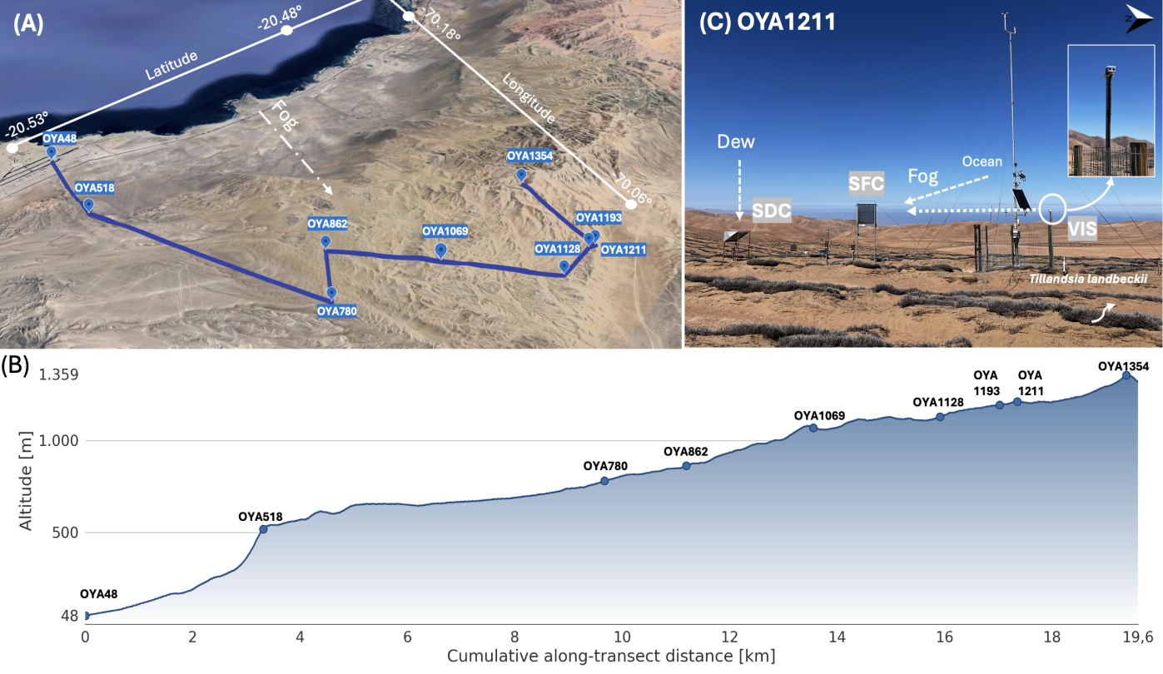
Figure 1: Overview of the study site at Cerro Oyarbide, Atacama Desert, Chile. (A) Satellite image showing a perspective view of the meteorological station topographic transect on Cerro Oyarbide. The blue line connects the stations along the topographic transect. The dotted line traces the dominant fog advection direction indicated. (B) Topographic profile of the transect showing station elevation (z, m a.s.l.) as a function of cumulative along-transect distance (km), illustrating how the stations are distributed across the vertical extent of the marine boundary layer and the stratocumulus fog band. (C) Photograph of station OYA1211, located at the upper border of the Tillandsia landbeckii fields, showing the main instrumentation setup: the visibility sensor (VIS), surface fog collector (SFC), and standard dew collector (SDC), together with the dominant fog and dew input pathways. Inset shows a detail of the VIS sensor mounted on the station mast.

Data and instrumentation
The dataset used in this study spans the full year 2024 at a 10-minute interval, includes air temperature (°C), relative humidity (%), wind speed (m/s) and direction (°), horizontal visibility (m), air pressure (Pa), and fog and dew collection (mL m⁻²). Data availability varies by station and sensor (Table 1), for example, stations OYA518, OYA780, OYA1128, and OYA1211 maintain almost complete continuity throughout 2024, while station OYA1069 shows critical gaps due to sensor malfunction, including total data loss of temperature and only 16.7% availability in relative humidity and wind direction, which exclude it from most subsequent thermodynamic gradients. Among these stations, OYA1211 is the most fully equipped of the entire transect and including, the standard dew collector (SDC), the standard fog collector (SFC), and the horizontal visibility sensor (Figure 1, C).
The main observations used in this study are the fog and dew collectors and the visibility sensor. The fog collector (SFC) is a 1 m² standard mesh that intercepts fog droplets (0.2 to 30 μm) advected by the wind. Droplets grow by coalescence and precipitate along the mesh into tipping bucket pluviometer, which measure the water volumes per time (Schemenauer & Cereceda, 1994). The dew collector (SDC) is a 1 m² tilted surface where water vapor condenses once surface temperature drops below the dew point; the water then flows by gravity into a tipping bucket pluviometer (Muselli et al., 2002). The SFC faces the prevailing fog advection from the ocean (west), the SDC captures vertical condensation toward the surface, and the visibility sensor is aligned perpendicular to the SFC for undisturbed optical measurements.
This ground-based network is further complemented by GOES-16 satellite observations, processed in Google Earth Engine at a spatial resolution of 2 km and synchronized every 10 minutes, which detect fog and low clouds (FLC) using a dual-band brightness temperature threshold algorithm, whose methodology can be found in Del Río et al. (2021) and Espinoza et al. (2024). These satellite data is used as a secondary layer and for regional validation of the fog or dew event classification criteria. All data have been processed in R using the tidyverse ecosystem and under version control on GitHub (Muñoz-Narbona et al., 2026).
Table 1: Percentage of data availability (%) for 2024 at a 10-minute temporal resolution across the ground monitoring network. The numeric suffix in each station’s name designates its operating altitude (m a.s.l.). Abbreviations: Temp (air temperature), HR (relative humidity), U (wind speed), DV (wind direction), Niebla (surface fog event validation), Pres (atmospheric pressure), Rad (global radiation), Vis (visibility), Rocío (dew collection), Dist (distance to the coastline). Dashes (–) indicate that the variable is not monitored by the station. GOES-16 satellite images maintained 100% availability for low cloud (FLC) detection throughout the entire study period.
Station | Dist (km) | Temp (°C) | HR (%) | U (m/s) | DV (°) | Fog (mm) | Pres (hPa) | Vis (m) | Dew (mm)
OYA48 (AERP.) | 0.86 | 100% | 100% | 100% | 100% | – | 100% | 0% | –
OYA518 | 4.18 | 99% | 99% | 97% | 99% | 99% | 99% | 0% | –
OYA780 | 9.83 | 99% | 99% | 98% | 99% | 99% | 99% | 0% | –
OYA862 | 8.67 | 86% | 91% | 86% | 91% | 9% | 0% | 0% | –
OYA1069 | 10.75 | 0% | 17% | 0% | 17% | 17% | 0% | 0% | –
OYA1128 | 12.92 | 100% | 100% | 100% | 100% | 100% | 0% | 0% | –
OYA1193 | 13.12 | 90% | 92% | 90% | 92% | 92% | 0% | 0% | –
OYA1211 | 13.11 | 100% | 100% | 100% | 100% | 100% | 100% | 93% | 100%
OYA1354 | 11.41 | 83% | 83% | 83% | 83% | 92% | 0% | 0% | –

Data Processing
The research strategy has been divided into three specific objectives, associated to each hypothesis: (1) characterize the temporal distribution of fog and dew events and their co-occurrence from visibility and GOES observations; (2) evaluate the atmospheric stability under each event type through potential temperature, specific humidity, and wind speed vertical gradients along the topographic station transect; (3) analyze the tendency on time of humidity, potential temperature and wind speed under fog and dew events.

OE1: Hierarchical classification of fog and dew events
To achieve the first specific objective, we used two criteria based on visibility and FLC detection, where visibility was the priority. Regardless of whether water is collected by the SFC or the SDC, the event is classified as fog if visibility falls below 1000 m. The event is classified as dew if visibility is equal to or above 1000 m. GOES-16 FLC served as a secondary criterion when visibility is unavailable, given its coarser spatial resolution and vertical uncertainty, since a detected low cloud pixel does not necessarily intersect the topography.
$$\text{Event Type}=\left\{\begin{matrix}\text{fog}, & \text{if visibility}<1000\text{ m, or visibility is unavailable and GOES FLC}=1 \\ \text{dew}, & \text{if visibility}≥1000\text{ m, or visibility is unavailable and GOES FLC}=0\end{matrix}\right. (1)$$
In addition to the classification algorithm, a manual review is performed. The automatic classification is compared against the visibility curve and the GOES signal. Isolated errors are corrected, and days of atypical behavior are documented. For example, an abrupt drop and recovery of visibility within a short period is likely caused by sensor lens dew condensation, or debris such as dust particles or insects obstructing the sensor rather than an actual fog event, and is reclassified as dew. Likewise, when a continuous event is interrupted by an isolated 10-minute segment classified differently, this segment is corrected to match the surrounding event.

OE2: Analyse the atmospheric stability through the thermodynamic vertical gradients
After reclassified fog and dew events using the satellite and visibility criteria, we analyse the atmospheric stability of fog and dew reclassified event. For analyzing the atmospheric stability we use two thermodynamic conserved variables of potential temperature (θ), specific humidity (q) and wind speed (U). Potential temperature is calculated as follows:
$$θ=T⋅{\left(\frac{P_{0}}{P}\right)}^{R/C_{p}} (2)$$
where T is the absolute air temperature (K), P₀ is the pressure (hPa) measured at the lowest station, P is the atmospheric pressure level at every station (hPa), R is the constant gas of dry air (287.08 J kg⁻¹ K⁻¹) and c_{p} is the specific heat of dry air (1004.67 J kg⁻¹ K⁻¹). Specific humidity (q) is approximated using the mixing ratio (r), since in the lower troposphere the water vapor mass is much smaller than the dry air mass and the total pressure greatly exceeds the vapor pressure, so that q ≈ r. ‘q’ is estimated using the following expression:
$$q≈r=ϵ\frac{e}{P−e} (3)$$
where ϵ is he ratio of the molecular weight of water vapor to that of dry air (ϵ=0.622 kg kg-1), e is the water vapor pressure (hPa), obtained from relative humidity and saturated vapor pressure.
To calculate the vertical gradients that are used as a proxy of atmospheric stability we used:
$$\frac{∂ϕ}{∂z}∼\frac{Δϕ}{Δz}=\frac{ϕ_{2}−ϕ_{1}}{z_{2}−z_{1}}, ϕ∈\{θ,q,U\} (4)$$
where $ϕ$ represents the conservative scalar of $θ$, q or U, z1 the reference altitude level (48 m asl) and z2 the altitude of each station. Both the vertical gradients and the temporal rates presented below correspond, in principle, to partial derivatives; however, given the finite number of observations available, they are approximated here as finite differences (Δ). Vertical gradients ∂φ/∂z are calculated along the 48–1354 m transect in relation to the coastal baseline, to determine the stability of the MBL, with φ ∈ {θ, q, U}.

OE3: Analyse the temporal tendency of conserved variables
To achieve the third specific objective, we calculated temporal rates ∂φ/∂t using forward finite differences, with φ ∈ {θ, q, U}. Fixed delays ranging from 10 min to 180 min are used to characterize the response to event onset. Differences of 1 hour, with a tolerance of up to 2 hours, are used for the diurnal cycle and annual distribution statistics. This temporal rate operationalizes the third objective, associated with the dynamics hypothesis. All timestamps are processed in UTC (mainland Chile local time = UTC−4).
$$\frac{∂ϕ}{∂t}∼\frac{Δϕ}{Δt}=\frac{ϕ_{2}−ϕ_{1}}{t_{2}−t_{1}}, ϕ∈\{θ,q,U\} (5)$$

Results and discussion
In this section we present the results organized into three subsections, each one associated to a specific objective and its corresponding hypothesis. First, we present the reclassification of the fog and dew events instrumentally recorded at station OYA1211 during 2024, based on visibility and GOES-16 FLC observations, together with their seasonal and diurnal distribution (Section 3.1). Second, we characterize the atmospheric stability under each reclassified event type through the vertical gradients of potential temperature, specific humidity and wind speed along the topographic transect (Section 3.2). Finally, we analyze the temporal evolution of specific humidity, potential temperature and wind speed after the onset of fog and dew events (Section 3.3).

Fog and dew events instrumental reclassification
- Figure 2 shows the total atmospheric water collection frequency in relation to the year (top bar) and the contribution of fog and dew occurance classified by the collector and reclissified by our visibility criteria. The top bar places the problem in its true magnitude: the active window of atmospheric water occupies only 8.6% of the year (91.4% without events), so each misclassified interval weighs proportionally more than its duration suggests.
- Within this window, direct instrumental detection reports 49.2% fog, 46.8% mixed fog+dew, and only 4.0% dew.
- However, once analysed the visibility combined by satellite observation of FLC the reclassification of fog and dew occurance shifts to 53.3% fog and 46.7% dew. These huge change evidence that collectors overlap in XX% the atmospheric water inputs when those are measured by any of the collectors.
- After the reclassification, the total frequency of fog collection is XX% over the year, and dew XX%. Those values are in agreement with FLC frequency which is XX% and visibility XX%.
- In other words, the instrumental overlap is not isolated noise: once corrected, the fraction of dew time increases one order of magnitude (4.0% → 46.7%). .
- The result nonetheless has two limitations that should be acknowledged, although they do not invalidate it: the visibility sensor is itself affected by condensation during dew (a slight drop that never crosses the fog threshold, visible in the dew panels of Figure 3), and the coarser resolution of GOES-16 means that a detected low-cloud pixel does not necessarily intersect the topography.
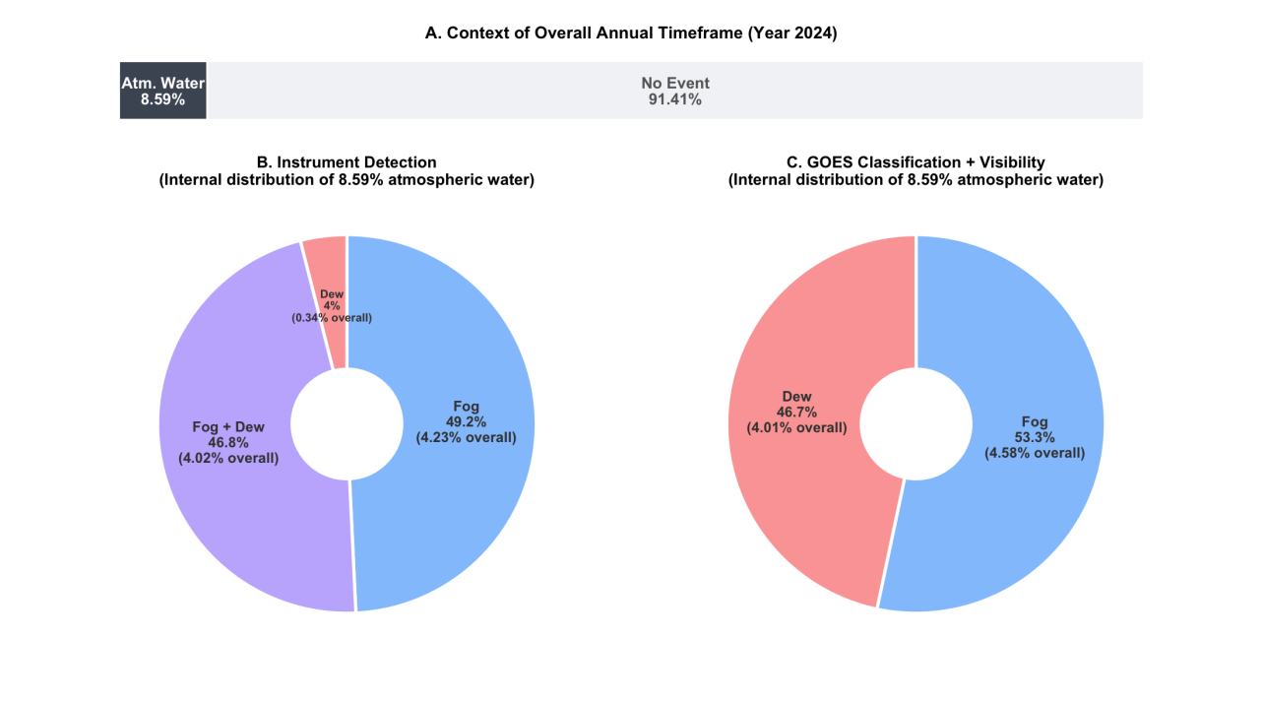
Figure 2: Classification of atmospheric water events at station OYA1211 during 2024. (A) Proportion of the year with atmospheric water (fog or dew collection) and without events. (B) Internal distribution of atmospheric water events according to the instrumental detection by the SFC and SDC. (C) Internal distribution after the classification based on visibility and GOES-16 FLC.
- To depen into how the reclassification based on visibility and satellite was made, we analyze specific cases.
- Figure 3 shows how our reclassification criteria works for specific days. For example, a typical fog day occurrs on april, 28th and september 21st. Here we see that visibility drops from 4000 m to almost near zero from 04:00 UTC to 13:00 UTC (XX-XX local time). While visibility drops, GOES satellite indicate presence of FLC and both collectors (fog and dew) register water collection. This event is classified as fog because.... The second one occurrs in september 21st, when visibility also dropped below 1000 m ....
- Contrary, and example of dew... (24 April and 28 November), visibility, the GOES FLC band, and the final classification clearly agree.
- Importantly, the instrumental band shows the raw overlap case by case: on 28 April both collectors record water during most of the fog event; on 21 September only the SDC records water while visibility remains below 1000 m and GOES detects low clouds; and on 24 April and 28 November only the SFC records water while visibility remains above 1000 m, intervals that the independent classifier assigns to dew.
- Days without events and particular cases (e.g., 17 May, where erratic visibility alternates between fog and dew within the same day) are shown in Appendix A (Figure 6).
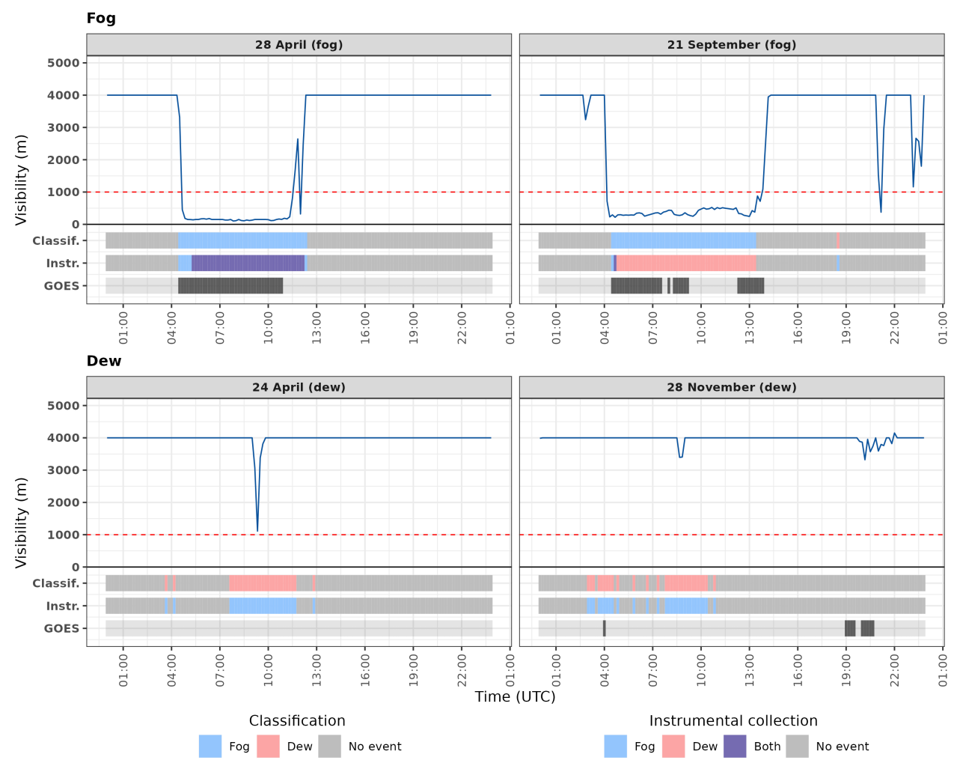
Figure 3: Examples of days classified as fog (28 April and 21 September 2024) and dew (24 April and 28 November 2024) at station OYA1211. The blue line shows horizontal visibility and the red dashed line the 1000 m threshold. Lower bands show, every 10 minutes, the final classification (Classif.), the instrumental collection before the classification (Instr.: fog collector only, dew collector only, both collectors, or no event), and the GOES-16 FLC detection.
- Figure 4 compares, for each month, the mean accumulated water before (instrumental) and after the classification. For fog, the classified mean exceeds the instrumental one in ten of twelve months, and August concentrates the maximum volume under both criteria (~130 mL).
- For dew, the pattern reverses: the classified mean is lower than the instrumental one in nine of twelve months (e.g., 0.7 versus 6.6 mL in February), except for January (10.6 versus 6.4 mL) and September (20.7 versus 15.1 mL), the latter being the month of maximum dew collection.
- Note that the classified mean sums the water of both collectors during each record, whereas the instrumental mean only considers the collector of each phenomenon, which partly explains the higher classified events values.
- The magnitude of both phenomena differs by about one order of magnitude: the classified fog mean ranges from ~13 to ~130 mL across months, whereas the classified dew mean ranges from ~0.7 to ~21 mL. Over the whole year, the classified fog mean (~76 mL) is about 16 times the classified dew mean (~4.6 mL), and dew accounts for only ~5% of the total classified water, despite occupying 46.7% of the active window (Figure 2).
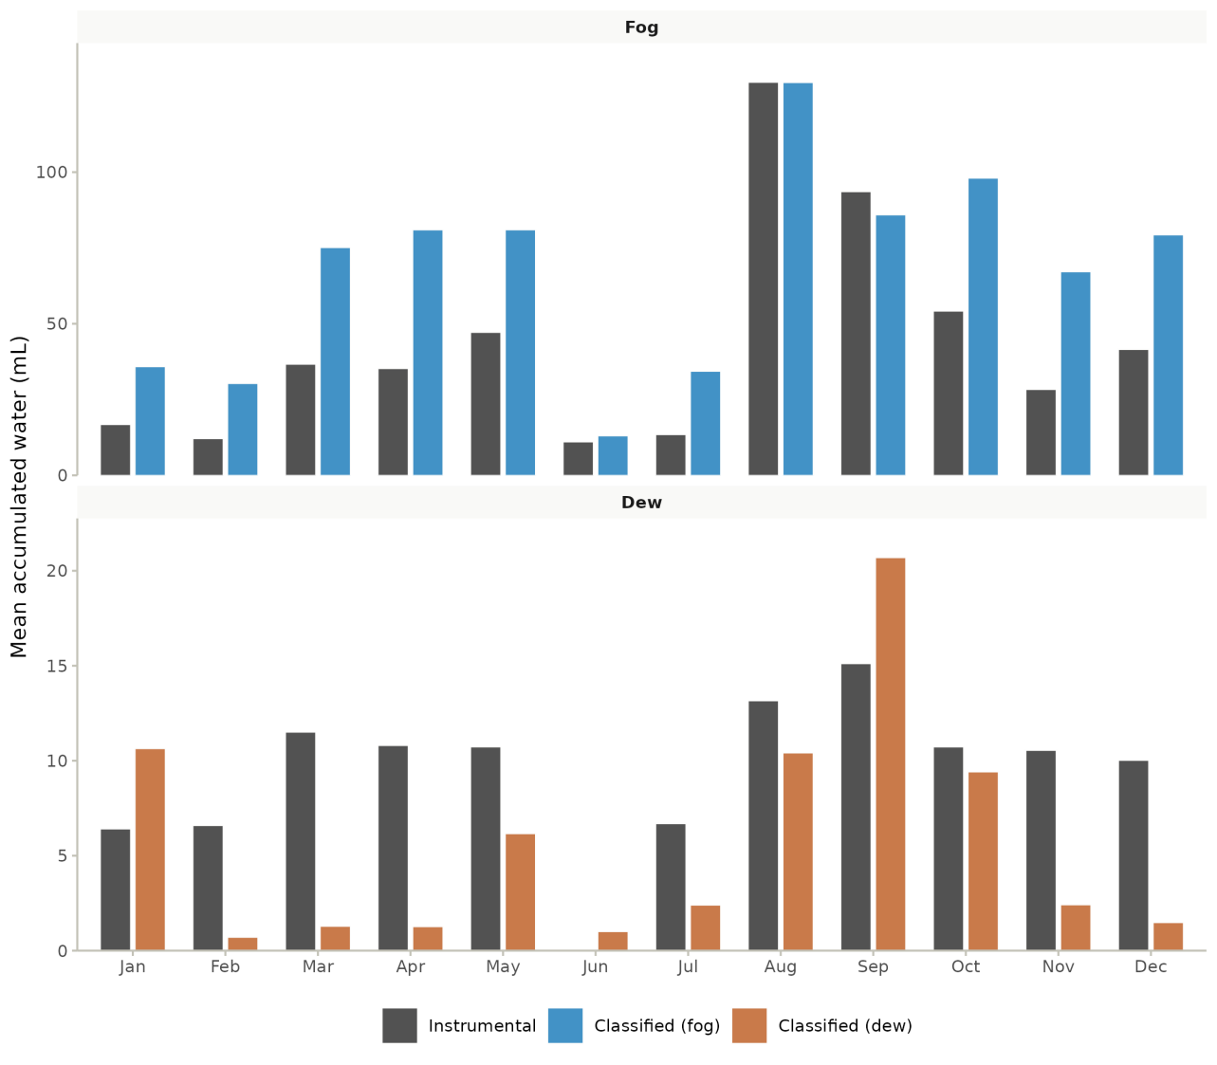
Figure 4: Monthly mean accumulated water per 10-min record (values > 0) at station OYA1211 during 2024, before (instrumental) and after the classification based on visibility and GOES-16 FLC, for fog (top) and dew (bottom). Note the different vertical scales of both panels. Instrumental fog and dew include all records in which the SFC or the SDC collected water, respectively, including simultaneous collection by both collectors.
- At the daily scale (Figure 5), classified fog shows a nocturnal plateau (~60 to 85 mL between 00:00 and 11:00 UTC) and a marked afternoon peak, reaching ~280 mL at 20:00 UTC (17:00 local time).
- Classified dew concentrates between 00:00 and 12:00 UTC (21:00 to 09:00 local time), with mean values below 8 mL, and almost disappears during the afternoon, when the instrumental dew records (up to ~28 mL at 20:00 UTC) coincide with the fog peak.
- The difference in magnitude also holds at the daily scale: nocturnal classified dew values (~4 to 8 mL) are an order of magnitude lower than the nocturnal classified fog plateau, and the afternoon fog peak (~280 mL) exceeds any dew value by more than one order of magnitude.
- This day/night asymmetry is consistent with advection versus radiative cooling mechanisms.
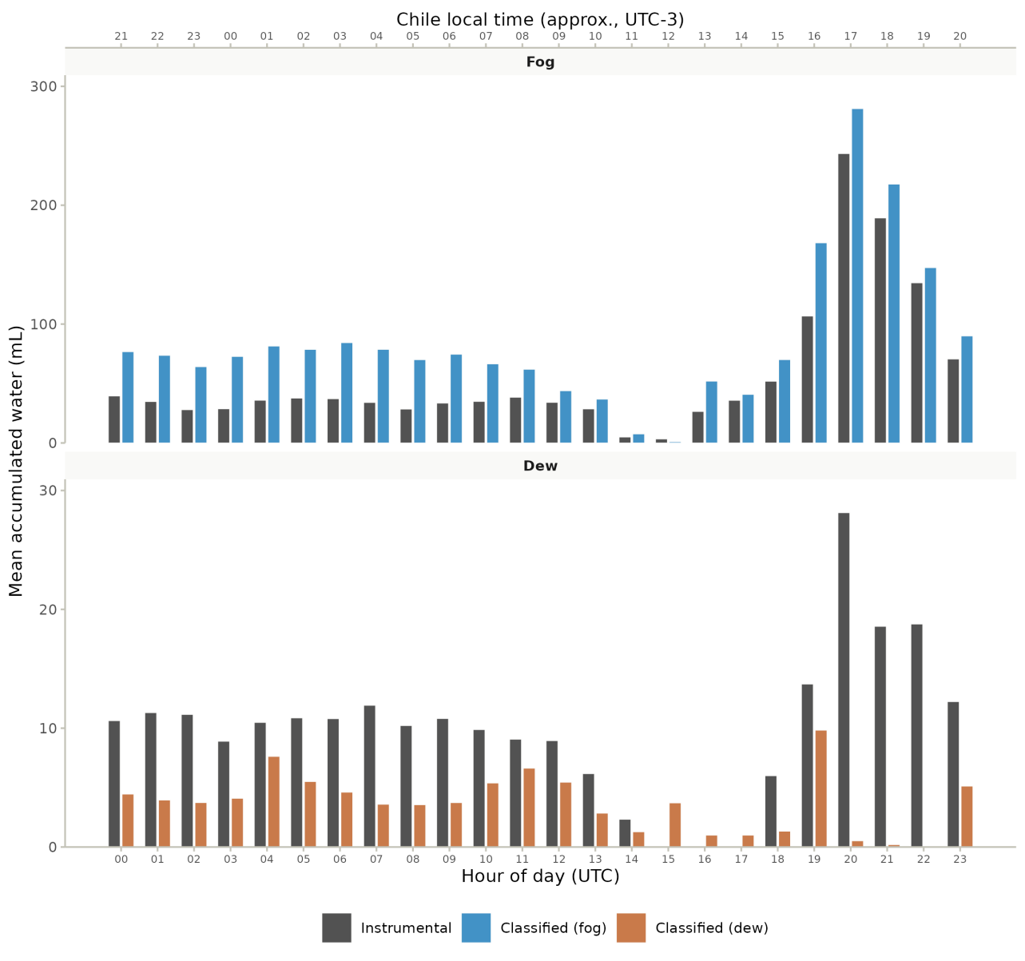
Figure 5: Hourly mean accumulated water per 10-min record (values > 0) at station OYA1211 during 2024, before (instrumental) and after the classification based on visibility and GOES-16 FLC, for fog (top) and dew (bottom). Note the different vertical scales of both panels. Lower axis in UTC and upper axis in approximate Chile local time (UTC-3).

Atmospheric stability under fog and dew events

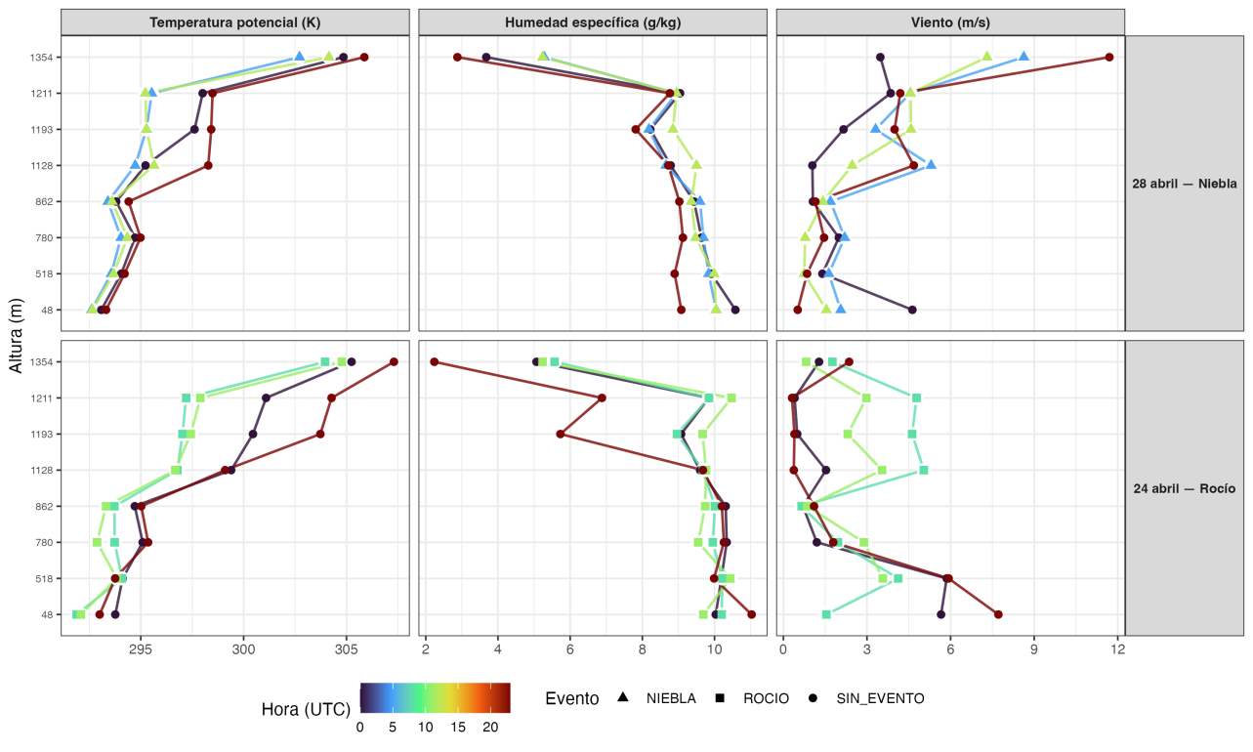
- At the scale of a single day, the previous figure already reveals the pattern: 28 April (fog) exhibits a nearly uniform θ profile between 48 and 1354 m a.s.l. (the signature of a well-mixed layer), whereas 24 April (dew) shows a vertical gradient similar to that of the non-event hours of the same day. The q and U profiles, however, show no equivalent contrast between the two regimes.
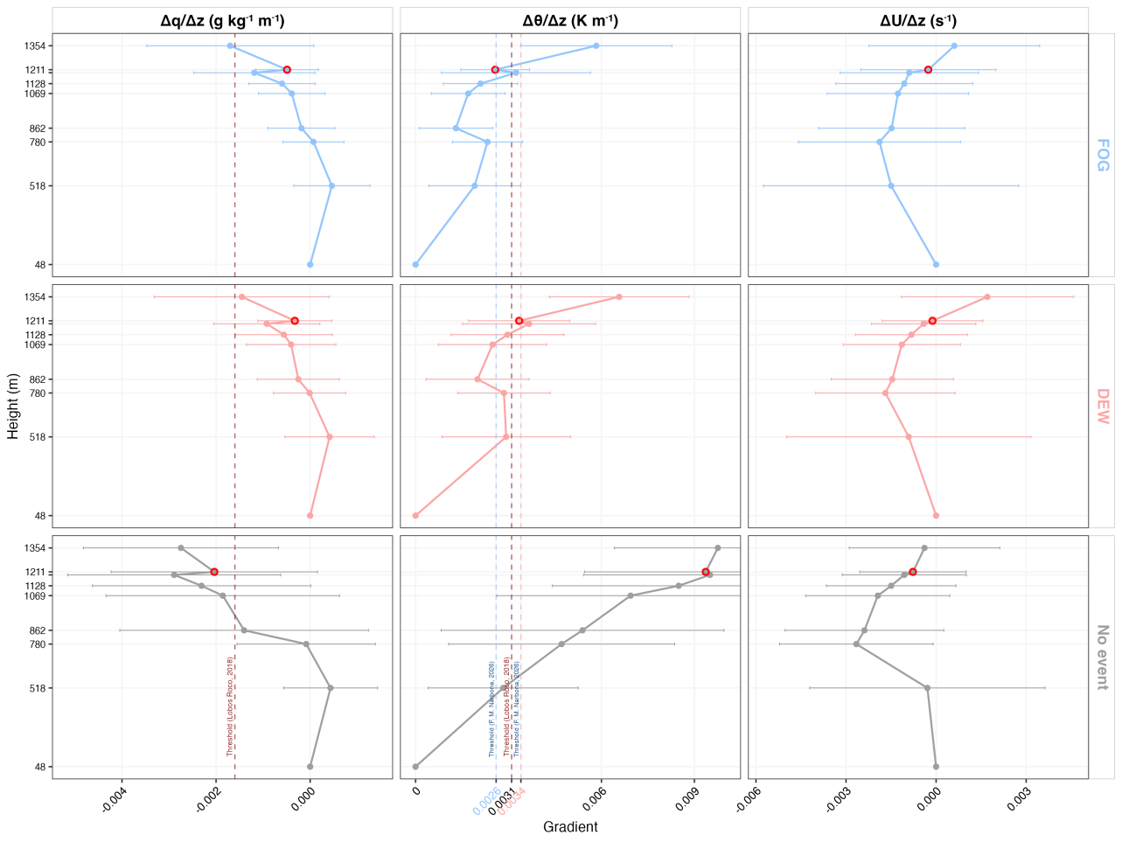
- The previous figure generalizes this pattern to the eight stations of the transect throughout 2024: fog is concentrated at Δθ/Δz < 0.0026 K m⁻¹, dew at 0.0026–0.0034 K m⁻¹, and non-event conditions jump to ≈ 0.0094 K m⁻¹, yielding three distinct regimes.
- Mann–Whitney/Kruskal–Wallis tests confirm that this contrast is robust for θ (r = 0.25, p < 0.001), but not for q or U (r ≈ 0.04–0.13); H2 is therefore fully supported, including its negative prediction.
- This repositions the general threshold of Lobos-Roco et al. (2018), 0.0031 K m⁻¹: in this dataset, it falls within the dew range rather than at the boundary between dew and non-event conditions, as previously assumed. That value separated fog from “everything else” without distinguishing, within that remainder, a dew regime in its own right.
- The physical reason is that both phenomena require a nearly saturated, well-mixed vapor column to initiate, so discrimination cannot be based on humidity; only thermal stability separates the regimes. As a secondary result, we also propose an updated Δq/Δz threshold to distinguish active events from non-event conditions (−0.0004 g kg⁻¹ m⁻¹), which refines (without replacing) the primary θ-based criterion.

Temporal evolution of humidity, heat and wind speed under fog and dew events
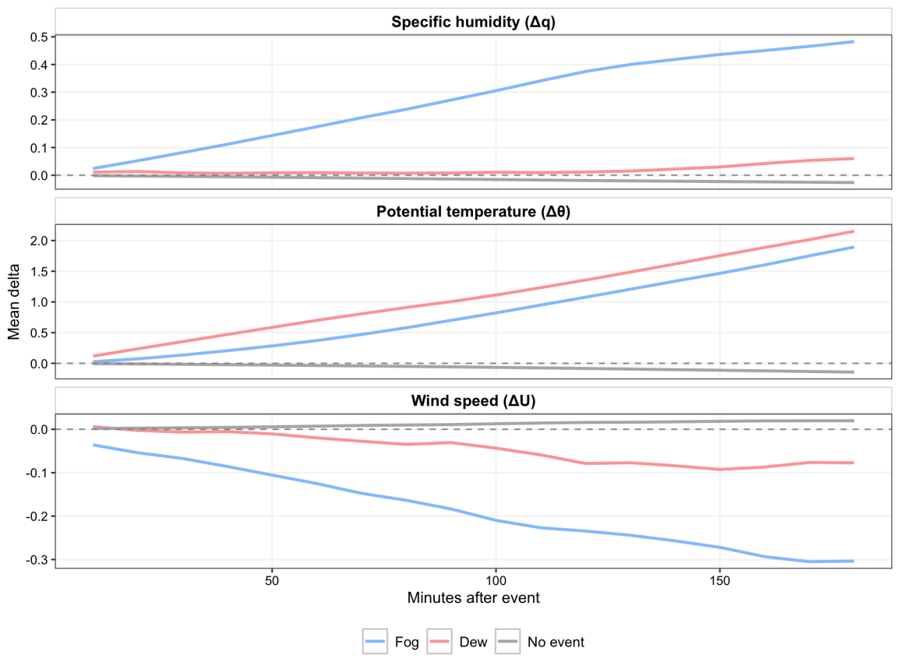
- The previous figure answers this question with all three variables simultaneously. Specific humidity behaves in opposite ways in each regime: fog accumulates +0.48 g kg⁻¹ 180 minutes after event onset, a sustained increase consistent with continuous advection of marine moisture, whereas dew reaches only +0.06 g kg⁻¹, close to neutrality rather than the marked drying expected from an active sink.
- Potential temperature also shows a strong contrast: dew exceeds fog at all times (+2.15 versus +1.89 K at 180 min), consistent with an episodic, radiatively forced mechanism rather than a steady advective one.
- Regarding wind, fog decelerates clearly (−0.30 m s⁻¹) as the cloud layer stabilizes the flow, whereas dew remains nearly neutral (−0.08 m s⁻¹), without reconfiguring the background wind field.
- Overall, the sign of the humidity tendency agrees with the prediction for both regimes, although the magnitude of the dew sink is smaller than previously reported for the region: H3 is supported in direction and refined in magnitude, and it is the θ and U signatures (not q alone) that most strongly support the advective-versus-radiative distinction.

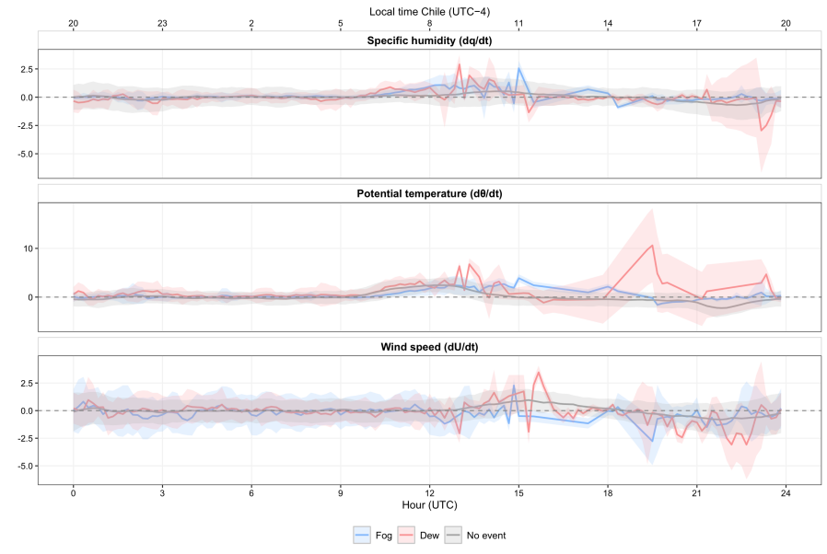
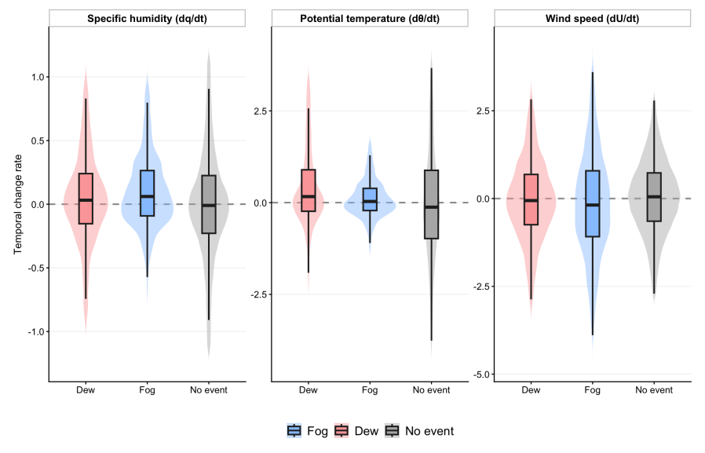
- The dew moisture sink is weaker than expected and its θ variability is high, which points to a real but episodic and locally forced mechanism, consistent with the seasonal/diurnal decoupling already shown in the previous figures. ***duda

Extra
- All of these thresholds and rates were derived under the 2024 ENSO context (El Niño → neutral transition), so their interannual generalization to other phases remains an explicit open question rather than an implicit assumption.
- Although fog remains the dominant phenomenon in terms of volume (Fig. 6), the ecohydrological relevance of dew rests not on its yield but on its temporal persistence, 46.7% of the active window (Fig. 5), which is ultimately why it merits sustained study despite its modest volumetric contribution.

Appendix A
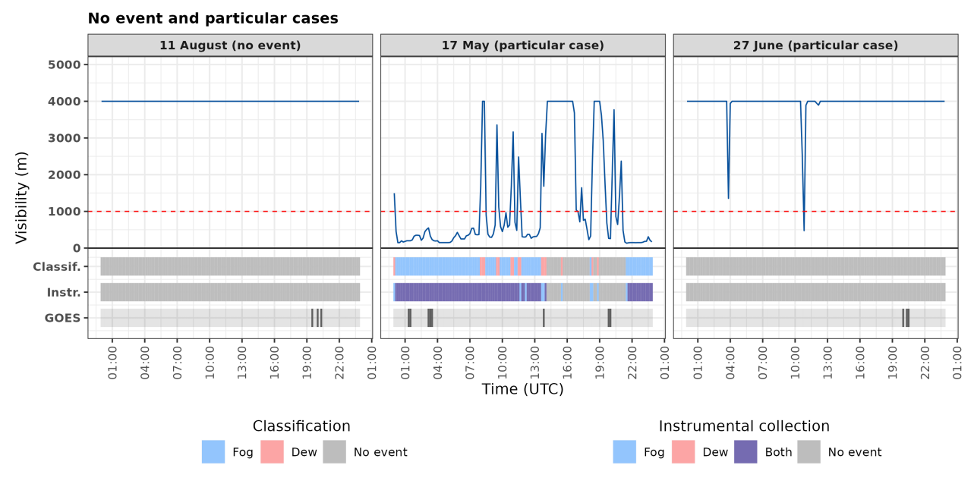
Figure 6: Examples of a day without events (11 August 2024) and particular cases (17 May and 27 June 2024) at station OYA1211. Bands as in Figure 3.

References
Albornoz, F., Río, C. del, Carter, V., Escobar, R., & Vásquez, L. (2023). Fog water collection for local greenhouse vegetable production in the atacama desert. Sustainability, 15(22), 15720. https://doi.org/10.3390/su152215720
Cereceda, P., Larrain, H., Osses, P., Farías, M., & Egaña, I. (2008). The spatial and temporal variability of fog and its relation to fog oases in the atacama desert, chile. Atmospheric Research, 87(3-4), 312–323. https://doi.org/10.1016/j.atmosres.2007.11.012
Cereceda, P., Osses, P., Larrain, H., Farı́as, M., Lagos, M., Pinto, R., & Schemenauer, R. S. (2002). Advective, orographic and radiation fog in the tarapacá region, chile. Atmospheric Research, 64(1-4), 261–271. https://doi.org/10.1016/s0169-8095(02)00097-2
Chamizo, S., Rodríguez-Caballero, E., Moro, M. J., & Cantón, Y. (2021). Non-rainfall water inputs: A key water source for biocrust carbon fixation. Science of The Total Environment, 792, 148299. https://doi.org/10.1016/j.scitotenv.2021.148299
Del Río, C., Lobos, F., Siegmund, A., Tejos, C., Osses, P., Huaman, Z., Meneses, J. P., & García, J.-L. (2021). GOFOS, ground optical fog observation system for monitoring the vertical stratocumulus-fog cloud distribution in the coast of the atacama desert, chile. Journal of Hydrology, 597, 126190. https://doi.org/10.1016/j.jhydrol.2021.126190
Espinoza, V., Lobos-Roco, F., & Río, C. del. (2024). Synoptic control of the spatiotemporal variability of fog and low clouds under ENSO phenomena along the chilean coast (17°-36° s). Atmospheric Research, 308, 107533. https://doi.org/10.1016/j.atmosres.2024.107533
Fessehaye, M., Abdul-Wahab, S. A., Savage, M. J., Kohler, T., Gherezghiher, T., & Hurni, H. (2014). Fog-water collection for community use. Renewable and Sustainable Energy Reviews, 29, 52–62. https://doi.org/10.1016/j.rser.2013.08.063
García, J.-L., Lobos-Roco, F., Schween, J. H., Río, C. del, Osses, P., Vives, R., Pezoa, M., Siegmund, A., Latorre, C., Alfaro, F., Koch, M. A., & Loehnert, U. (2021). Climate and coastal low-cloud dynamic in the hyperarid atacama fog desert and the geographic distribution of tillandsia landbeckii (bromeliaceae) dune ecosystems. Plant Systematics and Evolution, 307(5). https://doi.org/10.1007/s00606-021-01775-y
Gultepe, I., Tardif, R., Michaelides, S. C., Cermak, J., Bott, A., Bendix, J., Müller, M. D., Pagowski, M., Hansen, B., Ellrod, G., Jacobs, W., Toth, G., & Cober, S. G. (2007). Fog research: A review of past achievements and future perspectives. In Fog and boundary layer clouds: Fog visibility and forecasting (pp. 1121–1159). Birkhäuser Basel. https://doi.org/10.1007/978-3-7643-8419-7_3
Houston, J. (2006). Variability of precipitation in the Atacama Desert: Its causes and hydrological impact. International Journal of Climatology, 26(15), 2181–2198. https://doi.org/10.1002/joc.1359
Jabbusch, S., & Koch, M. A. (2025). Tillandsia landbeckii secures high phenotypic variation despite clonal propagation at the dry limits of plant life in the atacama desert. Perspectives in Plant Ecology, Evolution and Systematics, 66, 125846. https://doi.org/10.1016/j.ppees.2025.125846
Jacobs, A. F. G., Heusinkveld, B. G., Wichink Kruit, R. J., & Berkowicz, S. M. (2006). Contribution of dew to the water budget of a grassland area in the netherlands. Water Resources Research, 42(3). https://doi.org/10.1029/2005wr004055
Jung, P., Emrich, D., Briegel‐Williams, L., Schermer, M., Weber, L., Baumann, K., Colesie, C., Clerc, P., Lehnert, L. W., Achilles, S., Bendix, J., & Büdel, B. (2019). Ecophysiology and phylogeny of new terricolous and epiphytic chlorolichens in a fog oasis of the atacama desert. MicrobiologyOpen, 8(10). https://doi.org/10.1002/mbo3.894
Koch, M. A., Kleinpeter, D., Auer, E., Siegmund, A., Río, C. del, Osses, P., García, J.-L., Marzol, M. V., Zizka, G., & Kiefer, C. (2019). Living at the dry limits: Ecological genetics of Tillandsia landbeckii lomas in the Chilean Atacama Desert. Plant Systematics and Evolution, 305, 1041–1053. https://doi.org/10.1007/s00606-019-01623-0
Larrain, H., Velásquez, F., Cereceda, P., Espejo, R., Pinto, R., Osses, P., & Schemenauer, R. S. (2002). Fog measurements at the site “falda verde” north of chañaral compared with other fog stations of chile. Atmospheric Research, 64(1-4), 273–284. https://doi.org/10.1016/s0169-8095(02)00098-4
Latorre, C., González, A. L., Quade, J., Fariña, J. M., Pinto, R., & Marquet, P. A. (2011). Establishment and formation of fog-dependent <i>tillandsia landbeckii</i> dunes in the atacama desert: Evidence from radiocarbon and stable isotopes. Journal of Geophysical Research, 116(G3). https://doi.org/10.1029/2010jg001521
Li, H., Han, C., Yang, Y., & Chen, R. (2025). Advances and challenges in dew research on land surface: A review. Hydrology, 12(12), 320. https://doi.org/10.3390/hydrology12120320
Lobos Roco, F., Vilà-Guerau de Arellano, J., & Pedruzo-Bagazgoitia, X. (2018). Characterizing the influence of the marine stratocumulus cloud on the land fog at the atacama desert. Atmospheric Research, 214, 109–120. https://doi.org/10.1016/j.atmosres.2018.07.009
Lobos-Roco, F., Suárez, F., Aguirre-Correa, F., Keim, K., Aguirre, I., Vargas, C., Abarca, F., Ramírez, C., Escobar, R., Osses, P., & Río, C. del. (2024). Understanding inland fog and dew dynamics for assessing potential non-rainfall water use in the atacama. Journal of Arid Environments, 221, 105125. https://doi.org/10.1016/j.jaridenv.2024.105125
Malik, T., Gethin, D., Boy, F., Davies, G., & Parker, A. (2023). Re-engineering dew-harvesting cactus macrostructures to enhance water collection as an adaptive climate change strategy: An experimental comparison. Atmosphere, 14(12), 1736. https://doi.org/10.3390/atmos14121736
Monteith, J. L. (1957). Dew. Quarterly Journal of the Royal Meteorological Society, 83(357), 322–341. https://doi.org/10.1002/qj.49708335706
Muñoz-Narbona, F., Lobos-Roco, F., Del Río, C., & Acevedo, S. (2026). Thermodynamic characterization of fog and dew in the Atacama coastal desert (Version v1.0.0) [Computer software]. Zenodo. https://doi.org/10.5281/zenodo.21826557
Muselli, M., Beysens, D., Marcillat, J., Milimouk, I., Nilsson, T., & Louche, A. (2002). Dew water collector for potable water in ajaccio (corsica island, france). Atmospheric Research, 64(1-4), 297–312. https://doi.org/10.1016/s0169-8095(02)00100-x
Pinto, R., Barría, I., & Marquet, P. A. (2006). Geographical distribution of tillandsia lomas in the atacama desert, northern chile. Journal of Arid Environments, 65(4), 543–552. https://doi.org/10.1016/j.jaridenv.2005.08.015
Río, C. del, Lobos-Roco, F., Latorre, C., Koch, M. A., García, J.-L., Osses, P., Lambert, F., Alfaro, F., & Siegmund, A. (2021). Spatial distribution and interannual variability of coastal fog and low clouds cover in the hyperarid atacama desert and implications for past and present tillandsia landbeckii ecosystems. Plant Systematics and Evolution, 307(5). https://doi.org/10.1007/s00606-021-01782-z
Rutllant, J., & Montecino, V. (2002). Multiscale upwelling forcing cycles and biological response off north-central chile. Revista Chilena de Historia Natural, 75(1). https://doi.org/10.4067/s0716-078x2002000100020
Schemenauer, R. S., & Cereceda, P. (1994). A proposed standard fog collector for use in high-elevation regions. Journal of Applied Meteorology, 33(11), 1313–1322. https://doi.org/10.1175/1520-0450(1994)033<1313:apsfcf>2.0.co;2
Stull, R. B. (1988). An introduction to boundary layer meteorology. Kluwer Academic Publishers. https://doi.org/10.1007/978-94-009-3027-8
Wang, L., Kaseke, K. F., & Seely, M. K. (2016). Effects of non‐rainfall water inputs on ecosystem functions. WIREs Water, 4(1). https://doi.org/10.1002/wat2.1179

