Figures
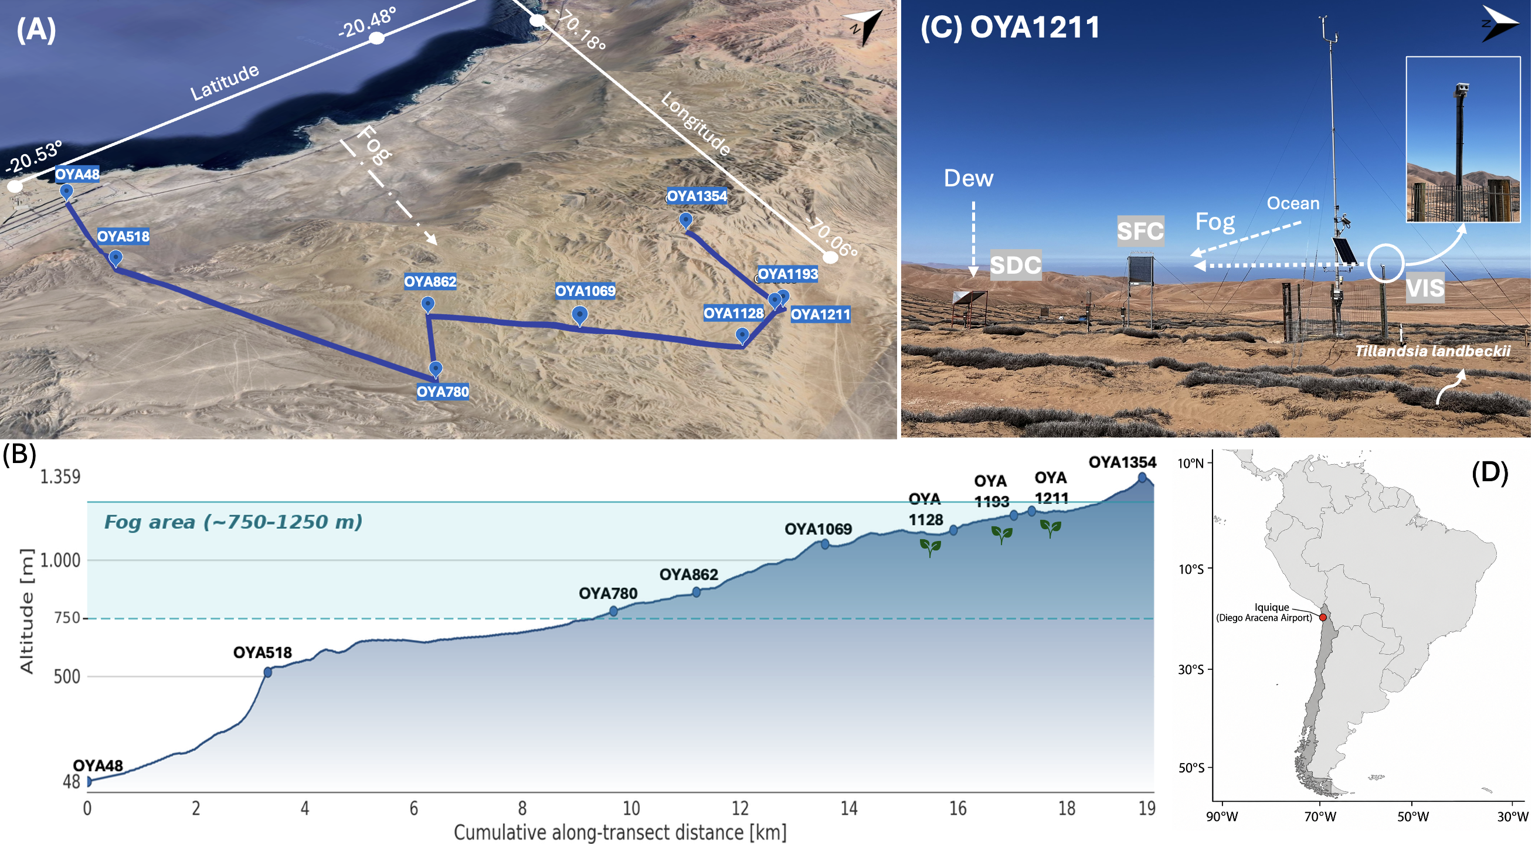
Figure 1. Study site overview at Cerro Oyarbide. (A) Satellite image showing a perspective view of the meteorological station topographic transect (blue line) on Cerro Oyarbide taken from Google Earth Pro. (B) Schematic topographic profile of the transect showing station elevation (m a.s.l.) and distance from the coast (km); plant icons represents the Tillandsia landbeckii ecosystem. (C) Photograph showing the main instrumentation setup at OYA1211 station: the visibility sensor (VIS), standard fog collector (SFC), and standard dew collector (SDC). The inset shows a detail of the VIS sensor mounted on the station mast. (D) South America. The red dot marks the location of the study site.

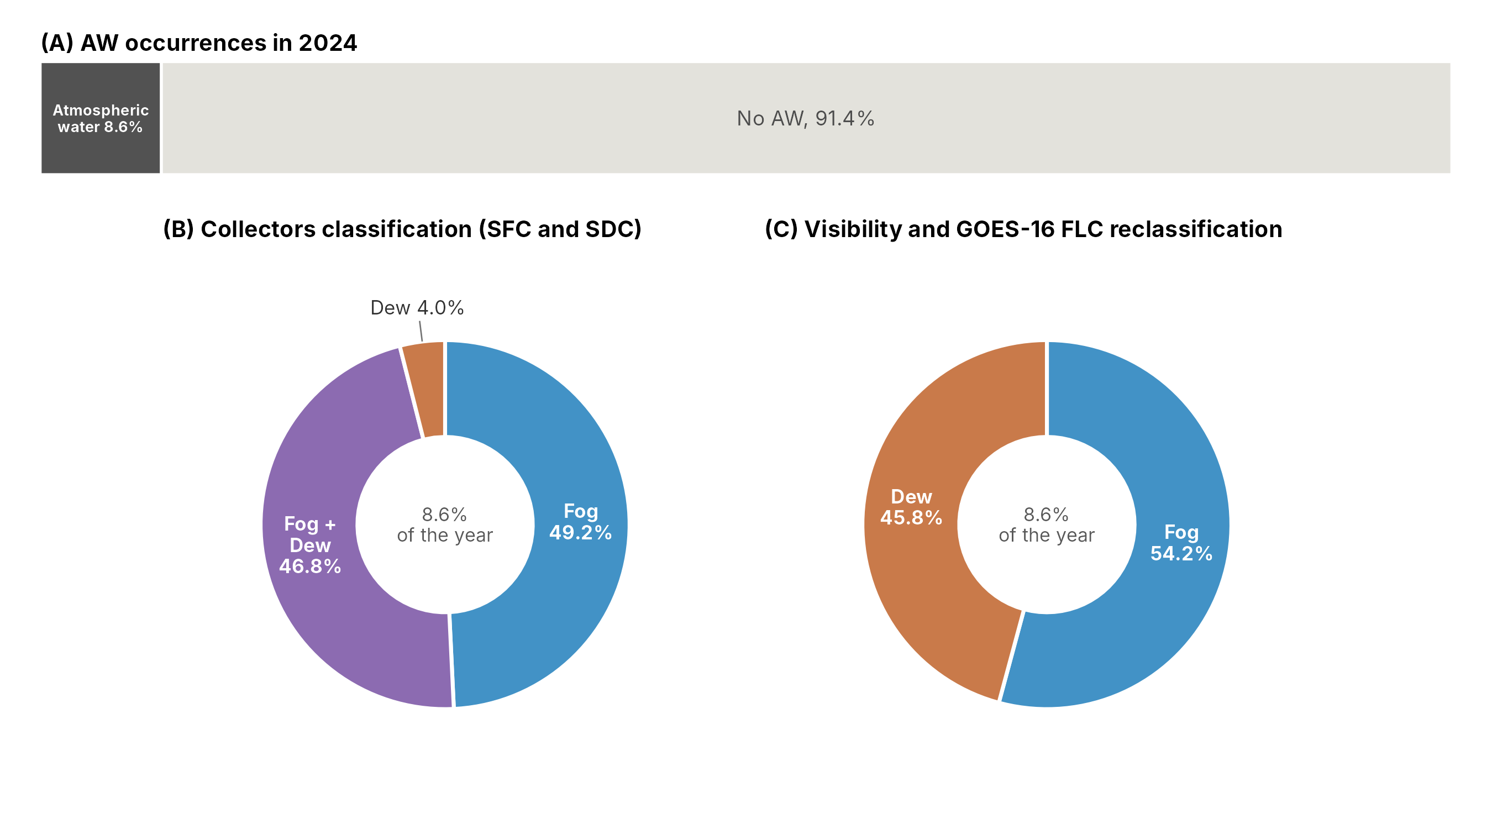
Figure 2. Classification of atmospheric water occurrences at station OYA1211 during 2024. (A) Proportion of the 10-min records of the year with atmospheric water occurrence (fog or dew collection) and with no AW occurrence. (B) Relative distribution of the AW occurrences according to the collector-based classification. (C) Relative distribution after the reclassification based on visibility and fog and low clouds (FLC) detection.

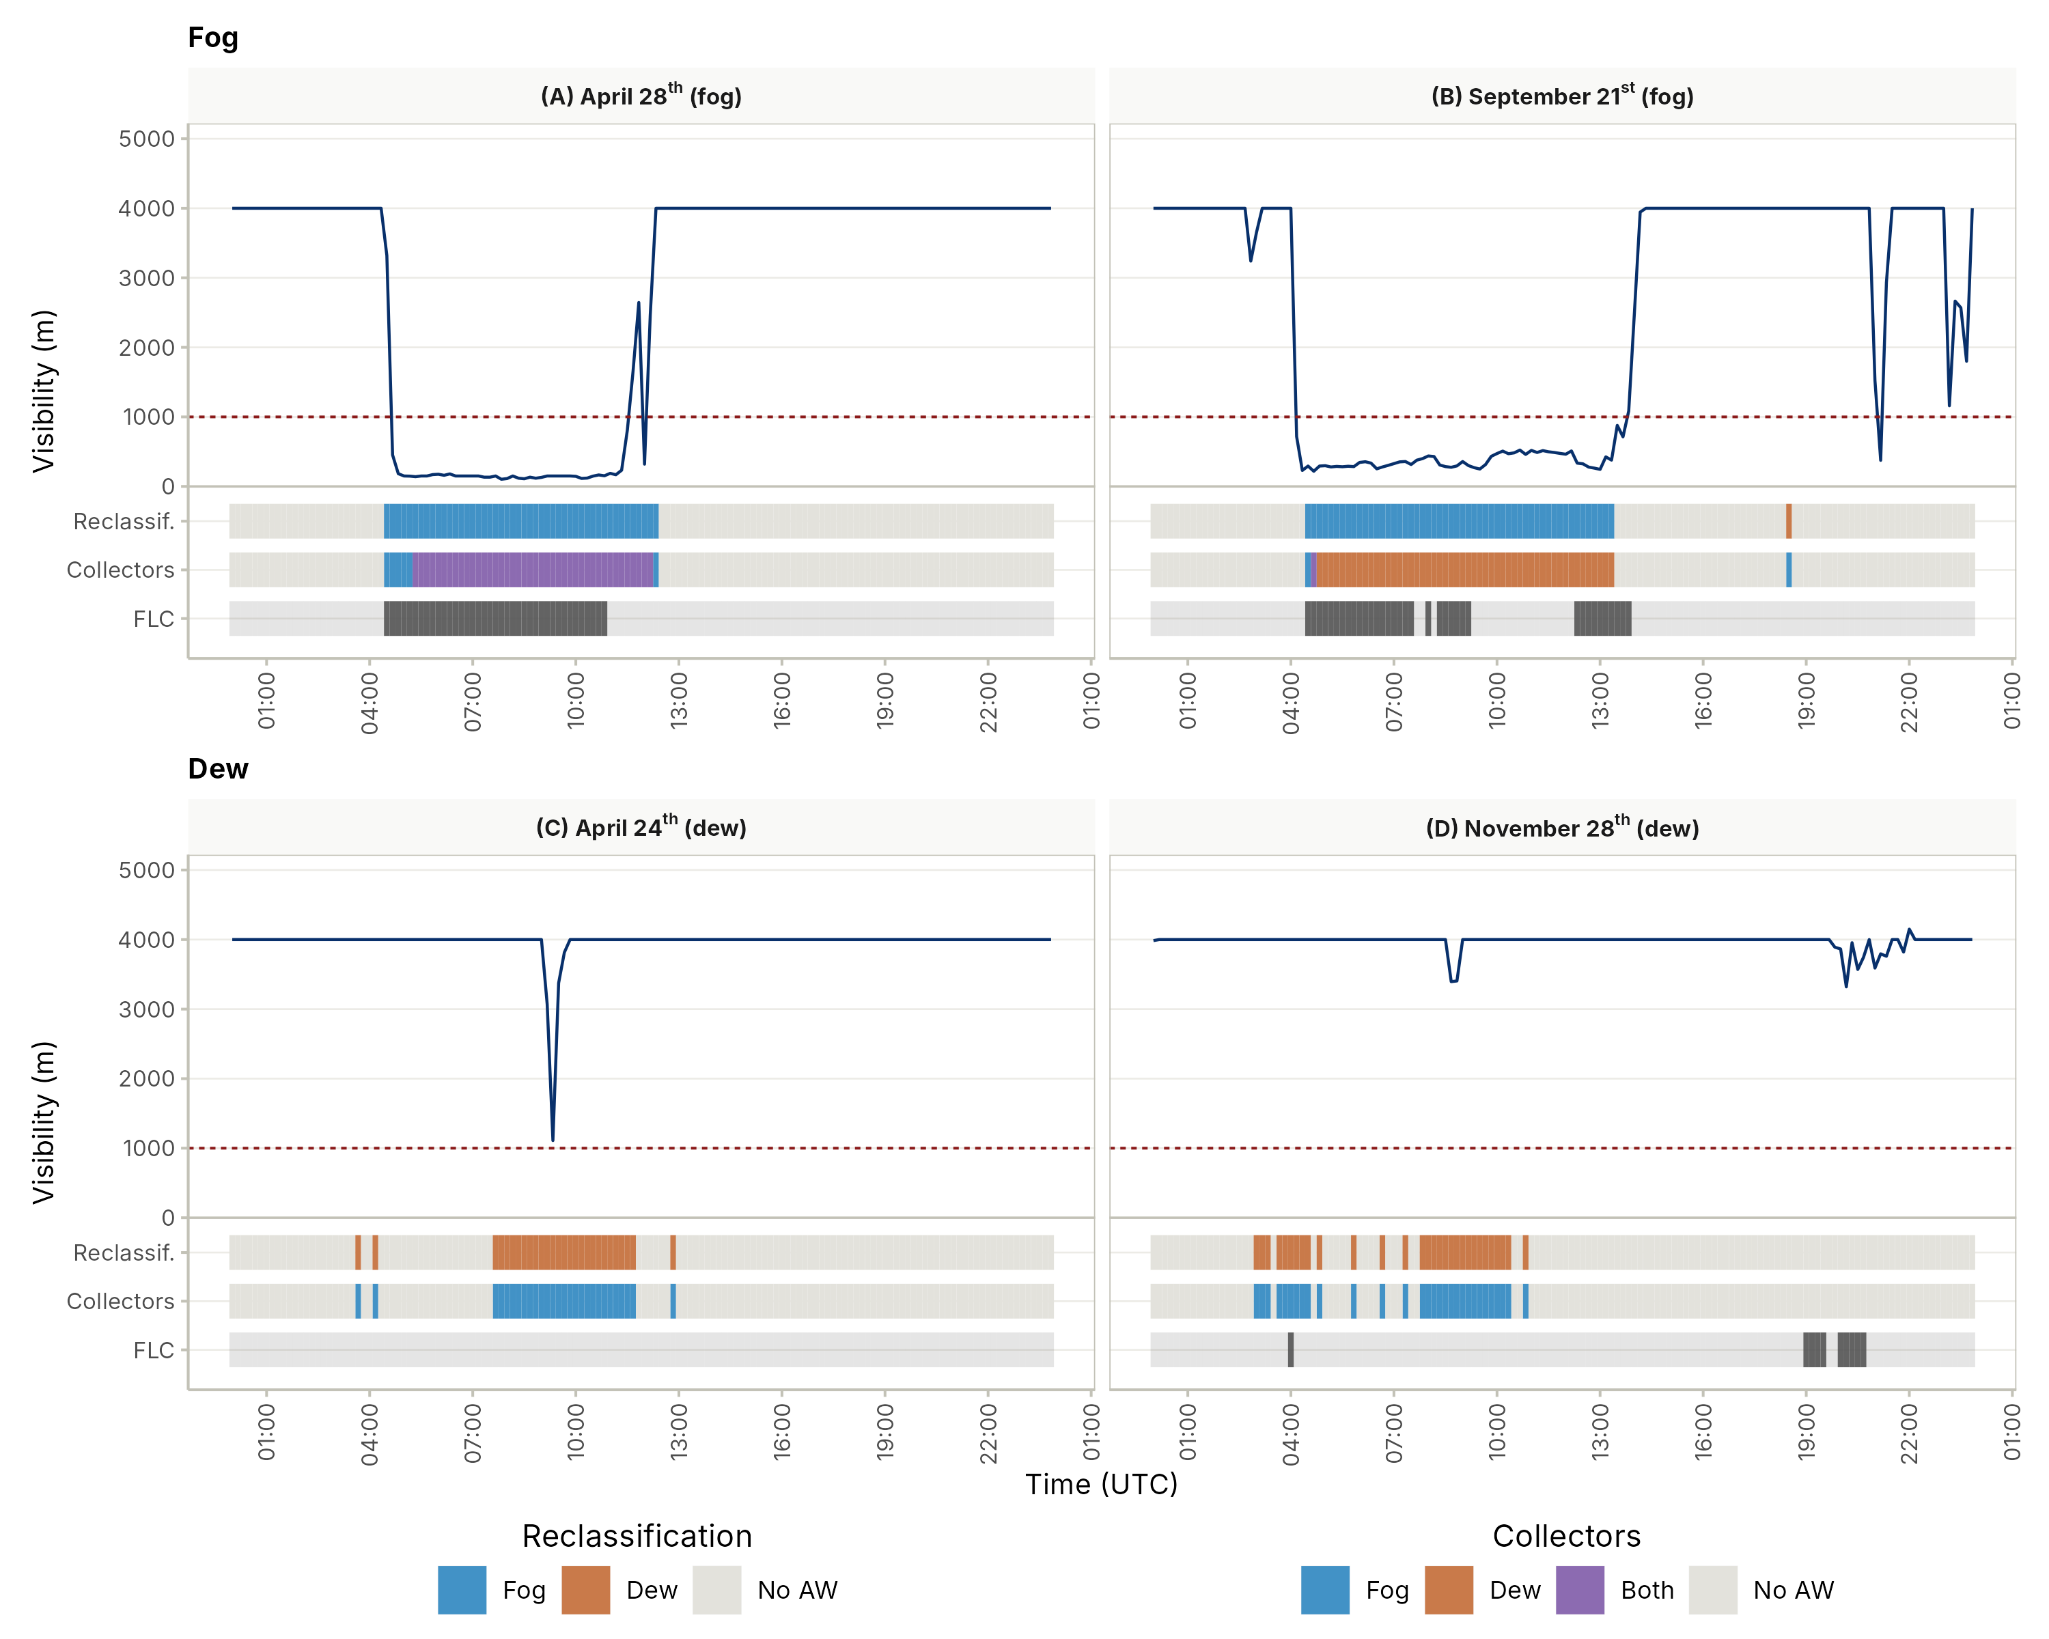
Figure 3. Diurnal variability of visibility (solid blue line; dashed red line: 1000 m threshold), FLC detection (dark grey) and fog (blue), dew (dark orange) or overlapped (purple) collection, as reclassified (Reclassif.) and by the collectors (Collectors), on typical cases at station OYA1211 on (A) April 28th, (B) September 21st, (C) April 24th and (D) November 28th, 2024. Times are in UTC.

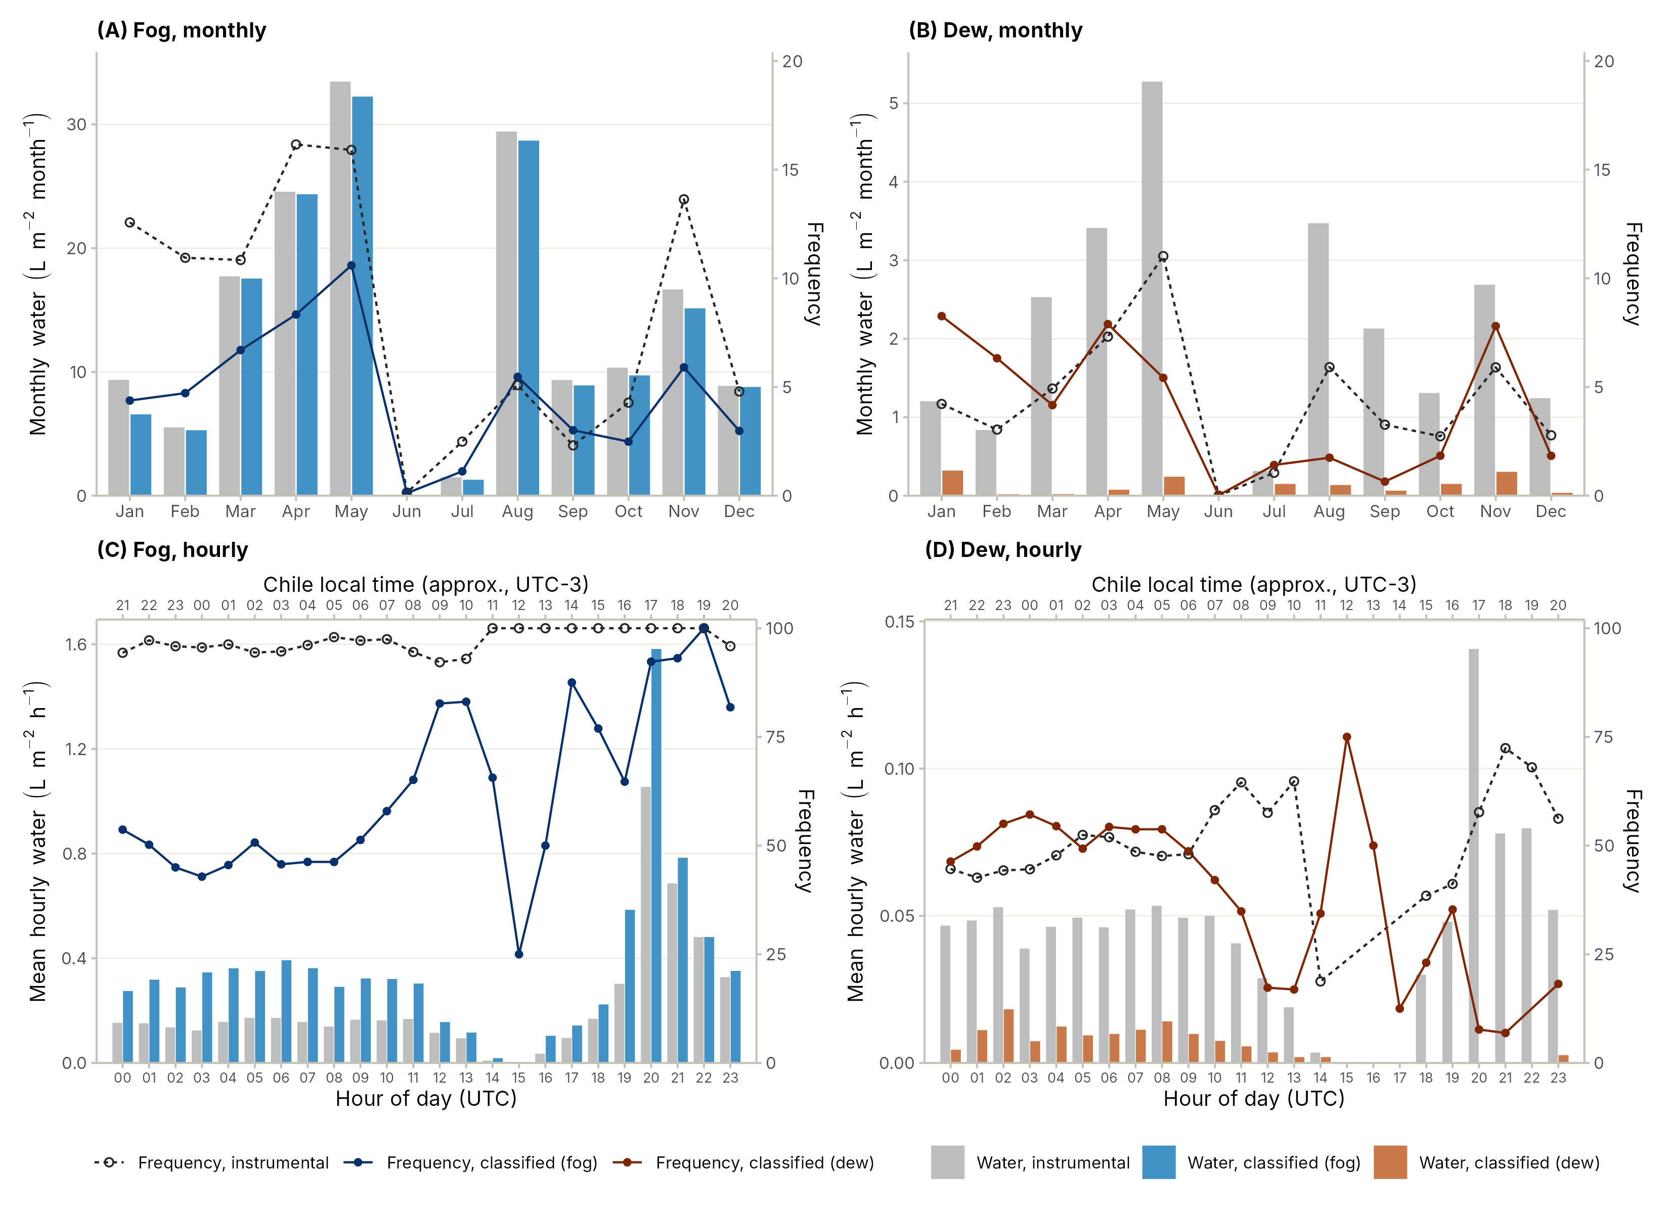
Figure 4. Seasonal (A and B) and diurnal (C and D) distribution of fog and dew occurrences and water collected at station OYA1211 during 2024. Bars show the total monthly water (A and B, L m⁻² month⁻¹) and the mean hourly water on the hours with water (C and D, L m⁻² h⁻¹), in grey as measured by the collector and in colours after the reclassification. Lines show the frequency (%) of the fog and dew records for the collector-based classification (dashed line, open circles) and the reclassification (solid line, filled circles), relative to all the 10-min records of each month (A and B) and to the AW records of each hour (C and D).

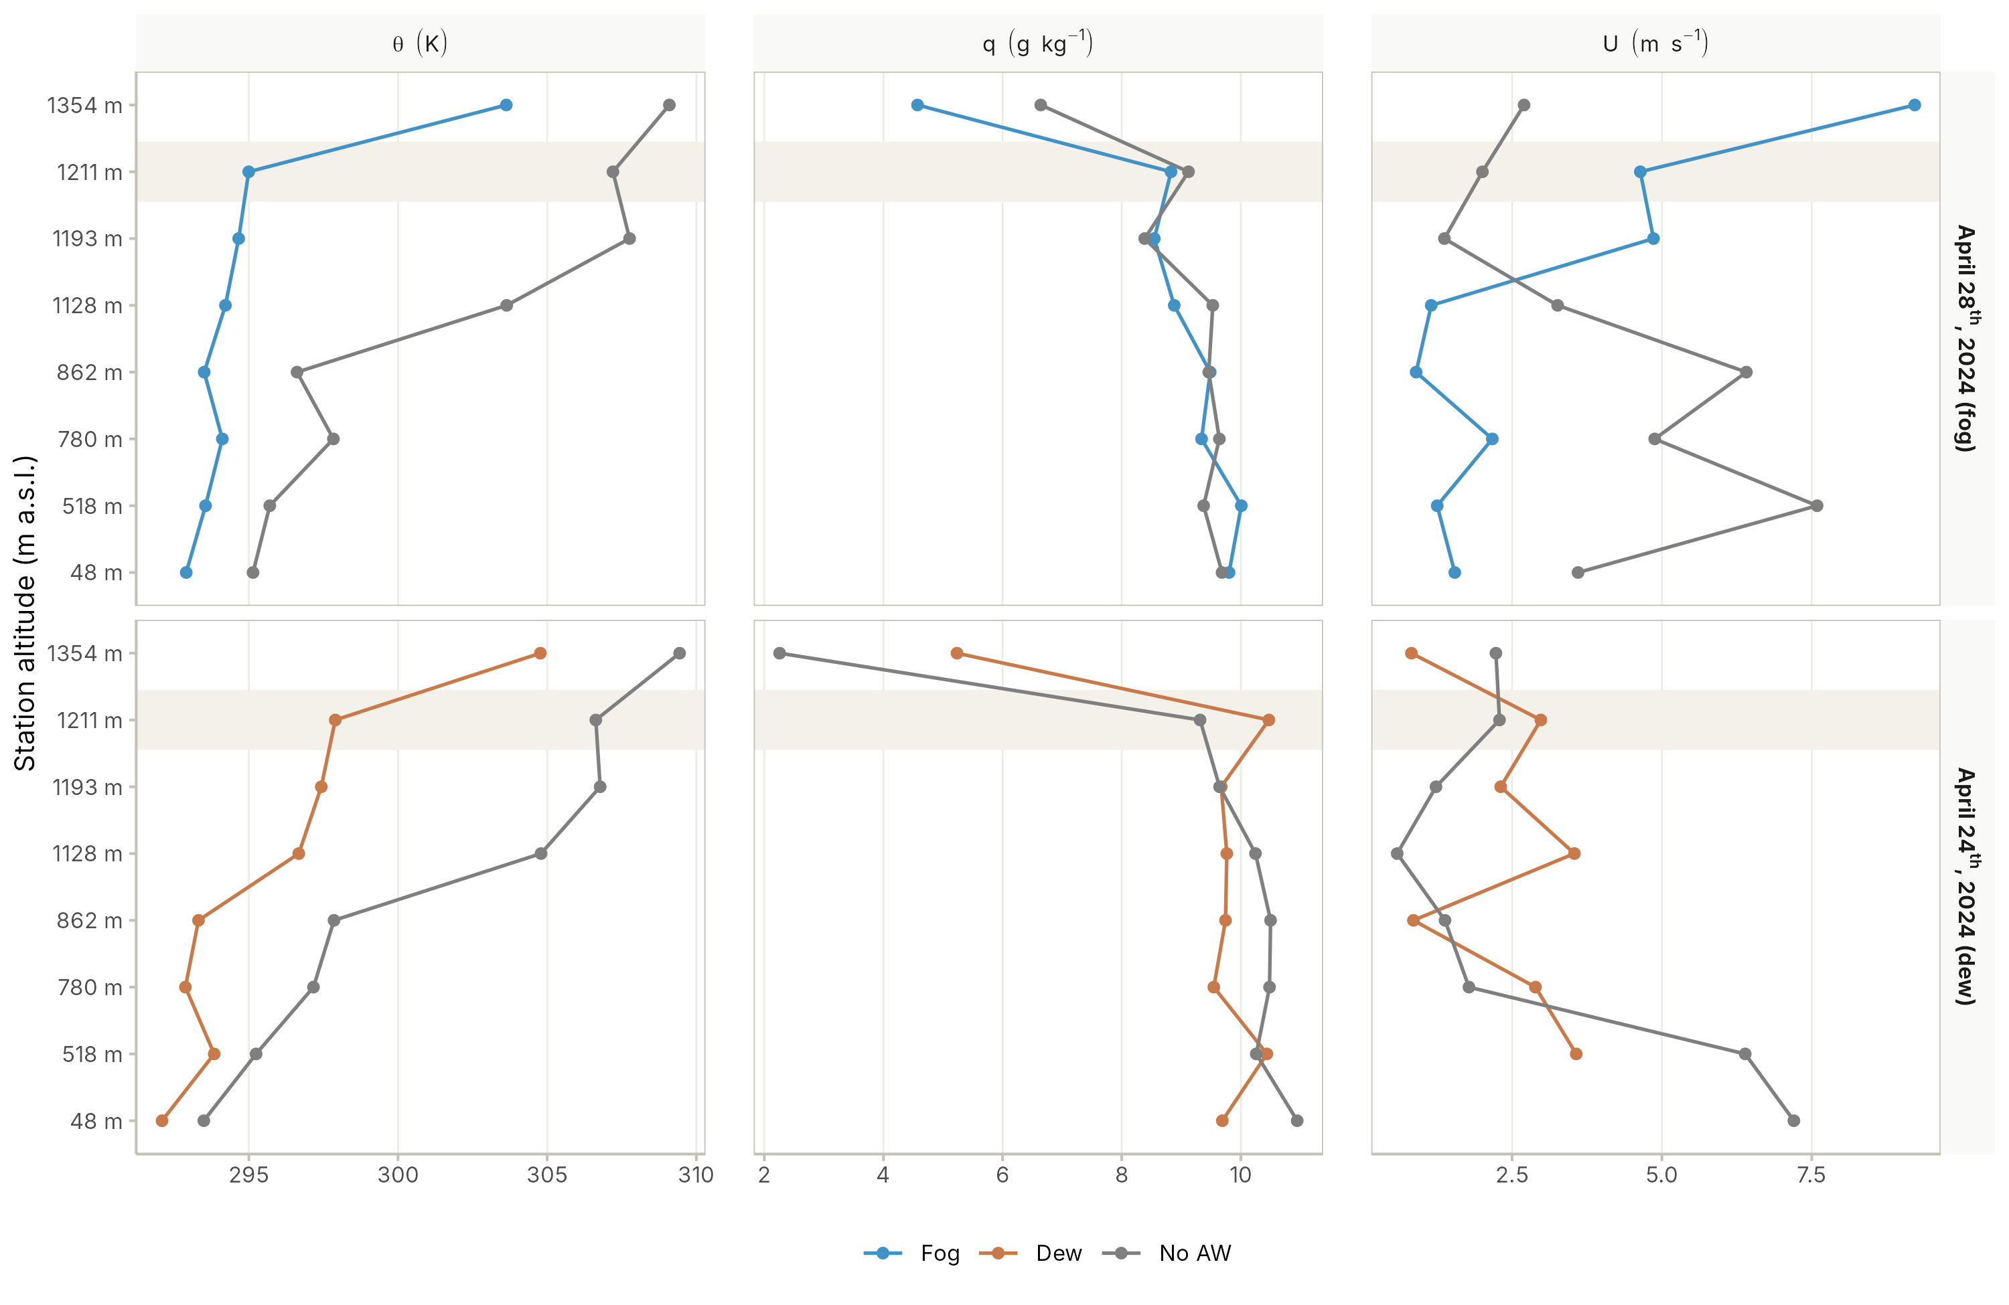
Figure 5. Vertical profiles of potential temperature (θ), specific humidity (q) and wind speed (U) along the Cerro Oyarbide transect on a typical fog (blue line) event, April 28th, 2024 (top), and a typical dew (dark orange line) event, April 24th, 2024 (bottom). On April 28th, the fog profiles correspond to 11:00 UTC and the no AW occurrence profiles (grey) to 17:00 UTC. On April 24th, the dew profiles correspond to 11:00 UTC and the no AW occurrence profiles (grey) to 22:00 UTC.

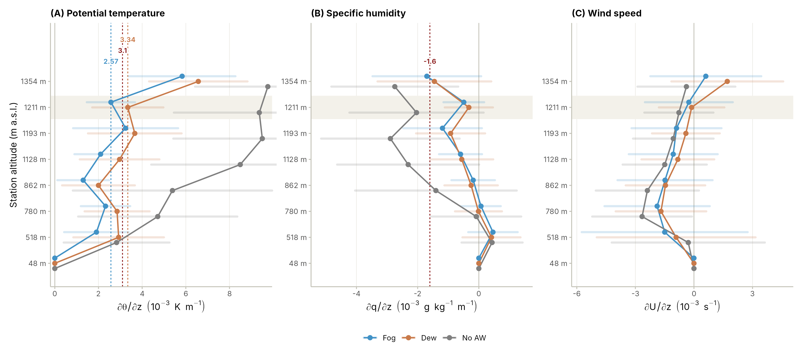
Figure 6. Mean vertical gradients of (A) potential temperature (∂θ/∂z), (B) specific humidity (∂q/∂z) and (C) momentum (∂U/∂z) between the coastal station (48 m asl) and each station of the transect for fog (blue), dew (orange) and no AW occurrence (grey) during 2024. Points show the mean and bars ±1 standard deviation; the shaded band marks OYA1211. Dashed lines show the thresholds of Lobos Roco et al. (2018) (dark red) and the mean ∂θ/∂z of fog and dew at OYA1211. Gradients are shown in units of 10⁻³.

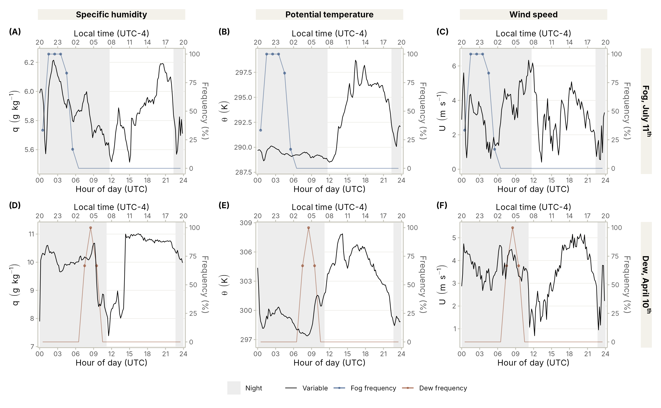
Figure 7. Diurnal cycle of (A, D) specific humidity (q), (B, E) potential temperature (θ) and (C, F) wind speed (U) at station OYA1211 (black line, left axis) on a night with fog (July 11th, 2024, top) and a night with dew (April 10th, 2024, bottom). Coloured lines (right axis) show the hourly frequency (%) of the 10-min records reclassified as fog (blue) or dew (dark orange). Grey shading represents the nightime. Times are in UTC (bottom axis) and local time (UTC−4, top axis).

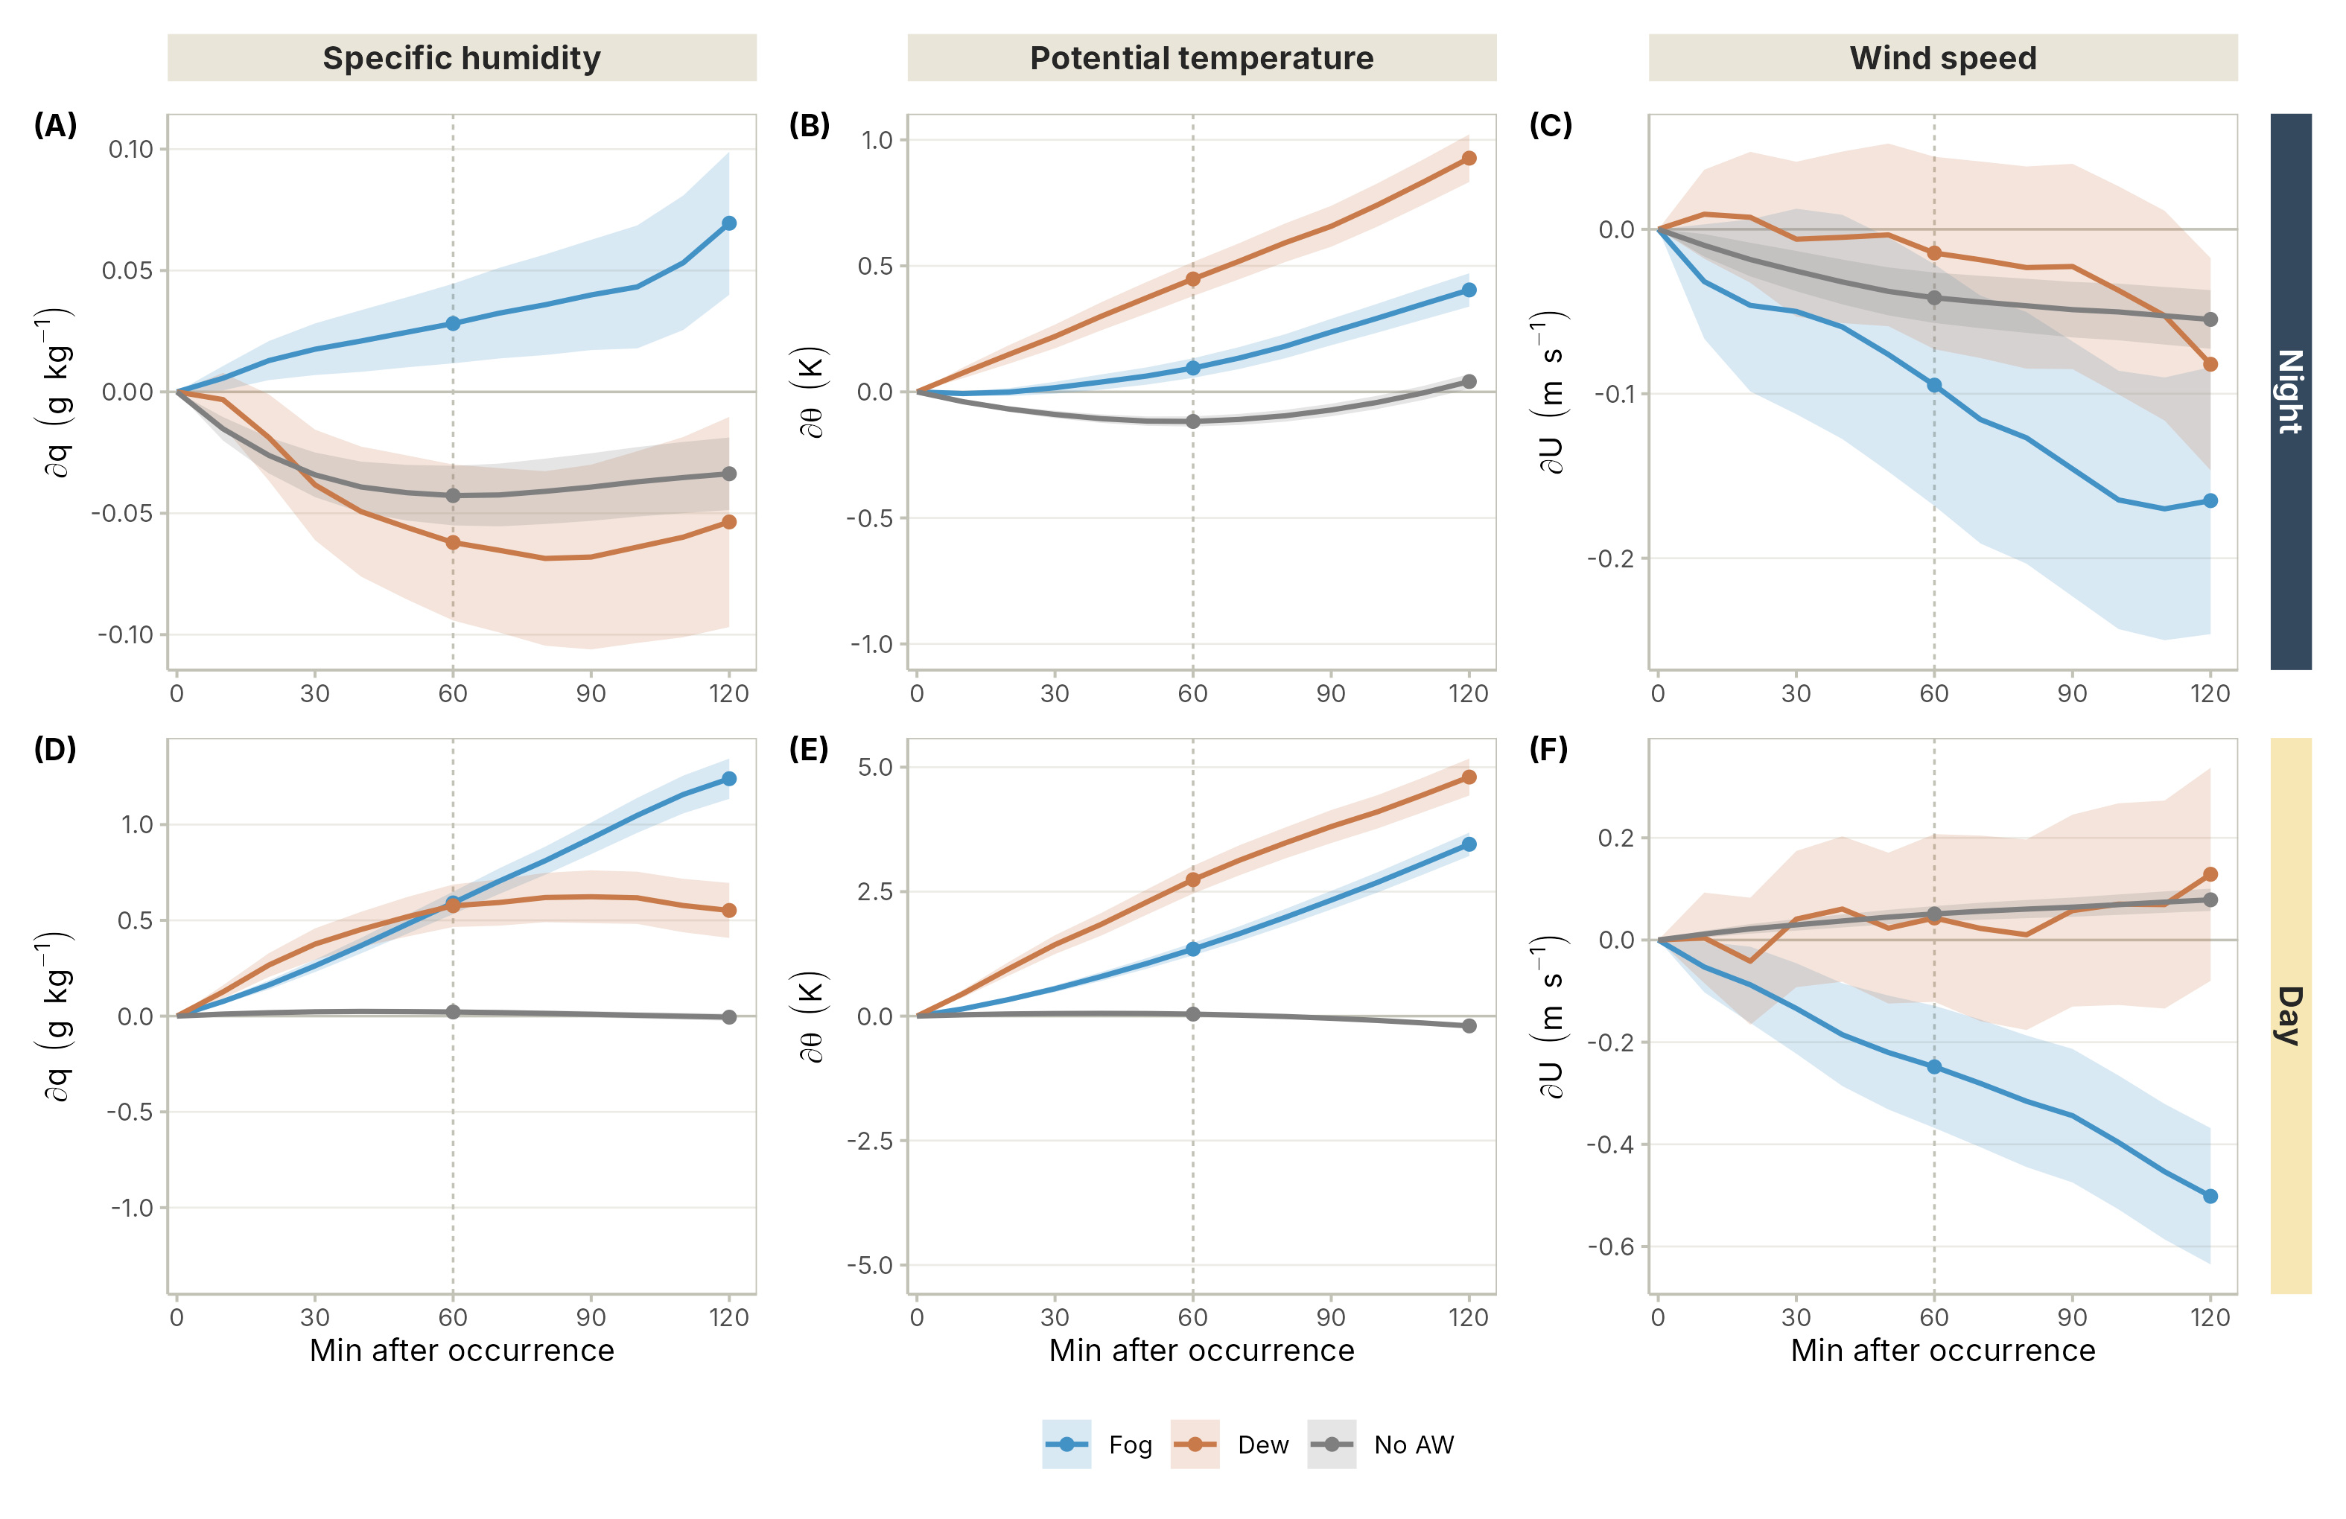
Figure 8. Rate of change of (A, D) specific humidity (q, g kg⁻¹), (B, E) potential temperature (θ, K) and (C, F) wind speed (U, m s⁻¹) at station OYA1211 from 10 to 120 min after each every record reclassified as fog (blue), dew (orange) and no AW occurrence (grey) during 2024, at night (A to C) and during the day (D to F). Shaded bands show the 95% confidence interval of the mean. The change after 60 min (dotted line) equals the mean ∂φ/∂t in units per hour.

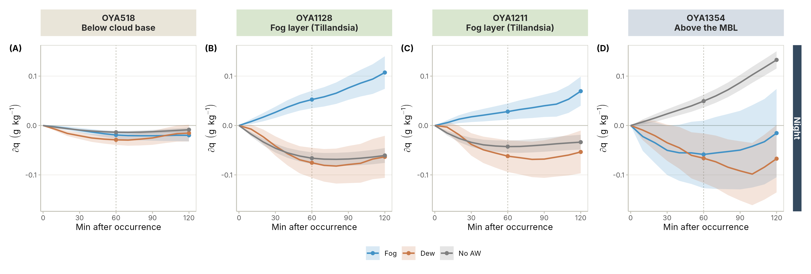
Figure 9. Nighttime rate of change of specific humidity (∂q, g kg⁻¹) from 10 to 120 min after reclassified fog (blue), dew (orange) and no AW occurrence (grey) during 2024, at (A) OYA518, (B) OYA1128 and (C) OYA1211, and (D) OYA1354. Shaded bands show the 95% confidence interval of the mean.

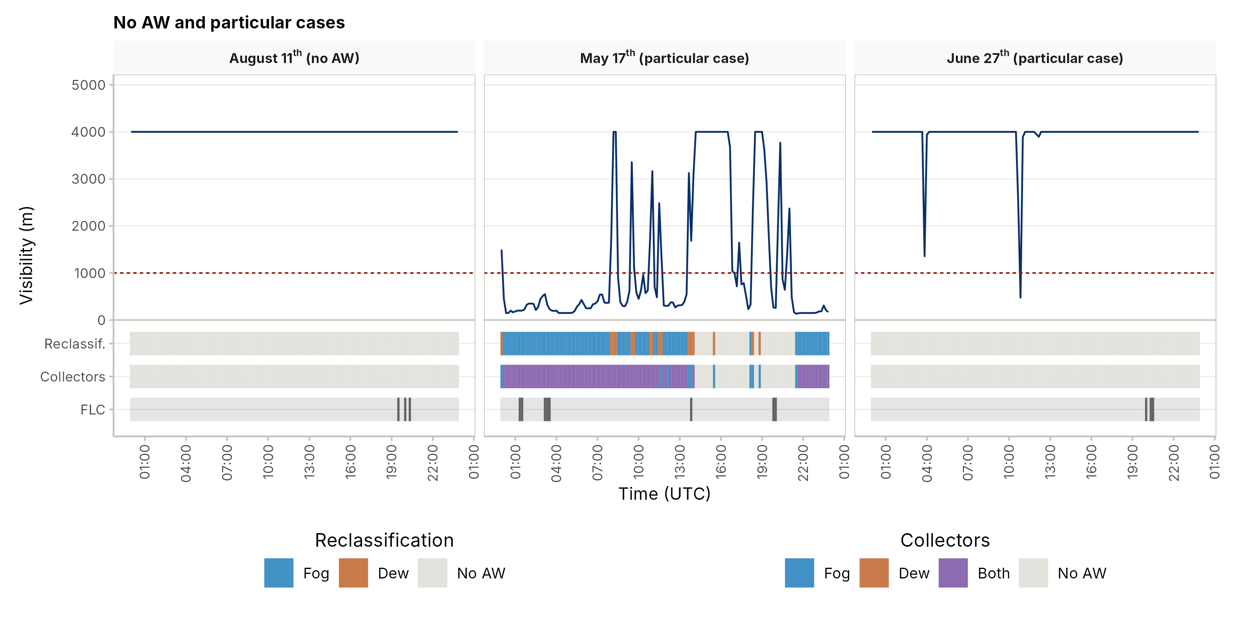
Figure A1. Particular cases of the classification at station OYA1211. A day with no AW occurrence (August 11th, 2024) and two particular cases (May 17th and June 27th, 2024). Lines and bands as in Figure 3.

