Thermodynamic characterization of the marine boundary layer during fog and dew occurrences in the hyperarid coastal climate of the Atacama Desert
F.M. Narbona, S. Acevedo, C. Del Río, A. Siegmund, F. Lobos-Roco
2026-11-02
Abstract
In the hyperarid coastal Atacama Desert, fog and dew are the main water sources for ecosystems like Tillandsia landbeckii and local communities. However, distinguishing the water contributions of fog and dew to the local water balance remains highly uncertain because standard fog and dew collectors’ measurements overlap. In this work, we reclassify fog and dew occurrences measured by collectors using ground-based visibility and satellite fog and low cloud (FLC) criteria. Moreover, we analyse the thermodynamic vertical structure of the marine boundary layer and its temporal tendency under reclassified fog and dew events using a nine-station topographic transect at the coastal mountain range (48 to 1354 m asl). Our main results indicate that atmospheric water (AW) episodes occur in 8.6% of the year, of which fog collection corresponds to 4.2%, dew to 0.3%, and there is an overlap between fog and dew collection of about 4.1%. However, when AW occurrences are reclassified using the visibility criteria, fog corresponds to 4.7% and dew to 3.9%. Our observations suggest that fog and dew occur under different thermal stability: fog ~2.57×10⁻³ K m⁻¹ (well-mixed) and dew > 3.34×10⁻³ K m⁻¹ (stratified). The specific humidity tendency shows that over the night, the air dries at a rate of −0.06 g kg⁻¹ h⁻¹ during dew episodes, while it slightly increases at a rate of 0.03 g kg⁻¹ h⁻¹ under fog episodes. This tendency intensifies over Tillandsia landbeckii field compared to bare soil. Our work suggests a feasible methodology for observational distinction and characterisation of fog and dew, applicable to broad hyperarid environments.
Keywords: Fog; dew; marine boundary layer; atmospheric stability; Atacama Desert

1. Introduction
In the coastal Atacama Desert, precipitation is almost null (Houston, 2006); thus, non-rainfall atmospheric water (AW), fog and dew are the main water sources sustaining hyperarid ecosystems and local communities (Lobos-Roco et al., 2024; Río et al., 2021). On the one hand, species like Tillandsia landbeckii are examples of fog- and dew-dependent vegetation, which, localised within 900 and 1200 m above sea level (asl), receive fog during the afternoon (Cereceda et al., 2008; García et al., 2021), and dew at night during periods of reduced fog (Jabbusch & Koch, 2025; Latorre et al., 2011). Other species share this dependence, including congeneric Tillandsia (Pinto et al., 2006) and biological soil crusts (Jung et al., 2019). Likewise, the cactus Copiapoa cinerea var. haseltoniana shows differential radiative cooling across its stem and spines, a property exploited in biomimetic dew harvesting designs (Malik et al., 2023), suggesting some desert plants may rely preferentially on this water source. On the other hand, coastal communities have historically used fog water as a drinking supply or for small-scale greenhouse vegetable production (Albornoz et al., 2023; Fessehaye et al., 2014), finding a sustainable solution to tackle permanent water scarcity. Besides the uses of AW water, distinguishing between fog and dew contributions to the local water balance remains a challenge. In hyperarid regions, this distinction is essential to understand their contribution to the hydrological cycle and the carbon balance of ecosystems (Wang et al., 2016). Moreover, in contrast to fog, our understanding of dew remains very limited (Li et al., 2025).
Coastal fog and dew are condensation processes that occur within the marine boundary layer (MBL), governed by turbulent mixing, advection and thermal stratification (Lobos-Roco et al., 2024; Stull, 1988). Fog forms when a moist air parcel saturates, then reaches the dew point ($T_{air}≤T_{dew}$) (Gultepe et al., 2007). In the Atacama, fog results from the advection of marine stratocumulus clouds, which are formed over the South East Pacific (SEP) Ocean under high subsidence promoted by the South Pacific Anticyclone (Cereceda et al., 2002; Cereceda et al., 2008; Rutllant & Montecino, 2002). This subsidence contrasts with the cold Humboldt Current and the cold water upwelling, forming a strong thermal inversion (~20 K) that limits vertical mixing, driving stratocumulus cloud formation (Espinoza et al., 2024). The anticyclonic circulation in the SEP transports these well-formed stratocumulus up to 50–60 km inland (Lobos-Roco et al., 2024; Río et al., 2021). Here, clouds get in contact with the coastal mountain range between 600 and 1200 m asl, forming a fog belt. One of the main thermodynamic characteristics of stratocumulus cloud-fog in the Atacama is that it develops under a well-mixed (turbulent) MBL, with low potential temperature gradients (∂θ/∂z < 3.1×10⁻³ K m⁻¹) (Lobos Roco et al., 2018) and continuous positive moisture advection (∂q/∂t ≈ 0.016 g kg⁻¹ h⁻¹) (Lobos-Roco et al., 2024).
In contrast, dew forms over surfaces, which driven by nocturnal radiative cooling, reach the dew point ($T_{surf}≤T_{dew}$), condensing directly on solid surfaces under clear, calm, humid conditions (Jacobs et al., 2006; Monteith, 1957). In thermodynamics terms, dew forms under a more stable surface layer (∂θ/∂z > 3.8×10⁻³ K m⁻¹) and a net negative specific humidity tendency (∂q/∂t ≈ −0.25 g kg⁻¹ h⁻¹) (Lobos-Roco et al., 2024). This contrast shows that atmospheric thermal stability is a reliable variable to distinguish between fog and dew, unlike the moisture gradient, which is limited by MBL humidity homogeneity (Lobos-Roco et al., 2024) since there is not contribution from the hyperarid surface. Conversely, since dew formation reduces the air humidity by transferring it to the surface, the ∂q/∂t also might play a role in distinguishing dew from fog.
Fog and dew can be quantified by measuring their respective collection rates. For that purpose, standardised passive collectors have been developed. On the one hand, the Standard Fog Collector (SFC) collects fog droplets over a vertical 1 m² polypropylene mesh (Schemenauer & Cereceda, 1994), with collection rates ranging from 3 to 8 L m⁻² day⁻¹ in the Atacama region (Cereceda et al., 2008; Larrain et al., 2002). On the other hand, the Standard Dew Collector (SDC) collects dew by cooling a 1 m² plate surface by nocturnal radiative loss (Muselli et al., 2002), yielding in arid and semi-arid regions worldwide up to ~0.6 L m⁻² day⁻¹, below a theoretical maximum of ~0.8 L m⁻² day⁻¹. In the Atacama, a SDC collects on average 0.1 L m⁻² day⁻¹ over a year of measurements (Lobos-Roco et al., 2024). Despite the effort to quantify fog and dew through passive collection, they fail to distinguish between the two phenomena due to an instrumental overlap in their collection periods, which leaves their relative contribution highly uncertain (Lobos-Roco et al., 2024).
In the context of the high uncertainty that fog and dew collection produces, in this study we aim to distinguish fog from dew by reclassifying their episodes based on ground-based and satellite visibility criteria, and analysing their atmospheric thermodynamic characteristics. In particular, we aim to answer: How do atmospheric stability and humidity tendency differ between fog and dew occurrences in the coastal Atacama Desert? To answer this question, we test three falsifiable hypotheses. Firstly, visibility-based dew frequency exceeds the one measured by SDC. Secondly, fog forms under a well-mixed MBL (∂θ/∂z ~0), whereas dew forms under a more stratified one (∂θ/∂z >0). Thirdly, fog develops under continuous humidity advection (∂q/∂t > 0), while dew forms under a surface humidity sink (∂q/∂t < 0), reflecting opposite atmospheric water vapour tendencies. To test these hypotheses, our research strategy was based on a combination of in-situ meteorological observations from a topographic transect and satellite information retrieved from the GOES satellite. This manuscript is structured as follows. Section 2 describes the study area and the methods used. Section 3 presents our results and discussions, divided into: (3.1) the occurrence of fog and dew, (3.2) the vertical thermodynamic structure of the MBL under fog, dew and no AW occurrence, and (3.3) the temporal evolution of thermodynamic variables under fog and dew episodes. Finally, Section 4 offers conclusions and future prospects of this study.

2. Methods

2.1 Study area: Cerro Oyarbide
The observational data source used in this study is located along a topographic transect placed at Cerro (mount) Oyarbide (~20.61°S, 70.07°W). This site is located in the Atacama coastal mountain range about 13 km inland from the coastline (Figure 1, B and D). The climate is hyper-arid, where almost no rain occurs, and the sole water inputs to the surface come from dew and fog. Such conditions only sustain Tillandsia landbeckii, a rootless plant that grows between 900 and 1200 m asl, in the upper border of the fog belt (García et al., 2021; Koch et al., 2019). This site works as a natural laboratory for studying fog and dew, since the station transect crosses the vertical extent of the MBL and the Sc-fog cloud layer located at ~1200 m asl (Del Río et al., 2021). This transect is composed of 9 stations placed from 48 to 1354 m asl (Figure 1, A). Within this transect, our main station, named OYA1211, is located on the upper border of Tillandsia landbeckii fields (Figure 1, C), allowing direct characterisation of the atmosphere-biosphere interaction at the same point where fog and dew collectors are installed.
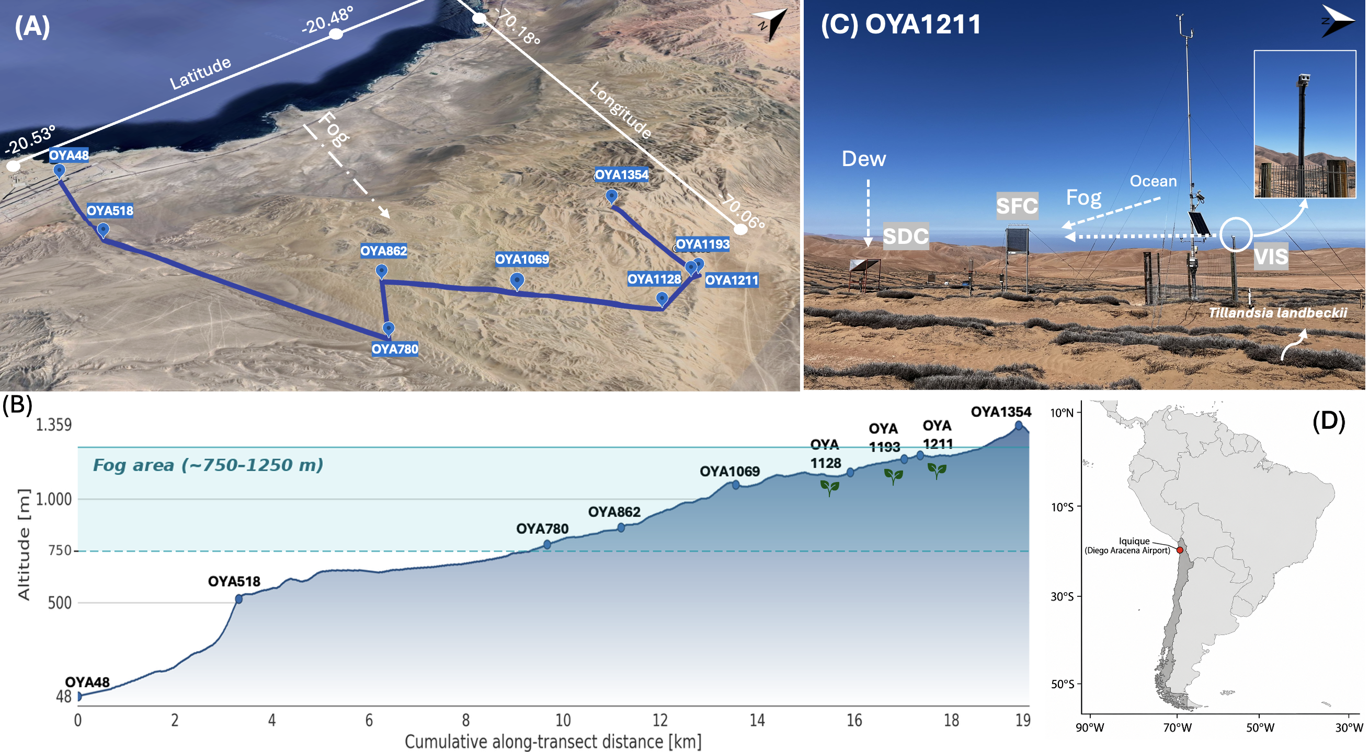
Figure 1: Study site overview at Cerro Oyarbide. (A) Satellite image showing a perspective view of the meteorological station topographic transect (blue line) on Cerro Oyarbide taken from Google Earth Pro. (B) Schematic topographic profile of the transect showing station elevation (m a.s.l.) and distance from the coast (km); plant icons represents the Tillandsia landbeckii ecosystem. (C) Photograph showing the main instrumentation setup at OYA1211 station: the visibility sensor (VIS), standard fog collector (SFC), and standard dew collector (SDC). The inset shows a detail of the VIS sensor mounted on the station mast. (D) South America. The red dot marks the location of the study site.

2.2 Data and instrumentation
The dataset used in this study spans the full year 2024 at a 10-minute interval, including air temperature (°C), relative humidity (%), wind speed (m s⁻¹), global radiation (W m⁻²), horizontal visibility (m), air pressure (hPa), and fog and dew collection (L m⁻²). Data availability varies by station and sensor, whose details are described in Table 1. The OYA1211 station is the most fully equipped one, including the standard dew collector (SDC), the standard fog collector (SFC), and the horizontal visibility sensor (Figure 1, C).
The fog collector (SFC) corresponds to a 1 m² mesh that intercepts fog droplets (0.2 to 30 μm) advected by the wind. Droplets grow by coalescence and precipitate along the mesh into a tipping bucket pluviometer, which measures the water volumes over time (Schemenauer & Cereceda, 1994). The dew collector (SDC) is a 1 m² tilted metallic surface where water vapour condenses on the surface when temperature drops below the dew point (Muselli et al., 2002). Dewfall is also measured using a tipping bucket pluviometer. The SFC faces the prevailing fog advection from the ocean (west), while the SDC captures vertical condensation toward the surface and its borders are protected against wind and fog. Likewise, the visibility sensor, that works as a primal classification criteria, is aligned perpendicular to the SFC for undisturbed optical measurements.
This ground-based network is further complemented by GOES-16 satellite observations, processed in Google Earth Engine at a spatial resolution of 2 km and synchronised every 10 minutes with ground observations. The satellite detects fog and low clouds (FLC) using a dual-band brightness temperature threshold algorithm, whose methodology can be found in Del Río et al. (2021) and Espinoza et al. (2024). These satellite data correspond to a binary variable, where FLC presence is 1, and absence is 0. All data have been processed in R using the tidyverse ecosystem and under version control on GitHub (Muñoz-Narbona et al., 2026).
Table 1: Data availability (%) for 2024 at a 10-minute resolution across the topographic transect. The numeric suffix in each station’s name corresponds to the station altitude (m asl). Abbreviations: Dist (km from coastline), Temp (air temperature), RH (relative humidity), U (wind speed), Fog (fog collection), Pres (atmospheric pressure), Rad (global radiation), Vis (visibility), Dew (dew collection).
Station | Dist (km) | Temp (°C) | RH (%) | U (m s⁻¹) | Rad (W m⁻²) | Fog (L m⁻²) | Pres (hPa) | Vis (m) | Dew (L m⁻²)
OYA48 | 0.86 | 100% | 100% | 100% | – | – | 100% | – | –
OYA518 | 4.18 | 99% | 99% | 97% | – | 99% | 99% | – | –
OYA780 | 9.83 | 99% | 99% | 98% | – | 99% | 99% | – | –
OYA862 | 8.67 | 86% | 91% | 86% | – | 9% | 0% | – | –
OYA1069 | 10.75 | 0% | 17% | 0% | – | 17% | 0% | – | –
OYA1128 | 12.92 | 100% | 100% | 100% | – | 100% | 0% | – | –
OYA1193 | 13.12 | 90% | 92% | 90% | – | 92% | 0% | – | –
OYA1211 | 13.11 | 100% | 100% | 100% | 100% | 100% | 100% | 93% | 100%
OYA1354 | 11.41 | 83% | 83% | 83% | – | 92% | 0% | – | –

2.3 Data Processing
The research strategy has been divided into three specific objectives (SO), associated with each hypothesis: (1) characterise the frequency of fog and dew occurrences and their co-occurrence from visibility and FLC observations; (2) evaluate the atmospheric stability under each occurrence through potential temperature (θ), specific humidity (q), and wind speed (U) vertical gradients along the topographic station transect; (3) analyse the tendency over time of q, θ and U under fog and dew occurrences.

2.3.1 SO1: Hierarchical classification of fog and dew occurrences
To achieve the first SO, we used two criteria based on ground visibility and FLC detection, with visibility as the priority. To classify the AW occurrence as fog, water must be collected by the SFC or the SDC, and ground visibility must fall below 1000 m, or FLC must be 1 (FLC presence). Conversely, to classify the AW occurrence as dew, water must be collected by the SFC or the SDC, and ground visibility must be higher than 1000 m, or FLC must be 0 (FLC absence). Finally, if no water is collected by the SFC or SDC, we classify the ocurrence as no AW type. The criteria read:
$$\text{Collection occurrence}=\left\{\begin{matrix}\text{fog:} & \text{if vis}<1000\text{ m, }\text{o}\text{r FLC}=1 \\ \text{dew:} & \text{if vis}≥1000\text{ m, or FLC}=0\end{matrix}\right. (1)$$
In addition to the classification algorithm, a manual review is performed. The automatic classification is compared against visibility and the FLC signal. Isolated errors are corrected, and days of atypical behaviour are documented. For example, an abrupt drop and recovery of visibility within a short period is likely caused by sensor lens dew condensation, or debris such as dust particles or insects obstructing the sensor rather than an actual fog occurrence, which are reclassified as dew. Likewise, when a continuous occurrence is interrupted by an isolated 10-minute segment classified differently, this segment is interpolated to the surrounding occurrence. We distinguish two classifications of the records with atmospheric water. The collector-based classification assigns each record to fog, dew or both according to the collector that registered water (SFC only, SDC only, or both collectors). Then, to estimate how much fog or dew has been collected per collector type, the reclassification assigns the SFC or SDC collected water to fog or dew according to the visibility and FLC criteria (Equation 1), regardless of the collector that registered water.

2.3.2 SO2: Analyse the atmospheric stability through the thermodynamic vertical gradients
After reclassifying fog and dew occurrences, we analyse the atmospheric stability using three conserved variables: potential temperature (θ), specific humidity (q) and wind speed (U). Potential temperature is calculated as follows:
$$θ=T⋅{\left(\frac{P_{0}}{P}\right)}^{R/C_{p}} (2)$$
where T is the absolute air temperature (K), P₀ is the pressure (hPa) measured at the lowest station, P is the atmospheric pressure level at every station (hPa), R is the gas constant for dry air (287.08 J kg⁻¹ K⁻¹), and c_{p} is the specific heat of dry air (1004.67 J kg⁻¹ K⁻¹).
Specific humidity is approximated using the mixing ratio (r), since in the lower troposphere the water vapour mass is much smaller than the dry air mass and the total pressure greatly exceeds the vapour pressure, so that q ≈ r. q is estimated using the following expression:
$$q≈r=ϵ\frac{e}{P-e} (3)$$
where ϵ is the ratio of the molecular weight of water vapour to that of dry air (ϵ = 0.622 kg kg⁻¹), and e is the water vapour pressure (hPa), obtained from relative humidity and saturated vapour pressure.
To calculate the vertical gradients that are used as a proxy of atmospheric stability, we used:
$$\frac{∂ϕ}{∂z}≈\frac{Δϕ}{Δz}=\frac{ϕ_{2}-ϕ_{1}}{z_{2}-z_{1}}, ϕ∈\{θ,q,U\} (4)$$
where $ϕ$ represents the conservative scalar of θ, q or U, z₁ the reference altitude level (48 m asl) and z₂ the altitude of each station. Both the vertical gradients and the temporal rates presented below correspond, in principle, to partial derivatives; however, given the finite number of observations available, they are approximated here as finite differences (Δ). Vertical gradients ∂φ/∂z are calculated along the 48–1354 m transect in relation to the coastal baseline, to determine the stability of the MBL, with φ ∈ {θ, q, U}.
The differences in the vertical gradients between fog, dew and no AW occurrence were tested with the Kruskal–Wallis test for the three groups and the Mann–Whitney test for each pair of groups, reporting the effect size r. The ability of ∂θ/∂z at OYA1211 to separate fog from dew, and dew from no AW occurrence, was evaluated with the area under the receiver operating characteristic (ROC) curve and its optimal cut-off (Youden index). These tests were used to define the new thresholds proposed in this study.

2.3.3 SO3: Analyse the temporal tendency of the thermodynamic variables
To achieve the third SO, we analyse the temporal evolution (tendency) of θ, q and U at OYA1211 under the reclassified fog, dew and no AW occurrences. The tendency is calculated as:
$$\frac{∂ϕ}{∂t}≈\frac{Δϕ}{Δt}=\frac{ϕ_{2}-ϕ_{1}}{t_{2}-t_{1}}, ϕ∈\{θ,q,U\} (5)$$
where φ represents θ, q or U, t₁ is the time of each 10-min measurement classified as fog, dew or no AW occurrence, and t₂ is the time right after. We use a (t₂ − t₁) interval of 10 to 120 minutes to assess temporal tendency in that range (Equation 5). These tendencies are divided into night or day, according to the global radiation measured at OYA1211 (night ≤ 5 W m⁻² ≤ day).
To assess whether the humidity tendency at OYA1211 is a local feature, the same methodology is applied to stations OYA518, OYA1128 and OYA1354, at the times reclassified as fog, dew or no AW occurrence at OYA1211. Note that stations OYA1128 and OYA1211 are located over the Tillandsia landbeckii field, whereas OYA518 and OYA1354 are above bare soil, being the latter permanently above the MBL.
These tendencies are tested with the Kruskal–Wallis and Mann–Whitney tests, after removing values beyond 1.5 times the interquartile range by station. The differences between OYA1211 and each other station at the same times are tested with the Wilcoxon signed-rank test, and the confidence intervals of the medians are obtained by bootstrap resampling.

3. Results and discussion
The complete observational dataset of the Cerro Oyarbide topographic transect allows us to reclassify the fog and dew occurrences detected by the passive collectors using visibility ground measurements and remote-sensing satellite observations (Section 3.1). This reclassification is then analysed through the vertical profiles of the thermodynamic variables (Section 3.2) and their temporal tendency during fog and dew occurrences (Section 3.3).

3.1 Fog and dew occurrences reclassification
Atmospheric water (AW) at Cerro Oyarbide is collected by at least one of the collectors only 8.6% of the time in 2024, whereas the remaining 91.4% of the year corresponds to no AW occurrence (Figure 2, A). These percentages reveal that the window of AW collection is very short; thus, each misclassified interval weighs proportionally more than its duration suggests. Within this window, the collector-based classification reports 49.2% of fog occurrences, 46.8% of mixed fog and dew, and only 4.0% of dew-only occurrences (Figure 2, B). However, by applying the ground visibility and satellite FLC criteria (Equation 1), the reclassification shifts to 54.2% for fog occurrences and 45.8% for dew occurrences (Figure 2, C). This significant change evidences that fog and dew collectors overlap in 46.8% of the total AW occurrences. This instrumental overlap is not an isolated noise; once corrected, the fraction of only dew occurrences increases by one order of magnitude, from 4.0% to 45.8%. Considering the entire year 2024, the reclassified only fog frequency reaches 4.7% of the time and the dew frequency 3.9%. The fog frequency agrees with two observations that are independent of the collectors, namely the frequency of FLC detected by GOES-16 over the station, 4.4% of the time in 2024, and the frequency of visibility below 1000 m, 5.2% of the time with available visibility.
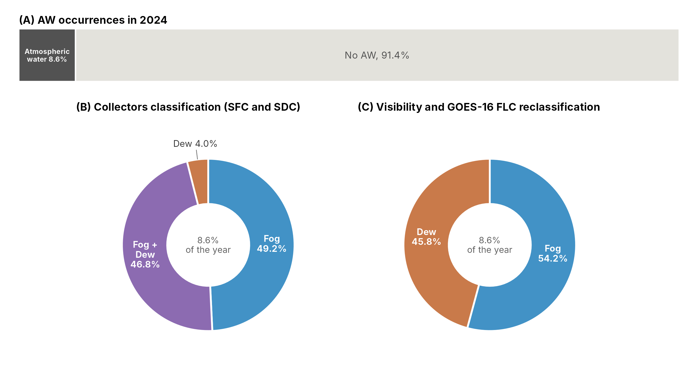
Figure 2: Classification of atmospheric water occurrences at station OYA1211 during 2024. (A) Proportion of the 10-min records of the year with atmospheric water occurrence (fog or dew collection) and with no AW occurrence. (B) Relative distribution of the AW occurrences according to the collector-based classification. (C) Relative distribution after the reclassification based on visibility and fog and low clouds (FLC) detection.
To deepen the analysis, we focus on four specific days in Figure 3, which are examples of typical fog and dew events. Typical fog days occur on April 28th and September 21st, 2024. On April 28th (Figure 3, A), visibility drops from 4000 m to 103 m, remaining below 1000 m from 04:40 to 12:00 UTC (00:40 to 08:00 local time). At the same time, FLC are present from 04:30 to 10:50 UTC, and both collectors measure water; therefore, occurrence is classified as fog. Likewise, on September 21st (Figure 3, B), visibility drops below 1000 m during the collection period, with a minimum of 218 m, from 04:30 to 13:20 UTC, and FLC is present from 04:30 to 13:50 UTC. In this case, only the SDC registers water, so the collector-based classification would assign the occurrence to dew, whereas the reclassification assigns it to fog. Conversely, typical dew days occur on April 24th and November 28th, 2024. On April 24th (Figure 3, C), visibility remains above 1000 m all day long, with a minimum of 1110 m at 09:20 UTC, and no FLC, while only the SFC registers water collection from 03:40 to 12:50 UTC. This occurrence is classified as dew. Similarly, on November 28th (Figure 3, D), visibility remains above 3300 m all day long and only the SFC registers water, from 03:00 to 10:50 UTC. During this period, FLC is present only at 04:00 UTC, and since visibility has priority over FLC in the classification criteria, the occurrence is classified as dew. Days with no AW occurrence and particular cases, such as May 17th, when erratic visibility alternates between fog and dew within the same day, are shown in Appendix A.
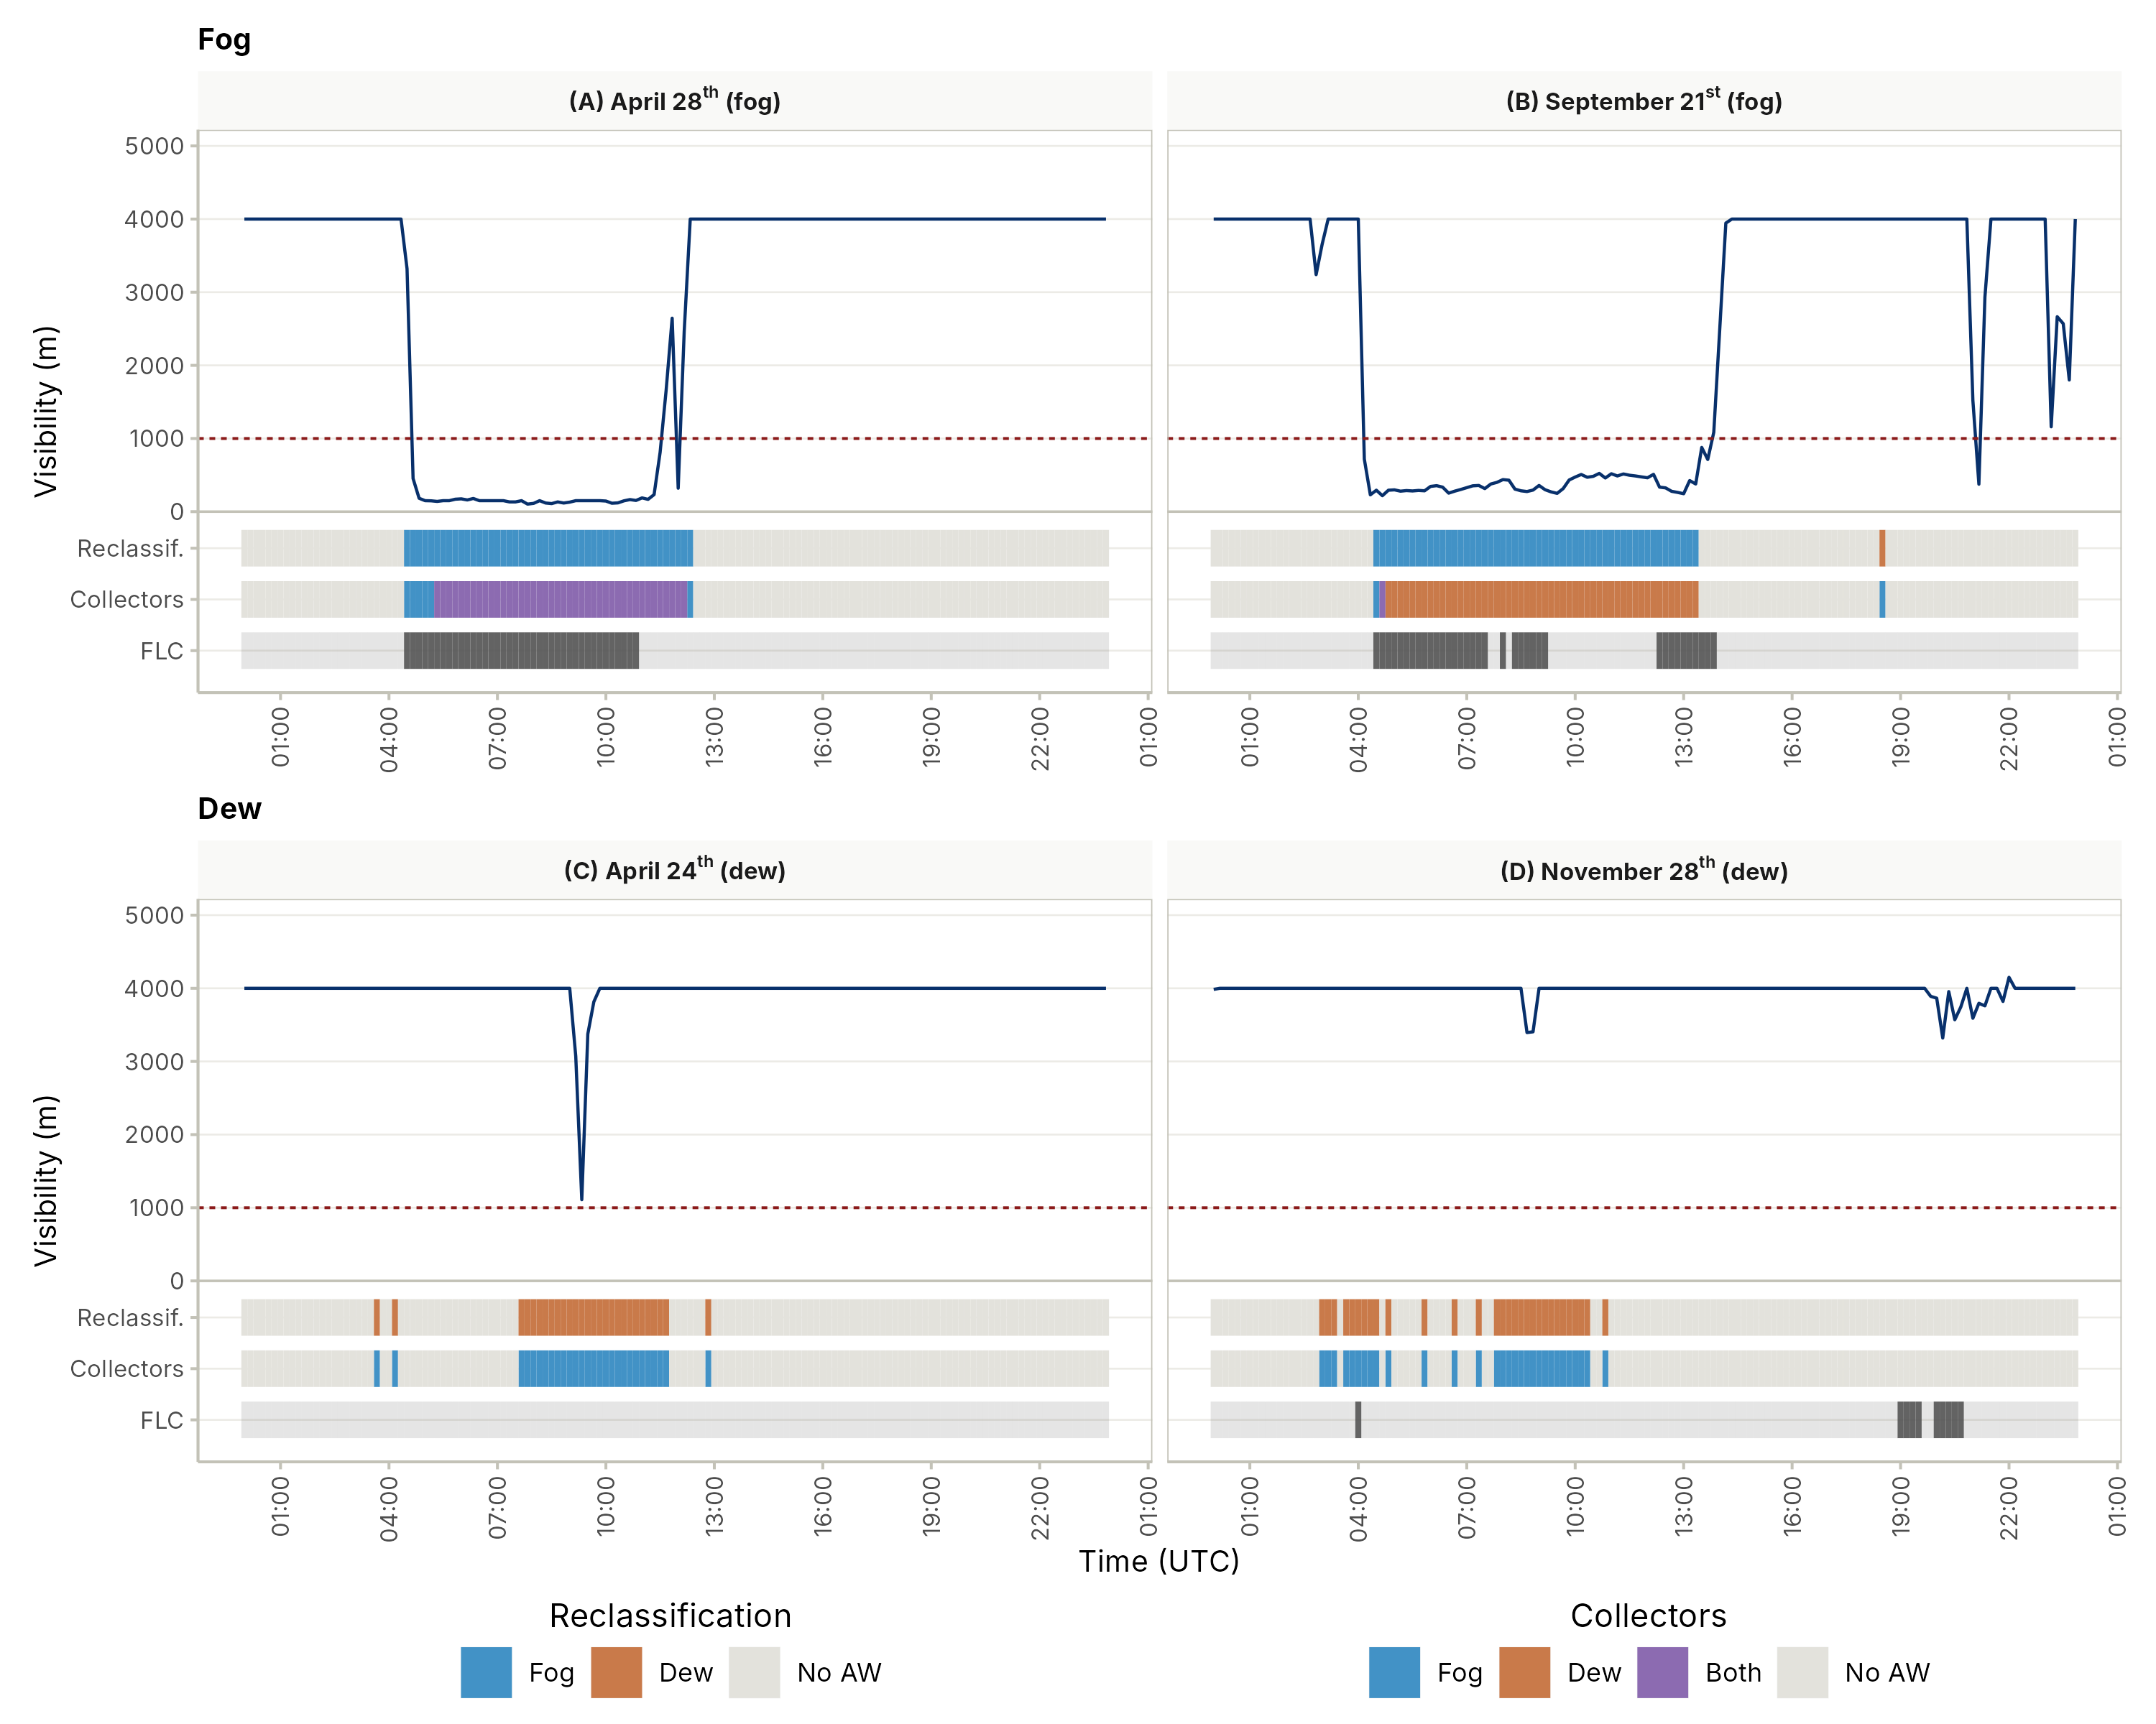
Figure 3: Diurnal variability of visibility (solid blue line; dashed red line: 1000 m threshold), FLC detection (dark grey) and fog (blue), dew (dark orange) or overlapped (purple) collection, as reclassified (Reclassif.) and by the collectors (Collectors), on typical cases at station OYA1211 on (A) April 28th, (B) September 21st, (C) April 24th and (D) November 28th, 2024. Times are in UTC.
Before the reclassification, the collectors register a combined 191 L m⁻² yr⁻¹ (0.52 L m⁻² day⁻¹), of which 167 L m⁻² yr⁻¹ for the SFC (0.46 L m⁻² day⁻¹) and 24 L m⁻² yr⁻¹ (0.07 L m⁻² day⁻¹) for the SDC. After the reclassification, the collectors register a combined 160 L m⁻² yr⁻¹ (0.44 L m⁻² day⁻¹), which corresponds to 84% of all the collected water. From this amount, 159 L m⁻² yr⁻¹ is attributed to the SFC (fog) and 1.5 L m⁻² yr⁻¹ to SDC (dew). The remaining 16% (31 L m⁻² yr⁻¹) is excluded from both totals because it was collected by a collector that is not designed for the reclassified phenomenon. For example, the SDC registers 23 L m⁻² yr⁻¹ of fog, which represents 94% of all the water collected by the SDC in 2024, while the SFC registers 8 L m⁻² yr⁻¹ of dew.
Fog provides almost all the collected water, both throughout the year and throughout the day (Figure 4, A and C). On the 76 days of 2024 with fog water, the reclassified fog yields on average 2.1 L m⁻² day⁻¹, with a median of 1.2 L m⁻² day⁻¹ and a maximum of 15.6 L m⁻² day⁻¹. The monthly mean ranges from 0.9 to 4.9 L m⁻² day⁻¹, with the highest values in August, 4.8 L m⁻² day⁻¹ over 6 days, and October, 4.9 L m⁻² day⁻¹ over 2 days, except June and July, with 0.07 and 0.4 L m⁻² day⁻¹, which have only 1 and 3 days with fog water. The reclassified fog yield exceeds that of the collector-based classification in all twelve months, because the days with low collection reclassified as dew are excluded. In terms of frequency, the collector-based classification, shown with dashed lines, has the SFC registering water in 98% to 100% of the AW records of every month, except August and September with 70% and 63%, and in 92% to 100% at every hour. Since both collectors often register water at the same time, their frequencies can add up to more than 100%. After the reclassification, shown with solid lines, fog and dew add up to 100%. Fog is more frequent than dew in eight of twelve months, reaching its maximum of 83% in June, although based on only six records. Over the day, the mean fog water on the hours with fog water remains between 0.28 and 0.39 L m⁻² h⁻¹ from 00:00 to 11:00 UTC, drops below 0.2 L m⁻² h⁻¹ between 12:00 and 18:00 UTC and peaks at 1.6 L m⁻² h⁻¹ at 20:00 UTC, although this peak is based on only 4 hours. Over the whole year, it is 0.32 L m⁻² h⁻¹ over 491 hours with fog water. Fog frequency exceeds 80% of the AW records at 12:00 and 13:00 UTC and between 20:00 and 23:00 UTC.
Dew is almost as frequent as fog, but its collected water is two orders of magnitude lower (Figure 4, B and D). On the 50 days of 2024 with dew water, the reclassified dew yields on average 0.03 L m⁻² day⁻¹, with a median of 0.016 L m⁻² day⁻¹ and a maximum of 0.14 L m⁻² day⁻¹, about 70 times less than fog. The monthly mean ranges from 0.009 L m⁻² day⁻¹ in February to 0.075 L m⁻² day⁻¹ in July, and no dew water is collected in June, whereas the SDC in the collector-based classification yields 0.10 to 0.71 L m⁻² day⁻¹. In the collector-based classification, the SDC registers water in 28% to 89% of the AW records across months, more frequently than the SFC only in August and September, with 82% and 89%. After the reclassification, dew is more frequent than fog in January, February, July and November, with 56% to 65% of the AW records. Over the day, dew is about as frequent as fog between 01:00 and 09:00 UTC, with 49% to 57% of the records. Its mean water on the hours with dew water remains between 0.005 and 0.018 L m⁻² h⁻¹ from 00:00 to 11:00 UTC, and 0.009 L m⁻² h⁻¹ over the 160 hours with dew water of the whole year, about 30 times less than fog, and no dew water is collected between 15:00 and 22:00 UTC. This low yield reflects that only 16% of the records reclassified as dew registered water in the SDC, since most of them were collected only by the SFC.
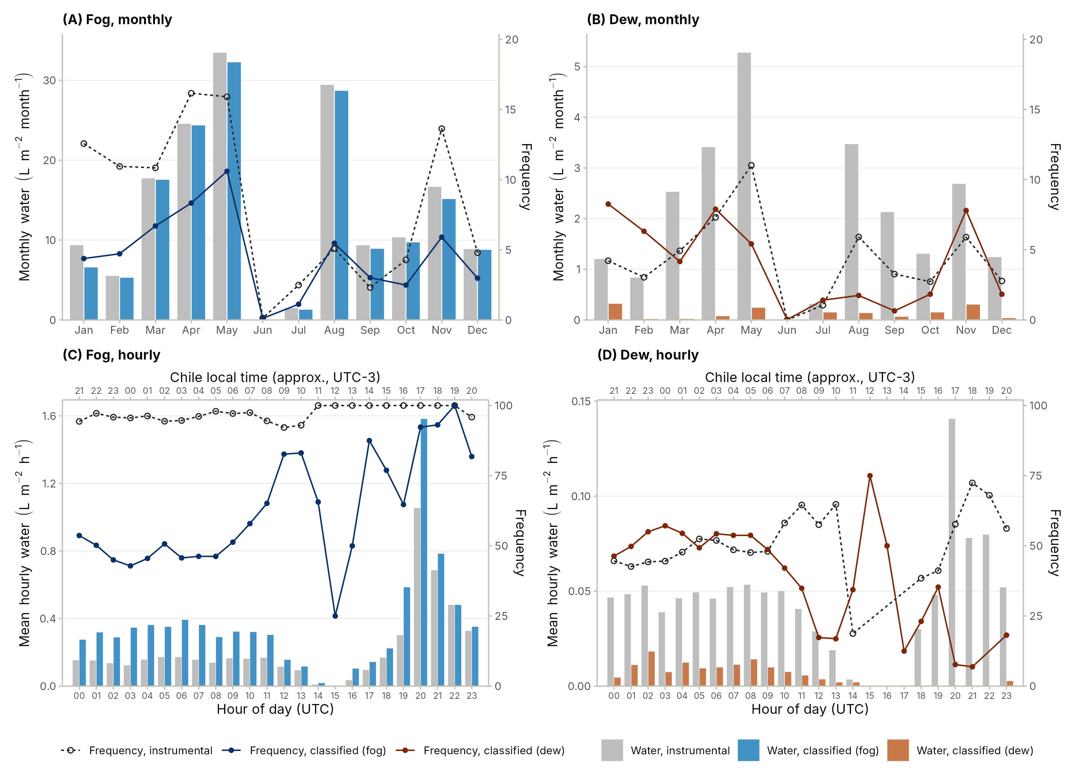
Figure 4: Seasonal (A and B) and diurnal (C and D) distribution of fog and dew occurrences and water collected at station OYA1211 during 2024. Bars show the total monthly water (A and B, L m⁻² month⁻¹) and the mean hourly water on the hours with water (C and D, L m⁻² h⁻¹), in grey as measured by the collector and in colours after the reclassification. Lines show the frequency (%) of the fog and dew records for the collector-based classification (dashed line, open circles) and the reclassification (solid line, filled circles), relative to all the 10-min records of each month (A and B) and to the AW records of each hour (C and D).
Our reclassification results suggest that even though dew frequency is 45.8% of AW, most of the water collected by the SDC is produced by fog. This reclassification changes the interpretation of collector yields: before reclassification, the SDC yield of 0.07 L m⁻² day⁻¹ is comparable to the 0.1 L m⁻² day⁻¹ reported for the Atacama (Lobos-Roco et al., 2024). However, 94% of it was collected during fog, thus dew yields measured with SDC at fog-exposed sites may be largely affected by fog water. The reclassified fog frequency of 4.7% agrees with the collector-independent satellite and ground visibility frequencies. These low frequencies are consistent with previous observations at the south of the Atacama, where fog frequency has been reported between 3 and 20% at inland sites (Lobos-Roco et al., 2024). Likewise, FLC frequency at Cerro Oyarbide has been previously reported at 5% (Jaeschke et al., 2019), which is consistent with our estimated frequency. The reclassified fog yield of 0.43 L m⁻² day⁻¹ exceeds the 0.16 to 0.20 L m⁻² day⁻¹ of an inland station reported by Lobos-Roco et al. (2024); however, it is far below the ~8 L m⁻² day⁻¹ of coastal fog oases (Cereceda et al., 2008).
The classification has two main sources of uncertainty. The first one is the visibility sensor, which is affected by condensation over the sensor lens during dew episodes, producing slight drops that, according to our criteria they should be classified as fog (Figure 3). The second one is the 2 km resolution of FLC, which means that a detected low-cloud pixel does not necessarily intersect the topography (Del Río et al., 2021; Espinoza et al., 2024). In addition, the SFC mesh material may condense during cool and humid nights (Beysens, 1995; Monteith, 1957), which may explain why most dew records were collected by the SFC.

3.2 Atmospheric stability under fog and dew occurrences
Once fog and dew occurrences are reclassified, we evaluate whether they develop under different atmospheric stability. Figure 5 shows vertical profiles of θ, q and U along the transect on April 28th for fog and April 24th for dew. For each AW episode, they show the hour with the most contrasting θ profile between fog and dew (11:00 UTC) and no AW occurrence (17:00 UTC on April 28th and 22:00 UTC on April 24th). On April 28th, θ increases by only 2.1 K between 48 and 1211 m asl compared to 12.1 K during the no AW occurrence. Similarly, on April 24th, θ increases by 5.8 K over the MBL during the dew occurrence, and during the no AW occurrence, it increases by ~13.1 K. In contrast, q and U do not show a comparable difference between fog and dew: 8.6 and 10.5 g kg⁻¹ over the MBL, respectively. Above 1211 m asl, fog and dew profiles show a sharp increase in θ of ~8.6 and 6.9 K, respectively, whereas the profiles with no AW occurrence, already warmer below, increase by only up to 2.8 K. Specific humidity decreases at 1354 m asl in all profiles because the station is placed outside the MBL, whereas the wind speed profiles do not follow a consistent pattern.
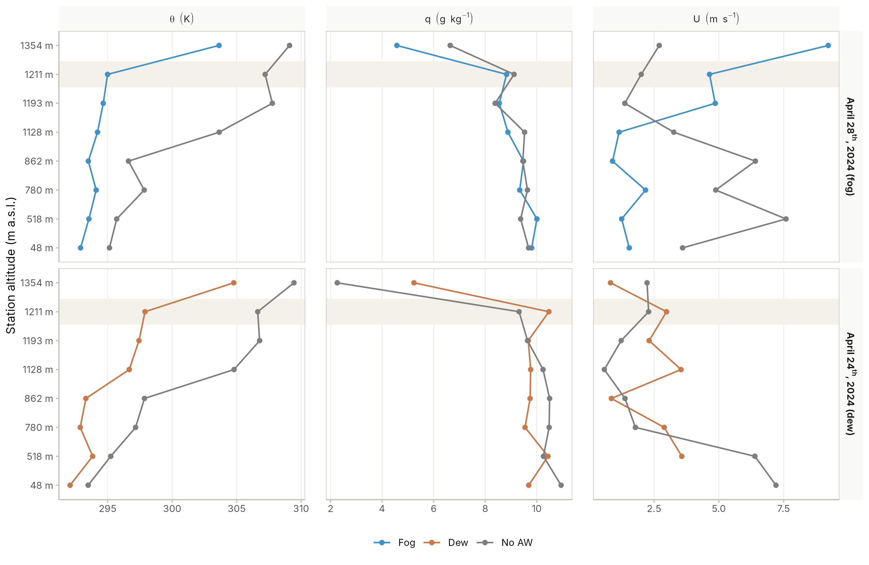
Figure 5: Vertical profiles of potential temperature (θ), specific humidity (q) and wind speed (U) along the Cerro Oyarbide transect on a typical fog (blue line) event, April 28th, 2024 (top), and a typical dew (dark orange line) event, April 24th, 2024 (bottom). On April 28th, the fog profiles correspond to 11:00 UTC and the no AW occurrence profiles (grey) to 17:00 UTC. On April 24th, the dew profiles correspond to 11:00 UTC and the no AW occurrence profiles (grey) to 22:00 UTC.
To verify whether the observed vertical structure of the MBL under fog and dew episodes holds at the annual scale, Figure 6 summarises the mean vertical gradients between the coastal reference station at 48 m asl and each station of the transect for fog, dew and no AW occurrence during 2024. Under fog, ∂θ/∂z remains low from 518 to 1211 m asl, around 2.57×10⁻³ K m⁻¹ at OYA1211. Under dew, the stability increases over the profile, with a mean of 3.34×10⁻³ K m⁻¹ at OYA1211. Under no AW occurrence, stability strongly increases to 9.4×10⁻³ K m⁻¹ at OYA1211. At 518 m asl, fog, dew and no AW occurrence show similar gradients, between 1.9×10⁻³ and 2.9×10⁻³ K m⁻¹, but from 780 m asl upward dew lies much closer to fog than to no AW occurrence. The difference in ∂θ/∂z between fog and dew is statistically significant both at OYA1211, with a Mann–Whitney effect size of r = 0.25 and p < 0.001, and along the transect, with r = 0.20 and p < 0.001. The three groups differ globally, with a Kruskal–Wallis χ² of 9116.2 at OYA1211 and 21627.5 along the transect, df = 2 and p < 0.001. However, fog and dew distributions of ∂θ/∂z overlap: at OYA1211, 54% of the fog records are below 2.6×10⁻³ K m⁻¹ and 31% exceed 3.1×10⁻³ K m⁻¹, whereas 52% of the dew records exceed 3.1×10⁻³ K m⁻¹. When used to separate fog from dew, ∂θ/∂z at OYA1211 reaches an area under the ROC curve of 0.64, with an optimal cut-off, given by the Youden index, of 3.4×10⁻³ K m⁻¹ and an accuracy of 63%. In contrast, ∂θ/∂z separates dew from no AW occurrence much more clearly, with an area under the ROC curve of 0.94, an optimal cut-off of 5.3×10⁻³ K m⁻¹ and an accuracy of 86%. The general threshold of 3.1×10⁻³ K m⁻¹ (Lobos Roco et al., 2018) falls between fog and dew occurrences at OYA1211, while 97% of the no AW occurrence records at this station exceed it. At 1354 m asl, ∂θ/∂z increases in all cases, with values of 5.8×10⁻³, 6.6×10⁻³ and 9.8×10⁻³ K m⁻¹ for fog, dew and no AW occurrence, respectively. This increase in the gradient above 1211 m asl is because station OYA1354 is located above the MBL.
Unlike θ, ∂q/∂z barely differs between fog and dew along the transect, e.g., −4.9×10⁻⁴ and −3.3×10⁻⁴ g kg⁻¹ m⁻¹ at OYA1211, respectively, with small effect sizes of r = 0.13 at OYA1211 and r = 0.04 along the transect. Under no AW occurrence, ∂q/∂z becomes more negative above 862 m asl, reaching −2.0×10⁻³ g kg⁻¹ m⁻¹ at OYA1211, so ∂q/∂z separates fog and dew from no AW occurrence, with r = 0.18 at OYA1211, better than fog from dew. At OYA1211, only 3.5% of the fog records and 4.9% of the dew records are beyond the threshold of −1.6×10⁻³ g kg⁻¹ m⁻¹ proposed by Lobos Roco et al. (2018). When fog and dew records are pooled and separated from no AW occurrence, ∂q/∂z at OYA1211 reaches an area under the ROC curve of 0.69, with an optimal cut-off of −1.7×10⁻³ g kg⁻¹ m⁻¹, which confirms the threshold of Lobos Roco et al. (2018). Finally, ∂U/∂z is negative at most stations, meaning that wind speed is lower above than at the coast, not differing significantly between fog, dew, and no AW. Overall, ∂θ/∂z is the only gradient that separates fog from dew with a non-trivial effect size, and the three gradients separate fog and dew from no AW occurrence more clearly than fog from dew. Table 2 summarises the resulting thresholds.
Table 2: Thresholds of the vertical gradients between the coastal station (48 m asl) and OYA1211 (1211 m asl) to separate fog, dew and no AW occurrence, obtained from the optimal cut-off (Youden index) of the ROC curves for 2024. Mean and mean ± 1 standard deviation (SD) of the gradients at OYA1211 for each regime. Values in units of 10⁻³ (∂θ/∂z in K m⁻¹ and ∂q/∂z in g kg⁻¹ m⁻¹).
Regime | ∂θ/∂z threshold | ∂θ/∂z mean | ∂θ/∂z mean − SD | ∂θ/∂z mean + SD | ∂q/∂z threshold | ∂q/∂z mean | ∂q/∂z mean − SD | ∂q/∂z mean + SD
Fog | < 3.4 | 2.57 | 1.46 | 3.68 | −1.7 to 0 | −0.49 | −1.16 | 0.17
Dew | 3.4 to 5.3 | 3.34 | 1.71 | 4.97 | −1.7 to 0 | −0.33 | −1.11 | 0.46
No AW | > 5.3 | 9.36 | 5.45 | 13.28 | ≤ −1.7 | −2.04 | −4.23 | 0.16

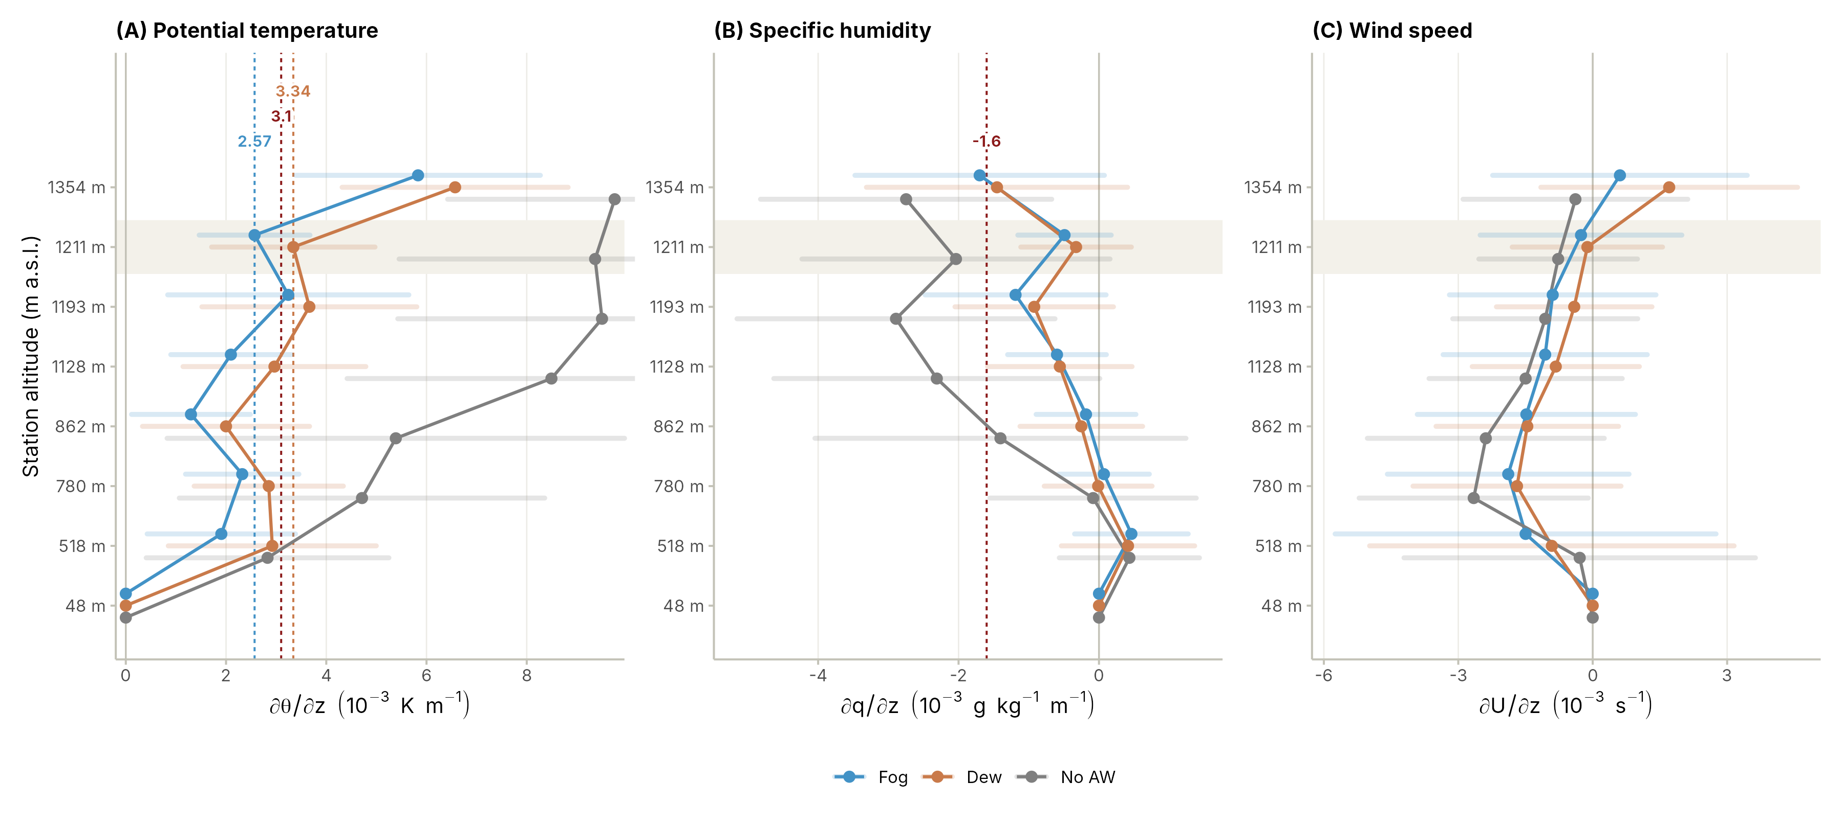
Figure 6: Mean vertical gradients of (A) potential temperature (∂θ/∂z), (B) specific humidity (∂q/∂z) and (C) momentum (∂U/∂z) between the coastal station (48 m asl) and each station of the transect for fog (blue), dew (orange) and no AW occurrence (grey) during 2024. Points show the mean and bars ±1 standard deviation; the shaded band marks OYA1211. Dashed lines show the thresholds of Lobos Roco et al. (2018) (dark red) and the mean ∂θ/∂z of fog and dew at OYA1211. Gradients are shown in units of 10⁻³.
The low ∂θ/∂z under fog is consistent with a well-mixed, stratocumulus-topped marine boundary layer (Lobos-Roco et al., 2026; Wood, 2012), in which θ is nearly constant below the MBL and increases above the inversion layer (Bohren & Albrecht, 1998; Wallace & Hobbs, 2006). With a cloud base at ~750 to 850 m asl (Del Río et al., 2021), a fully mixed MBL layer would yield a bulk 1.5×10⁻³ to 1.9×10⁻³ K m⁻¹ between 48 and 1211 m asl, close to the mean of 2.57×10⁻³ K m⁻¹ observed under fog at OYA1211. In contrast, thermal vertical gradients under dew occurrences lie between fog and no AW profiles, where the MBL remains moist and well-mixed and slightly thermally stratified, which promotes cloud dissipation and therefore surface radiative cooling (Jacobs et al., 2006; Monteith, 1957). The threshold reported by Lobos Roco et al. (2018), 3.1×10⁻³ K m⁻¹, separated fog from no-fog conditions without distinguishing dew. Our results refine this threshold by setting it at < 3.4×10⁻³ K m⁻¹ for fog conditions and between 3.4×10⁻³ K m⁻¹ and 5.3×10⁻³ K m⁻¹ for dew conditions (Table 2). In terms of ∂q/∂z, our results do not discriminate between fog and dew, confirming the −1.6×10⁻³ g kg⁻¹ m⁻¹ threshold of Lobos Roco et al. (2018) to separate fog from no AW occurrence. However, we propose a slightly different threshold of −1.7×10⁻³ g kg⁻¹ m⁻¹ that includes both fog and dew and separates them from no AW episodes.
We interpret the observed ∂θ/∂z and ∂q/∂z as follows. As reported in Lobos Roco et al. (2018), fog needs a well-mixed MBL in terms of temperature and humidity to form; otherwise, it dissipates. However, dew requires radiative cooling from the surface, which is only given by nighttime clear skies promoted by a stratified lower atmosphere. Nevertheless, dew also requires humidity in the air to condense on the surface; for this reason, we observe a well-mixed regime of humidity and thermal stratification under dew episodes. For no AW occurrence, both temperature and humidity must be stratified.

3.3 Temporal evolution of humidity, heat and wind speed under fog and dew occurrences
To evaluate the third hypothesis, we analyse the temporal evolution (tendency) of q, θ and U at station OYA1211 on days classified as fog and dew. Figure 7 shows the diurnal cycle of these thermodynamic variables in contrast to fog and dew frequencies. On July 11th, 2024, fog occurs from 00:40 to 05:00 UTC (20:40 to 01:00 local time, Figure 7, A to C). During this event, q increases from 5.6 to 6.2 g kg⁻¹ between 00:40 and 02:20 UTC and then decreases to 5.8 g kg⁻¹. At the same time, θ remains constant around 289 K, and U decreases from 3.5 to 1.4 m s⁻¹. After sunrise, θ increases by 9 K, reaching 298 K at 16:00 UTC, and q decreases to 6.2 g kg⁻¹ towards the afternoon. Conversely, on April 10th, 2024, dew occurs from 07:10 to 09:40 UTC (03:10 to 05:40 local time, Figure 7, D to F). Around the dewfall peak, q remains close to 10 g kg⁻¹, decreasing to 8.5 g kg⁻¹ at 10:00 UTC. During the same episode, θ reaches its daily minimum of 297.5 K, and U remains at 3.5 to 4.5 m s⁻¹. After sunrise, θ increases by 10 K, reaching 308 K at 13:00 UTC, and q increases abruptly to 11 g kg⁻¹ at 14:00 UTC.
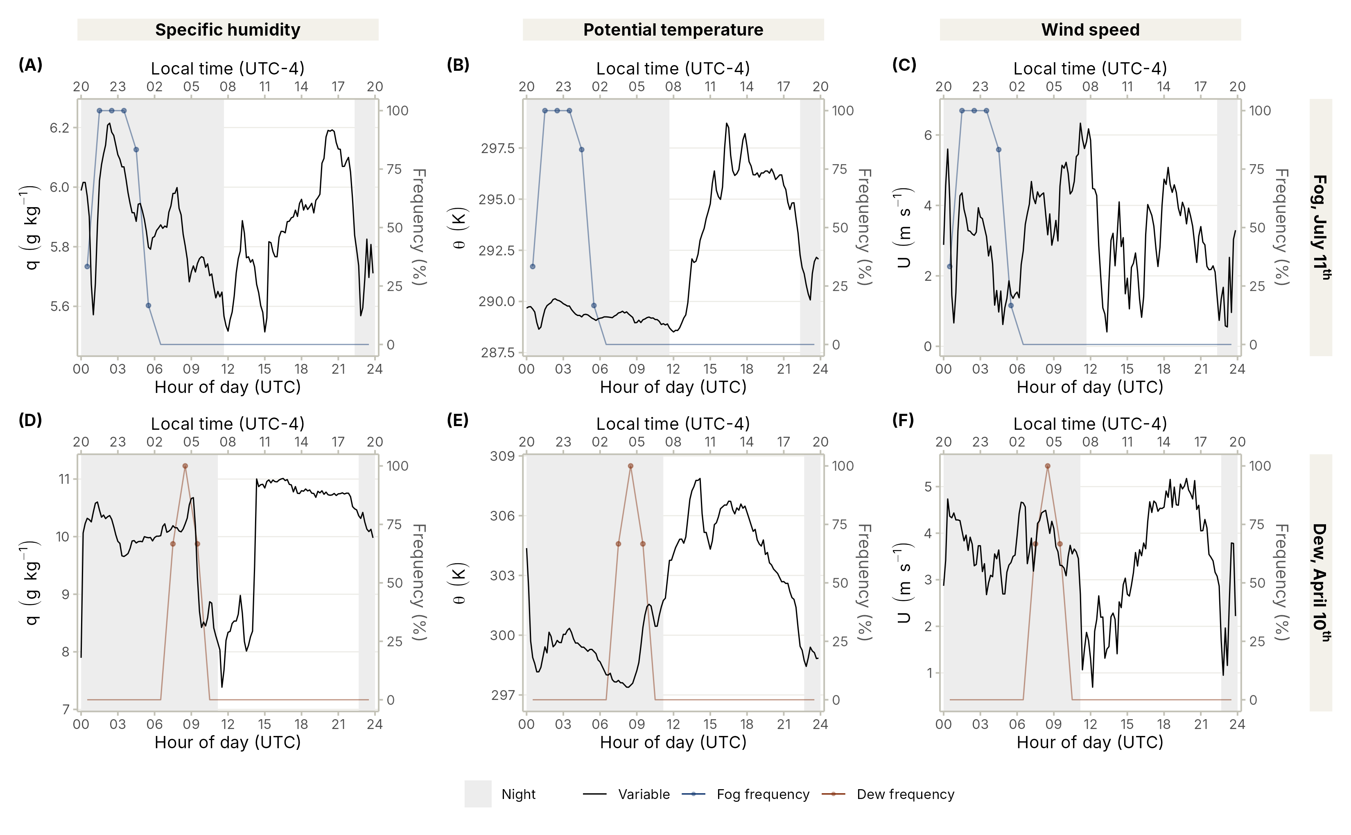
Figure 7: Diurnal cycle of (A, D) specific humidity (q), (B, E) potential temperature (θ) and (C, F) wind speed (U) at station OYA1211 (black line, left axis) on a night with fog (July 11th, 2024, top) and a night with dew (April 10th, 2024, bottom). Coloured lines (right axis) show the hourly frequency (%) of the 10-min records reclassified as fog (blue) or dew (dark orange). Grey shading represents the nightime. Times are in UTC (bottom axis) and local time (UTC−4, top axis).
Figure 8 shows the temporal change of thermodynamic variables when fog and dew occur at station OYA1211, separating daytime and nighttime. At night, q decreases after dew occurrences at an average rate of −0.06 g kg⁻¹ h⁻¹ during the first hour, slightly more than under no AW occurrence, with −0.04 g kg⁻¹ h⁻¹. In the case of fog, it increases slightly to 0.03 g kg⁻¹ h⁻¹ (Figure 8, A). Although the average nighttime humidity trend associated with dew formation is negative, it is about one-quarter of the −0.25 g kg⁻¹ h⁻¹ rate reported by Lobos-Roco et al. (2024). During the day, q increases by 0.59 g kg⁻¹ under fog and dew in the first hour, but after two hours, q during fog keeps increasing, while it barely changes under no AW occurrence (Figure 8, D). The median ∂q/∂t over the first hour is 0.39 g kg⁻¹ h⁻¹ under fog and 0.54 g kg⁻¹ h⁻¹ under dew, in the day, with no relevant difference between them (r = 0.04).
In the case of θ, it increases slightly after fog occurrences at night by 0.09 K h⁻¹, while after dew occurrences it increases more, by 0.45 K h⁻¹ (Figure 8, B). Excluding the occurrences whose 60-min window reaches sunrise, this nocturnal warming under dew is concentrated at the end of the dew occurrences: 0.82 K on average. With no AW occurrence, θ decreases by 0.12 K h⁻¹ during the first hour. During the day, θ increases strongly during the first hour, at 2.74 K h⁻¹ under dew compared with 1.35 K h⁻¹ under fog, while it barely changes under no AW occurrence (Figure 8, E). The largest difference between fog and dew appears during the day, with a median ∂θ/∂t of 2.64 K h⁻¹ under dew and 0.88 K h⁻¹ under fog and an effect size of r = 0.41, with p < 0.001 in the Mann–Whitney test, compared with r = 0.13 at night. When used to separate fog from dew, the daytime ∂θ/∂t reaches an area under the ROC curve of 0.76, with an optimal cut-off of 1.9 K h⁻¹ and an accuracy of 74%.
In the case of wind speed, it decreases after fog occurrences by −0.09 m s⁻¹ h⁻¹ at night and −0.25 m s⁻¹ h⁻¹ during the day, whereas it barely changes after dew occurrences (Figure 8, C and F). The effect sizes of ∂U/∂t between fog and dew are small, with r = 0.04 at night and 0.09 during the day.
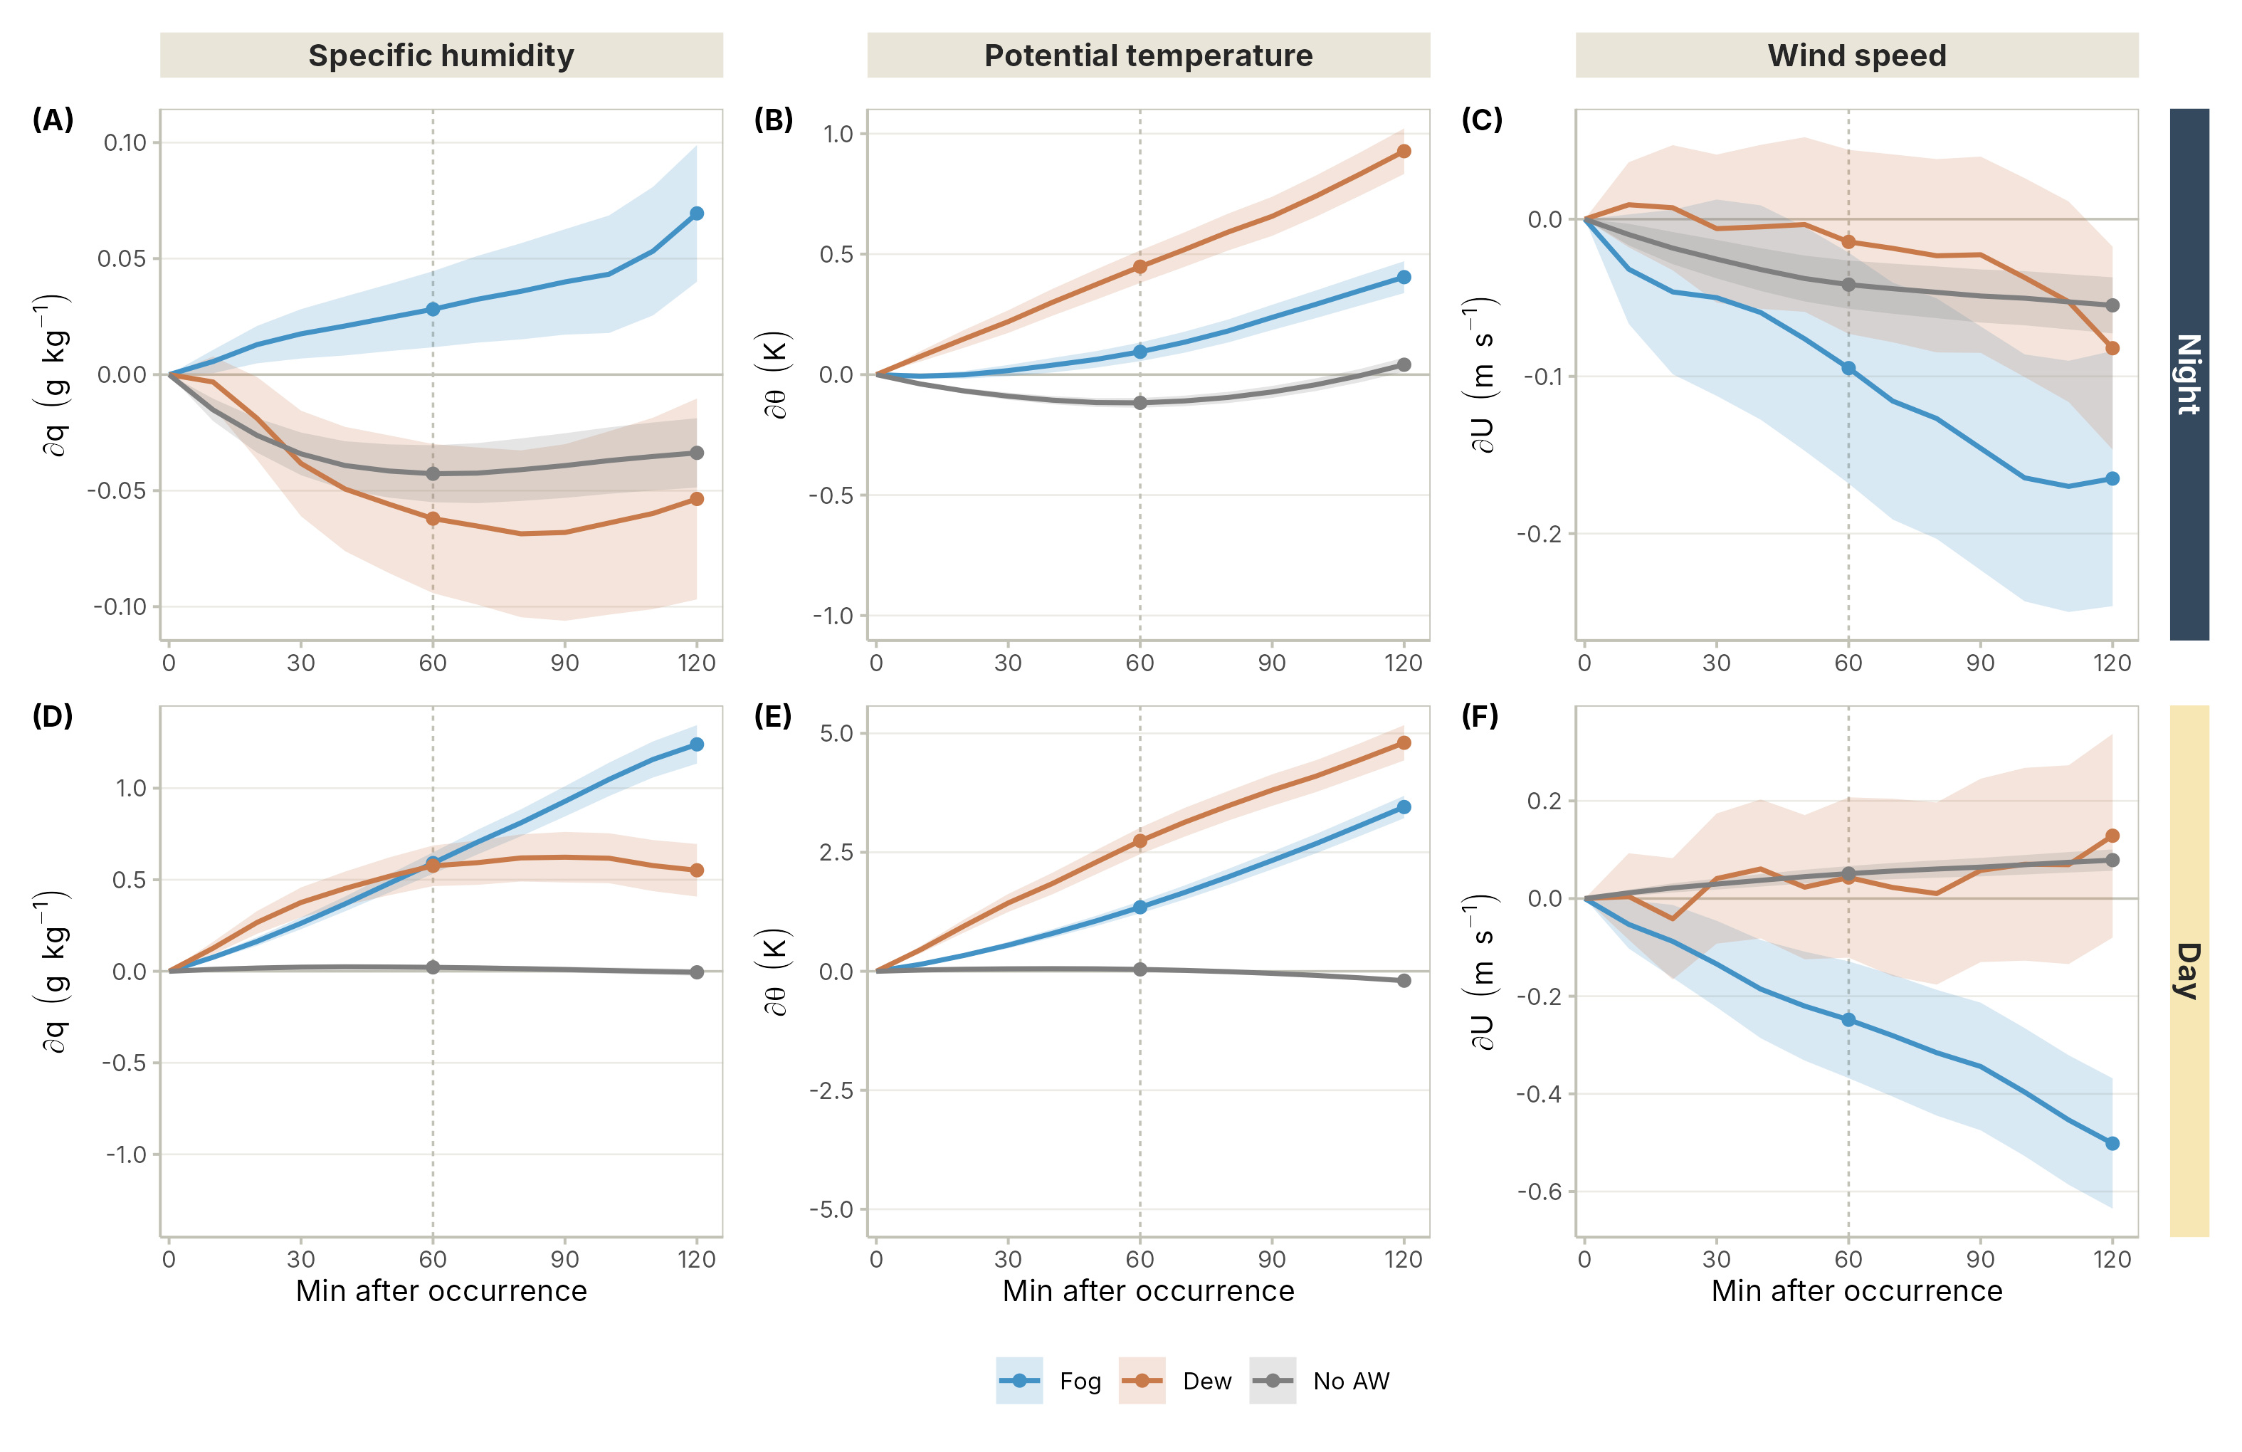
Figure 8: Rate of change of (A, D) specific humidity (q, g kg⁻¹), (B, E) potential temperature (θ, K) and (C, F) wind speed (U, m s⁻¹) at station OYA1211 from 10 to 120 min after each every record reclassified as fog (blue), dew (orange) and no AW occurrence (grey) during 2024, at night (A to C) and during the day (D to F). Shaded bands show the 95% confidence interval of the mean. The change after 60 min (dotted line) equals the mean ∂φ/∂t in units per hour.
Since the hyperarid environment does not contribute moisture from the soil to the atmosphere through evaporation, we focus the analysis of the temporal tendency on q at night. Similar to Figure 8, Figure 9 shows ∂q/∂t at stations OYA518, OYA1128, OYA1211 and OYA1354 during fog, dew, and no AW nights. At OYA518, ∂q/∂t barely changes under fog, dew or no AW occurrence, with rates between −0.03 and −0.01 g kg⁻¹ h⁻¹ (Figure 9, A). At the two stations located over the Tillandsia field, ∂q/∂t increases after fog occurrences by 0.05 g kg⁻¹ h⁻¹ at OYA1128 and 0.03 g kg⁻¹ h⁻¹ at OYA1211. Conversely, over these stations, q decreases after dew occurrences, by −0.08 g kg⁻¹ h⁻¹ at OYA1128 and −0.06 g kg⁻¹ h⁻¹ at OYA1211 (Figure 9, B and C). Under no AW occurrence, q also decreases at both Tillandsia field stations, with comparable dew rates. At OYA1354, q decreases following the onset of both fog and dew, at rates of −0.06 and −0.07 g kg⁻¹ h⁻¹, respectively; however, this station is located above the MBL and is therefore not representative of the fog or dew events classified at OYA1211. (Figure 9, D).
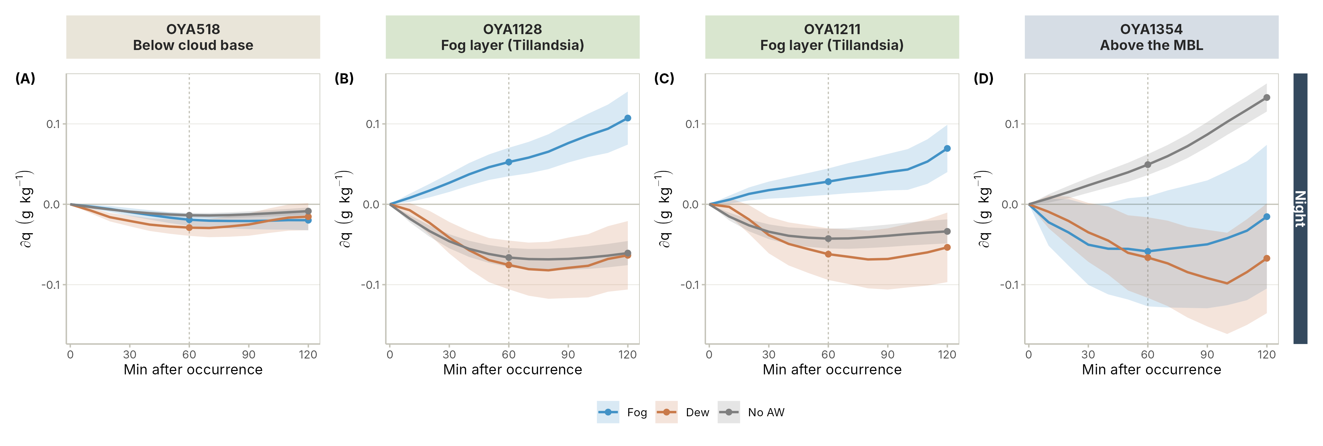
Figure 9: Nighttime rate of change of specific humidity (∂q, g kg⁻¹) from 10 to 120 min after reclassified fog (blue), dew (orange) and no AW occurrence (grey) during 2024, at (A) OYA518, (B) OYA1128 and (C) OYA1211, and (D) OYA1354. Shaded bands show the 95% confidence interval of the mean.
The temporal tendency of thermodynamic variables allows us to make some physical interpretations. Firstly, in terms of humidity, the nocturnal decreases of q under dew events are consistent with the mass transfer from the atmosphere to the surface when dew occurs. This decrease agrees with reported values in the Atacama of −0.25 g kg⁻¹ h⁻¹ during dew episodes (Lobos-Roco et al., 2024) and other places (Roode et al., 2010). Likewise, the nocturnal increases in q tendency during fog events are related to atmospheric moisture advection. The larger nocturnal decreases in q tendency over the Tillandsia field than at low-altitude stations suggest active mechanisms of plants to collect dew. Likewise, the negative tendency of q during no AW occurrences might indicate water vapour adsorption from the dry surface (Agam & Berliner, 2006; Li et al., 2025). Secondly, the nocturnal warming under dew episodes might partly be explained by the release of latent heat during the surface condensation process. Likewise, the slight nocturnal decrease of θ under no AW occurrence is consistent with the radiative cooling of the surface under clear skies (Stull, 1988).

4. Conclusions
In this study, we address the challenge of distinguishing fog from dew from an instrumental point of view, since fog and dew collectors greatly overlap in their measurements. Based on ground and satellite visibility criteria, we reclassified fog and dew collection measurements that occurred in 2024 over a coastal hyperarid ecosystem. Then, we analyse the thermodynamic structure under which fog and dew episodes develop, and finally, we study the temporal evolution (tendency) of the air thermodynamic variables under fog and dew episodes.
Regarding the first hypothesis, our reclassification suggests that dew events occurred more often than dew collectors can detect, although the amount of collected water is rather low. From the total AW occurrences (8.6%), fog and dew collectors misclassified 46.8% of fog and dew events, where dew collectors harvest AW water during fog events and vice versa. Based on the visibility criteria, dew occurrences increase from 4% of the total AW occurrences to 45.8%, which corresponds to 3.9% of the total in 2024. Besides, the helpfulness of ground and satellite criteria can be used to distinguish fog from dew occurrences; dew is based on a collector measurement, whose thermal properties greatly differ from natural surface properties like bare soil or Tillandsia fields. Therefore, natural dew conditions must be further studied using more sophisticated measurements to better evaluate the dew contribution of such hyperarid environments.
Besides this uncertainty, the reclassification allows us to study the vertical structure of the MBL under isolated fog and dew episodes. Our analysis corroborates our initial hypothesis, where fog develops under a well-mixed MBL (~2.57 K m⁻¹) and dew under a more stratified one (~3.4 K m⁻¹); however, both AW episodes occur under a moist, well-mixed MBL (-1.6 g kg⁻¹ m⁻¹). This thermodynamic structure is consistent with turbulent MBL inland advection during the day that produces fog from evening to night. In the case of dew episodes, which mainly occurred before sunrise, the MBL retreats to the ocean because of the nocturnal breeze, producing a stratification between the lower levels of the MBL and higher levels of the coastal topography. However, this stratification affects only temperature, and the remaining trapped humidity feeds dewfall.
Regarding the temporal evolution of thermodynamic variables under fog and dew occurrences, our analysis partially corroborates the initial hypothesis. For example, we only observe negative humidity tendencies during dew episodes at night (-0.06 g kg⁻¹ h⁻¹), which change strongly during daytime occurrences (0.59 g kg⁻¹ h⁻¹). Instead, fog always increases the humidity tendency either day or night, corroborating our hypothesis. The consistent positive humidity tendency during the day might be attributed to Tillandsia field morning evaporation; however, this must be further corroborated. Moreover, a notable feature that our data suggest is the stronger negative tendency of humidity at night under dew episodes over the Tillandsia fields, which might suggest a special mechanism used by Tillandsias to enhance dew formation. Likewise, the negative tendency observed at night over the Tillandsia field might be attributed to water vapour adsorption, a plant mechanism that needs further corroboration.
Our study contributes to help in the distinction of the non-rainfall water inputs that sustain hyerarid ecosystems in the coastal Atacama, bringing new information about atmospheric thermodynamic conditions that characterizes such episodes. Therefore, the method proposed here to make this distinction can be used widely in worldwide hyperarid regions as a first-order classification when it is only accounted for with routine meteorological measurements.

Appendix A. Particular cases of classification
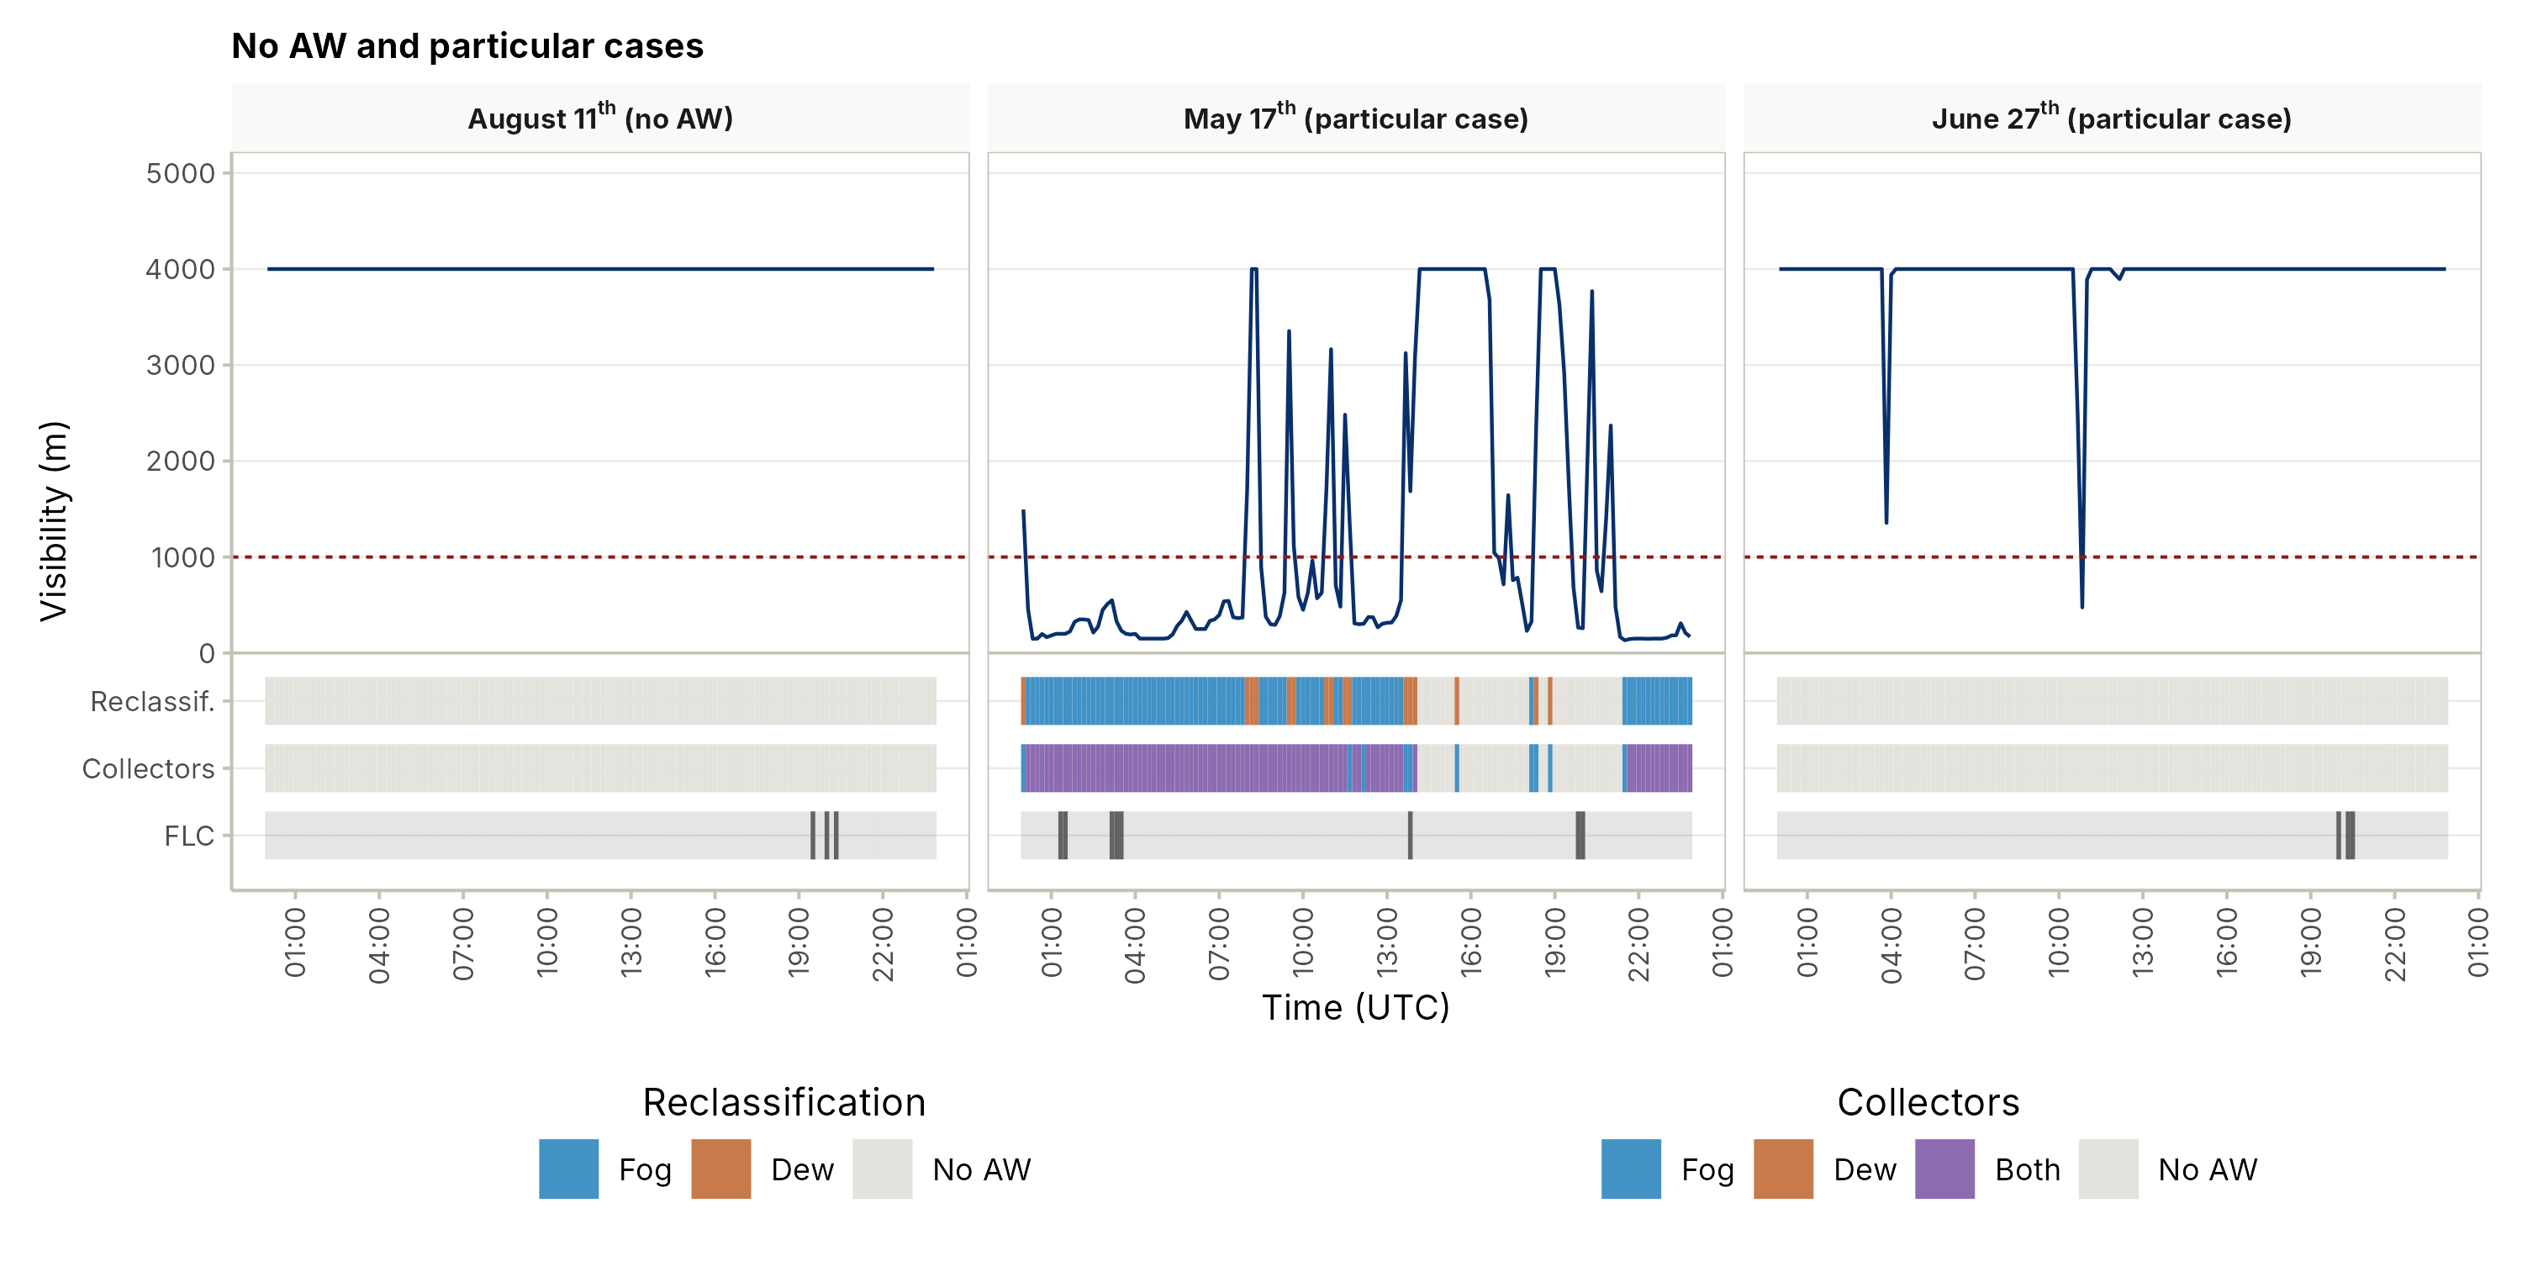
Figure A1: Particular cases of the classification at station OYA1211. A day with no AW occurrence (August 11th, 2024) and two particular cases (May 17th and June 27th, 2024). Lines and bands as in Figure 3.

5. Data availability
The data used in this work is available at https://doi.org/10.5281/zenodo.21826557

6. Author contributions
The article was written by FM-N and FL-R. The data were analyzed by FM-N with the supervision of FL-R. The data quality and organization was produced by FM-N with the supervision of SA. All the authors contributed to the revision of the manuscript.

Acknowledgements
This research was funded by FONDECYT 11250466. We acknowledge Centro UC Desierto de Atacama and Heidelberg University for field observations. We acknowledge Cristobal Merino for the satellite data provided and Francisca Virtuoso for the English editing. Finally, we acknowledge the anonymous reviewers for their valuable contribution to improving this work.

References
Agam, N., & Berliner, P. R. (2006). Dew formation and water vapor adsorption in semi-arid environments—a review. Journal of Arid Environments, 65(4), 572–590. https://doi.org/10.1016/j.jaridenv.2005.09.004
Albornoz, F., Río, C. del, Carter, V., Escobar, R., & Vásquez, L. (2023). Fog water collection for local greenhouse vegetable production in the atacama desert. Sustainability, 15(22), 15720. https://doi.org/10.3390/su152215720
Beysens, D. (1995). The formation of dew. Atmospheric Research, 39(1–3), 215–237. https://doi.org/10.1016/0169-8095(95)00015-J
Bohren, C. F., & Albrecht, B. A. (1998). Atmospheric thermodynamics. Oxford University Press.
Cereceda, P., Larrain, H., Osses, P., Farías, M., & Egaña, I. (2008). The spatial and temporal variability of fog and its relation to fog oases in the atacama desert, chile. Atmospheric Research, 87(3-4), 312–323. https://doi.org/10.1016/j.atmosres.2007.11.012
Cereceda, P., Osses, P., Larrain, H., Farı́as, M., Lagos, M., Pinto, R., & Schemenauer, R. S. (2002). Advective, orographic and radiation fog in the tarapacá region, chile. Atmospheric Research, 64(1-4), 261–271. https://doi.org/10.1016/s0169-8095(02)00097-2
Del Río, C., Lobos, F., Siegmund, A., Tejos, C., Osses, P., Huaman, Z., Meneses, J. P., & García, J.-L. (2021). GOFOS, ground optical fog observation system for monitoring the vertical stratocumulus-fog cloud distribution in the coast of the atacama desert, chile. Journal of Hydrology, 597, 126190. https://doi.org/10.1016/j.jhydrol.2021.126190
Espinoza, V., Lobos-Roco, F., & Río, C. del. (2024). Synoptic control of the spatiotemporal variability of fog and low clouds under ENSO phenomena along the chilean coast (17°-36° s). Atmospheric Research, 308, 107533. https://doi.org/10.1016/j.atmosres.2024.107533
Fessehaye, M., Abdul-Wahab, S. A., Savage, M. J., Kohler, T., Gherezghiher, T., & Hurni, H. (2014). Fog-water collection for community use. Renewable and Sustainable Energy Reviews, 29, 52–62. https://doi.org/10.1016/j.rser.2013.08.063
García, J.-L., Lobos-Roco, F., Schween, J. H., Río, C. del, Osses, P., Vives, R., Pezoa, M., Siegmund, A., Latorre, C., Alfaro, F., Koch, M. A., & Loehnert, U. (2021). Climate and coastal low-cloud dynamic in the hyperarid atacama fog desert and the geographic distribution of tillandsia landbeckii (bromeliaceae) dune ecosystems. Plant Systematics and Evolution, 307(5). https://doi.org/10.1007/s00606-021-01775-y
Gultepe, I., Tardif, R., Michaelides, S. C., Cermak, J., Bott, A., Bendix, J., Müller, M. D., Pagowski, M., Hansen, B., Ellrod, G., Jacobs, W., Toth, G., & Cober, S. G. (2007). Fog research: A review of past achievements and future perspectives. In Fog and boundary layer clouds: Fog visibility and forecasting (pp. 1121–1159). Birkhäuser Basel. https://doi.org/10.1007/978-3-7643-8419-7_3
Houston, J. (2006). Variability of precipitation in the Atacama Desert: Its causes and hydrological impact. International Journal of Climatology, 26(15), 2181–2198. https://doi.org/10.1002/joc.1359
Jabbusch, S., & Koch, M. A. (2025). Tillandsia landbeckii secures high phenotypic variation despite clonal propagation at the dry limits of plant life in the atacama desert. Perspectives in Plant Ecology, Evolution and Systematics, 66, 125846. https://doi.org/10.1016/j.ppees.2025.125846
Jacobs, A. F. G., Heusinkveld, B. G., Wichink Kruit, R. J., & Berkowicz, S. M. (2006). Contribution of dew to the water budget of a grassland area in the netherlands. Water Resources Research, 42(3). https://doi.org/10.1029/2005wr004055
Jaeschke, A., Böhm, C., Reyers, M., Merklinger, F. F., Bernasconi, S., Schefuß, E., Kusch, S., & Rethemeyer, J. (2019). Present and past distribution of fog-dependent Tillandsia vegetation in the hyperarid Atacama Desert. Geophysical Research Abstracts, 21, 1.
Jung, P., Emrich, D., Briegel‐Williams, L., Schermer, M., Weber, L., Baumann, K., Colesie, C., Clerc, P., Lehnert, L. W., Achilles, S., Bendix, J., & Büdel, B. (2019). Ecophysiology and phylogeny of new terricolous and epiphytic chlorolichens in a fog oasis of the atacama desert. MicrobiologyOpen, 8(10). https://doi.org/10.1002/mbo3.894
Koch, M. A., Kleinpeter, D., Auer, E., Siegmund, A., Río, C. del, Osses, P., García, J.-L., Marzol, M. V., Zizka, G., & Kiefer, C. (2019). Living at the dry limits: Ecological genetics of Tillandsia landbeckii lomas in the Chilean Atacama Desert. Plant Systematics and Evolution, 305, 1041–1053. https://doi.org/10.1007/s00606-019-01623-0
Larrain, H., Velásquez, F., Cereceda, P., Espejo, R., Pinto, R., Osses, P., & Schemenauer, R. S. (2002). Fog measurements at the site “falda verde” north of chañaral compared with other fog stations of chile. Atmospheric Research, 64(1-4), 273–284. https://doi.org/10.1016/s0169-8095(02)00098-4
Latorre, C., González, A. L., Quade, J., Fariña, J. M., Pinto, R., & Marquet, P. A. (2011). Establishment and formation of fog-dependent <i>tillandsia landbeckii</i> dunes in the atacama desert: Evidence from radiocarbon and stable isotopes. Journal of Geophysical Research, 116(G3). https://doi.org/10.1029/2010jg001521
Li, H., Han, C., Yang, Y., & Chen, R. (2025). Advances and challenges in dew research on land surface: A review. Hydrology, 12(12), 320. https://doi.org/10.3390/hydrology12120320
Lobos Roco, F., Vilà-Guerau de Arellano, J., & Pedruzo-Bagazgoitia, X. (2018). Characterizing the influence of the marine stratocumulus cloud on the land fog at the atacama desert. Atmospheric Research, 214, 109–120. https://doi.org/10.1016/j.atmosres.2018.07.009
Lobos-Roco, F., Espinoza, V., Keim-Vera, K., Muñoz, F., Suárez, F., & Hartogensis, O. (2026). Marine stratocumulus to land fog transition in the coastal mountain-range of atacama desert. https://doi.org/10.5194/egusphere-2026-2396
Lobos-Roco, F., Suárez, F., Aguirre-Correa, F., Keim, K., Aguirre, I., Vargas, C., Abarca, F., Ramírez, C., Escobar, R., Osses, P., & Río, C. del. (2024). Understanding inland fog and dew dynamics for assessing potential non-rainfall water use in the atacama. Journal of Arid Environments, 221, 105125. https://doi.org/10.1016/j.jaridenv.2024.105125
Malik, T., Gethin, D., Boy, F., Davies, G., & Parker, A. (2023). Re-engineering dew-harvesting cactus macrostructures to enhance water collection as an adaptive climate change strategy: An experimental comparison. Atmosphere, 14(12), 1736. https://doi.org/10.3390/atmos14121736
Monteith, J. L. (1957). Dew. Quarterly Journal of the Royal Meteorological Society, 83(357), 322–341. https://doi.org/10.1002/qj.49708335706
Muñoz-Narbona, F., Lobos-Roco, F., Del Río, C., & Acevedo, S. (2026). Thermodynamic characterization of fog and dew in the Atacama coastal desert (Version v1.0.0) [Computer software]. Zenodo. https://doi.org/10.5281/zenodo.21826557
Muselli, M., Beysens, D., Marcillat, J., Milimouk, I., Nilsson, T., & Louche, A. (2002). Dew water collector for potable water in ajaccio (corsica island, france). Atmospheric Research, 64(1-4), 297–312. https://doi.org/10.1016/s0169-8095(02)00100-x
Pinto, R., Barría, I., & Marquet, P. A. (2006). Geographical distribution of tillandsia lomas in the atacama desert, northern chile. Journal of Arid Environments, 65(4), 543–552. https://doi.org/10.1016/j.jaridenv.2005.08.015
Río, C. del, Lobos-Roco, F., Latorre, C., Koch, M. A., García, J.-L., Osses, P., Lambert, F., Alfaro, F., & Siegmund, A. (2021). Spatial distribution and interannual variability of coastal fog and low clouds cover in the hyperarid atacama desert and implications for past and present tillandsia landbeckii ecosystems. Plant Systematics and Evolution, 307(5). https://doi.org/10.1007/s00606-021-01782-z
Roode, S. R. de, Bosveld, F. C., & Kroon, P. S. (2010). Dew formation, eddy-correlation latent heat fluxes, and the surface energy imbalance at Cabauw during stable conditions. Boundary-Layer Meteorology, 135(3), 369–383. https://doi.org/10.1007/s10546-010-9476-1
Rutllant, J., & Montecino, V. (2002). Multiscale upwelling forcing cycles and biological response off north-central chile. Revista Chilena de Historia Natural, 75(1). https://doi.org/10.4067/s0716-078x2002000100020
Schemenauer, R. S., & Cereceda, P. (1994). A proposed standard fog collector for use in high-elevation regions. Journal of Applied Meteorology, 33(11), 1313–1322. https://doi.org/10.1175/1520-0450(1994)033<1313:apsfcf>2.0.co;2
Stull, R. B. (1988). An introduction to boundary layer meteorology. Kluwer Academic Publishers. https://doi.org/10.1007/978-94-009-3027-8
Wallace, J. M., & Hobbs, P. V. (2006). Atmospheric science: An introductory survey (2nd ed., Vol. 92). Academic Press.
Wang, L., Kaseke, K. F., & Seely, M. K. (2016). Effects of non‐rainfall water inputs on ecosystem functions. WIREs Water, 4(1). https://doi.org/10.1002/wat2.1179
Wood, R. (2012). Stratocumulus clouds. Monthly Weather Review, 140(8), 2373–2423. https://doi.org/10.1175/MWR-D-11-00121.1

