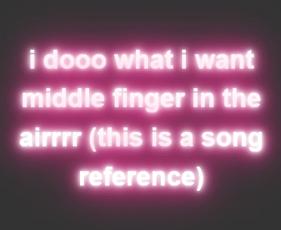

TIPS:
you’d need multiple text shadows that are slightly different colours (hotter pink, more red pink, more yellow pink of a shade etc)

