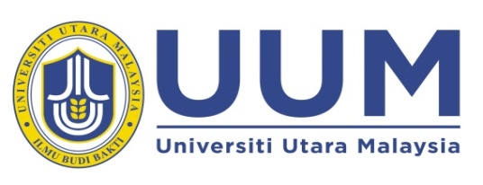
FINAL EXAMINATION {SEMESTER} SEMESTER {ACADEMIC_SESSION} SESSION
EXECUTIVE DIPLOMA BUSINESS MANAGEMENT (EDBM)

COURSE CODE/NAME |  |  |  |  | : | {COURSE_CODE} / {COURSE_NAME}
DATE |  |  |  |  | : | {DATE_DAY}
TIME |  |  |  |  | : | {TIME_DURATION}
VENUE |  |  |  |  | : | {VENUE}
INSTRUCTIONS:

1. | This question paper contains {MCQ_TEXT_EN} MCQ questions in Part A, {TRUE_FALSE_TEXT_EN} TRUE-FALSE questions in PART B and {STRUCTURED_TEXT_EN} structured questions in PART C in {PRINTED_PAGE_TEXT_EN} printed pages excluding the cover page.
2. | You have to answer ALL questions in the ANSWER BOOKLET provided.
3. | Candidates are NOT ALLOWED to take both the examination question and answer booklet out of the Exam Hall.
4. | Candidates are subject to the UUM ACADEMIC DISHONESTY REGULATION PROCEDURES.
MATRIC NO.:
 |  |  | (in words) |  |  |  |  |  |  |  |  |  | (in numbers)
IDENTIFICATION CARD NO.:
LECTURER NAME: |  |  |  | MDM. NURAZWANI BINTI ZAKARIA
KUMPULAN GROUP: |  | A |  |  |  |  | NOMBOR MEJA  TABLE NO.:
DO NOT OPEN THIS EXAMINATION PAPER UNTIL INSTRUCTED

