LVM SWAP RESIZING

**Document history**

|  |  |  |  |
| --- | --- | --- | --- |
| **Version** | **Date** | **Author** | **Changes** |
| 1.0 | 12/4/2023 | Francisco Gutierrez | Initial Version |

**Table of contents**

Swap Expanding Process 2

Summary 2

1.1 Adding SWAP space 2

1.1.1 Expanding an LVM SWAP volume 2

1.1.2 Expanding LUN size 3

1.1.3 Updating/refreshing multipath 4

1.1.4 Expanding LVM SWAP size 5

1.1.5 Applying changes to SWAP 6

**CLASSIFICATION**

|  |  |  |  |
| --- | --- | --- | --- |
| Public (everyone) | Internal (company) | Restricted (to a team) | Confidential (only listed people) |
| Contains personal information in the document body | | | |

Swap Expanding Process

Summary

Swap space in Linux is used when the amount of physical memory (RAM) is full. If the system needs more memory resources and the RAM is full, inactive pages in memory are moved to the swap space. While swap space can help machines with a small amount of RAM, it should not be considered a replacement for more RAM. Swap space is located on hard drives, which have a slower access time than physical memory. Swap space can be a dedicated swap partition (recommended), a swap file, or a combination of swap partitions and swap files. Note that Btrfs does not support swap space.

In years past, the recommended amount of swap space increased linearly with the amount of RAM in the system. However, modern systems often include hundreds of gigabytes of RAM. As a consequence, recommended swap space is considered a function of system memory workload, not system memory.

Adding SWAP space

Sometimes it is necessary to add more swap space after installation. For example, you may upgrade the amount of RAM in your system from 1 GB to 2 GB, but there is only 2 GB of swap space. It might be advantageous to increase the amount of swap space to 4 GB if you perform memory-intense operations or run applications that require a large amount of memory.

You have three options:

1. Create a new swap partition.
2. Create a new swap file.
3. Extend swap on an existing LVM2 logical volume.

***It is recommended that you extend an existing logical volume.***

Expanding an LVM SWAP volume

By default, all Linux (RHEL, CentOS, Fedora, Ubuntu and Suse) like operating system uses all available space during installation, unless you decide to customize the partition configuration.

If you decided to use a default partition set, then a swap partition will be created over LVM and if you want to resize the swap space then you must first expand the LUN where the volume resides (in case of a SAN)and refresh multipath at OS level to reflect the changes or add a new physical volume to the volume group used by the swap space in case you don't want to expand the LUN or the system has LVM configurations over local disks.

After adding additional storage to the swap space’s volume group, it is now possible to extend it. To do so, perform the following steps (assuming /dev/vgswap/lvswap is the volume you want to extend by 2 GB)

Expanding LUN size

A set of steps/procedures must be executed before expanding SWAP size, let’s start by adding space to the LUN (from the SAN)

These are the available storages (SAN):

* DC05: <https://10.70.200.34/gui#volumes-all>
* DC11: <https://10.70.200.23/gui#volumes-all>

**Let’s use DC05 as an example:**

1. Right click over the desired LUN, in this case we are going to use ASQUH SWAP LUN as an example.
2. Click on “Expand” option.

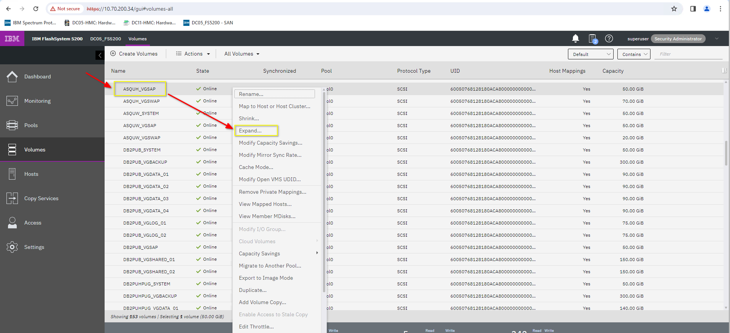

1. Choose how much space you want to add, in this case we are adding 20GB and please, **disable/leave “Format” check box**  , that is important, and it is more critical in non-swap (data type) volumes, disabling it will prevent data loss.

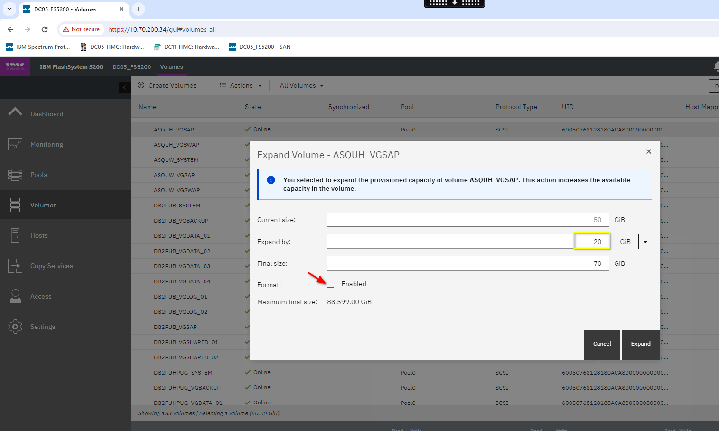

1. Finally, click “Expand” button.

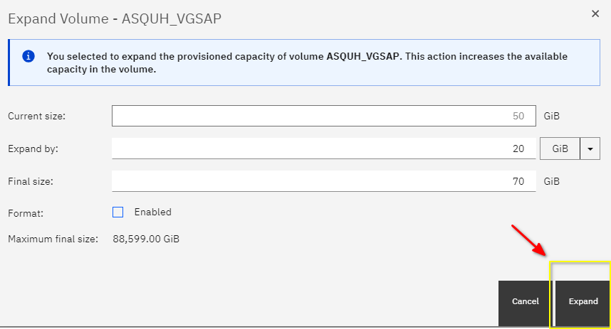

Updating/refreshing multipath

The following steps will let the system know about size changes.

1. Check swap multipath usage:

Run: pvs | grep swap

Output should be something like:



**The value in the rectangle will be the multipath WWID used by SWAP.**

1. List multipaths

Run: multipath -ll <WWID from previous command>

**e.g.**

multipath -ll 360050768128180aca800000000000092

Output should something like:

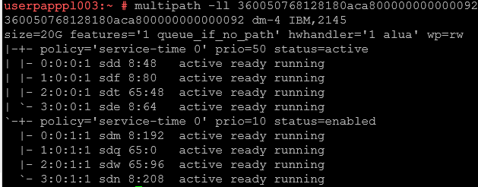

1. Rescan multipaths.

for device_name in $(ls /sys/block | grep sd)

do echo 1 > /sys/block/$device_name/device/rescan

done

1. Resize multipath.

Run: multipathd -k"resize map <WWID from “multipath -ll” command previously executed"

**Note:** Run this command twice just make sure the size is updated

**e.g.**

multipathd -k"resize map 360050768128180aca800000000000092"

Expanding LVM SWAP size

Creating swap partitions in Linux using Logical Volume Manager (LVM) is an important part of setting up a secure and efficient system. Swap partitions allow the system to store and access data in times of high memory usage, improving the performance of the system. Using LVM to create a swap partition makes it easier to manage and resize the partitions if needed in the future.

The following steps will allow you to increase SWAP space inside a LVM.

1. Scan PV’s to get current information:

This information will be useful to run the physical volume resize command.

Run: pvscan

Output should be something like:



1. Resize physical volume (PV):

Run: pvresize /dev/disk/by-id/<desired-device>

**Note:** Check the desired device from pvscan command output

**e.g.**

pvresize /dev/disk/by-id/dm-name-360050768128180aca800000000000092

Applying changes to SWAP

To apply changes to the SWAP space, it is necessary to let the system know that we are not using it while we apply the changes.

Please run the following steps to apply changes to the SWAP space.

1. Identify the LVM name assigned to SWAP.

Run: lvdisplay | grep -i swap

Output should be something like this:

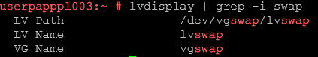

1. Shutdown SWAP space

Run: swapoff <LVM path>

**Note:** Get path from previous command “lvdisplay”

**e.g.**

swapoff /dev/vgswap/lvswap

1. Extend SWAP volume.

Run:

lvextend -L+<desired size in GB> <LVM path>

**Note:** Get path from previous command “lvdisplay”

**e.g.**

lvextend -L+45G /dev/vgswap/lvswap

1. Let the system know about the SWAP changes

Run: mkswap -f <LVM path>

**Note:** Get path from previous command “lvdisplay”

**e.g.**

mkswap -f /dev/vgswap/lvswap

1. Turn on the updated SWAP.

Run: swapon <LVM path>

**Note:** Get path from previous command “lvdisplay”

**e.g.**

swapon /dev/vgswap/lvswap

1. Check updated SWAP.

**e.g.**

free -h

Output should be something like this:

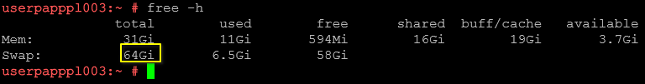

Note: The system will take some to start using the new SWAP space.