**Intervention:**

After a national standardized assessment test (does not count for grades), parents are given a physical report that shows the student’s in one of 3 labels: (i) Early Stage, (ii) In Process, (iii) Satisfactory. This are the percentages in each label for Mathematics and Communications.

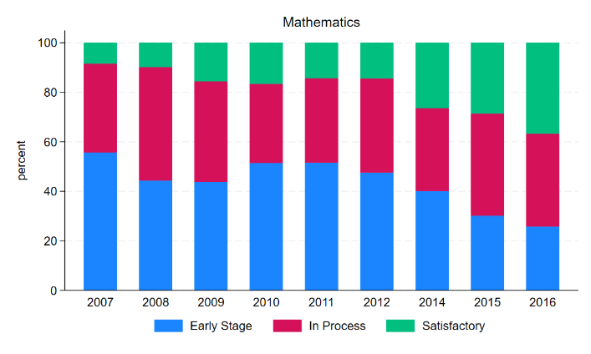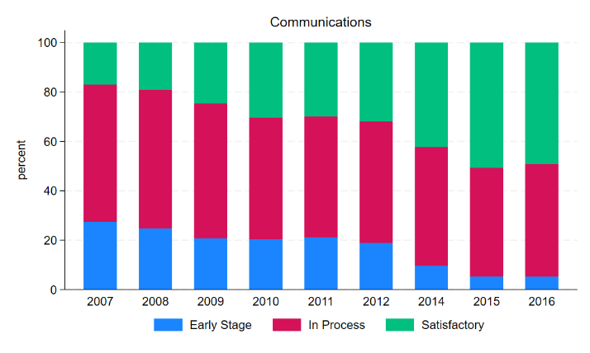

This is a sharp RD, there are 2 cutoffs for each grade. Distribution is

generally smooth around cutoff

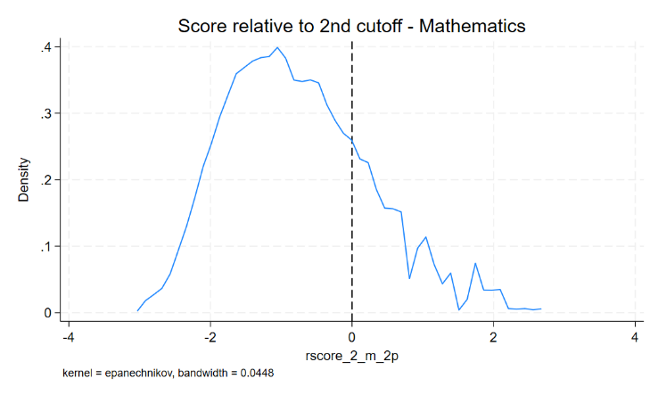

**Question: What are the effects of informing a parent that a child is:**

* **“Satisfactory” rather than “In Process”**
* **“In Process” rather than in “Early Stages”**

The literature about information to parents points out a few things:

* Pass/Fail effect depends on income. Low income students have a positive effect in graduation while High income students a positive effect in 4year college enrollment.
* Persistent effects of earning a more positive mathematics label on the collegegoing decisions of urban, low-income students. No ELA, suburban, high income.
* Less-educated parents in my setting have less accurate beliefs. Beliefs are important in the context of information provision: The bigger the bias the more potential for impact.
* Most of it is on 8th+ graders. Not much on 2nd graders.

At first glance, we don’t see any clear results. This is an example for 4th grade score in mathematics based on 2nd grade labels.

For 8th grade, we see some results although not too consistent:

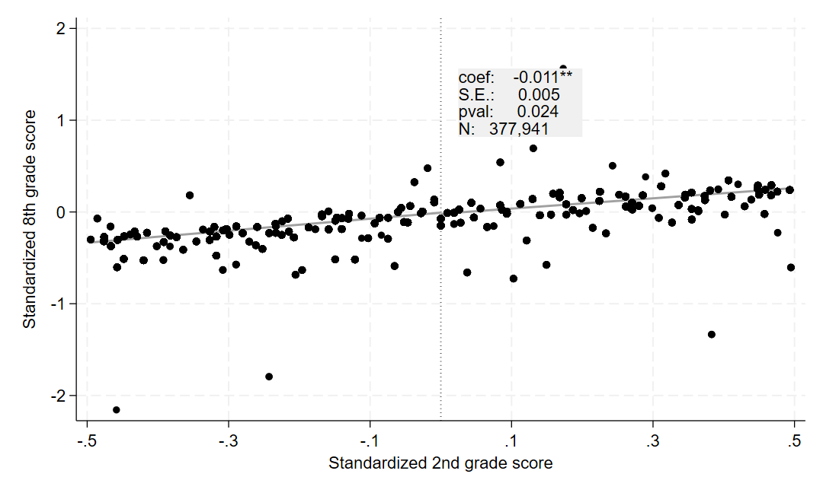

Some other outcomes we can look at:

1. Aspirations/Expectations: What is the highest level of education they (parents or children) think they’ll achieve?

No effects found

1. Choice of school? Based on average score in 8th grade class

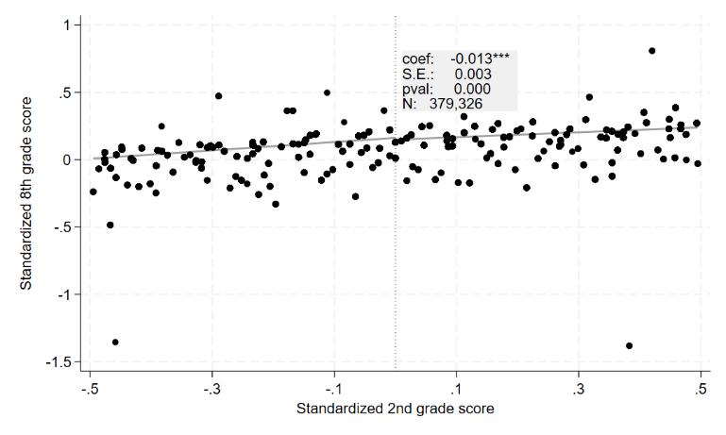

1. Grade progression
2. College applications, admissions, choice of major, etc.

Some questions:

* Does fixed effects make any sense here? By school? By year?
* How can I think about the 4 RDs at once?
* How to think about the fact that some schools might’ve not given the reports to parents? Perhaps proxy by parents who report schools informing about grades?
* How can the interaction in siblings play a role here?