Sistensis

**Foro 3: Base Line 1.2**

* Maestría en Ingeniería de Software
* Desarrollo Multicapas
* Dr. Francisco Eduardo Oliva Ibarra
* López Gómez Francisco Ismael
* 21245753
* 2/Agosto/2021

Contenido

1 Introduction 2

1.1 Stakeholders 3

*1.2 All the code/* features of the system*:* 3

2 Documentation / Requirements: 3

3. Design: 4

3.1 Diagrams of software 4

3.2 Modules o software 5

3.2.1 Module Therapist 5

3.2.2 Module Tutor 6

3.2.3 Module Patient 7

3.2.4 Module Exercises 8

3.2.5 Module Connection 9

3.2.6 Module Therapy 10

3.2.7 Module Reports 12

3.2.8 Module Login 13

4. Configuration and version: 14

**Base Line _**

**Study Case:** Design and implementation of a brain-computer interface for the training of cognitive functions

# 1 Introduction

The software CogniDron-EEG is the porpouse reduce ADHD for children whit this mental disorder. In addition, this software may help for training of a few cognitive functions as therapy. The goal of CogniDron-EEG is to provide real-time feedback using a drone. This drone executes a move accordingly a the a brain reading of a patient.

According to studies, people with a specific mental disorder, children who have ADHD have certain characteristics in their brain. For example, one EEG study showed that it is common to find an increase in theta waves on patients. As a result, cognitive functions are impaired, making it difficult to care and regulate behavior. That is why it seeks to give feedback so that with a series of therapeutic sessions, the patient achieves greater control over her behavior. Although there are similar systems on the market, CogniDron-EEG seeks to offer a system capable of generating reports based on previous records and therapeutic sessions by providing feedback with a drone. With the use of the drone it is sought that they can be more attractive to patients. Also yo can see the porpuse of therapy and whit this you get more imformation about de tha patien and preper better the theray in case the trerapist change. It should also be noted that the session data will have an extra security mechanism to back up the data. This will be achieved by sending each report to an external server to guarantee its subsequent analysis which can be accessed from another computer.

## 1.1 Stakeholders

• User (Therapists)

• Administrator

• Patient

## *1.2 All the code/* features of the system*:*

* The system allows you to register therapists, tutors, and patients.
* The system allows the communication between devices (Drone and Emotiv +)
* The system allows a therapeutic session with 2 types of exercises (Neurofeedback and Brain Control)
* The system gives feedback in real time with the drone
* The system allows you to control the difficulty threshold in the exercises.
* The system creates reports of therapeutic sessions for each patient.
* The session data will be recorded and stored on a server in the cloud.
* The patient will have a previous training to control the drone.
* Add Music for the therapy

# 2 Documentation / Requirements:

The most important documentation for the developer of this project is the Software Requirements Specification or SRS. To make it easier or understand the requirement they are present in tables, but if you want to read in more detail you can go to this link https://github.com/francisco2124/Cognidron_EEG_Requerimientos .

Table 2. Requirement of exercises

Table 1. Requirement of people

|  |  |  |
| --- | --- | --- |
| ***Functional requirements of people*** | | |
| **Identifier** | **Requirement** | **Priority** |
| FFRP-001 | Add therapists | High |
| FFRP-002 | List therapists | High |
| FFRP-003 | Consult therapists | High |
| FFRP-004 | Edit therapists | High |
| FFRP-005 | Delete therapists | High |
| FFRP-006 | Add tutors | High |
| FFRP-007 | List tutors | High |
| FFRP-008 | Consult tutors | High |
| FFRP-009 | Edit tutors | High |
| FFRP-010 | Delete tutors | High |
| FFRP-011 | Add patients | High |
| FFRP-012 | List patients | High |
| FFRP-013 | Consult patients | High |
| FFRP-014 | Edit patients | High |
| FFRP-015 | Delete patients | High |

|  |  |  |
| --- | --- | --- |
| ***Functional requirements of therapeutic exercises*** | | |
| **Identifier** | **Requirement** | **Priority** |
| RNFE-001 | Elevate drone | High |
| RNFE-002 | Move drone back and forth | High |
| RNFE-003 | Move drone left and right | High |
| RNFE-004 | Landing drone | High |
| RNFE-005 | Rotate drone right | High |
| RNFE-006 | Rotate drone left | High |
| RNFE-007 | Mind control with a command | High |
| RNFE-008 | Mind control with two commands | High |
| RNFE-009 | Mind control with three commands | High |
| RNFE-010 | Free mind control | High |

Table 4. Non-functional requirements

|  |  |  |
| --- | --- | --- |
| ***Non-Functional Requirements of System*** | | |
| **Identifier** | **Requirement** | **Priority** |
| RNFR-001 | Velocity of request | High |
| RNFD-001 | Add nice colors | Medium |
| RNFD-002 | Add Icons | Medium |
| RNFD-003 | Add images to exercises | High |
| RNFD-004 | Graphics for the reports | High |
| RNFU-001 | Help module | Medium |
| RNFU-002 | Show mistakes messages | Medium |
| RNFU-003 | Maximum 3 clicks (Navigation) | Medium |
| RNFU-004 | Types of views | Medium |
| RNFS-001 | Protection from unwanted access | High |
| RNFS-002 | User permits | Medium |
| RNFS-003 | Protect reports data | High |
| RNFF-001 | Send reports | Medium |
| RNFF-002 | Add music for therapy | Medium |

|  |  |  |
| --- | --- | --- |
| ***Functional Requirements of System*** | | |
| **Identifier** | **Requirement** | **Priority** |
| RNS-001 | Login | High |
| RNS-002 | Connection estate | High |
| RNS-003 | View brain waves | High |
| RNS-004 | Pre-test | High |
| RNS-005 | Show exercises | High |
| RNS-006 | Activate sensors | High |
| RNS-007 | Emergency control | High |
| RNS-008 | Create and consult reports | High |
| RNS-009 | Purpose of the therapy | High |
| RNS-009 | Send record to a server | High |

Table 3. Requirement of system

# 

# 3. Design:

## 3.1 Diagrams of software

This section shows some diagrams that are the result of the analysis of the requirements for the design of the CogniDron-EEG software development. However, a full version of the document entitled "Cognidron_Software_Design" is available in the repository https://github.com/francisco2124/Cognidron_EEG_Requerimientos. Figure 1 shows the component diagram of the CogniDron-EEG system. This diagram shows the highest-level architectural design that the system will have. Additionally, this diagram shows the relationships between the individual components of the system, as well as the types of interaction between them.

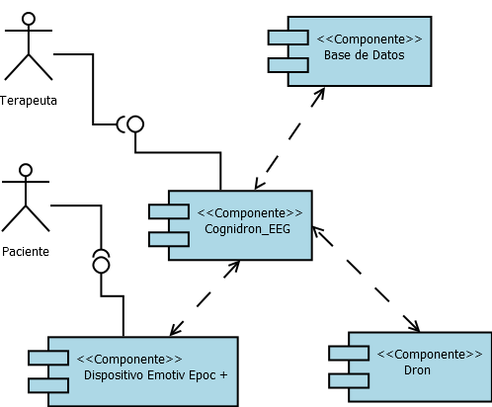

Figure 1. Component diagram

On the other hand, Figure 2 shows a sequence diagram, which is a graphic representation of how a therapy is carried out by means of a neurofeedback-type exercise. Therapeutic neurofeedback exercises require a numerical evaluation to compare if the subject under therapy is capable of reaching the expected threshold through the excitation or inhibition of brain waves.

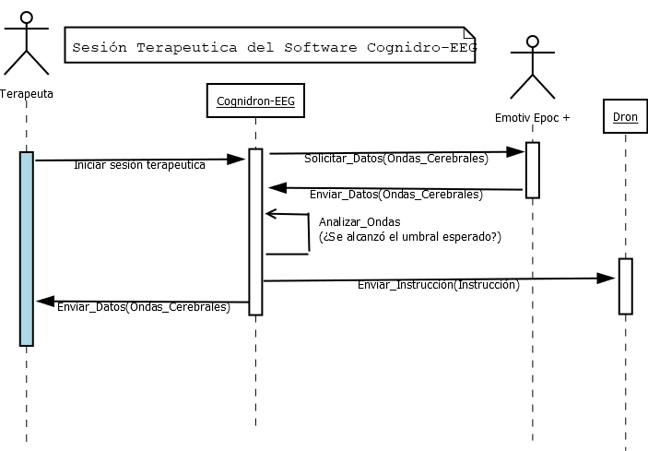

Figure 2. Sequence diagram

In diagram 3 it is observed that to achieve effective control of a drone it is necessary for the patient to go through a written training where they must achieve effective control with a single command, then with 2 commands, 3 commands and finally 4 commands, which is the maximum number allowed by the headband. This is necessary since if it is not possible due to the difficulty of replicating a brain reading, it will not be possible to control it correctly.

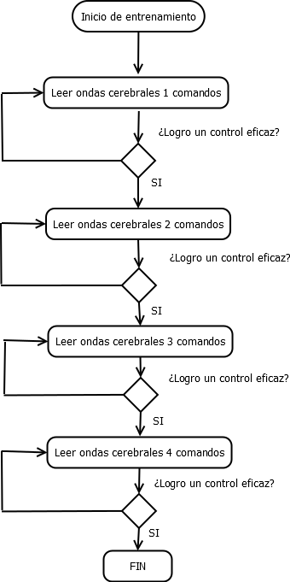

Figure 2. Sequence diagram of training

## 3.2 Modules o software

### 3.2.1 Module Therapist

The therapist module has the function of allowing the administrator user to add data of a new therapist as well as to modify, delete, list and consult his data. Basically, it is the first module that the user will use the system in addition to the login. Therapists are the people in charge of registering patient data and, if applicable, their tutors, they will also be the ones who use the system to carry out a therapy.

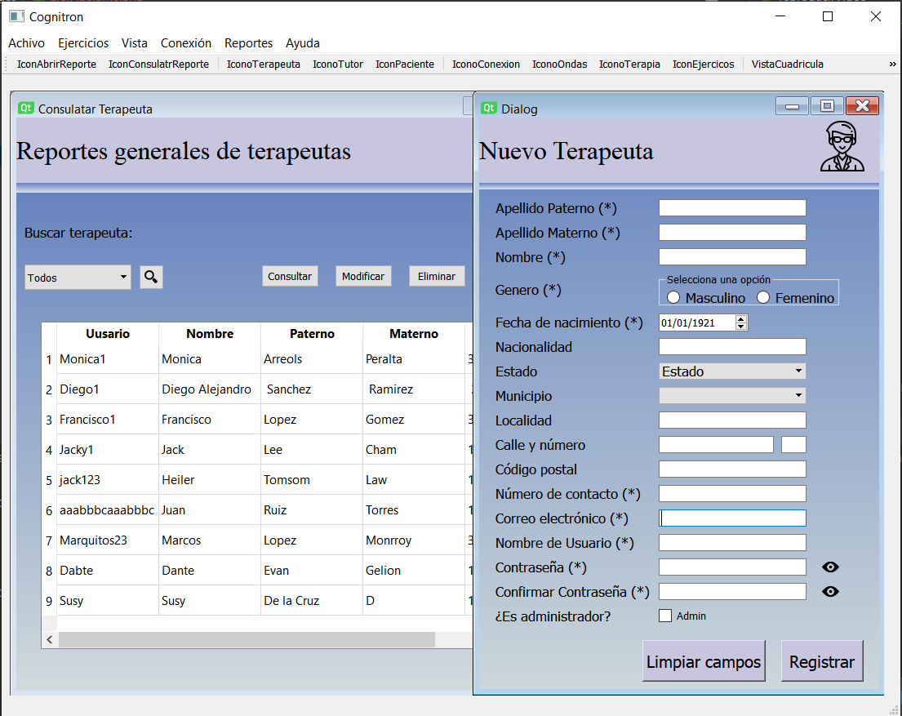

### 

Figure 1: View for register a new therapist.

### 3.2.2 Module Tutor

The tutor module will be used to register, edit, consult, list and delete tutor data for one or more patients. Its function is to be able to record relevant data of a tutor who is a minor or who cannot take care of himself, with the intention of making known the relevant data of the sessions and their general value in relation to the therapies he has performed. In figure 3.2 you can see the relevant data of a tutor for the CogniDron-EEG software.

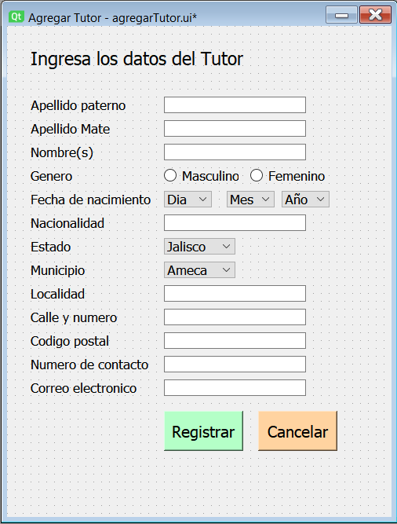

Figure 3.2: View for register a new tutor.

### 3.2.3 Module Patient

The patient module, like the previous 2, will be used to register, edit, consult, list and delete data, but this time it will be data of a patient. Its function is to be able to record relevant data of a patient as shown in figure 3.3. These data will be very important to carry out a therapy and to generate a report. Basically, the patient's data such as age and diagnosis will determine the type of therapy that will be given in each therapeutic session.

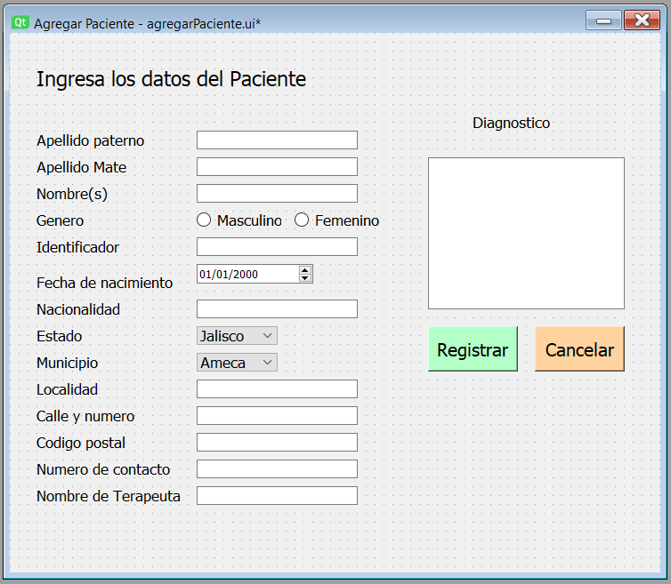

Figure 3.3: View for register a new patient.

### 3.2.4 Module Exercises

The exercise module has the function of presenting the user with a list of available exercises according to a previous selection of the type of exercise. Which can be 2 types: The first neurofeedback which seeks to regulate the behavior of patients through feedback, which in this case will be done through the flight of a physical drone as shown in figure 3.4. The second type, which is Mind Control, has the function of putting into practice the cognitive functions of the patient according to a comparison of one or more previous readings associated with a specific motive of the drone.

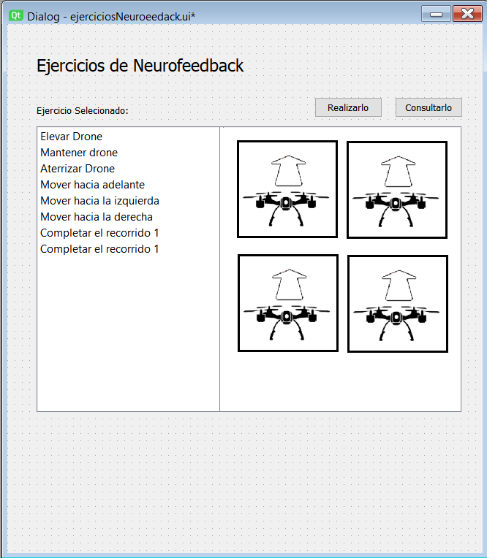

Figure 4: View for show a list exercises.

### 3.2.5 Module Connection

The connection module can be considered the most important since it will be in charge of allowing the connection of the Emotiv headband and the physical drone. Its main function will be to show floating messages that allow the user to know if there is a problem with the connection as shown in figure 3.5 where an alert message can be seen advising the user that it is necessary to check that there is a headband connected. This module is very important since the cognidron-EEG software will work in conjunction with the main Emotiv system and there are important restrictions to be able to establish the connection, which are recovered through code, such as the verification of permissions or login in the Emotiv system.

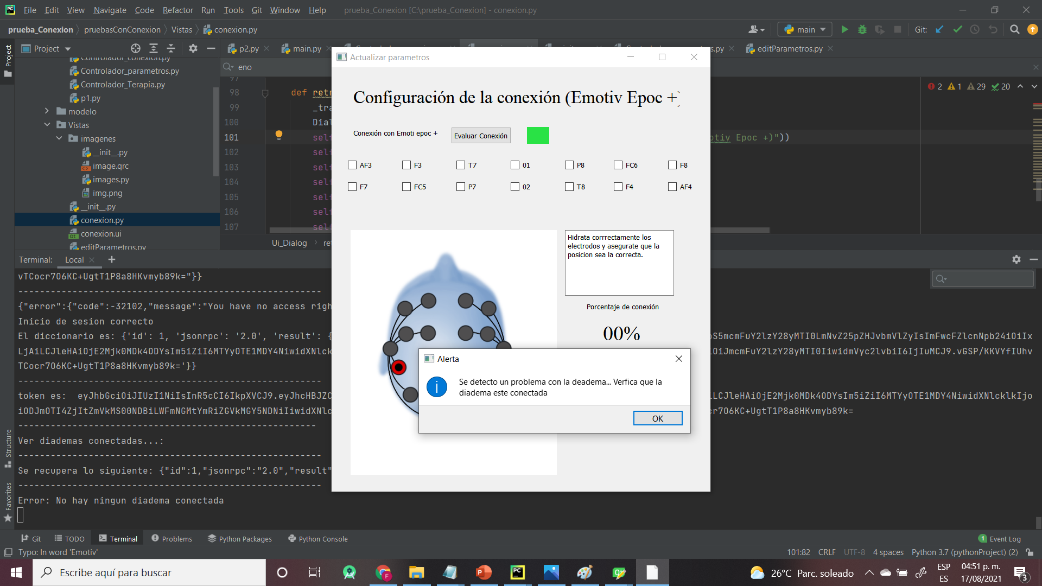

Figure 3.5: View for the connection whit auricular Emotiv.

### 3.2.6 Module Therapy

The therapy module is responsible for making a therapy session possible .as shown in figure 3.5. This module is where the sale will be displayed for the selection of a patient, a data profile, if necessary, establish a schedule of the therapeutic session, other relevant data for the session such as the date, type and name of the exercise or the data of the therapist. In addition, this module will allow to visualize the brain waves of the patient in real time and a window with instructions for the patient. In addition, this sale will have an emergency control in case control of the drone is lost.

Its objective will be to make use of the connection to be able to give feedback in real time to the patient with the physical drone according to their brain waves.

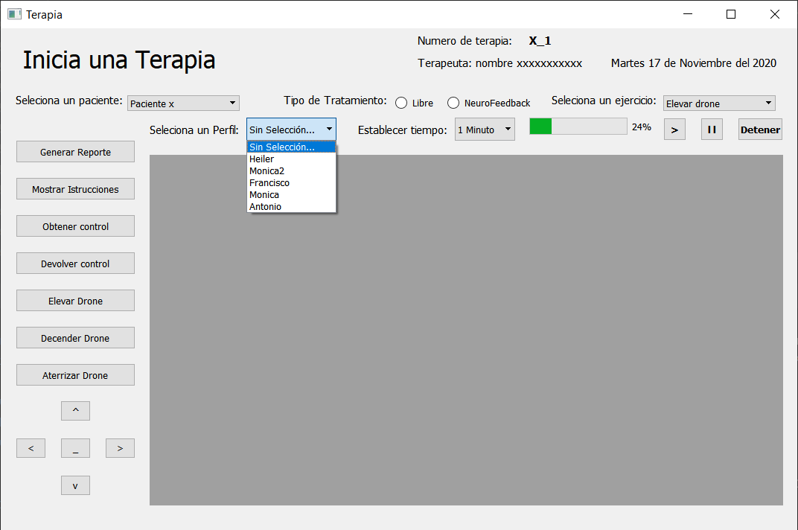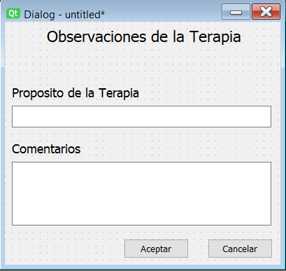

Figure 3.6: View for perform a therapy.

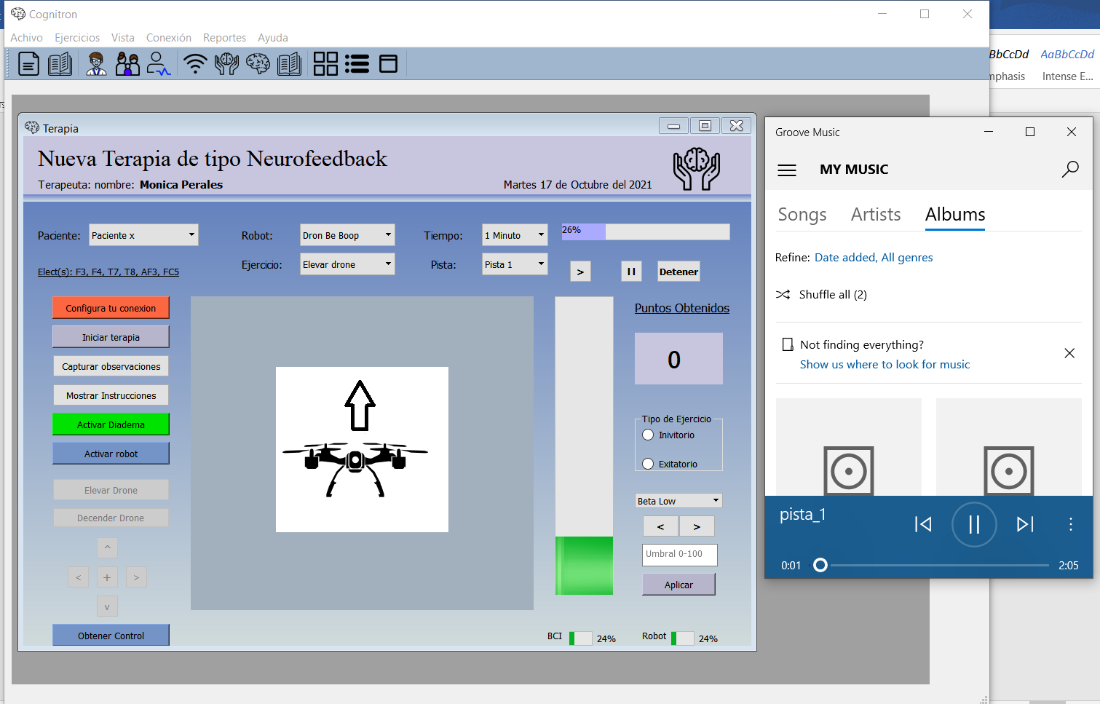

Figure 3.7: Music for the therapy.

### 3.2.7 Module Reports

The reports module is in charge of collecting all the important information of the modules to show the results of a therapeutic session to the therapist and the patient. The system offers the consultation of the reports, it also allows to show graphic reports of the goals achieved in each session of a patient to be able to analyze the advance or setback of the patients and be able to make better decisions in relation to the therapy that is being carried out as shown in figure 3.8. In addition, the system can generate a pdf document with the relevant data of the session so that it can be easily sent or consulted on another occasion.

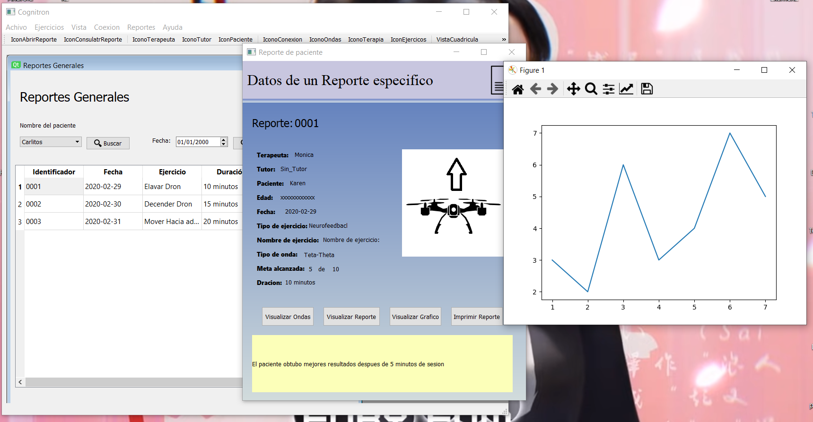

Figure 3.8: CogniDron-EEG Software report module windows.

### 3.2.8 Module Login

The login module has the function of validating the credentials of the users. Basically, it is the first window that the user will see as shown in figure 3.9 and its objective is to provide security to the data registered in the system.

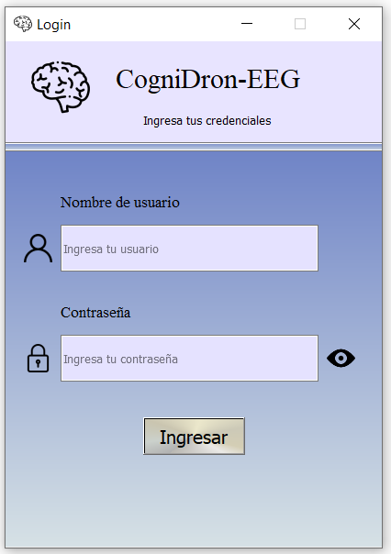

Figure 3.9: View for login.

# 4. Configuration and version:

Technologies used for the software

* Python Version 3.7
* IDE PyCharm version 2021.1.0.PC-211.6693.115
* MySQL database engine version 8.0.17.0
* PyQt5 as a link for the QtPy 1.9.0 graphic library
* Cortex V2.0
* MySQL-python-1.2.5 library
* OS library to open files
* MTPlotlib library version 3.3.2 for the generation of graphics
* Pandas library version 1.1.3 for data structure management and analysis
* PaPDF library version 1.1.5 for the generation of PDF files
* UJson library version 4.0.1 for encode data in JSON format
* Csv library for create file CSV