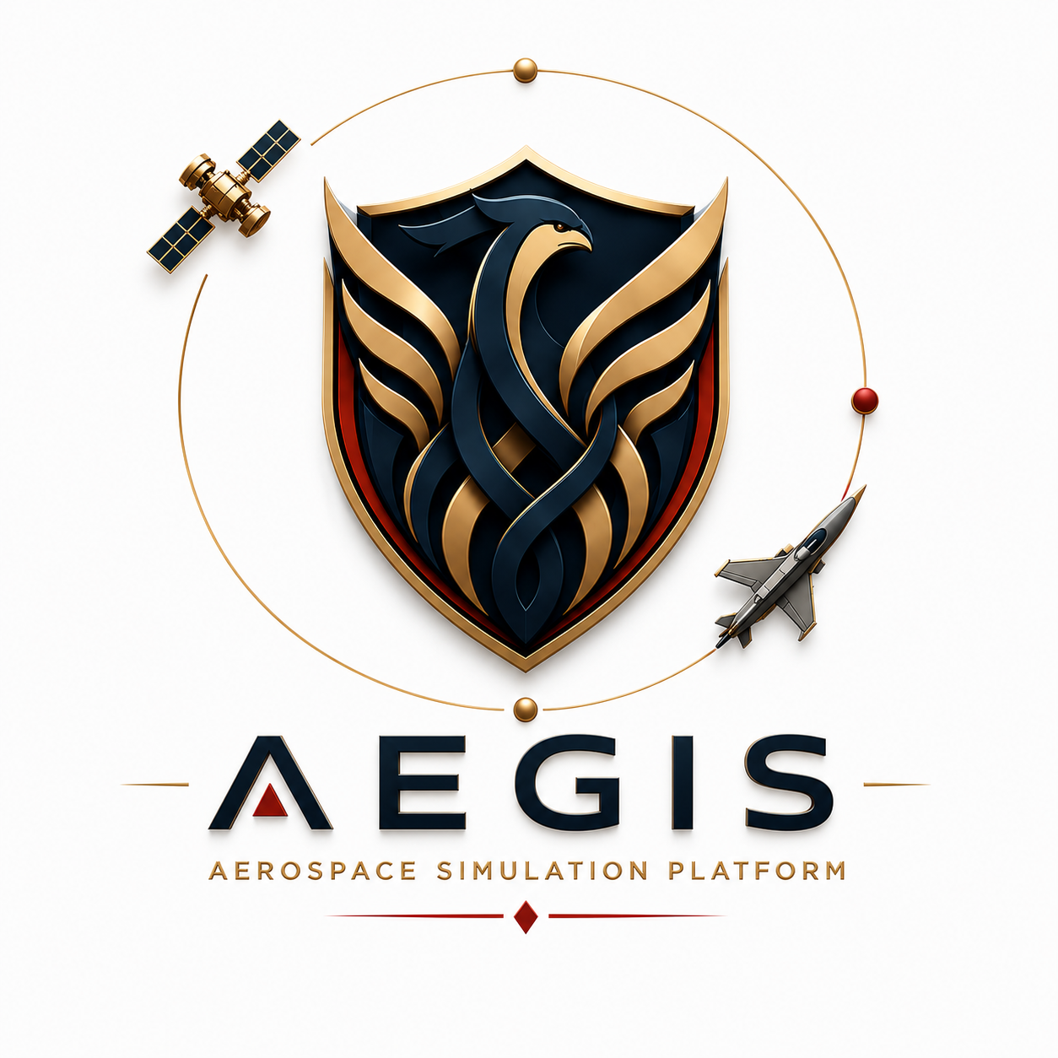
System Architecture
Version 1.0

Francisco Rodrigues Oliveira

University of Minho
Aerospace Engineering

July 2026
Table of Contents
1. Purpose and Scope 2
2. Architectural Goals 2
3. System Context 2
4. High-Level Architecture 2
5. Data Flow 3
6. Technology Stack 3
7. Deployment View 3
8. Quality Attributes 3

1. Purpose and Scope
This document describes Aegis at the system level: its boundaries, its major building blocks, how information flows between them, and the technology choices that realise it. The Software Architecture Document goes one level deeper, into class- and module-level design inside each of these blocks.

2. Architectural Goals
The architecture exists to serve one non-negotiable rule, carried over unchanged from the project's first day: the domain is sovereign. All simulation logic — movement, sensing, detection, alerting, state transitions — lives in one layer that has no knowledge of, or dependency on, any GUI concept. The GUI is a client of that layer, never the other way around.

3. System Context
Aegis is a standalone desktop application. Its only actor is the human operator interacting through the GUI; there are no external systems, network services, or databases in the current scope. All computation happens in-process, on a single machine.

4. High-Level Architecture
The system is organised into two layers with a single, narrow channel between them:
- Domain layer (domain/) — entities, value objects, and services that model the mission: World, Scenario, Simulation, SimulationSnapshot, Satellite, Sensor, Fire, Position, Observation, Detection, DetectionEngine, Alert, AlertEngine, ControlTower.
- GUI layer (gui/) — PySide6 windows and reusable components that present whatever the domain reports and translate operator actions into calls on the domain's public API (simulation. start/pause/resume/stop/step, world.add_entity/remove_entity).
The channel between them is deliberately narrow: the GUI receives only a SimulationSnapshot from each step and never reaches into World or its entities directly for anything other than the plain data SimulationSnapshot already exposes.

5. Data Flow
A mission's data flows in one direction, from scenario definition down to the operator's screen:
Scenario
↓
World
↓
Entities (Satellite, Fire)
↓
Satellite → Sensor → Observation
↓
ControlTower
↓
DetectionEngine → Detection
↓
AlertEngine → Alert
↓
SimulationSnapshot
↓
GUI rendering (MapView, Mission Status, Mission Log)
Operator actions flow the opposite way, but only as far as the domain's public methods: a click on Start/Pause/Resume/Stop calls the corresponding Simulation method; Add Entity / Remove Selected call World.add_entity / World.remove_entity with a domain object the GUI constructed from its own form fields.

6. Technology Stack
- Python 3 — implementation language for both layers.
- PySide6 (Qt6) — GUI framework: windows, layouts, signals, QPainter-based custom drawing (map terrain, entity icons, rotating globe).
- numpy / Pillow (optional) — used only by the rotating Earth background widget for image projection and frame caching; every other feature runs without them.
- No database, no network stack, no external APIs.

7. Deployment View
Aegis is distributed and run as a single desktop process (python main.py). There is no client-server split, no installation beyond a Python environment with the dependencies in requirements.txt, and no persisted external state between runs today.

8. Quality Attributes
- Modularity each domain concept and each GUI concern is its own file/class; the two layers can be worked on, tested, or replaced independently.
- Extensibility the Scenario/World/Simulation triad and the Home→Signal navigation pattern were designed from the first mission onward to support additional mission types without core changes.
- Maintainability the domain-sovereignty rule means a change in how the GUI looks can never silently change what a mission does, and vice versa.
- Portability PySide6/Qt6 runs unmodified on Windows, Linux, and macOS.

