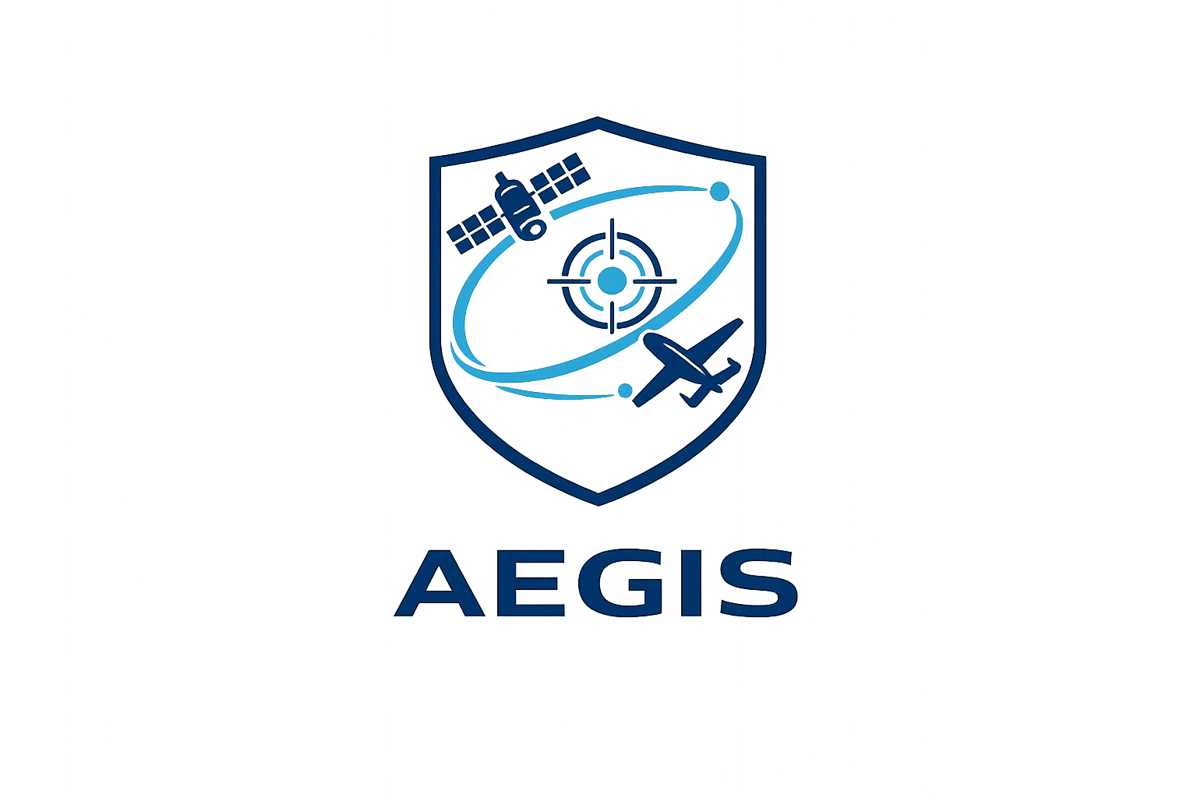

Vision Document
Version 0.1

Author: Francisco Rodrigues Oliveira
Date: 8th June 2026
Status: In Progress
Every year, natural disasters and security-related events require rapid, coordinated, and informed responses. Modern aerospace systems, combining satellites, unmanned aerial vehicles (UAVs), and autonomous technologies, play an increasingly important role in environmental monitoring, surveillance, and decision support.
Aegis is a modular aerospace mission simulation framework designed to model and evaluate cooperative missions involving multiple autonomous assets. Its purpose is to provide a flexible software platform where different mission scenarios, vehicles, sensors, and operational concepts can be simulated, analysed, and extended.
The first reference mission focuses on the detection and confirmation of wildfires through the coordination of an Earth observation satellite and a UAV. However, the framework is designed from the outset to support additional mission types, such as maritime surveillance, search and rescue, environmental monitoring, and reconnaissance, without requiring changes to the simulation core.
The project follows professional software engineering practices, including modular architecture, clean code principles, comprehensive documentation, version control, and automated testing. Beyond serving as a technical portfolio project, Aegis aims to provide a realistic engineering environment for exploring aerospace systems, autonomous platforms, and mission-level decision making.
The intended audience includes students, researchers, and engineering enthusiasts interested in aerospace systems, autonomous vehicles, Earth observation, and mission simulation.

