Lallemand Plant Care Geostatistics Trial Report

LPC

2023-01-11

# Trial description

**Field name**: {FIELD_NAME}

**Area size**: {field_area}

**Crop**: {crop_name}

**Variety**: {variety}

**Previously crop**: Silage corn

**Sowing date**: {sowing_date}

**Harvesting date**: {harvest_date}

**Spacing between rows**: {inter_ro_cm} cm

**Type of soil**: {field_soil}

**Irrigated area**: {field_irrigation}

**Crop year**: 2021

**Farmer**: {first_name} {last_name}

**Location**: {town} ( {zipcode} )

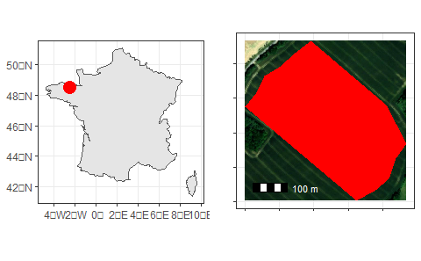

**Experimental design**: Strip geostatic design, two treatments, three strips for T1 and two strips for T2, 36m width, the length was according to the area length.

|  |  |
| --- | --- |
| {T1_T2_POINTS} | {T1_POINTS} |
| {T2_POINTS} |

# Statistical Method

After the cleaning and filtering step, an analysis of variance was performed to identity if there were significative differences between the borders and middle rows. In case of significative difference, the borders were taken out from the model. Generally, borders rows can present difference from the middle rows due to the fact they are on a transition area between two treatments. Right after, the yield map and semivariogram were built for each treatment. The whole area presented {TOTAL_YIELD_POINTS} yield measurement points, {TOTAL_T1_POINTS} for T1 and {TOTAL_T2_POINTS} for T2. Based on the data, a statistical test was developed from geostatistical simulations (Analysis of spatial discontinuities). For kriging, models were calibrated, and the model of 80% points coming from each treatment was used to simulate the yield in the total area, because it is the best percentage of points for simulations. The other 20% of data was used to evaluate the model and measure the accuracy.

# Results

On model T1 is possible to see the yield in the whole area if T1 was applied in the entire field and model T2 shows how the yield would look if T2 was used in the entire area.

|  |  |
| --- | --- |
| {T1_T2_MODEL} | {T1_MODEL} |
| {T2_MODEL} |

Comparing model T2 map against model T1 map is possible to see that model T2 presented a yield gain in {TOTAL_PERCENTAGE} % of the area.

{YIELD_GAIN_HISTOGRAM}

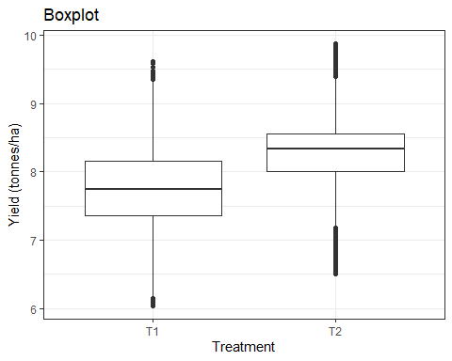

ANOVA result for yield.

|  |  |  |
| --- | --- | --- |
| Treatment | Yield (tons/hectare) | Standard deviation (tons/hectare) |
| T1 | {T1_MEAN} | {T1_STD_DEV} |
| T2 | {T2_MEAN} | {T2_STD_DEV} |
| p value <{P_VALUE} | | |

ANOVA result at 1% of significance showed a high statistical difference between T2 and T1 and this difference was {MEAN_DIFFERENCE} tons/hectare.