Building cars using Anim8or

This tutorial assumes some basic knowledge of Anim8or to get started. Be sure you know most of the tools that Anim8or has, before starting this tutorial. If I had to rank this, it would probably fall into the splines + box modeling category at a bit higher than beginner level.

The first step is the draw the basic outline of the car. If you look at the picture below, I have done a similar thing.
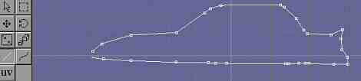Notice that this spline is not closed. To close it, double-click on it and click the closed spline option. After you have done that you will get something similar to this.
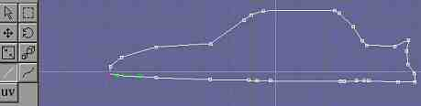When drawing the spline, be sure to have the same number of control points at the same general places as mine.
Next we shall extrude this to get a very rough outline of a car. Be sure to not cap either side. After you have extruded it, you should have something like this.
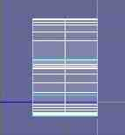
Now that we have a rough outline of a half of a car it is time to add some more detail to it. Select the outer edges of the mesh as shown in the picture below.
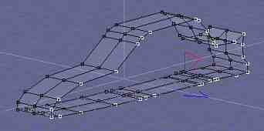Now switch to point-edit mode and add some edges to our mesh as described below. Put your mouse close to the point from which you desire to draw the extra line. While holding the right mouse button, move the mouse towards the direction of the desired point of ending. Continue building new edges. About 1/10the way through I got this.
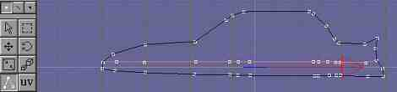 After I finished I had something that looked like this.
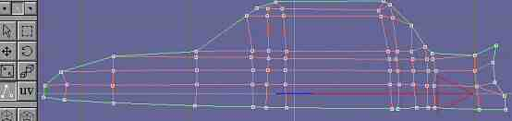 This is of course, after I selected the outer edges. While in point-edit mode go edit/fill holes. After you do that, you should get an image similar to this one.
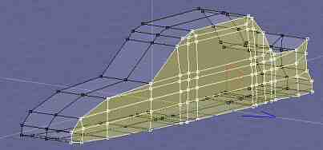After this I moved some points around, deleted/added some edges to this side and got to this.
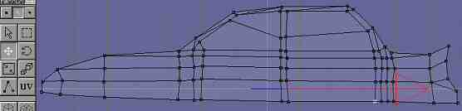
This process was more similar to trial and error, so it is rather hard to describe. One thing I should mention though, is that whatever you do, be sure to have something similar to mine, especially at the top part. Most importantly, be sure to have these faces for the windows.
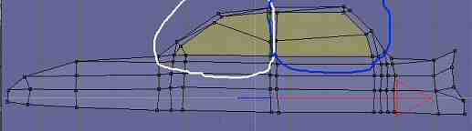

For the next step, select the points as shown in the picture below.
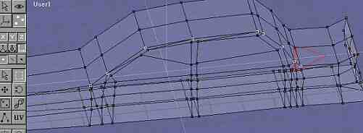Now got to top view or got to the view that shows the top of our car and move these points about as much as shown in the picture below.
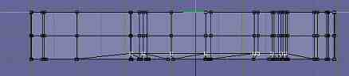

Now select another set of points as show in the picture below.
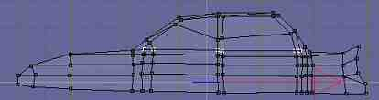
Go to side view and move these points as shown here.
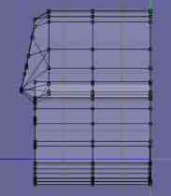Note that on this picture I seem to have moved more than just the points I selected in the previous picture. That is because, if you have not already noticed, the window edges have more than 2 points. In order to give the windows a more planar look I had to move those points also. If you have more than 2 points for your windows then move the extra edges so that on side view you will become something similar to what I got.

Lets go to front view again and select some more points as shown.
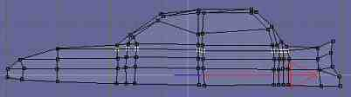 After selecting these points, move them and then select the points below the ones already selected (be sure to select the points the way I have). Move them too. Repeat the process until in side view, you have something similar to this.
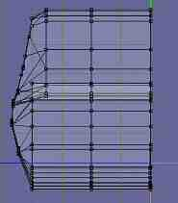 Now it is the time to give our windows a material of their own. Select the faces as shown in the picture below, then make a new material, again following directions from the picture.
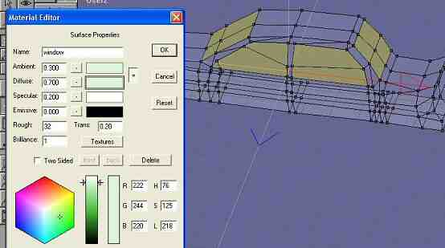Name the new material window or anything you wish then apply it to the selected faces. Before doing all this, make sure that you have already made a material for the car and have applied it.
If you look at your car, you will see something not far from being a car. You may notice though that our car is missing wheels. They are not hard to make, but before we do, we must do something else first.

Since I am sure that most of you will try at turn your mesh into a subdivision object to see how it looks, I am sure that almost all of you will run into a strange problem. After you subdivide your car, it’s windows will look unrealistic, as though connected seamlessly to the metal parts. This problem is very easy to fix if you follow the steps described below.

Select all faces except those that have the window material applied to them. You should get something like this.
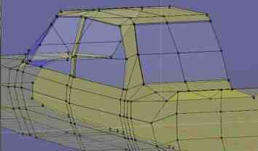Now using the joint-extrude tool from face editing menu, extrude this faces just a little bit. You should get something similar to what I have above. (It’s hard to notice, but look hard at the places where the windows and the metal meet, you’ll see the edges from the extrusion)

At this point if you look at your model from different angles you might notice that you have some edges that you’d rather not have. Look at the picture below to see what I am talking about.
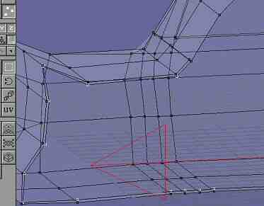Select the points as shown. (there are more, this picture just shows some of them. These points/edges are at the parts where later you are going to join your mesh with its mirror. Simply speaking they are on the inside part of the half-car.) Be careful not to select the points that are part of the window. After selecting these points, delete them. “So I gave my windows an extra face or two”, you may think “what good are they.” Before you get the answer to that question, you must firs select those faces and apply the window material. This process may be a little too frustrating, but don’t give up. Apply the material to them one by one to make the job easier.
To make sure you are selecting the right faces, look at the picture below and compare it to what you have.
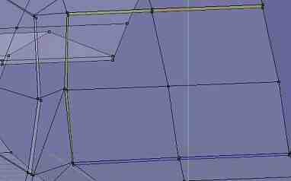After applying the window material to these edges, turn your model into a subdivision object for a moment or two, and see how clean and nice the window edges seem.

The time has now come to make the bumpers. For the front bumper, select and joint-extrude the faces as shown below.
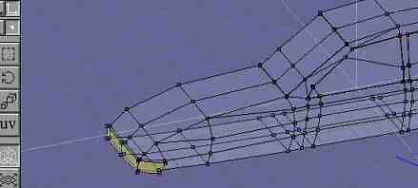

Similarly do the back bumper to get something like this.
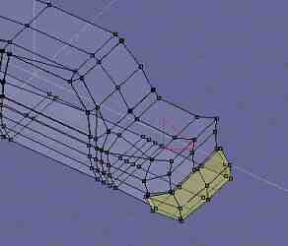Maybe you remember from before that by doing this you get some unwanted edges and points. Well you know what they say (or not say) if you don’t like it, get rid of it. That is exactly what we are going to do. I got this point for my back bumper.
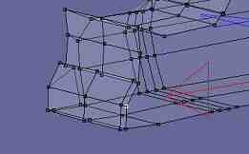Being careful not to select some wanted points or edges I selected this one and deleted it. You do the same for your front and back bumpers.

Now we are ready to get on with making the holes for the wheels.

In front view select the edges you would like to have the holes for the wheels to be and cut those. After that delete any points or edges inside the wholes you have just created. Move some points after that, add some edges to give a round feel to the hole. For the front side, I got this more mine.
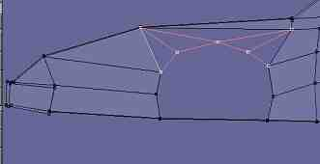
Now go the bottom and make a similar hole to get something like this.

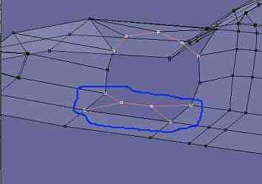
Select the appropriate edges and using the command edit/fill holes bring the hole to life. This is what I got for mine.

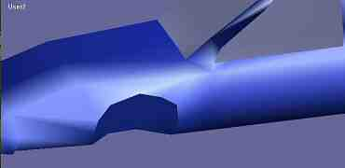Do the same thing for the back part of the car.
Now you should be ready to start making the head-lights for a car that looks something like this.
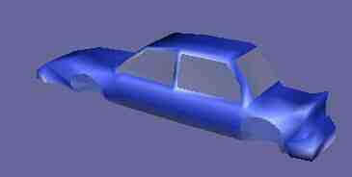

We will make the wheels after making the head-lights.

Select the faces where you would like the head lights to be. This is what mine looks like.
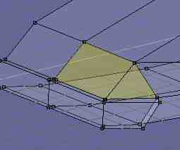The next step is to make these faces a little smaller. Use the resize face tool to get an image similar to what you see below.
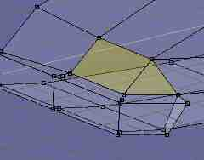Next lets make a material just for the head-lights.
Follow the picture for the material.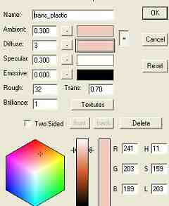For the next step, joint-extrude the selected faces just a bit. I got this for mine.
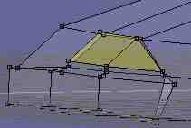We are now ready to make the actual head-lights.

Make a new object and name it whatever you desire.
Next, make a spline such us this one. 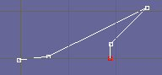Lathe it and name it light-silver. Then make a new spline that looks like this.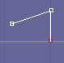Lathe it and name it light-bulb. Now lets create the materials for these two wonders.
The material for the light-silver object should be this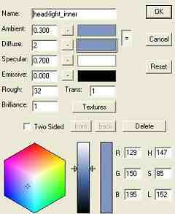.
The material for the light-bulb should be this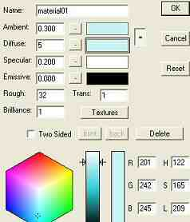. You are free to change anything about these two materials, just be sure to leave the diffuse values as they appear. Put our two meshes together to form the actual head-light. Next place them in your car as shown in the picture or in any other way you may desire.
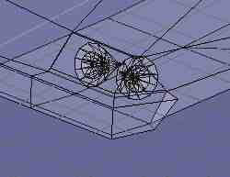
I am going to leave making the light for the back and other parts to you. I trust you can do it easily.
For the head-lights to look a bit better we must make a bit of adjustments to the car material you have created and applied to the car (hopefully). First, make sure that all of the faces of the car are facing the same direction, i.e when you select them they are all the same color when you look at them head on. If some faces are facing a different direction, you can fix this by selecting them and doing edit/Flip Normals. Now make these adjustments to the car material. Make it two-sided, and give the back the following properties.
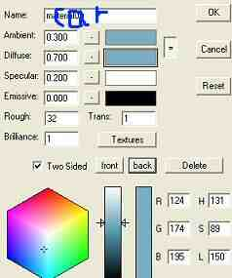. There, now you are ready to turn your half-car into a full-fleshed speed hungry piece of machinery (right!). First, make sure your model is centered with the empty part facing the “virtual mirror” (by “virtual mirror” I mean the axis you are going to mirror along). Next do build/mirror. Before going any farther, be sure to make a copy of your half car as a separate object. Now join your to half-cars by build/join solids. Select the points to be joined together like in the picture below and do edit/merge points.
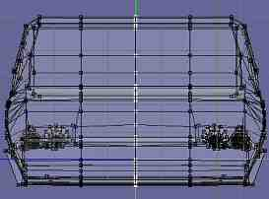This is what I got for mine.

Now we are ready to make the wheels (actually we were ready a long time ago, but still it’s not too late).

Make a new object and call it wheel or whatever else you want.
Create an n-gon from build/primitiver/n-gon. Be sure it has 12 points/sides. Extrude it and then delete the extruded part. Using the add-edge tool add some edges until you get something like this. 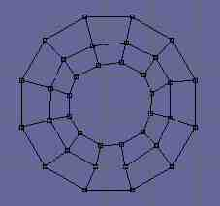
Now move some points around until you get something like this. (You are free to make any other shape that you want, though).
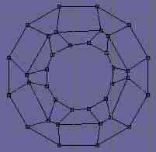Now add faces using the edit/fill holes command to get it to look like this.
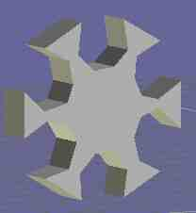Next, create the tire for this. (Just make a tire cross-section spline and lathe it. Be sure to have it the right distance away from the axis of rotation/lathe) Lathe it with 12 sides.
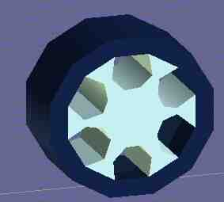Since you have the same number of edges you can easily join the two together to get what I have above. The materials are nothing special, so I am living that part to you.
Now add the wheels to your car. Your work is not over, yet; however, now you have to move some points around until you get the car to get the shape you want (especially in the front part. There is no right way of doing it, just a matter of taste). Hint: you can add a lot of bumpy detail by using the face extrude tool. After you are happy with what you see render it. I made two images, one subdivided and one not. Here they are.
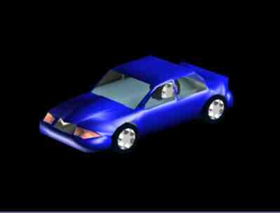Not subdivided.
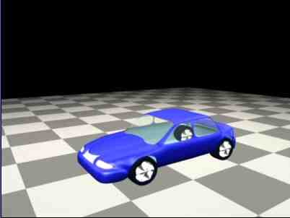Turned into a subdivision object.

Generally if you are not going to add detail after subdividing, it’s a good idea to turn it into a subdivision object for later editing. I am leaving the interior to you, for I don’t know of a stable way of making one. Good luck with your models.

Ter-Isahakyan Levon

(C)2003 R. Levon Ter-Isahakyan
All Rights Reserved

