[**Lab-java-sql**](https://github.com/ironhack-labs/lab-java-sql)

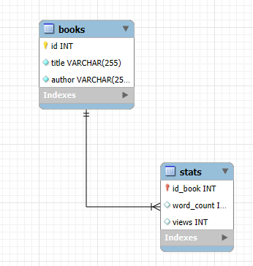1)

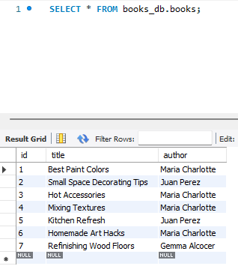

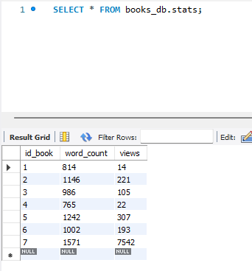

2)

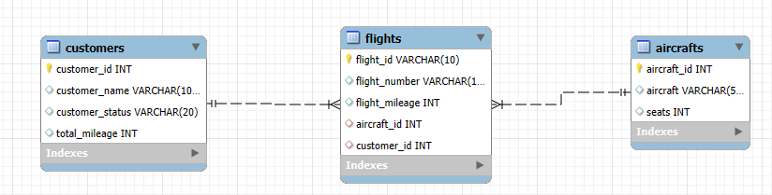

**QUERIES PARA CREAR TABLAS:**

CREATE TABLE aircrafts (  
 aircraft_id INT AUTO_INCREMENT PRIMARY KEY,  
 aircraft VARCHAR(50) UNIQUE,  
 seats INT  
);  
  
CREATE TABLE customers (  
 customer_id INT AUTO_INCREMENT PRIMARY KEY,  
 customer_name VARCHAR(100),  
 customer_status VARCHAR(20),  
 total_mileage INT  
);  
  
CREATE TABLE flights (  
 flight_id VARCHAR(10) PRIMARY KEY,  
 flight_number VARCHAR(10),  
 flight_mileage INT,  
 aircraft_id INT,  
 customer_id INT,  
 FOREIGN KEY (aircraft_id) REFERENCES aircrafts(aircraft_id),  
 FOREIGN KEY (customer_id) REFERENCES customers(customer_id)  
);  
  
  
INSERT INTO aircrafts (aircraft, seats) VALUES  
('Boeing 747', 400),  
('Airbus A330', 236),  
('Boeing 777', 264);  
  
INSERT INTO customers (customer_name, customer_status, total_mileage) VALUES  
('Agustine Riviera', 'Silver', 115235),  
('Alaina Sepulvida', 'None', 6008),  
('Tom Jones', 'Gold', 205767),  
('Sam Rio', 'None', 2653),  
('Jessica James', 'Silver', 127656),  
('Ana Janco', 'Silver', 136773),  
('Jennifer Cortez', 'Gold', 300582),  
('Christian Janco', 'Silver', 14642);  
  
INSERT INTO flights (flight_id, flight_number, flight_mileage, aircraft_id, customer_id) VALUES  
('DL143-A', 'DL143', 135, 1, 1),  
('DL122-A', 'DL122', 4370, 2, 1),  
('DL122-B', 'DL122', 4370, 2, 2),  
('DL122-C', 'DL122', 4370, 2, 3),  
('DL53-A', 'DL53', 2078, 3, 3),  
('DL222-A', 'DL222', 1765, 3, 3),  
('DL143-B', 'DL143', 135, 1, 4),  
('DL37-A', 'DL37', 531, 1, 4),  
('DL143-C', 'DL143', 135, 1, 5),  
('DL122-D', 'DL122', 4370, 2, 5),  
('DL222-B', 'DL222', 1765, 3, 6),  
('DL222-C', 'DL222', 1765, 3, 7),  
('DL222-D', 'DL222', 1765, 3, 8);

**QUERIES EJERCICIOS:**

select count(distinct flight_number) as 3_total_flights from flights;  
  
select avg(flight_mileage) as 4_flight_mileage_AVG from flights;  
  
select avg(seats) as 5_aircraft_seats_AVG from aircrafts;  
  
select customer_status, avg(total_mileage) as 6_mileage_by_status_AVG from customers  
group by customer_status;  
  
select customer_status, max(total_mileage) as 7_max_miles_flown from customers  
group by customer_status;  
  
select count(aircraft) as 8_aircraft_boeing_count from aircrafts   
where aircraft like '%boeing%';  
  
select flight_number, max(flight_mileage) as 9_fligths_between from flights  
where flight_mileage between 300 and 2000  
group by flight_number;  
  
select customers.customer_status, avg(flight_mileage) as 10_flight_by_status_avg from flights  
inner join customers on flights.customer_id = customers.customer_id  
group by customers.customer_status;  
  
select customers.customer_status, max(aircrafts.aircraft) as 11_aircraft_by_gold from aircrafts  
join flights on aircrafts.aircraft_id = flights.aircraft_id  
join customers on flights.customer_id = customers.customer_id  
where customers.customer_status like "gold"  
group by customers.customer_status;