External libraries in this project are managed by NuGet. To update the packages, open the package manager console.
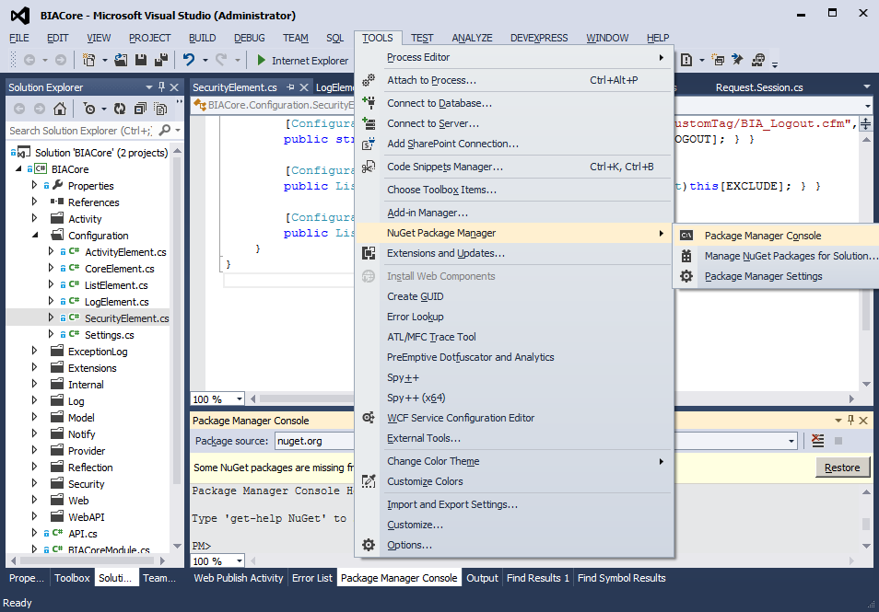
Then restore any missing packages.
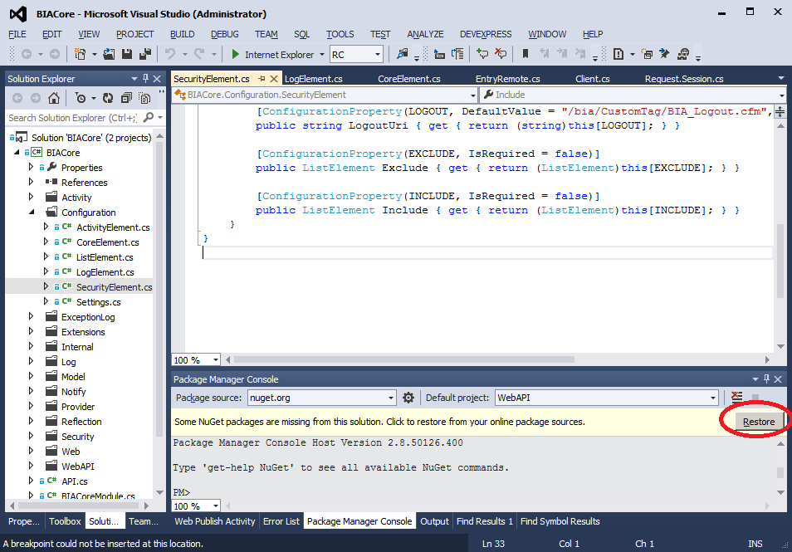
This will prompt you for your AD credentials.
The packages will then be updated and added to the project as appropriate.

If it complains about 407 proxy authentication required, that’s IronPort messing with NuGet’s SSL certificate. Load up Fiddler, and try again.

