**Model 2**

**(Without influential points 2 and 4)**

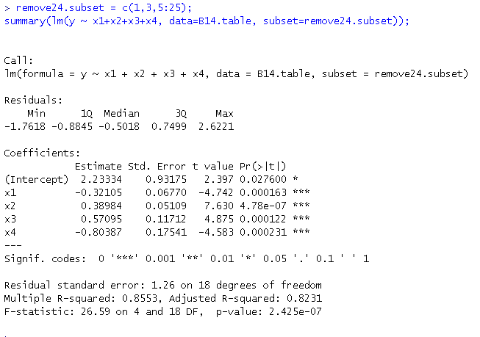

* Model 2 has quite different estimated coefficients than model 1
* Model 2 has smaller Std. error for parameter estimation
* Model 2 has larger t statistic and equivalently smaller p-values

**Model 1**

**(Initial model)**

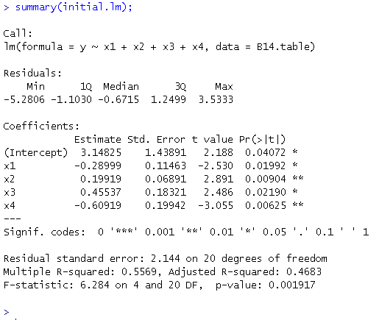

* Model 1 is the initial model and it has larger error in its parameter estimated coefficients
* Equivalently, model 1 has smaller adjusted $R^{2}$