STAT 5531 - linear models

chapter 2 – additional excercise

**Thanh Doan – Student ID 0159701**

|  |  |
| --- | --- |
| exercise 2.19 |  |

**R code to generate 500 samples and compute sample estimates for question a, b, c, d**

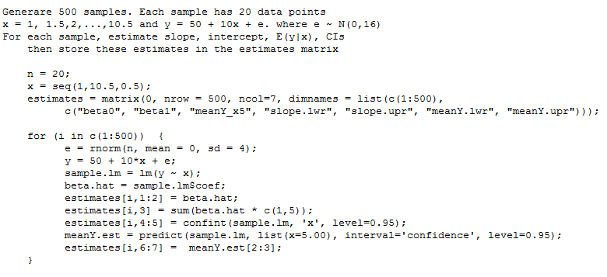

**a – Histograms of sample values of beta0 and beta1**

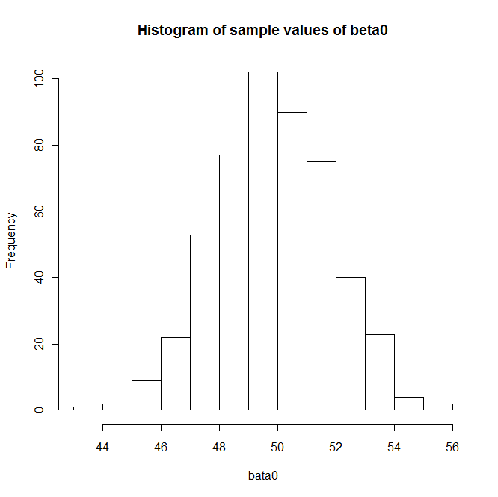

|  |  |
| --- | --- |
|  |  |

**R code to draw histograms using estimate values generated by the R code in previous page**

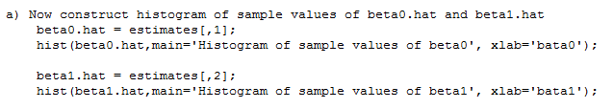

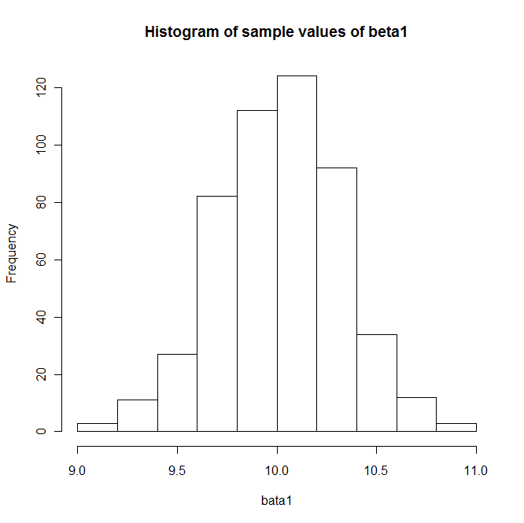

**Discuss the shape of the histograms:**

* The histogram for $β_{0}$ is centered around 50.
* The one for $β_{1}$ is centered around 10.
* These histograms are ***consistent*** with the model $y=50+10x+ ∈$

**b – Histogram of the 500 estimates of E(y | x = 5) from 500 samples**

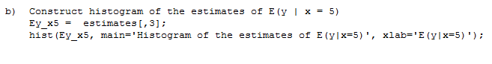

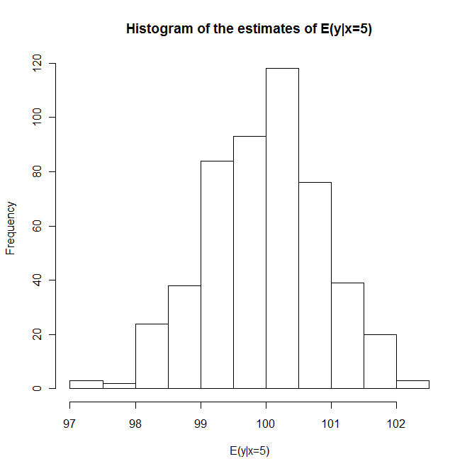

**Discuss the shape of the histogram:**

* The histogram of the estimate values of $E \left(y \right| x=5)$ is centered around 100.
* This histogram is ***consistent*** with the model $y=50+10x+ ∈$

**c – Compute 95% CI on the slope. How many intervals contain the true value of $β_{1}=10$**

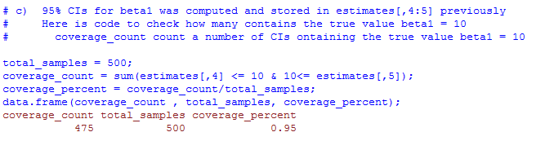

**Answer:**

* 475 confidence intervals contain the true value of $β_{1}=10$
* 475 intervals out of 500 samples are 95%. It sounds like the number is too good to be true. But it is true number computed from the R code a above

**d – Compute 95% CI on E(y | x=5).**

How many intervals contain the true value of E(y | x=5 ) = 100

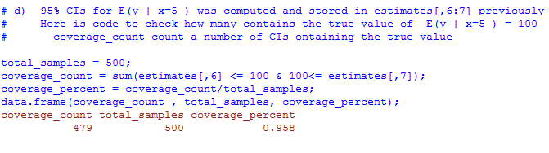

**Answer:**

* 479 intervals (95.8%) contain the true value of E(y | x=5 ) = 100
* This is ***consistent*** with the model $y=50+10x+ ∈$