MEMORANDUM
To: Shawn Janzen - CEO of Janzen Consulting Group
From: Francisco Rezzonico
Date: 26 August 2026
Subject: Univariate Summary of EV Brand and CAFV Eligibility

Since the emergence of electric cars in the automotive market, governments have designed various tax incentives to encourage the purchase of cars with a lower carbon footprint. As a result, when buying a new vehicle, consumers are increasingly weighing eligibility for these incentive programs and the associated savings. For this reason, it is of interest to compare the five of the top 5 makes to see if there are significant differences between them in this regard. Results suggest that there are, meaning that some companies may have a comparative advantage that could lead to higher sales and profits.
For this analysis, the Electric Vehicle Population dataset provided by the State of Washington has been used (State of Washington - Electric Vehicle Population Data, 2025). Since the dataset had a total of 39 vehicle makes, it was filtered to include only five selected manufacturers: Tesla, Nissan, BMW, Toyota, and Mercedes-Benz. This selection was not based on frequency, but was made to maintain a clear focus for the project. The analytic sample includes 103,032 vehicles registered to these five brands. This analysis addresses the following key questions: Do certain EV brands differ in the proportion of vehicles that qualify for Clean Alternative Fuel Vehicle (CAFV) incentives, and is there a statistically significant association between vehicle make and CAFV eligibility?
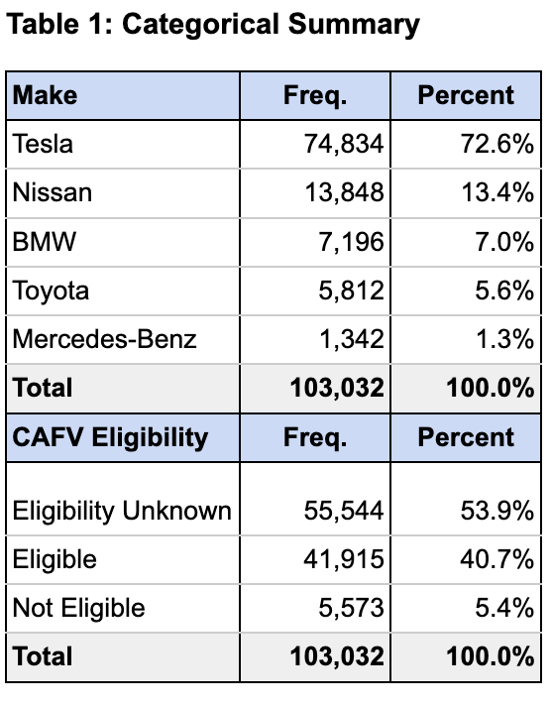
The "vehicle make" variable, which is the independent variable, tells us which company produced each EV. The options in this summary are Tesla, Nissan, BMW, Toyota, and Mercedes-Benz as reported during registration. No categories were changed or grouped together. Only these five brands were included. Table 1 shows that Tesla accounts for 72.6% of all EVs in the dataset. Nissan is the next most common at 13.4%. The other three brands make up much smaller shares. These results show the market is heavily tilted toward Tesla. The other manufacturers have much lower numbers.
CAFV eligibility (dependent variable) asks if a vehicle qualifies for special incentives. These incentives include benefits like carpool lane access or state tax breaks. Each vehicle is recorded as eligible, not eligible, or eligibility unknown. There are no missing data for this variable. More than half of the vehicles, or 53.9%, are marked as "unknown" for eligibility (Table 1). About 41% are listed as eligible and 5% as not eligible (Table 1). The large number of vehicles with "unknown" eligibility makes it hard to know who actually gets the incentives. This uncertainty is a major limitation for understanding how well the CAFV program is working.
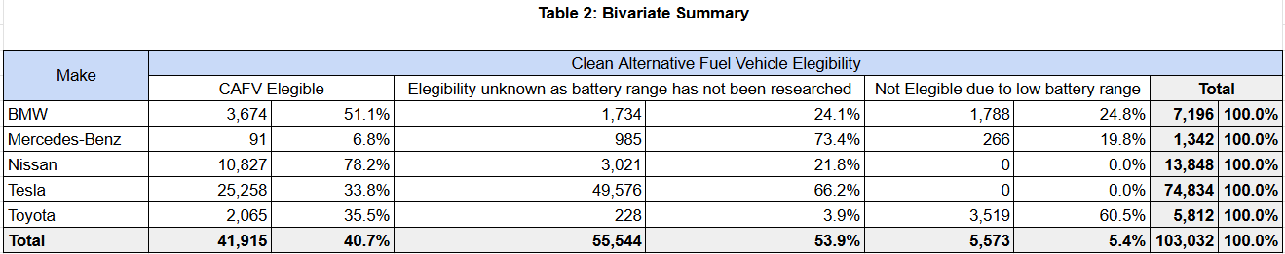
To address the questions that motivate this memorandum, a Chi-Square Independence Test has been performed on both variables. For this, given the large sample size, a significance level of 0.01 has been chosen according to the social science rule of thumb (α=0.01). The results provide enough statistically significant evidence to reject the null hypothesis, $X^{2}$(8, n = 103,032) = 58,018, p < 0.01. Therefore, the evidence indicates that there is a relationship between the car manufacturer and whether that car qualifies for special incentives. To determine the nature of such a relationship, Table 2 is presented. It shows the unstandardized effect size and suggest that, in general, vehicles produced by Nissan will be eligible for benefits and, if they do not qualify, it will be because of lack of information about their battery’s autonomy. It is noteworthy that Tesla, despite their focus and investment in electric vehicles only, is the second manufacturer with the least amount of qualifying vehicles. In a similar way, when considering the standardized effect size, the Cramer’s V value for this test is 0.53, thus suggesting a strong relationship between both variables. Finally, the power of this test is over 0.99, implying a high probability of capturing an effect when the effect is real or not obtaining it if the effect is not present. At this point, it is important to remark the imbalance existing in the frequency table, as the vehicles produced by Tesla represent almost 75% of the sample. This could lead to extreme results and, therefore, future studies should aim to subset the make variable by frequency, thus analyzing the top most popular ones.
For the high number of vehicles with "unknown" CAFV eligibility, we suggest improving manufacturer reporting and communication. Better transparency results in making informed choices and understanding potential savings. In regards to manufacturers, we recommend prioritizing meeting CAFV criteria to remain competitive and attract more buyers through incentive eligibility. For consumers, comparing CAFV eligibility across brands is important, as our findings reveal significant variation in eligibility. Ultimately, clearer reporting practices and greater alignment with CAFV standards will not only enhance consumer confidence but also ensure that incentive programs fulfill their intended purpose of accelerating the transition to cleaner transportation.
References
data.wa.gov. (2025, August 23). State of Washington - Electric Vehicle Population Data. Data.gov.
https://catalog.data.gov/dataset/electric-vehicle-population-data
Washington State Department of Licensing. (2025, September 16). Electric Vehicle Population Data: Data.WA:
State of Washington. data.wa.gov, the official Washington state open data portal. https://data.wa.gov/Transportation/Electric-Vehicle-Population-Data/f6w7-q2d2

