MEMORANDUM
To: Shawn Janzen – CEO of Janzen Consulting Group
From: Francisco Rezzonico
Date: August 28, 2026
Subject: Key factors in pricing private room rentals to tourists in Manhattan, NYC

While the tourist appeal of New York results in consistently high demand for accommodation, fierce competition in this market requires property owners (target population) to remain competitive. For that, pricing is a key factor. This paper therefore aims to analyze how property characteristics affect market price. Specifically, it is of interest to investigate whether more flexible conditions, combined with low service fees and high popularity of the accommodation, allow for higher prices to be charged. The results suggest that the only influencing factor is the fees charged and that they have a large effect on the price.
The analysis was performed on a database that collects information about property rentals in NYC (NY Property Rental Data, n.d.). It contains more than 100,000 observations and it has 85,244 NAs, some of which represent a value of 0 according to the dataset dictionary. In those cases, the necessary transformation was carried out, and in the rest, they were eliminated. Additionally, it is noteworthy that the dataset was filtered to analyze 891 observations corresponding to private rooms in five of the most popular Manhattan neighborhoods among tourists: Midtown, West Village, Nolita, SoHo, and Upper East Side.
Table 1. Quantitative Summary
 | Freq. | Min | Max | Med. | Mean | SD | Skewness
Price | 891 | 51 | 1,198 | 577 | 592.1 | 324.04 | 0.17
Service Fee | 891 | 0 | 240 | 115 | 118.1 | 65.02 | 0.17
Reviews | 891 | 1 | 389 | 9 | 27.41 | 40.78 | 2.73
Min. Nights | 891 | 0 | 6 | 2 | 2.21 | 1.28 | 0.87
The dependent variable, price, measures the daily rental price of the room in US dollars, assuming real values between 51 and 1,198. It should be noted that no transformation was performed on this variable. Furthermore, when analyzing its histogram, it’s interesting to note that its distribution has no obvious peak. On the contrary, excluding the range from $0 to $100, it shows a relatively equal frequency (around 90 observations) for each of the price ranges.
Table 2. Categorical Summary
 | Freq. | Percent
Cancellation Policy
Flexible | 312 | 35.01%
Moderate | 282 | 31.65%
Strict | 297 | 33.33%
Total | 891 | 100.00%
As for the independent variables, the first is the service fee. This variable did not undergo any transformation and measures the service fee (in US dollars) charged for each stay at the property, adopting real values between 0 and 240. When graphing this variable against price, the positive linear relationship observed is of interest. This indicates that as the price increases, the fee also increases, suggesting that it could be standard practice in the industry to charge a fixed percentage of the total value of the stay. Secondly, the number of reviews indicates how many reviews a listing has, measured in positive integers. Its distribution exhibits significant positive
skewness, reflecting the presence of a few properties with a considerably higher number of reviews than the others. It is also striking that in such a touristy area with high demand for accommodation, 75% of properties have only 35 reviews or less. The third independent variable, minimum nights, measures the minimum stay required when booking a room. Although no transformation was performed on this variable, it was decided to exclude outliers as there were many and they were far away from the third quartile. Thus, it takes integer values between 0 and 8. Its histogram shows that a large proportion of properties require a minimum of only one night (industry standard), although approximately 23% and 22% require 2 and 3 nights, respectively. Finally, cancellation policy provides a measure of how stringent the cancellation conditions for a reservation at the property are. The only transformation performed on this variable is the conversion of NAs into a new level for the variable (no set policy). However, none of the observations analyzed here adopt that level. Thus, the possible values are flexible, moderate, and strict. It is worth noting that there is no dominant cancellation policy, even when analyzing policies by neighborhood. The only exception is for properties on the Upper East Side, where flexible policies predominate over the rest.
To study the effect of predictors on the daily price of accommodation, the following multiple linear regression model is estimated:

Price = 9.879 + 4.953 * Service Fee – 0.023 * Reviews – 1.286 * Cancellation Pol. (Strict) – 2.840 * Cancellation Pol. (Moderate) – 0.329 * Minimum Nights + ε

It is important to note that the reference group chosen for the cancellation policy is the dummy variable corresponding to a flexible policy, given that it is of interest to analyze whether stricter (and generally more profitable) conditions negatively affect the room price. In addition, an alpha equal to 0.05 is used to analyze the statistical significance of the coefficients and the model in general.
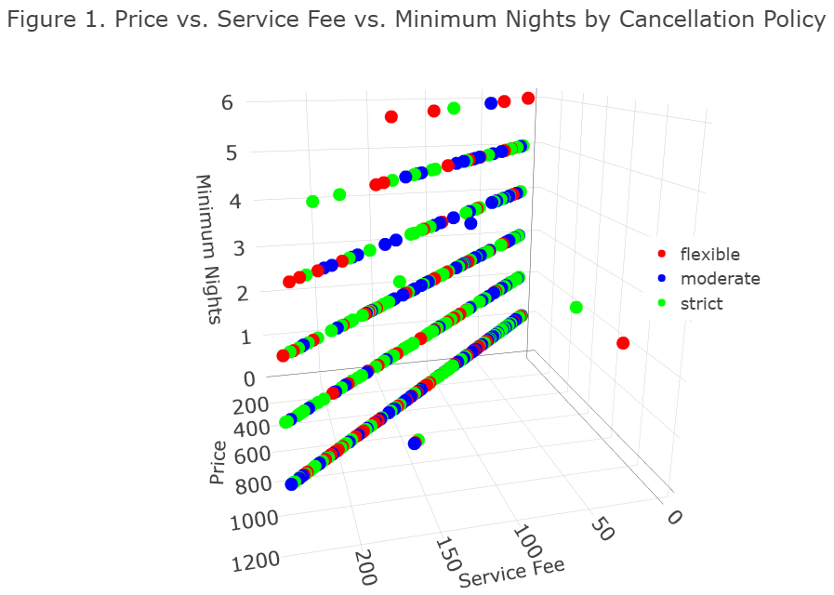
Before analyzing the results, it is important to note that three of the OLS assumptions are not met. First, the Q-Q Residuals graph shows that the standardized residuals for the different theoretical quantiles are clustered around a horizontal line at zero, thus suggesting that the assumption of normally distributed errors is violated. Secondly, as can be seen in the Residuals vs. Leverage graph, there is one observation with a corresponding Cook's distance greater than 0.5 and another data point that approaches that value. Thus, the assumption of no influential outliers is not met. However, given the sample size and the fact that there are only two observations, this problem could be solved by excluding these observations from the analysis. Finally, although inspection of the diagnostic plots does not allow definitive conclusions to be drawn regarding the fulfillment of the assumption of homoscedasticity, the results of the Breusch-Pagan test provide sufficient statistical evidence to suggest the presence of heteroscedasticity in the errors. The results show that the entire model is statistically significant (F(5, 885) = 14,823,86, p<0.05), implying that the model performs better than average and making it suitable for generalizing the results to the entire population. Regarding the adjusted $R^{2}$, it adopts a value of 0.988, which implies that roughly 99% of the variability in the number of reviews is explained by the minimum number of nights. Additionally, the $f^{2}$ statistic is 82.33, indicating a large effect, and the power is over 0.99, suggesting that over 99% of times the null hypothesis will be correctly rejected.
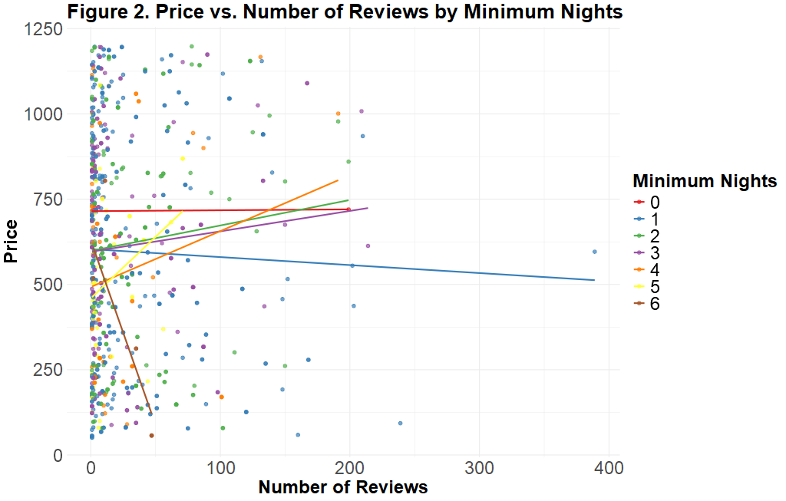
As for the regression coefficients, the one corresponding to the service fee variable suggests that, holding everything else constant, a $1 increase in the fee leads to an average increase of almost $5 in the price of accommodation. This coefficient is not only statistically significant, but also meaningful given its large impact on the dependent variable. The coefficient for the number of reviews (neither statistically nor substantively significant) indicates that, all else being equal, for every 100 additional reviews, the price decreases by an average of just over $2. As for the coefficients for the dummy variables for cancellation policies, none are statistically significant or meaningful given the small effect on the dependent variable. Specifically, all else being equal, for accommodation with a strict (moderate) policy, the price is, on average, $1.3 ($2.8) lower than for those with flexible cancellation. Finally, the coefficient for the minimum number of nights (not statistically or substantively significant) implies that, all else equal, each additional night required to book a room decreases the price by an average of $0.3.
Overall, the results obtained don’t support the initial hypothesis. In specific, while keeping the service fees as lower as possible allows to set a price considerably lower and, therefore, more competitive, it is not true that more flexible conditions and a high popularity (measured in number of reviews) leads to an increase of the accommodation’s price. Therefore, a successful pricing strategy would imply keeping service fees to the lowest level possible, having a strict cancellation policy (allowing to improve rentability), setting a minimum of nights according to operational factors and neglecting any strategy to obtain more reviews. However, these results should be interpreted with caution given the violation of certain key assumptions that should be addressed in further studies by, for example, excluding outliers, choosing a different set of variables and including interaction terms.

Table 3. Regression Table
 | Dependent variable:
 | Price
Service Fee | 4.953*** (0.018)
Number of Reviews | -0.023 (0.029)
Cancellation Policy (Strict) | -1.286 (2.868)
Cancellation Policy (Moderate) | -2.840 (2.913)
Minimum Nights | -0.329 (0.934)
Constant | 9.879*** (3.784)
Observations | 891
R² | 0.988
Adjusted R² | 0.988
Residual Std. Error | 35.297 (df = 885)
F Statistic | 14,823.860*** (df = 5; 885)
Note: | *p<0.1; **p<0.05; ***p<0.01

