MEMORANDUM
TO: Marco Efraín Masís Fernández - CEO and Senior Producer at Tainy Records.
FROM: Francisco Rezzonico – Sr. Consultant at Janzen Consulting Group.
DATE: 08/25/2026
SUBJECT: Strategic analysis of the music market.

In a dynamic economy such as today's, diversification is important to protect companies' investments. Thus, given Tainy Records’ current focus on Latin American music, this memorandum aims to explore other investment opportunities. To this end, a database extracted from Spotify is used, this choice finding justification in the fact that it has been prepared for research purposes and that it contains variables that capture the most important features of songs.
Preliminary results reveal three main conclusions. First, a song is more likely to be popular if it belongs to the pop genre. Second, artists who have released five or more songs in the past are more likely to have a successful new song. Finally, new songs should be between 2:55 and 3:20 minutes long, and spoken words should not predominate in the song.
Table 1. Categorical Summary
 | Freq. | Percent
Genre
Dance | 2,692 | 29.18%
Hip-Hop | 2,910 | 31.54%
House | 452 | 4.90%
Indie-Pop | 2,042 | 22.13%
Pop | 1,131 | 12.26%
Total | 9,227 | 100%
Popularity
Popular | 2,325 | 25.20%
Not popular | 6,902 | 74.80%
Total | 9,227 | 100%
Artists
More songs than average | 6,792 | 73.61%
Less songs than average | 2,435 | 26.39%
Total | 9,227 | 100%
Table 2. Quantitative Summary
 | Freq | Min | Max | Median | Mean | Std. Dev. | Skewness
Duration | 9,227 | 33.16 | 786.55 | 183.79 | 188.46 | 49.26 | 1.27
Speechiness | 9,227 | 0 | 0.96 | 0.07 | 0.12 | 0.12 | 1.65
The above conclusions were obtained through statistical analysis of the “Spotify 1 Million Tracks” dataset, which was filtered by: 1) year, to include only songs released between 2020 and 2023; and 2) genre, including songs belonging to some of the five most popular ones. This yielded 9,227 observations, with no NA present. On the other hand, five variables were chosen. The first one is genre, which classifies songs into: dance, hip-hop, house, indie-pop, and pop. Interestingly, despite being one of the most popular genres, house songs make up less than 5% of the observations. The duration variable was recoded to measure the duration of the audio in seconds instead of milliseconds, thus assuming positive integer values. Although the histogram appears to show an approximately normal distribution, the data has a high positive skewness. The third variable, popularity, measures how successful the song is among listeners. Originally, this variable was a score that took integer values between 0 and 100, with higher numbers indicating greater popularity. However, it was transformed into a factor that groups songs that are in the top 25% of the data in the “Popular” category and the rest in “Not popular.” On the other hand, speechiness tracks the presence of spoken words in songs. It is a variable that assumes real values between 0 and 1. In addition, its distribution is negatively skewed, with values less than 0.2 exhibiting the highest frequency. Finally, the artists variable initially contained the singer of each song. However, it was recoded to obtain a factor that groups singers according to how their number of songs compares to the average number of songs per artist. Its values can be “Artist with fewer songs than average” or “Artist with more songs than average,” with the first group being significantly dominant.
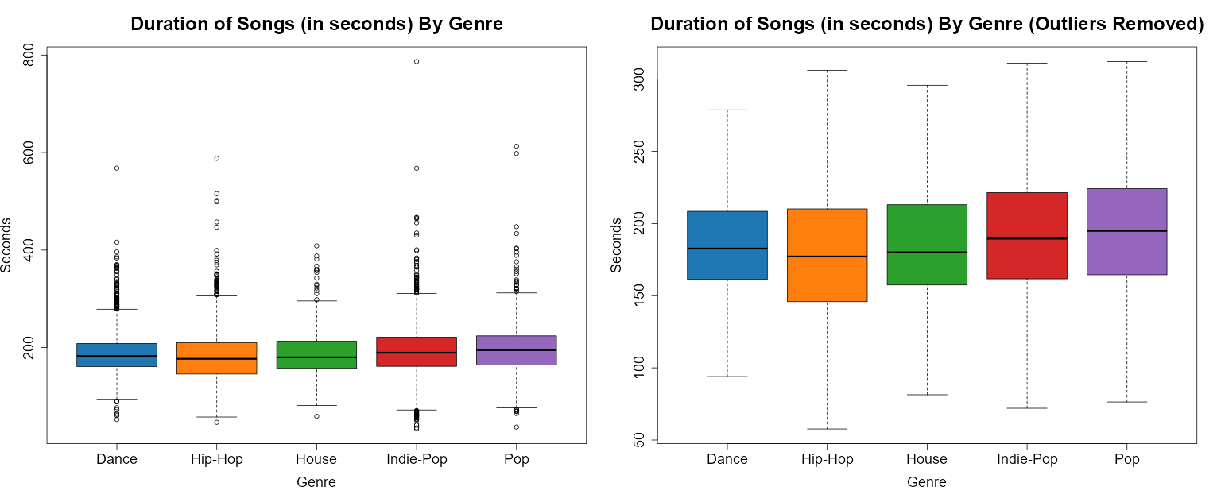
The next step in understanding business opportunities in the music industry is to explore the relationships between variables. In this regard, analysis of the duration of songs grouped by genre shows a large presence of extreme values in all genres, thus evidencing high volatility. When the effect of outliers is isolated, the median duration is similar between songs of different genres and is between 175 and 200 seconds. This suggests a tendency to produce relatively short songs that require less production time and are less expensive.
Table 3. Bivariate Speechiness Summary by Genre
 | Freq | Min | Max | Med. | Mean | Std. Dev. | Skewness
Dance | 2,692 | 0.02 | 0.55 | 0.06 | 0.09 | 0.08 | 2.28
Hip-Hop | 2,910 | 0.00 | 0.96 | 0.21 | 0.22 | 0.14 | 0.64
House | 452 | 0.03 | 0.44 | 0.05 | 0.08 | 0.08 | 2.54
Indie-Pop | 2,042 | 0.02 | 0.90 | 0.04 | 0.07 | 0.08 | 4.12
Pop | 1,131 | 0.02 | 0.61 | 0.05 | 0.08 | 0.08 | 2.55
When analyzing speechiness broken down by musical genre, there are significant differences between hip-hop and the other four genres. In this regard, hip-hop shows a significantly higher median, which is in line with the characteristics of this genre, including the heavy reliance on rap in this type of songs. Furthermore, it is the genre that shows the lowest skewness and, therefore, evidence that, despite the large dispersion of the data, its distribution is symmetrical. In contrast, the other genres show a lower proportion of spoken words and, therefore, a greater relative importance of instrumentals.
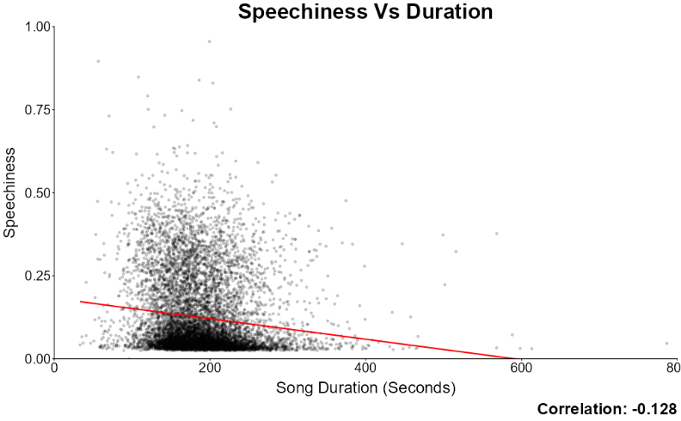
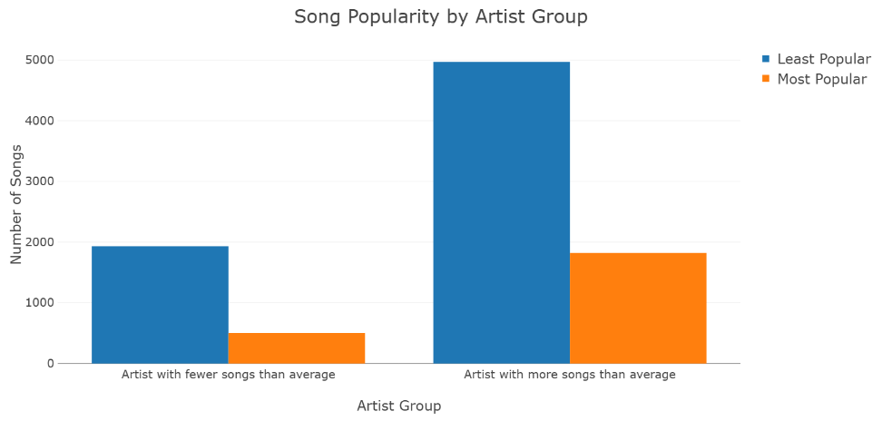
When it comes to popularity, it is interesting to analyze how it is affected by the number of songs an artist has. In particular, singers who have released more songs than average are more likely to have their next song to become popular as well. This suggests that achieving success requires specific industry knowledge that can only be gained through experience and that, once an artist is popular, their listener base will continue to listen to their new songs. Furthermore, it should be noted that the data shows a tendency for artists not to be discouraged by the fact that they are not popular, thus continuing to release songs.
When we analyze the correlation between duration and speechiness there was a weak negative correlation (-0.1284), indicating that as the duration of a track increases, the presence of spoken-word elements tends to decrease. This inverse relationship is further substantiated by the linear regression model, which visually demonstrates a slight downward trend, consistent with the observed correlation coefficient.
Analyzing the categorical variable popularity in relation to duration, we observed that the mean duration of tracks is relatively consistent across popularity levels, with only a marginal difference of approximately 2 points between popular and non-popular songs. However, the distributional characteristics differ notably: popular tracks exhibit a narrower range between minimum and maximum durations, suggesting greater uniformity. In contrast, non-popular tracks display more extreme values, indicating higher variability. This pattern is clearly illustrated in the box plot which highlights the tighter interquartile range and fewer outliers among popular songs.
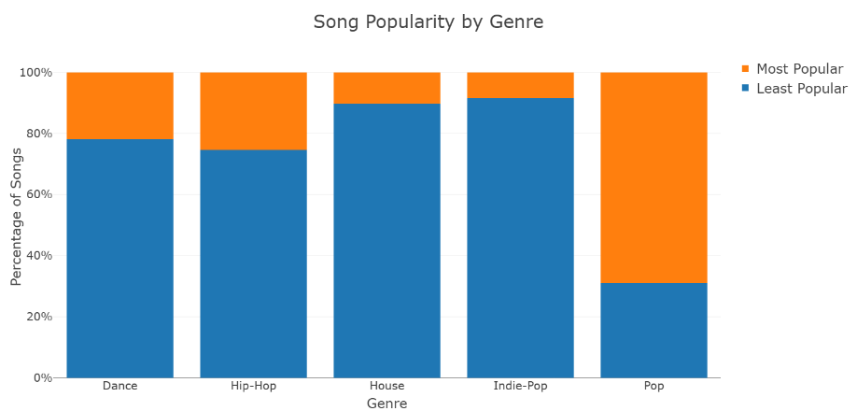
The categorical analysis of genre and popularity revealed noteworthy insights. While dance and hip-hop emerged as the most frequently represented genres in the dataset, just approximately 20% and 25% of tracks within these genres were classified as highly popular. In contrast, pop demonstrated a significantly higher success for our project because of its lower representation and although fewer pop tracks were produced during the analyzed period giving us a good insight , nearly 75% of them achieved top popularity status. This suggests that pop may represent a strategic opportunity for producers such as Tainy, given its high performance relative to output volume.
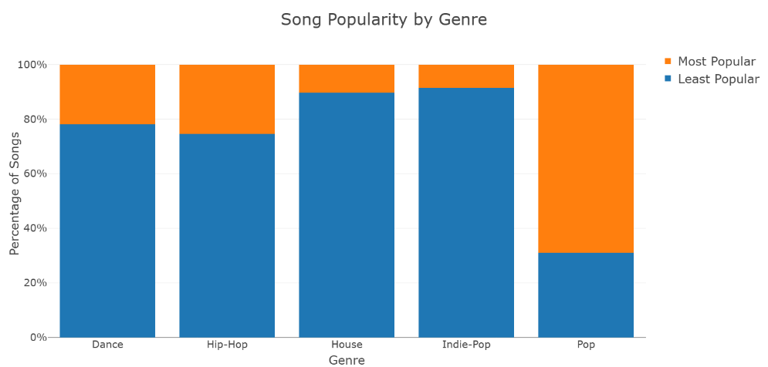
After some analysis of the different variables, we have seen that speechiness, genre and popularity were those ones that give us the better insights in these projects. A great evidence over the genre hip-hop comes with this analysis which is the genre that has the highest volume of tracks on Spotify dataset. In non popular and in popular categories this genre shows a high average of speechiness compared with other categories. But also, something interesting, within hip-hop, less speech-heavy tracks appear more frequently among the top-popular group, suggesting that reduced spoken-word content may be associated with higher popularity potential. The boxplot visualized this observation, revealing that speechiness is more strongly influenced by genre than popularity. While the difference in speechiness between popular and non-popular modes overall, genre, particularly hip-hop highlight meaningful variation.
Overall, this analysis based on Spotify data highlights several key strategic opportunities for Tainy Records. In particular, the pop genre stands out for its high potential given its lower saturation (i.e., there are few songs in the platform) and its high likeliness of becoming popular. At the same time, investing in producing hip-hop songs is discouraged due to its high costs associated with a longer producing time product of the high presence of spoken words. Finally, the analysis suggests that songs’ duration should be around 3 minutes and that artists with higher number of songs should be preferred for future contracts. We believe these recommendations will help the company to focus on strategies that will maximize revenues and strengthen its competitive edge.

