1. Nick, a resident of Ann Arbor, is allocating spending between food and housing. Given his preferences, income, and the current prices, Nick is consuming 30 units of housing and 40 units of food. Assume that Nick cannot leave Ann Arbor. The city of Ann Arbor is considering two policies to raise tax revenue:

Policy 1 would collect $300 from each resident (a flat tax).

Policy 2 would collect $10 for each unit of housing purchased (a property tax).

1. Is the following statement true or false? “The two policies will have the same effect on Nick’s consumption choices.” Explain your answer.
2. Is the following statement true or false? “The two policies will collect the same amount of tax revenue from Nick.” Explain your answer.
3. Suppose that Emily is deciding how to allocate her weekly food budget between two different types of food: processed food (P) bought at the store and fresh food (F) bought at a farmer’s market. Both are normal goods. Initially the price of processed food is PP = $2 and the price of fresh food is PF = $4. Emily has a fixed weekly food budget of $100.
   1. On the graph below, draw her food budget constraint, labeling the intercepts, any kink points (if applicable), and slopes. Put processed food on the vertical axis and fresh food on the horizontal axis. Label this BC0.

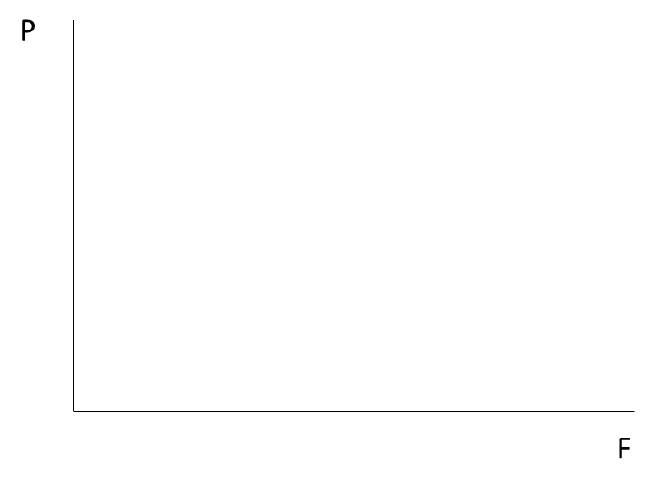

In order to get people to consume more fresh and local food, many cities, states, and non-profits have introduced fresh-food incentive programs. [1]

Michigan has a program that provides a matching subsidy for every dollar spent on fresh food, up to $20. This program has the effect of reducing the price of first 10 units of fresh food purchased by individuals from $4 to $2. Any fresh food purchased beyond these first 10 units must be purchased at the original price of $4.

* 1. Draw the new budget constraint on the graph below, labeling all intercepts, any kink points (if applicable), and slopes. Label this BCMI.



New York City has a program that provides a subsidy for every dollar spent on fresh food without any limit. This program has the effect of reducing the price of fresh food purchased by individuals from $4 to $3.

* 1. Draw the new budget constraint on the graph above (same as for part c), labeling all intercepts, any kink points (if applicable), and slopes. Label this BCNY.
  2. Suppose Emily is already spending all of her money on fresh food without any special program. Which program – Michigan or New York’s – is likely to have the biggest impact on her consumption of fresh food? Draw indifference curves to explain your answer.

1. A person is allocating spending between two goods: housing (a normal good) and ramen noodles (an inferior good). What is the effect of a decrease in the price of housing? Circle all that apply. [No explanation needed]
   1. Consumption of housing will definitely increase
   2. Consumption of housing will definitely decrease
   3. Consumption of housing may increase or decrease
   4. Consumption of ramen noodles will definitely increase
   5. Consumption of ramen noodles will definitely decrease
   6. Consumption of ramen noodles may increase or decrease
2. True or False. “If consumers are choosing between two normal goods, then if the price of both goods doubles, the substitution effect will cause consumption of the less expensive good to increase.” Briefly explain your answer.
3. Suppose that the state of Michigan is deciding how to allocate its spending between two “goods”: health care (H) and education (E). Both are normal goods. Initially the price of health care is PH = $3 and the price of education is PE = $2. Michigan has a total income of $1600 (from tax revenue).
   1. On the graph below, draw the budget constraint, labeling the intercepts, any kink points (if applicable), and slopes. Put health care on the vertical axis and education on the horizontal axis. Label this BC0.

* 1. Now suppose that the price of health care increases to PH = $4. Draw the new budget constraint on the graph below, labeling all intercepts, any kink points (if applicable), and slopes. Label this BC1.

To alleviate the hardship on states of rising health care costs, suppose the Federal government introduced a program through which it provided a matching grant to states for spending on education. This program had the effect of reducing the price of the first 400 units of education purchased by states from $2 to $1. Beyond 400 units there is no federal grant and the price remains at $2. You should assume that all states have an income of 1600 and face this same budget constraint.

* 1. Draw the new budget constrain on the graph below, labeling all intercepts, any kink points (if applicable), and slopes. Label this BC2.

* 1. If a state was spending most of its income on education before the federal matching grant program (when facing BC1 from part c, when PH = $4 and PE = $2), is it likely to increase or decrease its spending on health when the federal grant program is introduced? Explain.

1. **Consumer Choice.** Suppose that the Ford School is deciding how to allocate its spending between two extracurricular things: student clubs (C) and public lectures (L). Both are normal goods. Initially the price of one club is Pc = $100 and the price of one lecture is PL = $200. An anonymous donor has given The Ford School $6000 to spend on these two activities.
   1. On BOTH graphs below (this page and next page), draw the budget constraint, labeling the intercepts, any kink points (if applicable), and slopes. Put student clubs on the horizontal axis and lectures on the vertical axis. Label this BC0.

L

C

To foster student community-building, the Provost’s office is considering two different policies:

Policy A: Provide all units on campus with $300 that can only be spent on student clubs.

Policy B: Provide units on campus with 1-to1 matching funds. That is, for each dollar a unit spends on student clubs, the Provost’s office will provide the unit with one additional dollar that can be spent on clubs or lectures.

* 1. Draw the new budget constraint for Policy A on the graph below, labeling all intercepts, any kink points (if applicable), and slopes. Label this BCA.

L

C

* 1. Draw the new budget constraint for Policy B on the graph above, labeling all intercepts, any kink points (if applicable), and slopes. Label this BCB.
  2. Explain why Policy A might not cause the Ford School to increase the number of clubs by 3 (i.e. the full amount of the subsidy).
  3. If the Ford School was initially spending almost its entire budget on student clubs, which policy would likely increase the number of Ford School clubs the most?

1. The programs described below are loosely based on http://www.doubleupfoodbucks.org/ (Michigan) and http://www.nyc.gov/html/doh/html/cdp/cdp_pan_health_bucks.shtml (New York).