Optimization in Economic Theory:
Lagrange’s Method
Jack King

Exercise 2.1: The Cobbs-Douglas Utility Function

Consider the consumer’s problem with utility function 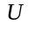 defined by the following function

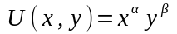
Find a way for showing that the given utility function yields the constant-budget-shared demand functions defined by:
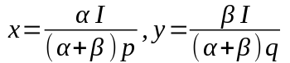
The budget constraint is
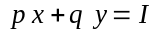

We begin by constructing the Lagrangian 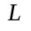 using the utility function and the constraint

And now proceed with the partial derivatives, that involve implicit derivation, and optimize the results:
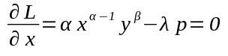

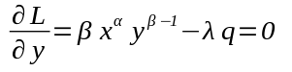

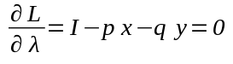

If we clear for 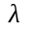 in the two first partial derivatives we have:

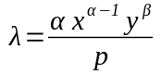

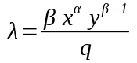

So we can find a relationship between  and 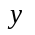 doing some Algebra, as shown:

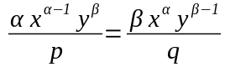

Therefore, multiplying both sides by 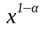

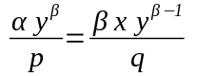

and now, multiplying both sides by 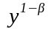

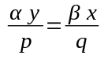

From there we find and relationships:

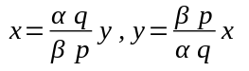

Now lets substitute these, one at the time, in the respective Lagrange multiplier partial derivative as follows:
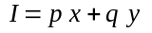
Lets begin with :
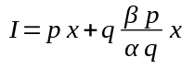

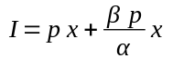

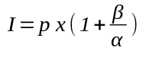

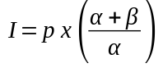

So we lastly solve for :

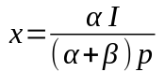

Now we follow the same process for :

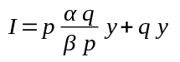

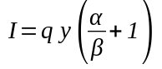

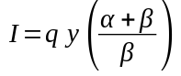

Solving for , we have:
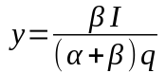

So we proved that the Utility function yields the constant-budget-shared demand functions.

Lastly, we find the lagrange multiplier, lets use a previously obtained result, from the Lagrangian partial derivatives:

There we substitute the results obtained for and , $\ref{x}$ and $\ref{y}$ respectively, and so we have:

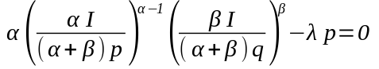

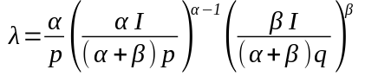

And finally:

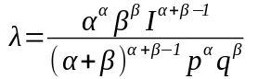

which give us an expression of the Lagrange multiplier in terms of the utility function and budget constraint parameters.

Exercise 2.2: The Linear Expenditure System

Let the utility function be defined as:

where 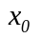, 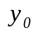 are given constants, and
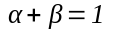
The budget constraint is

Show that the optimal expenditures on the two goods are linear functions of income and prices.
The utility function brings with it a rich range of possible optimum choice. The budget shares of the two goods can now vary systematically with income and prices. One good can be a necessity and the other a luxury (but neither good can be inferior since 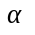 and 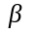 must be positive). But the expenditures still have a simple functional form. For these reasons, this specification was popular in the early empirical work on consumer demand.

Lets build the Langrangian:

And now calculate the partial derivatives, the optimal points that is:

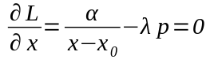

So we solve for x:
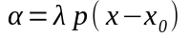
therefore:
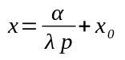

Optimum for :
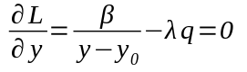

We now solve for y:
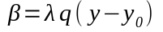
therefore:
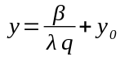

Optimum for :
Lets substitute the found expressions of and in the last equation:

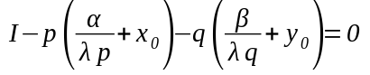

and do simplify:
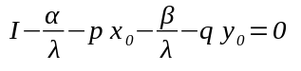

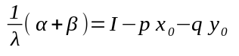

Hence, due to restriction given above:
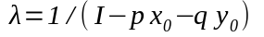

We now proceed to find two expressions for in terms of and and find the value of them in terms of the parameters.
From the partial derivative of the Lagrangian with respect to we can easily see that

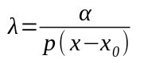

we can equal this equation with the optimization partial derivative result for lambda:

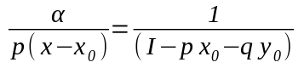

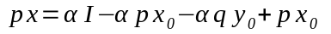
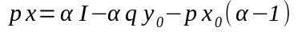

Remember the restriction of alpha and beta constants summing up to one, so we have:
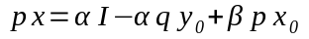
From the partial derivative of the Lagrangian with respect to we follow the same procedure as we did with :
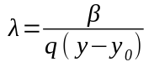

we can equal this equation with lambda optimization result:

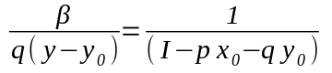

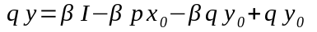
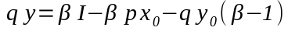

Remember the restriction about alpha and beta constants summing up to one, so we have:

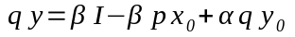
So we now have both Optimal expenditures for and that show a linear dependency on the initial parameters of both, the utility function and budget constraint as well.

Excercise 3.1: Rationing

Suppose a consumer has the utility function

where 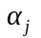 are positive constants summing to one. The budget constraint is

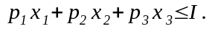
In addition, the consumer faces a rationing constraint: he is not allowed to buy more that 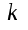 units of good 1.

Solve the optimization problem. Under what condition on the various parameters is the rationing constraint binding?

We do construct the Lagrangian function as follows

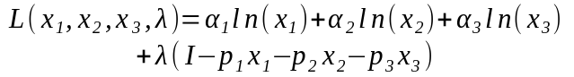

We do assume that the quantities of goods variables 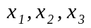 are non negative which “binds” the expressions of the partial derivatives to be exact equations, and not unequalities as the Kuhn-Tucker Theorem would render necesary, by the term binding, we refer to the fact that when a single inequality, say 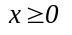, is binding if it holds as an equation. That is, according to Kuhn-Tucker theorem, for the optimization of Lagrangian we must have:

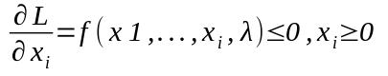

Therefore, as we have all quantities of goods non-negative, then 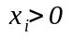 holds for each good variable which in turn allows the optimization of the goods variables to be binding, rendering an equation, in other words, we do have:

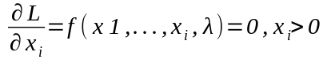

With this theoretical considerations in mind, now let’s proceed to calculate the optimization conditions for each variable and the Lagrange multiplier as well, considering the goods variables binding for the optimization expressions:

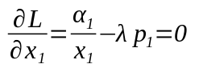

from this result we can express 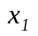 as a function of

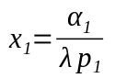

we do the same process for the variables 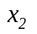 and 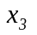, this is for :

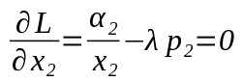

from this result we can express as a function of

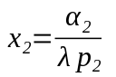
and now for

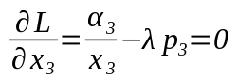

from this result we can express as a function of

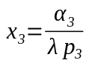

Now we have all goods variables expressed as functions of the Lagrange multiplier.

Let’s apply the optimization method for the Lagrange multiplier in our Lagrangian function, taking into account the Kuhn-Tucker Theorem, that states that, the partial derivative of the Lagrangian function with respect to a lagrangian multiplier, must be related to the multiplier itself by “complementary slackness”, by this we mean that because of our inequality constraint, the optimization of the lagrangian multiplier is given by the expression:

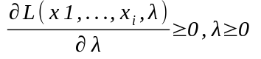

as given by the Kuhn-Tucker Theorem and the complementary slackness imply that if the two inequalities just given cannot be strict simultaneously, then that pair of inequalities show complementary slackness.
Which in our exercise renders this expression:
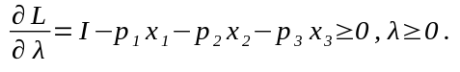

The optimization of the lagrange multiplier just given, can be expressed in terms of the goods variables if we use the optimization expressions found above, let’s substitute those findings in the last expression:

can be expressed as:

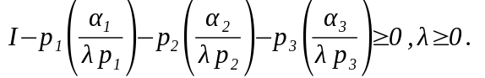

This provides us with two possibilities or two cases to analyze, either is equal to zero, or greater than zero. Let’s analyze those cases.

Case: 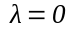

If we have , then that would imply, that our goods variables would be undefined, and that makes no sense, that is:

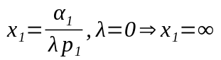

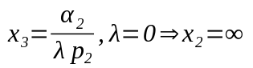

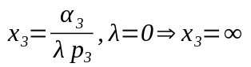

Therefore, , is not a valid case.

Case: 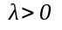

If , then by the coupled expressions complementary slackness,

we have binding for the Income and can be expressed as an equation, not only as an inequality, so we have:

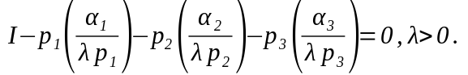

Let’s work out the Income expression:

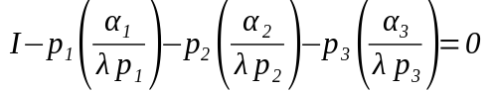

we can easily that we can simplify:

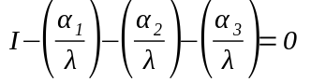

yet another step:
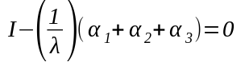

and lastly we can solve for the langrangian multiplier:

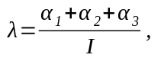
plug in the given condition:

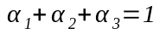

So we have a final expression for the lagrangian multiplier in terms of the income:

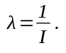

As , the last expression implies that the Income, 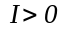 as well.
We are now in a position where we can solve the optimization problem for the all goods variables as well, lets plug the found expression of the lagrangian multiplier, into the goods variables expressions found when optimizing the Lagrangian function.

For the variable good we have:

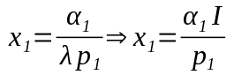

From this last expression, if we take into account that both 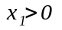 and , we hence can infer that we only have two options for 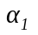 and 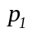, either they are both positive, or both negative, and none of them can be zero. Keep those implications in mind, as they might be solved by the practical economical terms of the problem statement. As the problem statement clearly says, the constant are positive, therefore, both and have to be positive.

For the variable good we have:

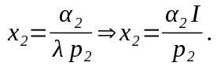

And finally, for the variable good we have:

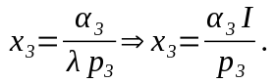

So we have solved the optimization of the Utility function and comply with the budget inequality constraint. We also found some restrictions on variables, lagrangian multiplier and parameters, let’s summarize them:
Constant parameters given by the exercise information

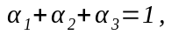
All alpha coefficients are positive constants.

We began with the assumption that the quantities of goods variables

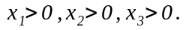
But now we have the necessary information to prove that the assumption is correct, given the fact that complimentary slackness of the lagrange multiplier and the optimization result in terms of lambda and feasibility of Case and goods variables optimization solution:

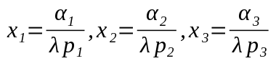
-
altogether show that
keeping in mind that:
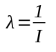

we also found that the budget constraints coefficients are positive

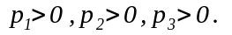

as the result of the lagrangian optimization.

And for the exact same reasons the budget constraint now holds a binding:

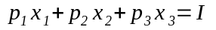
Let’s do question ourselves about the budget constraint expression coefficients. The exercise provided rationing constraint tells us that the the customer is not allowed to buy more than k units of good , that is:
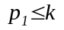
when this inequality binds we have 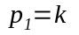, and therefore the expression for the good variable Lagrange optimization becomes:

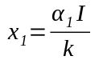

So now we can express the budget constraint, now a binding, as follows:

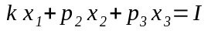

And keep in mind the lagrangian optimization goods variables equations, solved for :

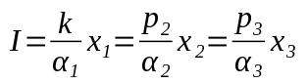

Let’s express the budget constraint binding as a function of one of the goods variables, picking for example, so let’s express in terms of from the binding constraint:

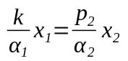

hence
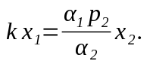

Now let’s express in terms of , taking their relationship from the lagrangian optimization goods variables equations
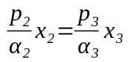
therefore
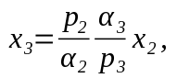

consider the lagrangian optimization for :

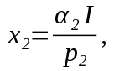

and let’s substitute these expressions for in the budget constraint as a binding as follows:

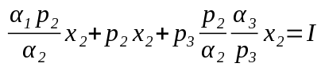

now let’s use optimization expression and substitute:

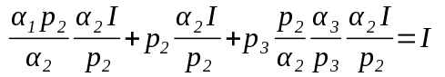

and simplify that expression

this expression verifies the given condition of the exercise.

