Music Traveler :Structured Web App Development

1. Requirements definition
- Scope
Project Name: Music Traveler
Purpose: Improve my development and project management as an exercise. The side project also is been made to test my capacities and add it to my portfolio to demonstrate my abilities.
Overview: This web application is intended for discovering new music through genres and artists the user likes. It is a web app that uses online services for showing the information and searching for new info in a well structured and appealing for the user.
The info is structured by directions in Google Maps, and the info will be fetched and updated from Freebase, Wikipedia and other free open databases with especial music related info. For playing the actual songs it will use Youtube , Myspace and Goear.
The app will encourage to find new music similar to you’re already provided music tastes.
It will show the songs like a travel to another marker selected, it will also show the musicians around the world that produce the same kind of music .
All the info will be taken from external free online services, it will only centralize an manage the info.
- Requirements
Overview: The application will be completely Javascript , Jquery,Css ,Html5 Based.
Application Language Scripting : Javascript
JS Framework: Jquery , Google Maps Api , Google Maps Libraries.
Hosting : Starting with a free host. Later buy domain.
Sever SideScripting: PHP
Server Database: Mysql
Version Control: GitHub
Design & Mockup: Creately & MockFlow
Money: Side Project
Time: 20 hrs
2. Design
- Design: Application Map
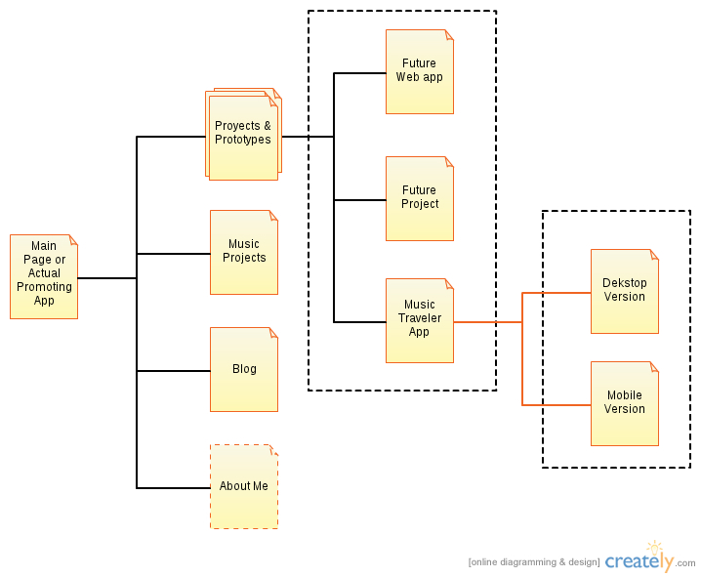
- Design: Database
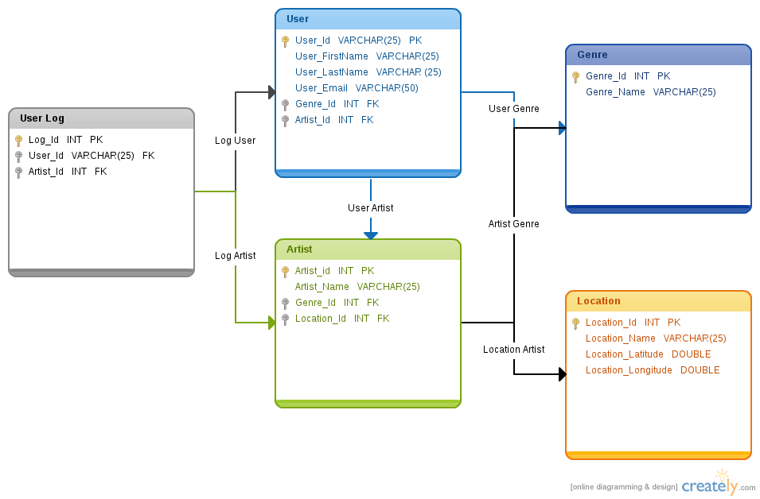

- Design: Page Structure
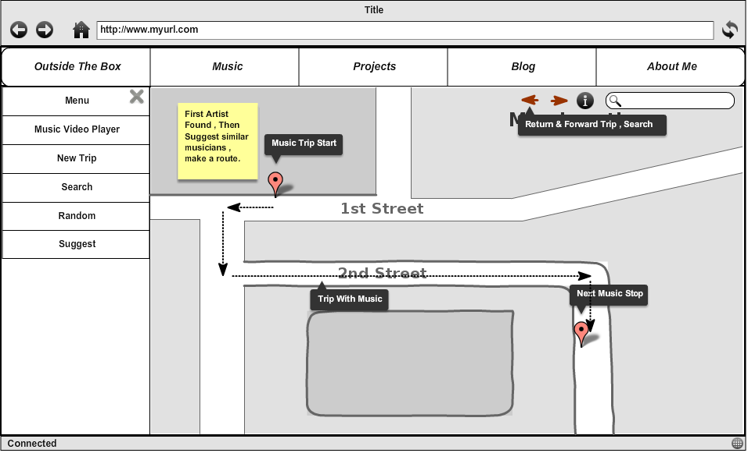

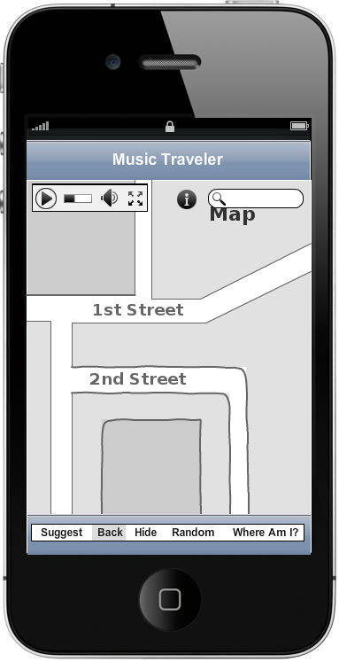
- Design: Server-side Language :Pending
- Design: Client-Side Language
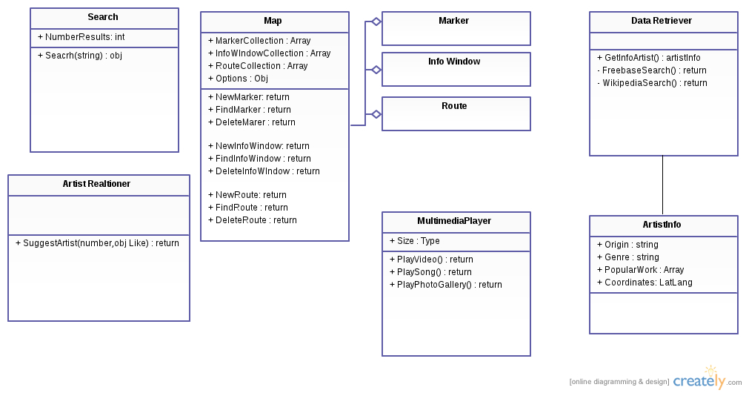
- Design: JS Framework
JQuery
Jquery Mobile
Google Maps API V3: Added Libraries
3. Implementation
- Implementation: Database
- Implementation: HTML
- Implementation: CSS
- Implementation: Server-side language
- Implementation: JavaScript
4. Test

5. Release

Referencias:
http://es.scribd.com/doc/10042348/The-Woork-Papers-N1-Structured-process-you-must-know-to-develop-a-web-application?olddoc=1

