**Deep Time-Series Analysis:**

**Features**

**Uma imagem com texto, captura de ecrã, Tipo de letra, número

Os conteúdos gerados por IA poderão estar incorretos.**

***Trend Analysis***

* **Old: stl_features (trend_strenght)**
* **New: trend_strength (Trend Strength)**

**Source:** tsfeatures

**Description:** Computes the strength of trend in a time series

**Uma imagem com texto, file, captura de ecrã, Tipo de letra

Os conteúdos gerados por IA poderão estar incorretos.Formula:**

* **Old: crossing_points**
* **New: median_crosses (Median Crosses)**

**Source:** tsfeatures

**Description:** Computes the number of times a time series crossed the median line

**Formula:**

1. Compute the median line
2. Return the number of times the series values cross the median line

* **Old: Pelt**
* **New: trend_changes (Trend Changes)**

**Source:** ruptures

**Description:** Detection of trend changing points: Linearly penalized segmentation

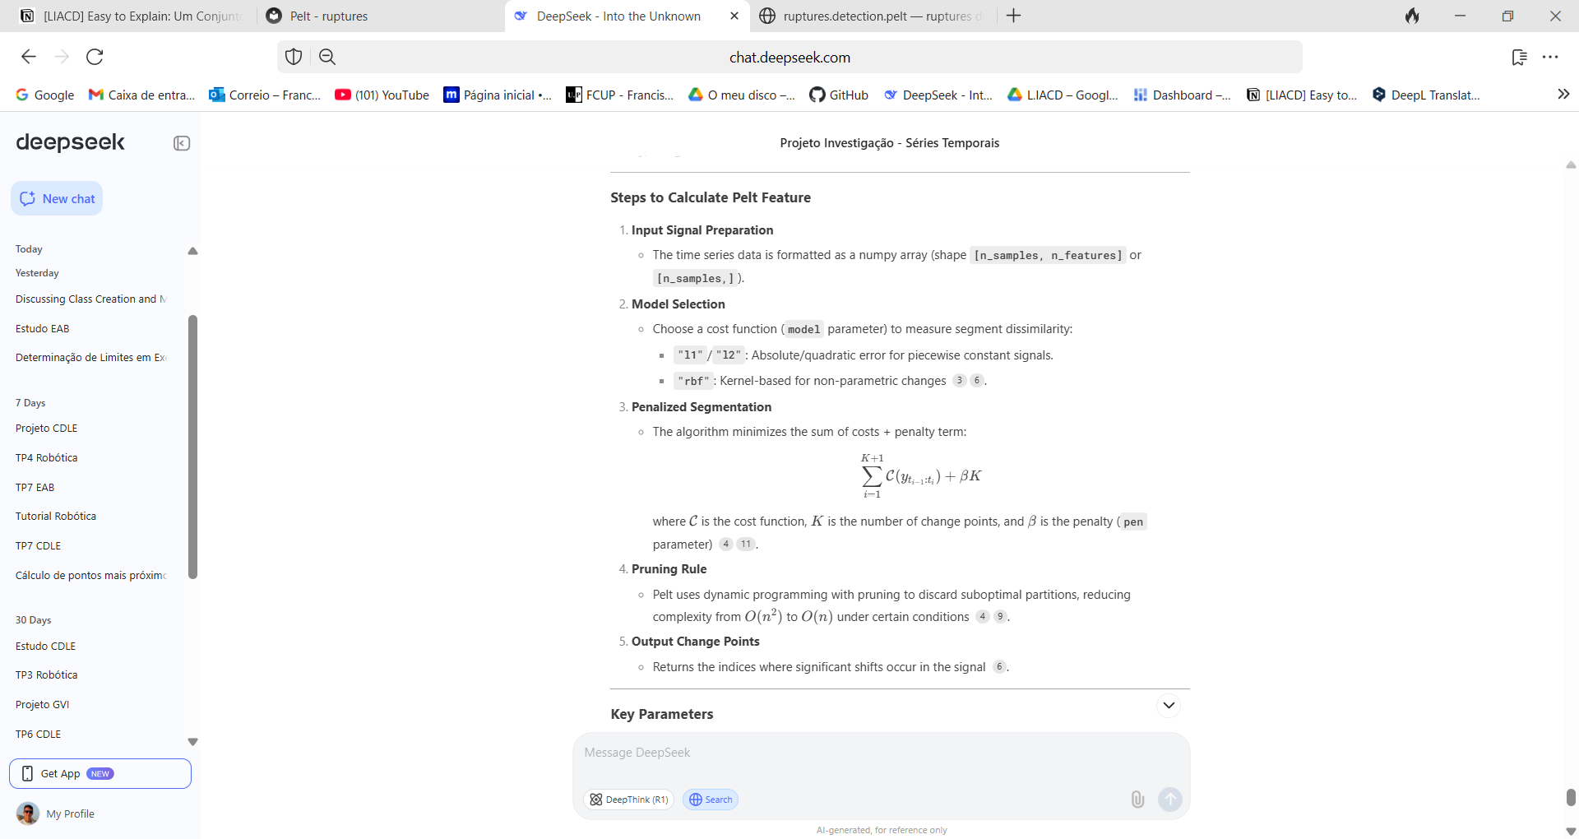**Formula:**

* **Old: Linear Regression**
* **New: linear_regression_slope (Linear Regression Slope)**

**& linear_regression_r2 (Linear Regression R2)**

**Source:** scikit-learn

**Description:** Computes the linear regression of a time series using the Ordinary Least Squares

**Formula:**

**Uma imagem com texto, Tipo de letra, recibo, branco

Os conteúdos gerados por IA poderão estar incorretos.**

***Noise/Complexity***

* **Old: special_entropy**
* **New: forecastability (Series Forecastability)**

**Source:** antropy

**Description:** Forecastability measure of a time-series (Shannon entropy)

**Formula:**

* **Old: entropy_pairs**
* **New: entropy_pairs (Entropy Pairs)**

**Source:** catch22

**Description:** Computes the probability of a two letter sequence, being the possible letters A, B and C, that represent the third lowest values of the series, the third median values and the third highest values

**Formula:**

1. Converts each value in the time series into one of three symbols ('A', 'B', or 'C') using an equi-probable binning in which the lowest 3rd of values are assigned 'A', the middle 3rd 'B', and the highest 3rd of values are given 'C'.
2. It then analyses the probabilities of all two-letter sequences ('AA', 'AB', 'BB', …) and outputs the entropy of this set of probabilities.

* **Old: high_fluctuation**
* **New: fluctuation (Series Fluctuation)**

**New Name:** Series Fluctuation (fluctuation)

**Source:** catch22

**Description:** Computes the proportion of difference magnitudes that are greater than 4% of the standard deviation of the time series.

***Seasonality Detection***

* **Old: acf_timescale**
* **New: ac_relevance (Autocorrelation Relevance)**

**Source:** catch22

**Description:** Captures the first 1/e crossing of the auto-correlation function. Measures the first time lag at which the autocorrelation function drops below 1/e.

**Formula:**

1. Compute the autocorrelation function
2. Return the first 1/e crossing

* **Old: stl_features (seasonal_strenght)**
* **New: seasonal_strength (Seasonal Strength)**

**Source:** tsfeatures

**Description:** Computes the strength of trend in a time series

**Uma imagem com texto, file, captura de ecrã, Tipo de letra

Os conteúdos gerados por IA poderão estar incorretos.Formula:**

***Volatility/Outliers***

* **Old: rs_range**
* **New: window_fluctuation (Window Fluctuation)**

**Source:** catch22

**Description:** Computes the fluctuation in defined timescale window

**Formula:**

1. Compute a cumulative sum of the time series
2. Compute the level of fluctuation (e.g., root-mean-square deviations from local low-order trends) across windows corresponding to a given timescale. Different methods exist for detrending time-series windows at a given timescale, including (relevant to these two features):
3. Rescaled range analysis removes a line connecting the endpoints of each window and computes the range of the remaining points (Caccia et al., Physica A, 1997)
4. DFA fits a k-order polynomial to each window and computes the residuals from this fit.
5. Looks for linear scaling in the log(timescale)–log(fluctuation) plot.

***Model Selection***

* **Old: Trev**
* **New: st_variation (Short-Term Variation)**

**Source:** catch22

**Description:** Computes the average across the time series of the cube of successive time-series differences.

**Formula:**

⟨(*xi*+1​−*xi*​)3⟩*t*​, for time-series values x, at all time points, t

* **Old: acf_feature (x_acf1)**
* **New: ac (Autocorrelation)**

**Source:** tsfeatures

**Description:** Returns the autocorrelation function.

**Formula:**

1. Compute and return the autocorrelation

* **Old: acf_feature (diff1_ac10)**
* **New: diff_series (Differenced Series)**

**Source:** tsfeatures

**Description:** Returns the autocorrelation of the differenced series.

**Formula:**

1. Compute the differenced series
2. Compute and return autocorrelation of the differenced series

* **New: complexity (Series Complexity)**

**Source:** NEW

Uma imagem com Tipo de letra, diagrama, branco, texto

Os conteúdos gerados por IA poderão estar incorretos.**Description:** Computes the complexity of a time-series to help choosing the parameters in nearest-neighbor algorithms (using CIDM)

**Formula:**

***Clustering/Classification***

* **Old: mode10**
* **New: rec_concentration (Records Concentration)**

**Source:** catch22

**Description:** Captures the relative position of the most probable value in relation to the mean

**Formula:**

1. z-score the input time series.
2. Compute a histogram using 10 bins.
3. Return the location of the bin with the most counts.

* **Old: calc_centroid**
* **New: centroid (Series Centroid)**

**New Name:** Series Centroid (centroid)

**Source:** tsfel

Uma imagem com Tipo de letra, diagrama, branco, file

Os conteúdos gerados por IA poderão estar incorretos.**Description:** Computes the centroid along the time axis

**Formula:**