Analysen aus Praesentation

Table of contents

## 1 Quarto

if (!require("pacman")) install.packages("pacman")

Loading required package: pacman

pacman::p_load(haven, psych,  
 sjmisc, sjPlot, writexl, lmerTest,  
 tidyverse, multilevelTools, parameters)

## 2 MLM-Motivierendes Beispiel

load("../data/df_example1.RData")  
load("../data/df_example1c.RData")  
  
df_example1d <- read.table(file = "../data_simulation/example1drep2.dat", header = FALSE,   
 na.strings = "*", strip.white = TRUE) |> as_tibble()  
names(df_example1d) <- c("w", "y", "x", "id")  
df_example1d <- df_example1d |> select(id, everything())  
  
df_example1d <- df_example1d |>   
 de_mean(y, x, grp = "id")

## 3 Variante 1: Klassisches lineares Modell ohne Berücksichtigung der hierarchischen Datenstruktur

v1_results <- lm(y ~ x, df_example1d)  
model_parameters(v1_results) |> print_html()

| Parameter | Coefficient | SE | 95% CI | t(998) | p |
| --- | --- | --- | --- | --- | --- |
| (Intercept) | 3.89 | 0.08 | (3.74, 4.04) | 50.92 | < .001 |
| x | 0.15 | 0.03 | (0.08, 0.21) | 4.40 | < .001 |
|  | | | | | |

## 4 Variante 2: Personen-Mittelwerte

df_personlevel <- df_example1d |> group_by(id) |>   
 summarise(across(c(y,x), mean))  
  
v2_results <- lm(y ~ x, df_personlevel)  
model_parameters(v2_results) |> print_html()

| Parameter | Coefficient | SE | 95% CI | t(98) | p |
| --- | --- | --- | --- | --- | --- |
| (Intercept) | 3.70 | 0.18 | (3.35, 4.06) | 20.76 | < .001 |
| x | 0.24 | 0.08 | (0.08, 0.40) | 2.96 | 0.004 |
|  | | | | | |

Grossere Standardfehler / Konfidenzintervalle

## 5 Variante 3: Mehrebenen-Modell

ri.fs_modell <- lmer(y ~ x_dm + x_gm + (1 | id), data = df_example1d)  
model_parameters(ri.fs_modell) |> print_html()

Table 1: Model Summary

| Parameter | Coefficient | SE | 95% CI | t(995) | p |
| --- | --- | --- | --- | --- | --- |
| Fixed Effects | | | | | |
| (Intercept) | 3.70 | 0.18 | (3.35, 4.05) | 20.76 | < .001 |
| x dm | -0.03 | 0.05 | (-0.12, 0.06) | -0.62 | 0.536 |
| x gm | 0.24 | 0.08 | (0.08, 0.40) | 2.96 | 0.003 |
| Random Effects | | | | | |
| SD (Intercept: id) | 0.67 |  |  |  |  |
| SD (Residual) | 0.97 |  |  |  |  |
|  | | | | | |

Separat pro Person

df_example1d |>  
 filter(id %in% 1:4) |>  
 mutate(time = rep(1:10, 4)) |>   
 mutate(id = as.factor(id)) |>   
 ggplot(aes(x = time, y = y, group = id, color = id)) +   
 geom_point() +  
 geom_smooth(method = lm) +  
 facet_wrap(vars(id))

`geom_smooth()` using formula = 'y ~ x'

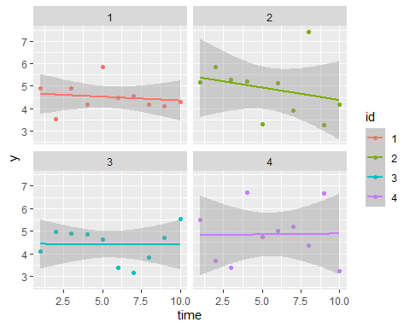

ggsave("Plots/01_separat_zeit.png", width = 10, height = 7)

`geom_smooth()` using formula = 'y ~ x'

sep_plot <- function(df, y, x, idvar, idnum) {  
 df |>  
 filter(!!sym(idvar) %in% idnum) |>   
 mutate(!!sym(idvar) := as.factor(!!sym(idvar))) |>   
 ggplot(aes(x = x, y = y, group = !!sym(idvar), color = !!sym(idvar))) +   
 geom_point() +  
 geom_smooth(method = lm) +  
 facet_wrap(vars(!!sym(idvar)))  
}  
  
sep_plot(df_example1d, "y", "x", "id", 1:4)

`geom_smooth()` using formula = 'y ~ x'

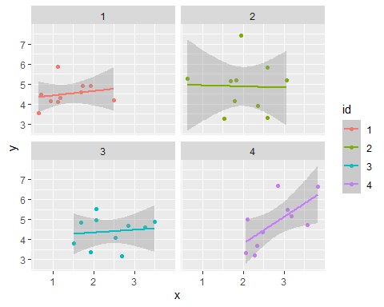

ggsave("Plots/01_separat_yx.png", width = 10, height = 7)

`geom_smooth()` using formula = 'y ~ x'

## 6 Sample Paper

### 6.1 Einlesen

df_example_cli <- read.table(file = "../data_simulation/example_cli1.dat", header = FALSE,   
 na.strings = "999.000000", strip.white = TRUE) |> as_tibble()  
names(df_example_cli) <- c("w", "y", "x", "pattern", "id")  
df_example_cli <- df_example_cli |> select(id, everything())  
  
df_example_cli <- df_example_cli |>   
 de_mean(y, x, w, grp = "id")  
  
df_example_cli <- df_example_cli |>   
 group_by(id) |>   
 mutate(  
 y_dm_l1 = lag(y_dm),  
 day = 1:10  
 )  
  
df_example_cli <- df_example_cli |> filter(!is.na(y)) |> ungroup()  
  
df_example_cli <- df_example_cli |> sjlabelled::var_labels(y = "Daily Negative Affect", y_dm_l1 = "Previous-day Negative Affect", x_dm = "Daily Illegitimate Tasks", x_gm = "Illegitimate Tasks (average)", w = "Coworker support")  
  
save(df_example_cli, file = "../data/df_example_cli.RData")

### 6.2 Analysis

library(franzpak)  
cortable_integriert2 <- cortable_multilevel(df_example_cli,  
 varnames = c("w", "y", "x"),  
 grp = "id")

Warning in cor(diffs, use = use, method = method): the standard deviation is  
zero

Warning in cov2cor(xvals$rwg): diag(V) had non-positive or NA entries; the  
non-finite result may be dubious

Warning in cor(new.data[, (nvar + 1):ncol(new.data)], diffs, use = "pairwise",  
: the standard deviation is zero

cortable_integriert2 |> kableExtra::kable()

| Variable | M | SD | ICC | 1. | 2. | 3. |
| --- | --- | --- | --- | --- | --- | --- |
| 1.w | 2.91 | 0.62 | > .99 | - | .24* | -.01 |
| 2.y | 4.19 | 1.02 | .46 | NA | - | .34*** |
| 3.x | 1.88 | 1.23 | .65 | NA | .29*** | - |

ri.rs_modell <- lmer(y ~ x_dm + x_gm + y_dm_l1 + (1 + x_dm | id), data = df_example_cli)  
model_parameters(ri.rs_modell) |> print_html(pretty_names = "labels")

Table 1: Model Summary

| Parameter | Coefficient | SE | 95% CI | t(551) | p |
| --- | --- | --- | --- | --- | --- |
| Fixed Effects | | | | | |
| (Intercept) | 3.71 | 0.14 | (3.43, 3.99) | 26.22 | < .001 |
| Daily Illegitimate Tasks | 0.30 | 0.05 | (0.19, 0.40) | 5.44 | < .001 |
| Illegitimate Tasks (average) | 0.26 | 0.06 | (0.14, 0.39) | 4.09 | < .001 |
| Previous-day Negative Affect | -0.14 | 0.04 | (-0.22, -0.05) | -3.27 | 0.001 |
| Random Effects | | | | | |
| SD (Intercept: id) | 0.66 |  |  |  |  |
| SD (x_dm: id) | 0.32 |  |  |  |  |
| Cor (Intercept~x_dm: id) | 0.84 |  |  |  |  |
| SD (Residual) | 0.67 |  |  |  |  |
|  | | | | | |

cli_model <- lmer(y ~ x_dm + x_gm + y_dm_l1 + w + w*x_dm + (1 + x_dm | id), data = df_example_cli)  
model_parameters(cli_model) |> print_html(pretty_names = "labels")

Table 1: Model Summary

| Parameter | Coefficient | SE | 95% CI | t(549) | p |
| --- | --- | --- | --- | --- | --- |
| Fixed Effects | | | | | |
| (Intercept) | 2.97 | 0.36 | (2.26, 3.68) | 8.24 | < .001 |
| Daily Illegitimate Tasks | 0.43 | 0.27 | (-0.09, 0.96) | 1.62 | 0.107 |
| Illegitimate Tasks (average) | 0.26 | 0.06 | (0.14, 0.38) | 4.31 | < .001 |
| Previous-day Negative Affect | -0.14 | 0.04 | (-0.22, -0.05) | -3.29 | 0.001 |
| Coworker support | 0.25 | 0.11 | (0.03, 0.48) | 2.23 | 0.026 |
| Daily Illegitimate Tasks * Coworker support | -0.05 | 0.09 | (-0.22, 0.13) | -0.53 | 0.595 |
| Random Effects | | | | | |
| SD (Intercept: id) | 0.64 |  |  |  |  |
| SD (x_dm: id) | 0.32 |  |  |  |  |
| Cor (Intercept~x_dm: id) | 0.91 |  |  |  |  |
| SD (Residual) | 0.67 |  |  |  |  |
|  | | | | | |

plot_model(cli_model, type = "int", terms = c("x_dm", "w"))

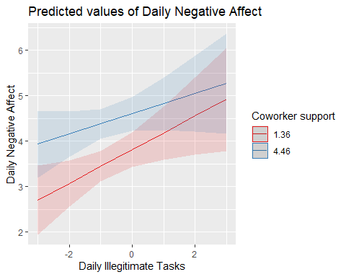

ggsave("Plots/examplepaper_CLI.png", width = 7, height = 5)

### 6.3 Export to Excel table

# cortable_integriert2 |> writexl::write_xlsx()  
# h1_modelsummary <- model_parameters(ri.rs_modell)  
# h2_modelsummary <- model_parameters(cli_model)